Cinematography in 2023
2.1 million film screenings were shown in indoor cinemas, watched by 49.7 million viewers. 535 indoor cinemas had 1.6 thousand screens.
⇧ 20.1%
Increase in the number of audience in indoor cinemas in comparison to 2022
362 films were produced for presentation in cinemas and television.

Cinemas activity
There were 1.6 thousand screens with 298.2 thousand seats for the audience in indoor cinemas. Compared to 2022, the number of audience increased by 8.3 million people. Most of indoor cinemas operated in Mazowieckie Voivodship (83). Among other Voivodships, Śląskie (53), Wielkopolskie (52), Dolnośląskie (49) and Małopolskie (46) also stood out. The largest number of screenings per one indoor cinema was recorded in Kujawsko-Pomorskie Voivodship (128.5 thousand), and the fewest in Świętokrzyskie Voivodship (54.3 thousand).

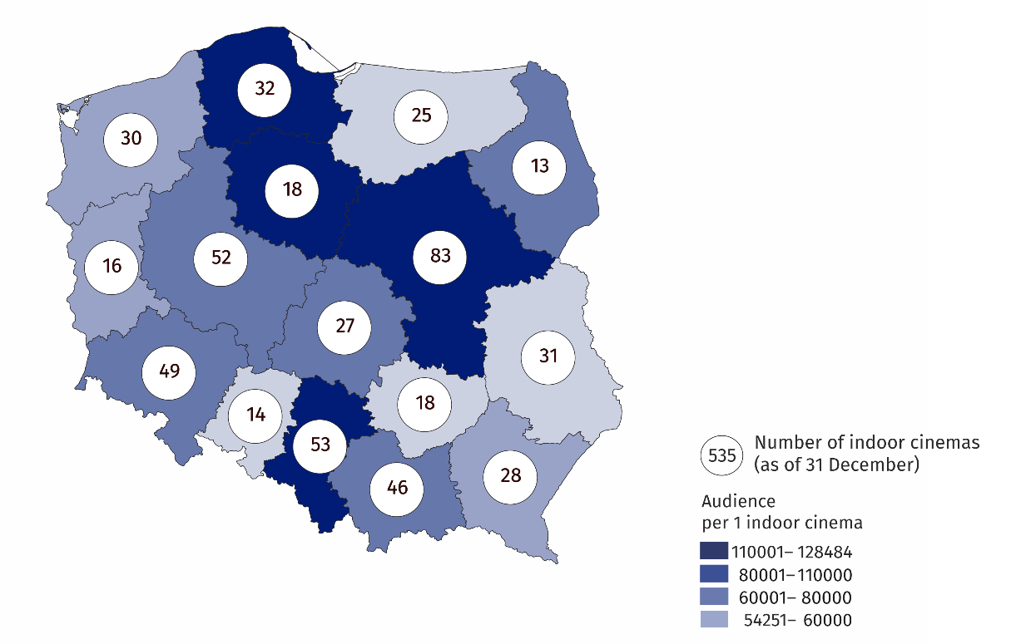
Map 1. Indoor cinemas in 2023
19.2% of audience in indoor cinemas watched films in Mazowieckie Voivodship
Among indoor cinemas, the largest group were entities with one screen – 312 (58.3%). Miniplexes (with 3 to 7 screens) constituted 21.1% of the total number of indoor cinemas, multiplexes (with 8 or more screens) – 11.6%, while indoor cinemas with two screens – 9.0%. The multiplexes displayed 49.6% of the total number of screenings, watched by 49.8% of the total audience. The miniplexes displayed 37.3% of screenings, watched by 35.7% of audience. One multiplex had an average of 2.0 thousand seats for the audience and displayed an average of 17.1 thousand screenings.
58.3% of the total number of indoor cinemas had one screen

Chart 1. Indoor cinemas by number of screens in 2023
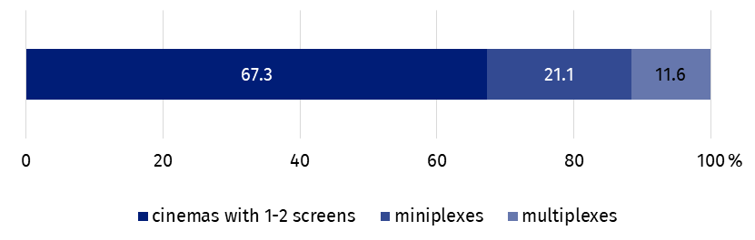
As of 31 December

Film production
In Poland, 106 full-length films and 256 medium- and short-length films intended for cinemas and television were produced (112 and 255 respectively in 2022). On an annual basis, the number of produced full-length feature films decreased by 16.5% (from 85 to 71), of which cinema feature films decreased by 14.5% (from 55 to 47) and television feature films – by 20.0% (from 30 to 24). In 2023, 205 documentary films were produced, 177 documentary films were intended for television and 28 for cinemas.

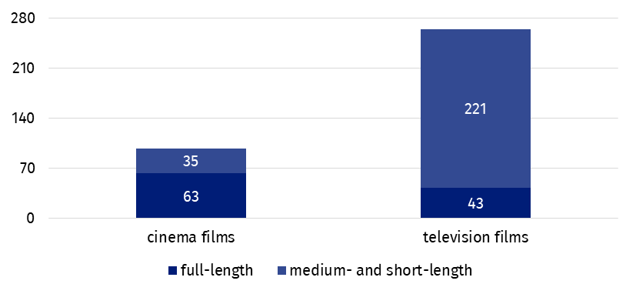
Chart 2. Films produced in 2023
The most frequently produced type of full-length films were feature films, which accounted for 67.0% of the total number of cinema and television feature films, while documentary films dominated among medium- and short-length films (68.4% of the total number of cinema and television medium- and short-length films).

Chart 3. Films produced by type in 2023
Documentary films accounted for 56.6% of the total number of produced films
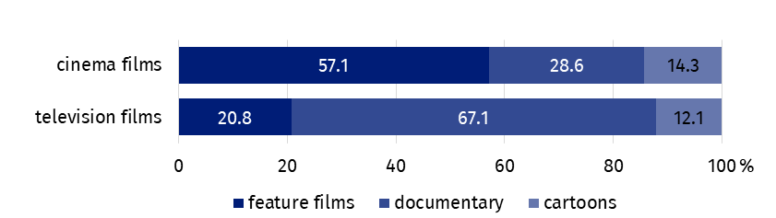
In the case of quoting data from the Statistics Poland, please provide information: "Statistics Poland data source", and in the case of publishing calculations made on data published by the Statistics Poland, please provide information: "Own study based on Statistics Poland data".
Prepared by:  Statistical Office in Kraków  Director Agnieszka Szlubowska  Phone: (+48 12) 420 40 50 | Issued by:  Press Office  Mobile: (+48) 695 255 032  Phone: (+48 22) 608 38 04, (+48 22) 449 41 45,  (+48 22) 608 30 09  e-mail: obslugaprasowa@stat.gov.pl

stat.gov.pl/en/

@StatPoland

@GlownyUrzadStatystyczny

gus_stat

glownyurzadstatystycznygus

glownyurzadstatystyczny
Related information
Culture and national heritage in 2022
Cinematography in 2022
Terms used in the official statistics
Indoor cinema
Audience
Film

