The impact of the COVID-19 epidemic on selected elements of the labour market in Poland in the fourth quarter of 2021
In March 2020, the state of epidemic threat was anno-unced in Poland, followed by the state of epidemic in connection with the spread of an infectious disease caused by the SARS-CoV-2 virus, named COVID-19. Fol-lowing the assessment of the epidemic situation, solutions were introduced by law to prevent and counteract the spread of the said virus and to combat the disease caused by it. These solutions were also applica-ble to the labour market. Among them, for instance, was the introduction of the possibility of working from outside a permanent workplace, that is remote work. The data presented in this publication were obtained from the Labour Demand Survey.
6.9%
the share of people who worked remotely on 31 December 2021 due to the epidemic situation in the total number of employed persons
The Labour Demand Survey is conducted using the representative method on a quarterly basis. According to the scope of the survey, it covers notional economy entities and their local units employing at least 1 person. The survey shows that at the end of the fourth quarter of 2021, the number of occupied jobs was almost the same as at the end of the third quarter of 2021.
Chart 1. Occupied jobs
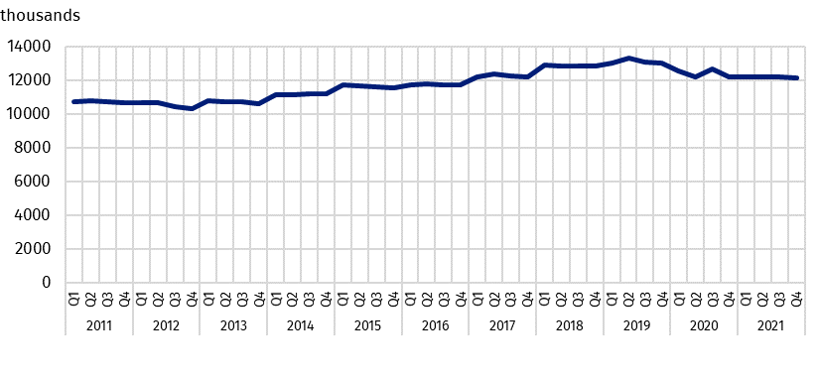
As at the end of the quarter

Remote work during the period of epidemic threat
The epidemic situation that occurred in March 2020 limited the activities of national econo-my entities in their hitherto existing form. This was manifested, on the one hand, by the liquidation of jobs, and on the other hand, by the fact that employers became open to forms of employment enabling staff to maintain social distance. One of such forms is remote work.
At the end of December 2021, the share of people who worked remotely due to the epidemic situation in the total number of employed persons covered by the Labour Demand Survey was 6.9%, 3.9 percentage points lower than at the end of December 2020. During the fourth quarter of 2021, the extent of remote work in the public sector was higher than in the private sector. However, in both sectors, this share was lower than in the fourth quarter of 2020.
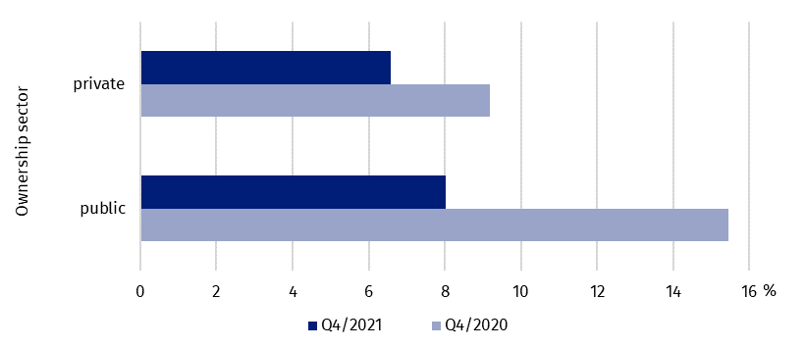
Chart 2. The share of employed persons working remotely due to the epidemic situation by
ownership sector
As at the end of the quarter
Across the whole economy, the use of remote work in order to reduce the epidemic risk remained highest in national economy entities with 50 employed persons or more. The share of people working remotely in entities of this size was 8.8%, 3.8 percentage points fewer than in the fourth quarter of 2020. In national economy entities with up to 9 employed persons, remote work was performed by 2.6% of employed persons, and in entities with 10-49 employed persons – 5.5%.
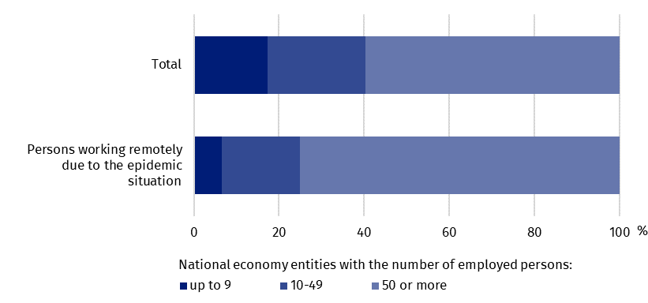
Chart 3. The structure of employed persons by size of units in the fourth quarter of 2021
As at the end of the quarter
Remote work caused by the epidemic was implemented by employers in individual regions at different scales.

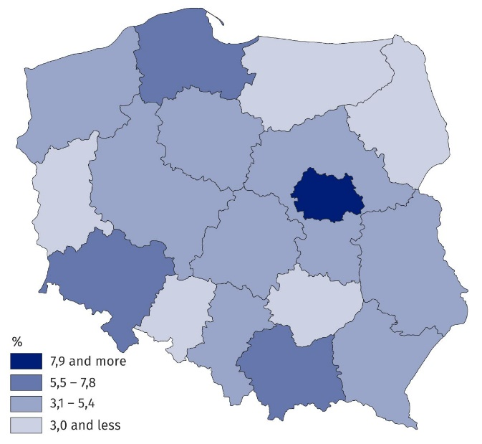
Map 1. The share of employed persons working remotely due to the epidemic situation
by region (NUTS 2016) in the fourth quarter of 2021
As at the end of the quarter
The transition to remote work to a significantly higher degree than statistically in Poland took place in the Warszawski stołeczny region. As a result of the epidemic situation, approximately every sixth employed person worked remotely there. Among the remaining regions, the use of this form of work in the realities of the epidemic threat was least common in the Świętokrzyskie and Warmińsko-Mazurskie regions, where among the remaining regions, the use of this form of work in the realities of the epidemic threat was least common in the Świętokrzyskie, Podlaskie and Warmińsko-Mazurskie regions. In each of these regions remote work due to the COVID-19 threat was performed by 2.4% of employed persons.
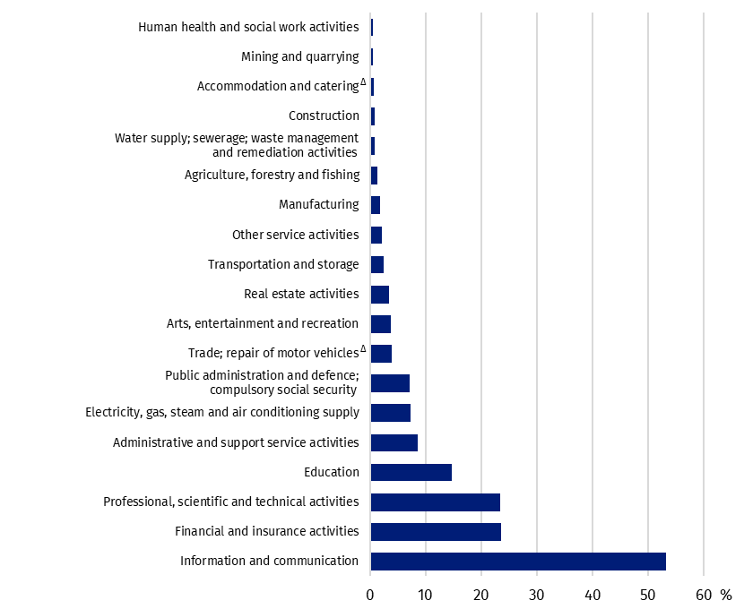
Chart 4. The share of employed persons working remotely due to the epidemic situation in
selected PKD/NACE sections in the fourth quarter of 2021
As at the end of the quarter

Performing remote work in the third quarter of 2021 varied depending on the kind of activ-ity. For example, in the information and communication section, remote work was performed by 53.3% of employed persons. As regards other sections, a relatively large share of employed persons covered by this form of work due to the outbreak of an infectious disease caused by the SARS-CoV-2 virus also occurred in the financial and insurance activities sec-tion as well as in the professional, scientific and technical activities section.

Employed persons who due to the epidemic situation received a care allowance during a period of leave resulting from the necessity to take personal care of a child under 8 years of age
By virtue of the Act of 2 March 2020 on Special Solutions to Prevent, Counteract and Combat COVID-19, Other Infectious Diseases and Crisis Situations Caused by Them, working parents or legal guardians were provided with the possibility to receive a care allowance during a pe-riod of leave resulting from the necessity to take personal care of a child under 8 years of age in case of a closure of a nursery, nursery school, children’s club or school. In the fourth quarter of 2021, 0.6% of employed persons were exercising this right in Poland, the vast ma-jority of whom worked in the private sector.
In the fourth quarter of 2021, compared to the fourth quarter of 2020, the share of em-ployed persons receiving a care allowance during a period of leave resulting from the ne-cessity to take personal care of a child under 8 years of age re-mained at a similar level
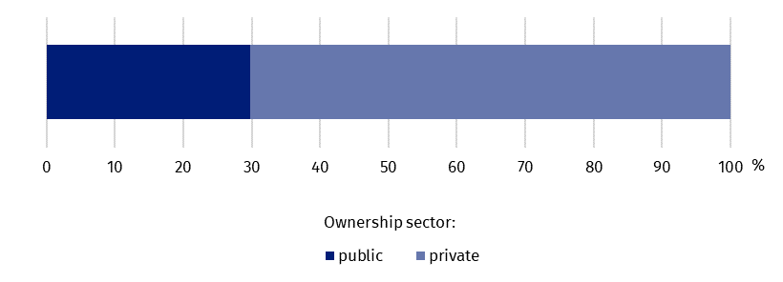
Chart 5. The structure of employed persons who due to the epidemic situation received a care
allowance during a period of leave resulting from the necessity to take personal care of a child under 8 years of age in case of a closure of a nursery, nursery school, children’s club or school by ownership sector in the fourth quarter of 2021
Of employed persons who due to the epidemic situation were recipients of a care allowance during a period of leave resulting from the necessity to take personal care of a child under 8 years of age in case of a closure of a nursery, nursery school, children’s club or school the largest number worked in entities with 50 or more employed persons – 46.2%.
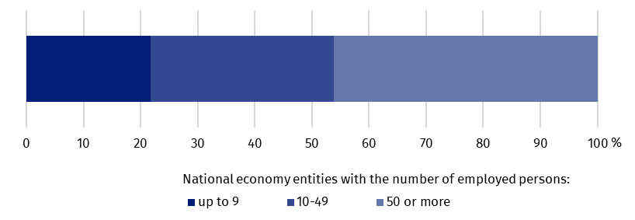
Chart 6. The structure of employed persons who due to the epidemic situation received a care allowance during a period of leave resulting from the necessity to take personal care of a child under 8 years of age in case of a closure of a nursery, nursery school, children’s club or school by size of national economy entities in the fourth quarter of 2021
The scale of taking leave to care for a child for the said reason in particular regions was quite similar. The share of the number of working parents and legal guardians exercising the right to care for a child due to the epidemic situation ranged from 0.5% to 0.9%.
According to the survey, relatively the highest number of employed persons, that is 1.0%, took leaves from work because of caring for a child in the other service activities section.
The largest number of employed persons who exercised the right to take care of a child due to the spread of COVID-19 were parents and legal guardians working in sections: trade; repair of motor vehicles^{Δ} and manufacturing.
The analysis of the structure of employed persons who due to the epidemic situation received a care allowance during a period of leave resulting from the necessity to take personal care of a child under 8 years of age in case of a closure of a nursery, nursery school, children’s club or school by PKD/NACE section shows that employed persons from sections: trade; repair of motor vehicles^{Δ}, manufacturing and education accounted together for more than 50% of all persons receiving the allowance.
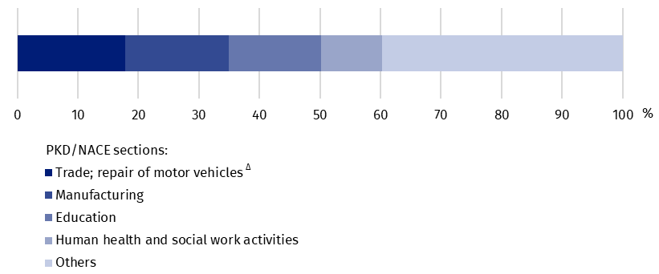
Chart 7. The structure of employed persons who due to the epidemic situation received a care allowance during a period of leave resulting from the necessity to take personal care of a child under 8 years of age in case of a closure of a nursery, nursery school, children’s club or school by PKD/NACE section in the fourth quarter of 2021

Employed persons who due to the epidemic situation received a sick pay or sickness allow-ance because of undergoing quarantine or isolation
When compared with 31 December 2020, the scale of receving a sick pay or sickness allowance because of undergoing quarantine or isolation by employed persons as at 31 December 2021 slightly decreased
In the fourth quarter of 2021, in order to limit the spread of the infectious disease, forms of temporary isolation due to the suspicion of infection, for instance quarantine or isolation, were still in use. Employed persons who were recipients of a sick pay or sickness allowance due to quarantine or isolation as at 31 December 2021, constituted 2.1% of the total employed population. Such cases were recorded at a similar scale in both the public and private sectors.
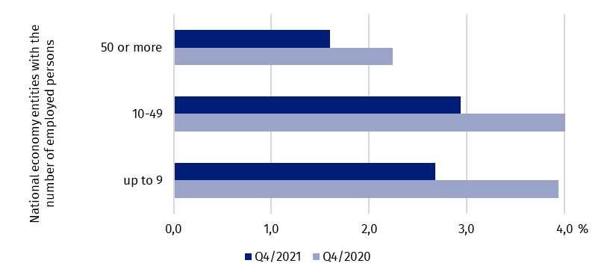
Chart 8. The share of employed persons who received a sick pay or sickness allowance
because of undergoing quarantine or isolation by size of national economy entities
As at the end of the quarter
The scale of using this kind of temporary isolation (i.a. quarantine or isolation) due to the su-spicion of infection was higher in the fourth quarter of 2021 than in the fourth quarter of 2020. This was the case regardless of the size of an entity.
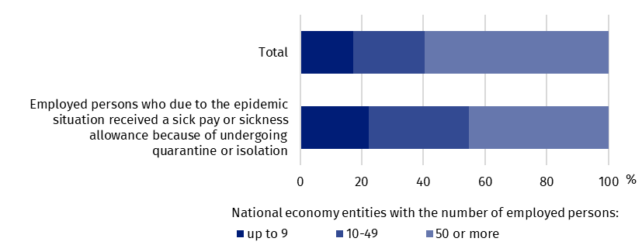
Chart 9. The structure of employed persons by size of national economy entities in the fourth quarter of 2021
As at the end of the quarter
Quarantine or isolation of employed persons took place in all regions, with relatively the highest occurrence in the Zachodniopomorskie and Opolskie regions. In each of these regions, employed persons who were recipients of a sick pay or sickness allowance because of undergoing quarantine or isolation as at 31 December 2021, accounted for 3% of employed persons. When looking at kinds of activities, it can be noted that at the end of December 2021, the largest share of employed persons subject to the obligation of quarantine or isolation was recorded in the accommodation and catering^{Δ} section and the other service activities section.

Summary
The SARS-CoV-2 virus began to spread in Poland in the first quarter of 2020. The results of the survey show that the time of the pandemic changed the situation in terms of occupied and unoccupied jobs, and after a significant reduction in the number of these jobs in 2020, in all quarters of 2021, the number of employed persons, which reflects the number of occupied jobs, returned to the level of 2019.
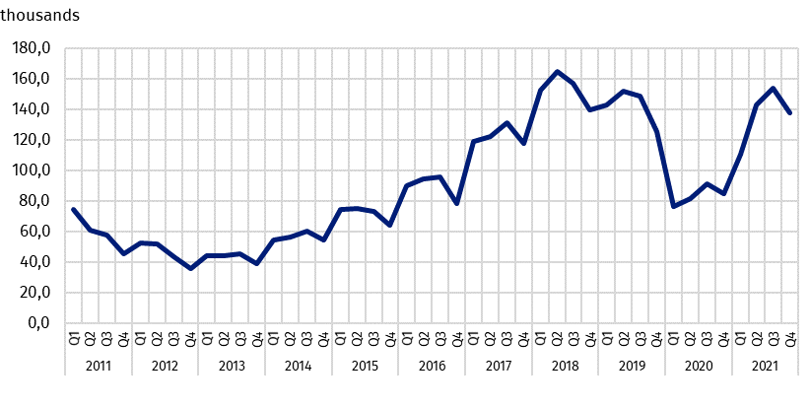
Chart 10. Job vacancies
As at the end of the quarter
The phenomena presented in this news release will be monitored in subsequent editions of the Labour Demand Survey.
In this news release abbreviated names of NACE, Rev. 2 sections were used. Abbreviations are marked with a ‘Δ’ symbol. Full names are available on the Eurostat website at: https://ec.europa.eu/eurostat/data/classifications
In the case of quoting Statistics Poland data, please provide information: "Source of data: Statistics Poland", and in the case of publishing calculations made on data published by Statistics Poland, please provide information: "Own elaboration based on Statistics Poland data.”

Prepared by:  Statistical Office in Bydgoszcz  Director Wiesława Gierańczyk, Ph.D.  Phone: (+48 22) 366 93 90 | Issued by:  The Spokesperson for the President  of Statistics Poland  Karolina Banaszek  Phone: (+48) 695 255 011
Press Office  Phone: (+48 22) 608 38 04  e-mail: obslugaprasowa@stat.gov.pl | stat.gov.pl/en/
 | @StatPoland
 | @GlownyUrzadStatystyczny
 | gus_stat
 | glownyurzadstatystycznygus
 | glownyurzadstatystyczny
Related information
The impact of the Covid-19 epidemic on selected elements of the labour market in the third quarter of 2021
The demand for labour in the third quarter of 2021
The demand for labour – annual publication
Methodological report. The demand for labour
Other publications that contain the results of these surveys: stat.gov.pl → Topics → Labour market
Data available in databases
Knowledge databases – Labour market
Strateg → Themes → Labour market
Local Data Bank → Labour market
Terms used inn official statistics
Demand for labour
Vacancies
Newly created jobs

The collected data come from the voluntary responses of reporting units to four additional questions atta-ched on the Reporting Portal to ‘the Labour Demand Survey’. Approximately half of the units that completed the reports answered the questions about the impact of the pandemic situation on the way enterprises oper-ate and behave.

