The demand for labour in the second quarter of 2022
⇩ 5.9%
Decrease in the number of job vacancies compared with the end of the previous quarter
At the end of the second quarter of 2022, there were 149.3 thousand job vacancies in Poland, 4.5% more than in the corresponding period of the previous year. Over the year, the number of newly created jobs decreased (by 6.8%), whereas the number of jobs liquidated increased (by 12.6%). In the second quarter of 2022, there were 2.1 newly created jobs per liquidated job.
The Labour Demand Survey is conducted using the representative method on a quarterly basis, on the Z–05 reporting form. It covers national economy entities employing at least one person. At the end of the second quarter of 2022, private sector entities constituted the vast majority, whereas in terms of entity size – entities with up to 9 employed persons (respectively 91.1% and 69.0% of the total number of entities, i.e. the same as at the end of the second quarter of 2021).
At the end of the second quarter of 2022, the majority of national economy entities with job vacancies were entities with up to 9 employed persons, while job vacancies in these entities accounted for slightly more than a quarter of the total number job vacancies
In the second quarter of the current year, 6.2% out of 652.0 thousand national economy entities, i.e. slightly more than in the corresponding period of 2021, had job vacancies. Among entities that had job vacancies, 87.3% were private sector entities. More than half of the entities with job vacancies (56.8%) had up to 9 employed persons.
Table 1. Basic results of the Labour Demand Survey
QUARTERS  A – corresponding quarter of the previous year = 100  B – previous quarter = 100 | Jobs |  |  |  | Newly  created jobs | Liquidated jobs
 | Grand  total | occupied | vacant
 |  |  | total | including newly created
 | at the end of the quarter |  |  |  | during the quarter
 | In thousands
2021
Quarter 2 | 12 332.6 | 12 189.8 | 142.8 | 35.0 | 145.8 | 58.5
Quarter 3 | 12 325.9 | 12 172.4 | 153.5 | 35.7 | 132.6 | 57.8
Quarter 4 | 12 286.8 | 12 149.4 | 137.4 | 32.3 | 112.5 | 64.9
2022
Quarter 1 | 12 684.6 | 12 525.9 | 158.7 | 30.9 | 189.7 | 81.9
Quarter 2 | 12 659.3 | 12 510.0 | 149.3 | 28.5 | 136.0 | 65.9
A | 102.6 | 102.6 | 104.5 | 81.2 | 93.2 | 112.6
B | 99.8 | 99.9 | 94.1 | 92.2 | 71.7 | 80.5
In Poland, at the end of the second quarter of 2022, there were slightly fewer occupied jobs than in the first quarter. The number of job vacancies also decreased (starting from 2013, quarterly increases were recorded in the second quarters, and the highest in 2021).
At the end of the second quarter of the current year, there were more occupied and vacant jobs than in the corresponding quarter of 2021. Taking into account only the second quarters, the job vacancy rate was the highest since 2018. In the analysed quarter, the number of newly created jobs decreased on a year-over-year basis and the number of liquidated jobs increased.
Table 2. Selected indicators from the Labour Demand Survey
QUARTERS | Share of national economy entities with job vacancies | Job vacancy rate | The ratio of the num-ber of newly created jobs to the number  of liquidated jobs (during the quarter)
 | w % (as at the end of the quarter)
2021
Quarter 2 | 6.1 | 1.16 | 2.5
Quarter 3 | 6.7 | 1.25 | 2.3
Quarter 4 | 5.8 | 1.12 | 1.7
2022
Quarter 1 | 6.7 | 1.25 | 2.3
Quarter 2 | 6.2 | 1.18 | 2.1

Occupied jobs and job vacancies at the end of the second quarter of 2022.
The met demand for labour is measured as the number of occupied jobs and in the second quarter of 2022 there were 12 510.0 thousand such jobs. This means an increase of 2.6% on a year-over-year basis, but a decrease in relation to the previous quarter by 0.1%.
Both the number of occupied jobs and the number of job vacancies at the end of the second quarter of the current year were higher than in the corresponding period of the previous year
The majority of the occupied jobs, i.e. 59.4%, were in national economy entities with 50 or more employed persons. Out of the total number of occupied jobs, 74.5% were in private sector entities.
The analysis of data on job vacancies at the end of the second quarter of 2022 shows that compared with the same quarter of the previous year there were 4.5% more of them. Compared with the first quarter of the current year, the number of job vacancies decreased by 5.9% (in the previous year it increased by 29.6% on a quarterly basis).
The majority of job vacancies (54.5%) were in entities with 50 or more employed persons. Out of the total number of job vacancies, 85.3% were in private sector entities.
Chart 1. Structure of national economy entities and jobs by size of entities in the second quarter of 2022
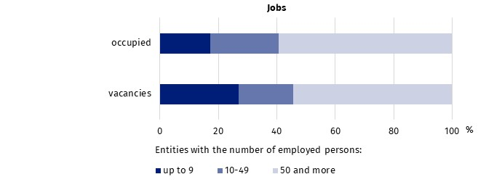
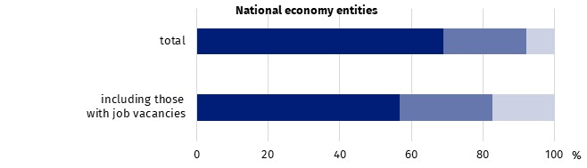
As at the end of the quarter
At the end of the second quarter of the current year almost every fifth job vacancy was a newly created job (28.5 thousand). The number of such jobs decreased on a year-over-year basis by 18.8% (in the corresponding quarter of 2021 it more than doubled).
Employees were sought, among other things, through labour offices, to which 13.8% of the total number of available job vacancies were reported.
One of the measures for assessing the situation on the labour market in terms of the reported demand for labour is the job vacancy rate, which is the share of job vacancies in the sum of the number of occupied posts and the number of job vacancies in a given period.
At the end of the second quarter of 2022, this rate was 1.18%. It was 0.02 percentage points higher compared with the corresponding quarter of 2021 but 0.07 percentage points lower than in the first quarter of the current year.
Chart 2. Job vacancy rate
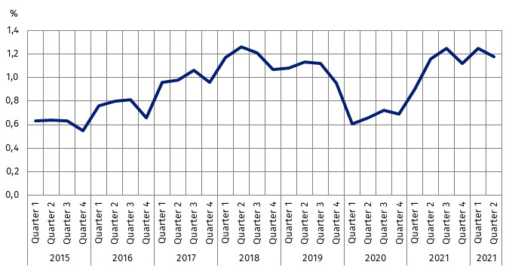
As at the end of the quarter
When looking at the job vacancy rate in the first quarter of 2022 in a territorial breakdown by region, it can be seen that its highest value was recorded in the Zachodniopomorskie region (1.94%), where the number of job vacancies increased on a year-over-year basis by 36.4%. High values of the rate were also recorded in the Warszawski stołeczny (1.54%), Dolnośląskie (1.43%) and Pomorskie (1.41%) regions. The lowest value of the job vacancy rate was recorded in the Lubelskie Voivodship (0.65%), where the number of job vacancies decreased by 24.1% compared with the second quarter of 2021.
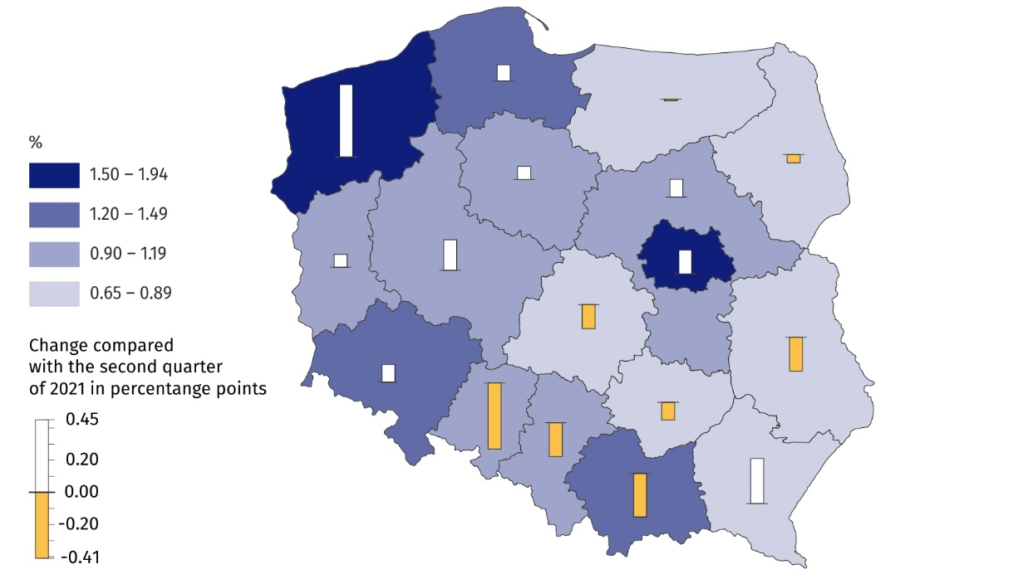
Map 1. Job vacancy rate by region (NUTS 2 level) in the second quarter of 2022
As at the end of the quarter
The highest job vacancy rate at the end of the second quarter of the current year was recorded in the Zachodniopomorskie region

When analysing the structure of jobs by kind of conducted activity, it can be noticed that at the end of the second quarter of 2022 it was similar to that observed in the previous quarter. The most jobs (23.0% of occupied jobs and 22.0% of job vacancies) were in entities from the Manufacturing section. There were, respectively, 2 871.8 thousand and 32.8 thousand of them. Compared with the corresponding quarter of 2021, the number of jobs in this section in the case of occupied jobs increased by 4.0%, and in the case of job vacancies – decreased by 0.7%.
The Trade; repair of motor vehicles^{Δ} section also had a significant share in the structure of jobs – at the end of the second quarter of 2022, occupied jobs accounted for 17.6%, and job vacancies for 13.5% of their total numbers. In the case of the structure of job vacancies, the largest annual increase in the share (by 2.1 percentage points) took place in this section.
In the Education section there was recorded the highest annual increase (8.5%) in the number of occupied jobs. At the end of the second quarter of 2022, occupied jobs in this section accounted for 10.8% of their total number (an increase in the share by 0.6 percentage points).
Compared with the end of the second quarter of 2021, the largest increase in the number of job vacancies was recorded in the Mining and quarrying section (an increase of 69.4%; job vacancies constituted 0.2% of the total number). In both sections: Accommodation and catering^{Δ} and Human health and social work activities, the number of job vacancies decreased slightly by more than 10% (they accounted for 3.2% and 4.6% of the total number of job vacancies, respectively).
The highest value of the job vacancy rate at the end of the second quarter of the current year was recorded in the Information and communication section (3.85%).
Data broken down by major occupational group show that the most jobs were in the major occupational group of Professionals. Professionals accounted for 22.9% of occupied jobs (2 866.6 thousand jobs), and for 24.9% of job vacancies (37.2 thousand jobs). Compared with the second quarter of 2021, the number of jobs in the major occupational group of Professionals increased by 6.4% and 15.5%, respectively. The job vacancy rate was 1.28%.
The highest job vacancy rate was recorded in the major occupational group of Craft and related trades workers
At the end of the second quarter of the current year significant parts of occupied jobs (1 811.3 thousand, i.e. 14.5% of the total number) and of job vacancies (34.3 thousand, i.e. the share of 23.0%) were in the major occupational group of Craft and related trades workers. Compared with the corresponding period of 2021, there was an increase in the number of jobs in this section, by 2.5% and by 9.2%, respectively. In the group of Craft and related trades workers there were 1.86 job vacancies per 100 jobs (the most among all major occupational groups).
Chart 3. Jobs by selected major occupational groups in the second quarter of 2022
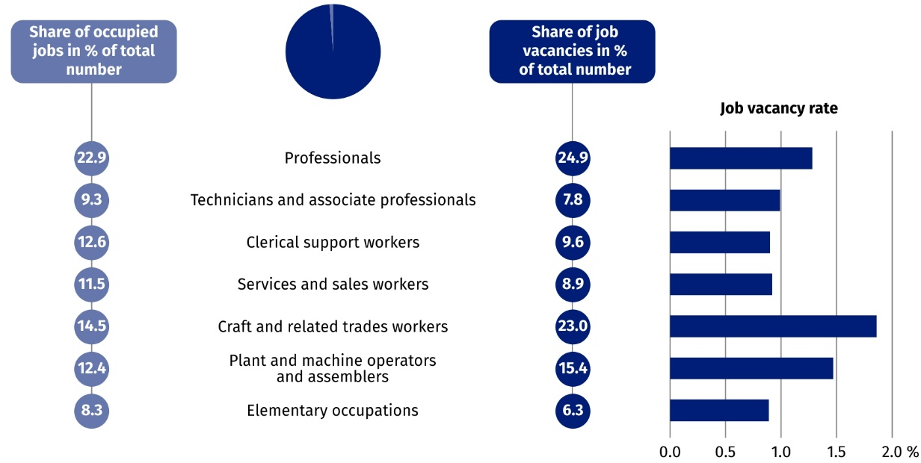
As at the end of the quarter

Newly created and liquidated jobs in the second quarter of 2022
In the second quarter of 2022, despite a decrease in the number of newly created jobs and an increase in the number of liquidated jobs on a year-over-year basis, a surplus of newly created jobs over liquidated jobs was still recorded
The Labour Demand Survey also enables to analyse the situation on the labour market in terms of newly created and liquidated jobs. During the second quarter of 2022, in Poland, 136.0 thousand jobs were created and 65.9 thousand jobs were liquidated. As a result of these changes, the number of jobs increased over the quarter by 70.1 thousand.
Compared with the corresponding period of the previous year, there was a decrease in the number of newly created jobs (by 6.8%, compared with an increase of 78.0% in the second quarter of 2021) and an increase in the number of liquidated jobs (by 12.6%, compared with a decrease of 37.4%).
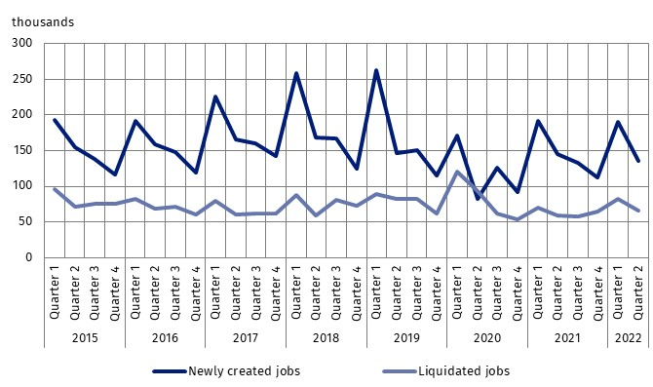
Chart 4. Newly created and liquidated jobs
When assessing the degree of adaptation of the labour market to the reported demand for labour, the ratio of the number of newly created jobs to the number of liquidated jobs in a given period can be used. In the second quarter of 2022, 2.1 new jobs were created per job liquidated (2.5 jobs a year ago).
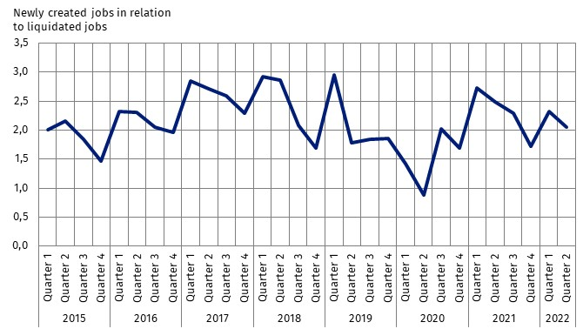
Chart 5. Ratio of the number of newly created jobs to the number of liquidated jobs

In the territorial breakdown, the largest number of newly created jobs per liquidated job in the second quarter of 2022 was in the Świętokrzyskie region (9.2 jobs). In the Zachodniopomorskie region, 3.5 new jobs were created per liquidated job. On the other hand, the lowest ratio – 1.1 newly created jobs per liquidated job – occurred in the Śląskie region.
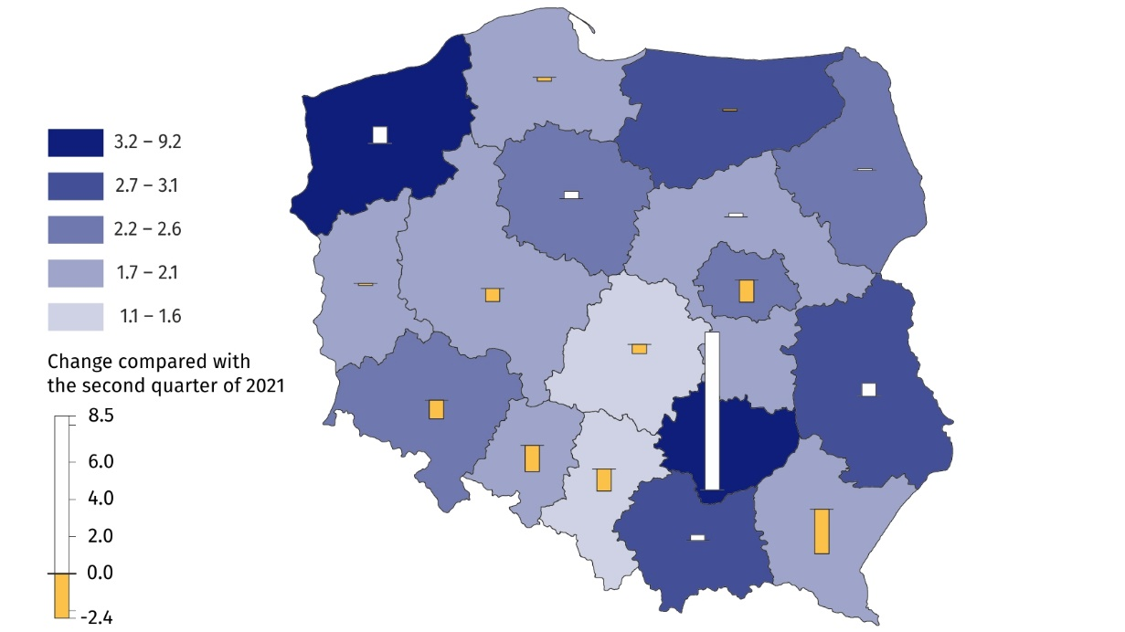
Map 2. Ratio of the number of newly created jobs to the number of liquidated jobs by region (NUTS 2 level) in the second quarter of 2022
In the second quarter of 2022, the largest number of newly created jobs per liquidated job was in the Świętokrzyskie region
In the analysed period, differences in the structure of jobs broken down by PKD/NACE section were also visible – the largest number of new jobs were created in entities from the Trade; repair of motor vehicles∆ section (24.3 thousand, but 15.2% fewer than in the second quarter of 2021). In the same period, 13.7 thousand jobs were liquidated in this section, 6.5% more on a year-over-year basis. There were 1.8 newly created jobs per liquidated job in this section (compared with 2.2 jobs in the second quarter of 2021).
In the second quarter 2022, the largest number of jobs were created and liquidated in the Trade; repair of motor vehicles∆ section
The Manufacturing section also had a significant share in the structure of jobs. New jobs created in the second quarter of 2022 accounted for 17.6% of their total number, and liquidated jobs – 19.8% of their total number (23.9 thousand and 13.1 thousand jobs, respectively). There were 1.8 newly created jobs per liquidated job in this section.
In the second quarter of 2022, the largest number of newly created jobs per liquidated job was in the Public administration and defence; compulsory social security section (5.1 jobs).

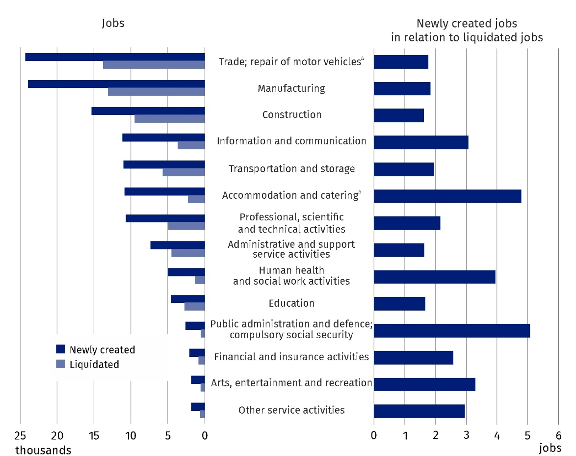
Chart 6. Newly created and liquidated jobs by selected PKD/NACE sections in the second quarter of 2022
In this news release abbreviated names of NACE, Rev. 2 sections were used. Abbreviations are marked with a ‘Δ’ symbol. Full names are available on the Eurostat website at: https://ec.europa.eu/eurostat/data/classifications
Relative numbers (rates, percentages) were calculated on the basis of absolute data expressed with greater accuracy than given in the study.
In the case of quoting Statistics Poland data, please provide information: ‘Source of data: Statistics Poland’, and in the case of publishing calculations made on data published by
Statistics Poland, please provide information: ‘Own elaboration based on Statistics Poland data.’

Prepared by:  Statistical Office in Bydgoszcz  Director Wiesława Gierańczyk, Ph.D.  Phone: (+48 22) 366 93 90 | Issued by:  The Spokesperson for the President  of Statistics Poland  Karolina Banaszek  Phone: (+48) 695 255 011
Press Office  Phone: (+48 22) 608 38 04  e-mail: obslugaprasowa@stat.gov.pl | stat.gov.pl/en/
 | @StatPoland
 | @GlownyUrzadStatystyczny
 | gus_stat
 | glownyurzadstatystycznygus
 | glownyurzadstatystyczny
Related information
The demand for labour in 2021 – annual publication
The demand for labour in the first quarter of 2022 — news release
The impact of the COVID-19 epidemic on selected elements of the labour market in Poland in the first quarter of 2022 – news release
Other publications that contain the results of these surveys: stat.gov.pl → Topics → Labour market
Methodological report. The demand for labour
Data available in databases
Knowledge Databases – Labour market
Strateg → Statistics by theme → Labour market
Local Data Bank → Labour market
Statistics for the SDGs – global indicators
Terms used in official statistics
Demand for labour
Vacancies
Newly created jobs
Liquidated jobs

Classification of Occupations and Specialisations (KZiS) – introduced by the Regulation of the Minister of Labour and Social Policy of 7 August 2014 on the classification of occupations and specialisations for the needs of the labour market and the scope of its applications (Journal of Laws (Dz. U.) item 1145 as amended).

