Disabled persons in 2021
1.0%
Increase in the number of employed disabled persons in medium and large enter-prises compared to 2020
At the end of 2021, the majority of disabled persons working in medium and large enterprises were employed in the private sector (75.2%). More than half of employed disabled persons worked in the section administrative and support service activities (102.3 thousand) and in the section manufacturing (79.1 thousand).

Disabled persons on the labour market
At the end of 2021, employed disabled persons accounted for 3.4% of the total number of people working in medium and large enterprises
As of 31 December 2021, 337.0 thousand disabled persons were working for 198.4 thousand entities, which employed more than 10 persons, they were employed mainly in administrative and support service activities (30.3%), including detective and security activities (18.7%) and service activities related to maintenance of buildings and green areas development (8.4%). Every fourth disabled person worked in manufacturing (23.5%), especially in the food processing (3.9%). 10.4% of disabled persons worked in health care and social assistance, predominantly in health care (8.2%).
Chart 1. Structure of employed disabled persons according to NACE sections in 2021
As of 31 December
As the end of December 2021, 61.0 thousand disabled persons were registered as unemployed in powiat labour offices, of which 14.0% persons were eligible for unemployment benefits. The number of unemployed disabled persons increased by 9.5% compared to 2020 and the number of persons eligible to unemployment benefits decreased by 8.4%. In the analysed group of unemployed, men were majority (55.4%), while in women constituted the majority eligible to unemployment benefits (52.7%).

Persons with a certificate on the level of disability or on the level of inability to work
Men accounted for 51.7% of persons with the certificate on the level of disability or on the level of inability to work
In December 2021, there were 2.3 million people in Poland receiving old age and other pension benefits and/or covered by insurance from the Social Security Institution, who were certified with the level of disability (issued by medical assessment commission) or certified with the level of inability to work (issued by the Social Security Institution).
In the surveyed population with a certificate of disability, men prevailed and accounted for 51.7%. Considering the age, men aged 64 (51.0 thousand) were the most frequent in the analysed group. Over 50.4 thousand men were 63 years old. The largest number of women with a certificate of disability were at age of 72 (31.5 thousand). Over 30 thousand women were 71 years old (30.5 thousand). The median age of men with a certificate of disability was 62 and the median age of women was 63.
Chart 2. Persons certified with the level of disability or the level of inability to work by sex and age in 2021
As of 31 December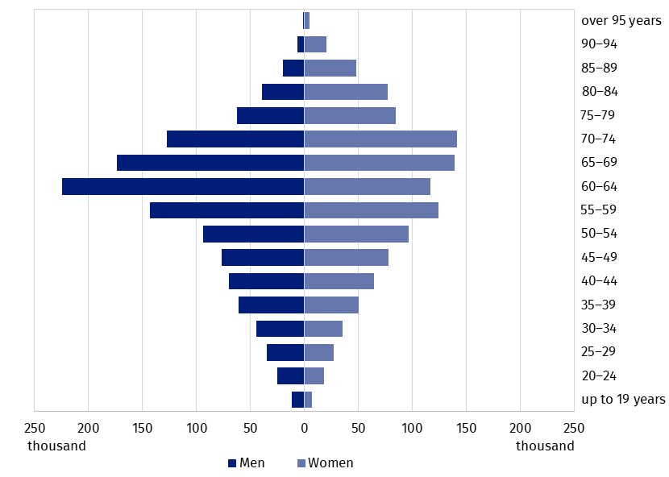
Source: Comprehensive IT System of the Social Insurance Institution.
Most of men and women with a certificate of the level of disability or the level of inability to work declared as their residence Śląskie Voivodship (141.6 and 123.5 thousand, respectively).
Half of the surveyed population lived in the following voivodships: Dolnośląskie, Małopolskie, Mazowieckie, Podkarpackie, Śląskie and Wielkopolskie. The least of surveyed persons declared as their residence Opolskie Voivodship (20.7 women and 24.1 thousand men).
The highest value of the index of the number of persons with a certificate of the level of disability or the level of inability to work per 10 thousand population was recorded in Lubuskie Voivodship (860)
The index of the number of persons with a certificate of the level of disability per 10 thousand population reached the highest level in Lubuskie Voivodship (860). The index exceeded 700 in the voivodships: Świętokrzyskie (737), Podkarpackie (714) and Kujawsko-pomorskie (710). In turn, the lowest number of surveyed persons with a certificate of disability per 10 thousand population lived in Mazowieckie voivodship (453). In addition, the value of the index was lower than 500 in Opolskie Voivodship (472).
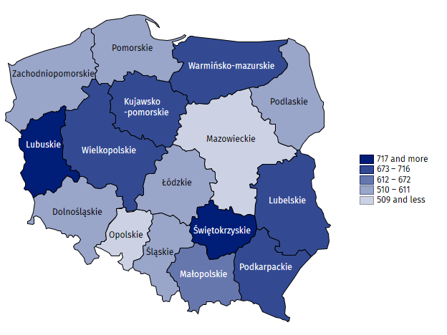
Map 1. Number of persons with a certificate of the level of disability or the level of inability to work per 10 thousand population by voivodships in 2021
As of 31 December
Source: Comprehensive IT System of the Social Insurance Institution.

Disabled persons insured in the Social Insurance Institution
Among 703.4 thousand persons covered by insurance from the Social Insurance Institution holding a valid certificate of the level of disability, nearly 60% had a moderate level and over 30% – a slight level of disability. Every tenth disabled person covered by insurance was certified with severe level of disability. The overwhelming majority of insured persons were Polish (702.7 thousand). Out of persons with foreign citizenship, the majority were citizens of Ukraine (365 persons).
Persons mostly are covered by social and health insurance under the employment contract (56.1%). In case of 16.2% of persons insurance contributions were paid by social welfare facilities or village mayors, mayors or presidents of cities. Moreover, nearly 7.4% of the surveyed group were unemployed persons who were not granted with either allowance or scholarship. Additionally, more than 5.7% of insured persons worked on the basis of agency agreements, commission contracts or contracts for services. Persons who are not eligible to old pension or disability pension pension due to inability to work prevailed in the group (over 70%). About 17% persons have been granted the right to pension due to inability to work and about 12% – right to old age pension.
In March 2022 the of the contribution assessment basis for old age pension and disability pension insurance was zero for over 38% disabled persons insured in Social Insurance Institution. In the analysed group, men prevailed (185.2 thousand men comparing to 84.5 thousand women) and persons with moderate level of disability (155.2 thousand comparing to 67.5 thousand persons with a slight level of disability and 45.9 thousand persons with severe level of disability).
In analysis the value of the revenues included in the basis of the assessment of contributions, over 50% of men and over 40% of women received income from 3 to 4 thousand PLN. People whose the basis of the assessment of contributions was from 4 to 5 thousand PLN constituted the second largest group (12.6% of women and 10.4% of men) and the consecutive group was in the range of 1–2 thousand PLN (10.4% of women and 9.0% of men). Despite the different levels of disability, the value of the revenue from 3 to4 thousand PLN, prevailed. The exception were people with a disability certificate without a level of disability, which were issued before they were 16, because the value of the revenue were most often in the range of 2–3 thousand PLN.

Education of students with disabilities and students with special educational needs
In the school year 2021/22, 6.7 thousand children attended special nursery schools and 40.8 thousand children with disabilities attended other pre-primary education facilities
In the school year 2021/22, there were 329 special nursery schools with 6.7 thousand children. The greatest number, namely 27.9% of children in special nursery schools, aged 7 years. Most children in special nursery schools were males (70.5%). There were 40.8 thousand children with disabilities in other nursery schools and other pre-primary education facilities, which accounted for 2.8% of the total number of children. Most children with disabilities attended general nursery schools (78.1%), including nursery schools with integrated sections (13.4%) and integrated nursery schools (12.1%).
Table 1. Pre-primary education facilities in the school year 2021/22
As of 30 September
SPECIFICATION | Facilities | Sections | Children
 |  |  | total | of whose with disabilitiesª
T O T A L | 22 430 | 75 020 | 1 472 572 | 40 804
Nursery schools | 13 483 | 58 996 | 1 196 841 | 31 870
Special | 329 | 1 400 | 6 700 | .
Integrated | 397 | 1 493 | . | 4 917
With integrated sections | 514 | 3 434 | . | 5 482
With special sections | 57 | 395 | . | 863
With integrated and special sections | 113 | 886 | . | 3 151
Other nursery schools | 12 073 | 51 388 | . | 17 457
Pre-primary education units | 59 | 74 | 1 044 | 14
Pre-primary centres | 1 425 | 2 096 | 27 176 | 4 405
Pre-primary sections in primary schools | 7 463 | 13 854 | 247 511 | 4 515
a Excluding children in special facilities.
There were 48.3 thousand children and youth in special primary schools. Additionally, 103.0 thousand pupils with special educational needs attended the sections of general primary schools. A total of 151.4 thousand pupils in special education, accounted for 4.8% of the total number of pupils of primary schools. Most pupils were males (68.4%). There were 45.7% children with disabilities among 3.9 thousand children learning individually.
In the school year 2021/22 there were 204.8 thousand children and youth with special educational needs in mainstream schools (excluding schools for adults), who accounted for 4.1% of the total number of students
Special education and care centres and special educational centres are organised for pupils with the certificate of special educational needs on the basis of disabilities but, for that reason, could not attend the nursery school or school in their place of residence. In the school year 2021/22, there were 357 such centres. 51.0% out of the 20.5 thousand available places were used. About 58.1% of pupils had intellectual disability. Subsequently, the centres provided care for children and youth with multiple disabilities (24.8%), deaf and hearing impaired (5.9%) and blind and vision impaired (3.3%).
Children and youth with a severe intellectual disability with the certificate of rehabilitation and education classes as well as children and youth with multiple disabilities, including intellectual disability with the certificate of special educational needs could fulfill one-year introductory school section obligation, full-time compulsory education and part-time compulsory education by attending rehabilitation and education centres. As of 30 September 2021, 188 rehabilitation and education centres provided 6.8 thousand places, out of which 90.5% were used. Centres offered classes for pupils with multiple disabilities (over 3.1 thousand) and for pupils with severe intellectual disability (2.7 thousand).
Post-primary education for youth with special educational needs was provided mainly in special schools. The majority of special schools were special vocational training schools and first degree sectoral vocational special schools, developing skills in specific professions. 29.4 thousand students attended all special schools. In addition, 23.7 thousand students with special educational needs attended the sections of secondary schools, including 38.5% students in the sections of general secondary schools, 31.6% students in the sections of technical secondary schools and 29.2% students in the sections of special first degree sectoral vocational schools. A total number of children and youth in special education at post-primary level amounted to 53.2 thousand and accounted for 3.2% of the total number.
240 students with special educational needs attended post-secondary schools, prevailingly in special post-secondary schools (87.9%).
In the academic year 2021/22, 19.9 thousand persons with disabilities attended higher education institutions (1.7% of the total number of students) and 5.4 thousand persons with disabilities graduated (1.8% of the total number of graduates). There were 0.6 thousand doctoral students with disabilities, whose accounted for 4.1% of all doctoral students.

Methodological notes
- Presented release news is the fourth nationwide study on the subject of disabled people, developed by the employees of the Statistical Office in Kraków. The scope of presented data does not exhaust the issue of disability due to its complex nature and diversity.
- The disability certification system in Poland is not uniform. It is defined by two basic legal acts:
  - The Act of 27 August 1997 on Vocational and Social Rehabilitation and Employment of Disabled Persons (uniform text, Journal of Laws 2021 items 573, 1981 and 2022 items 558, 1700) – in Art. 2, disability is defined as permanent or temporary inability to fulfil social roles due to permanent or long-term impairment of the body's efficiency, in particular resulting in inability to work. Art. 3 defines the level of disability: severe, moderate and slight, while Art. 4a mentions children up to 16 years of age who are certified without determining their level of disability. Disability adjudication institutions are powiat (first instance) and voivodship (second instance) disability adjudication units. The district labour and social security judiciary constitute the final instance,
  - The Act of 17 December 1998 on old pensions and disability pensions from the Social Insurance Fund (uniform text, Journal of Laws of 2022, items 504, 1504) – in Art. 12 defines a person incapable of work as one who has completely or partially lost the ability to work for paid employment due to a deterioration of the physical health and is not expected to regain the ability to work after retraining. Decisions on: inability to work, incapacity for independent existence and purposefulness of retraining, issued by the Social Insurance Institution, are converted into certificates on the level of disability in accordance with Art. 5 of the aforementioned Act on Vocational and Social Rehabilitation and Employment of Disabled Persons.
- Other decisions can be converted into disability certificates if they were issued before 1 January 1998 and have still been in force, are:
- Certificates of inability to work on a farm, issued by the Agricultural Social Insurance Fund,
- Decisions on inability to work/service, issued by adjudicating units in the Ministry of National Defence or the Ministry of Internal Affairs and Administration.
A person must have one of the above-mentioned certificates to be recognized as disabled in legally and formally.
- The release news takes advantage from:
- The data collections of the Social Insurance Institution (ZUS) and powiat labour offices on persons with a certificate of the level of disability or the level of inability to work issued by an authorised institution,
- The data provided by the Ministry of Science and Higher Education (MEiN) on children and youth with the opinion of the public psychological and educational counselling centre (or other public specialist outpatient clinic) on the need for special education and on students and doctoral students with a certificate on the level of disability issued by an authorised institution,
Special education is organised for children and youth with disabilities, socially maladjusted and at risk of social maladjustment, requiring special forms of learning and methods of work. It may be conducted within the general school system or individually. Children and youth with the certificate of special educational needs are not necessarily disabled in line with the provisions of the Act on Occupational and Social Rehabilitation and Employment of People with Disabilities. Likewise, students with disabilities do not need a certificate of special needs issued by an authorised institution.
- Statistical information from the Statistics Poland’s reports was also used to develop this news release.
In the case of quoting data from the Statistics Poland, please provide information: "Statistics Poland data source", and in the case of publishing calculations made on data published by the Statistics Poland, please provide information: "Own study based on Statistics Poland data".
Prepared by:  Statistical Office in Kraków  Director Agnieszka Szlubowska  Phone: (+48 12) 420 40 50 | Issued by:  The Spokesperson for the President  of Statistics Poland  Karolina Banaszek  Phone: (+48) 695 255 011
Press Office  Phone: (+48 22) 608 38 04  e-mail: obslugaprasowa@stat.gov.pl | stat.gov.pl/en/
 | @StatPoland
 | @GlownyUrzadStatystyczny
 | gus_stat
 | glownyurzadstatystycznygus
 | glownyurzadstatystyczny
Related information
Social assistance, child and family services in 2021
Terms used in official statistics
Disabled person
Disabled person with legal confirmation
Level of disability

Persons with a disability certificate based on Act of 27 August 1997 on Vocational and Social Rehabilitation and Employment of Disabled Persons (Journal of Laws 2021 items 573, 1981 and 2022 items 558, 1700).
Compiled on the basis of combined data sets from information systems of the Social Insurance Institution and after treating double counted and empty observations. Additional validation of the data set consisted in deleting the records on persons who died by 31 December 2021.
According to Art. 5 of the Act of 27 August 1997 on Vocational and Social Rehabilitation and Employment of Disabled Persons (Journal of Laws 2021 items 573, 1981 and 2022 items 558, 1700), the rulings of the Social Insurance Institution physician who certifies inability to work, incapacity for independent existence and the counselling on retraining are submitted with the application for certificates of the level of disability.
The declared voivodship of the registered living address corresponded in 99% with the voivodship of the actual living address. In occasional cases, when the registered address was not known, it was determined on the basis of the actual living address, and when there were no both addresses, on the basis of the mailing address.
Counted only once broken down by the main type of disability confirmed by the decision of an authorized institution.
Graduates from the academic year 2020/21.

