Outpatient health care in 2021
At the end of 2021, outpatient health care was carried out by 22.0 thousand outpatient departments and 3.8 thousand doctors and dentists practices providing services funded by public sources. During the year, 285.9 million doctors consultations and 30.7 million stomatological consultations were provided. Over 28% of total doctors consultations in primary health care were provided via telephone.
14.1%
Increase in the number of specialised doctors consultations compared to 2020

Outpatient departments and medical practices
At the end of 2021, outpatient consultations were provided by 22.0 thousand outpatient departments and 3.8 thousand doctors and dentists practices providing services funded by public sources
At the end of 2021, 25.7 thousand providers of ambulatory health care were operating –22.0 thousand outpatient departments and 0.7 thousand doctors practices and 3.1 thousand dentists practices providing services funded by public sources. 20.1 thousand providers of ambulatory health care were located in urban areas, and 5.6 thousand in rural areas.
The most outpatient departments were operating in Mazowieckie Voivodship (3 219), and the lowest – in Opolskie Voivodship (520). The highest number of practices providing health services funded by public sources was recorded in Wielkopolskie Voivodship (484), while the lowest – in Małopolskie Voivodship (126).

Chart 1. Outpatient departments by class of locality and voivodships in 2021
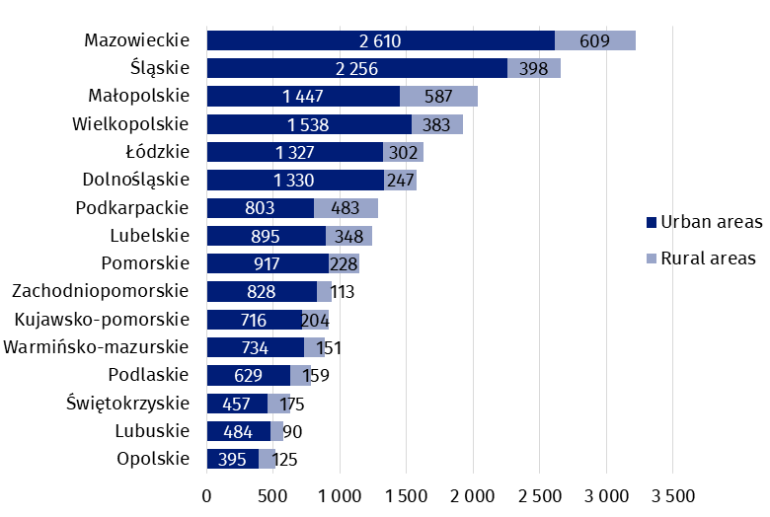
As of 31 December

Chart 2. Doctors and dentists practices providing health services funded by public sources by class of locality and voivodships in 2021
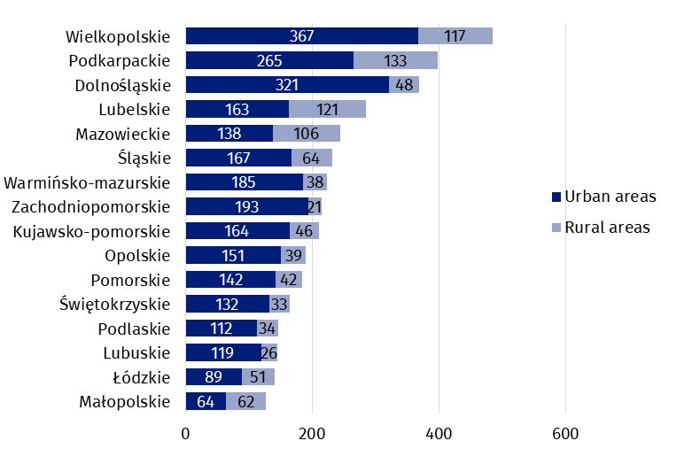
As of 31 December
In Poland, the number of population per 1 provider of ambulatory health care amounted to 1 481 persons (by 17 less than in the previous year). The highest value was recorded in Kujawsko-pomorskie Voivodship (1 812), while the lowest – in Podlaskie Voivodship (1 248).

Map 1. The number of population per 1 provider of ambulatory health care by voivodships in 2021

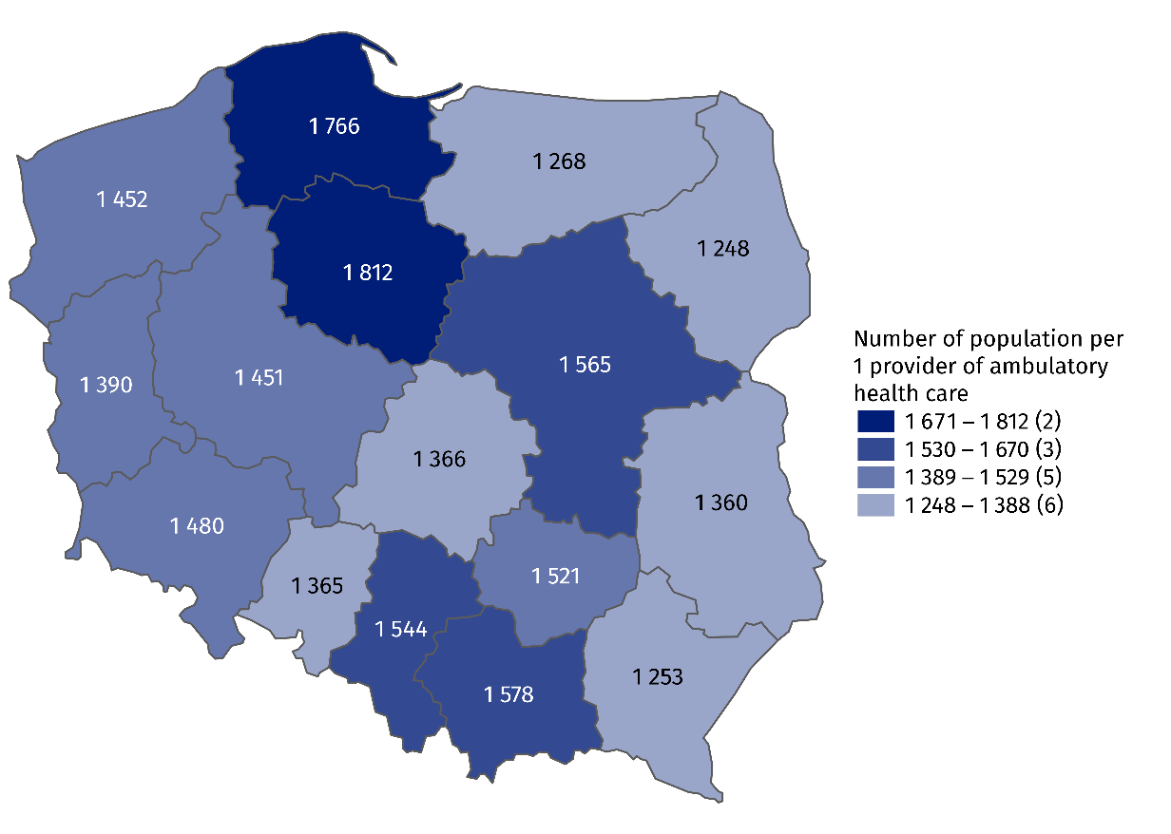
As of 31 December

Outpatient consultations
In 2021, there were provided 285.9 million doctors consul-tations and 30.7 stomatological consultations in outpa-tient health care
In 2021, there were provided 316.7 million outpatient consultations – 285.9 doctors consultations (increase of 11.4% compared to the previous year) and 30.7 million stomatological consultations (by 16.1% more than a year earlier). 171.3 million doctors consultations were in primary health care (by 9.7% more than in 2020), and 114.6 million – in specialised health care (increase of 14.1% compared to the previous year).
In primary health care children and youth in age up to 18 years had 32.2 million consulta-tions (increase of 26.6% compared to the previous year), while people aged 65 years and more – 59.5 million (by 5.8% more than a year earlier). There were 13.9 million specialised consultations provided to children and youth in age up to 18 years (by 22.0% more than in 2020) and 33.5 million consultations provided to people aged 65 years and more (by 14.1% more than in the previous year).

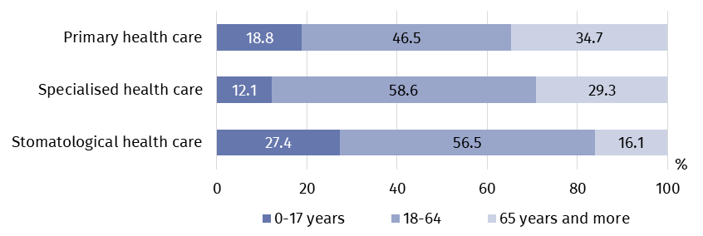
Chart 3. Outpatient consultations by type of consultation and patients’ age in 2021
Due to the outbreak of the COVID-19, special provisions for medical services delivery via telephone consultations were introduced, especially in primary health care settings.
In 2021, 48.6 million doctors consultations in primary health care and 14.6 million in specialised health care were provided via telephone (by 14.4% and 10.7% respectively less than in previous year). 71.4 thousand stomatological consultations were provided remotely.

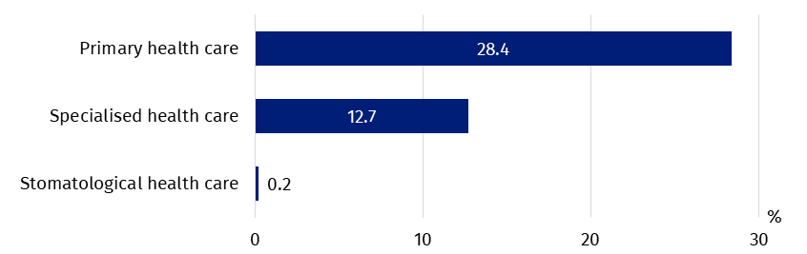
Chart 4. The share of telephone consultations in outpatient consultations by type of consultation in 2021

In specialised health care, the highest share of consultations was in surgical clinic (17.3%), then in gynecological and obstetrical clinics (10.9%) and ophthalmology clinics (9.0%).
Most doctors consultations in specialised outpatient health care were provided in surgical clinics
(approximately 20 million)

Chart 5. Specialised doctors consultations by type of clinic in 2021

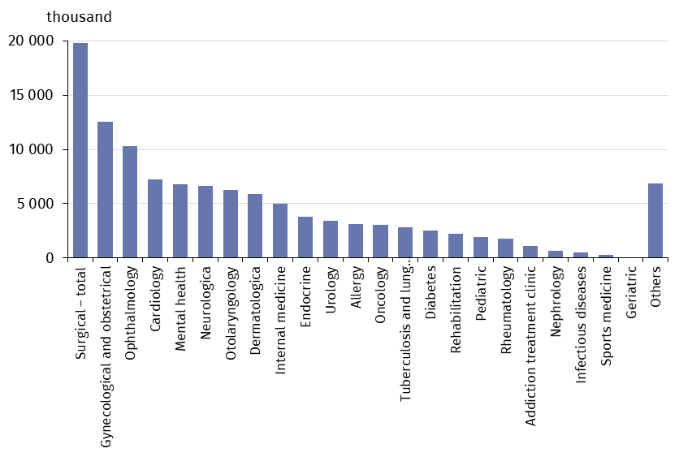
In 2021, the average number of outpatient consultations per capita was 8.3
In 2021, the average number of outpatient consultations per capita was 8.3. The highest value was recorded in Mazowieckie Voivodship (9.3), while the lowest – in Opolskie Voivodship (6.9).

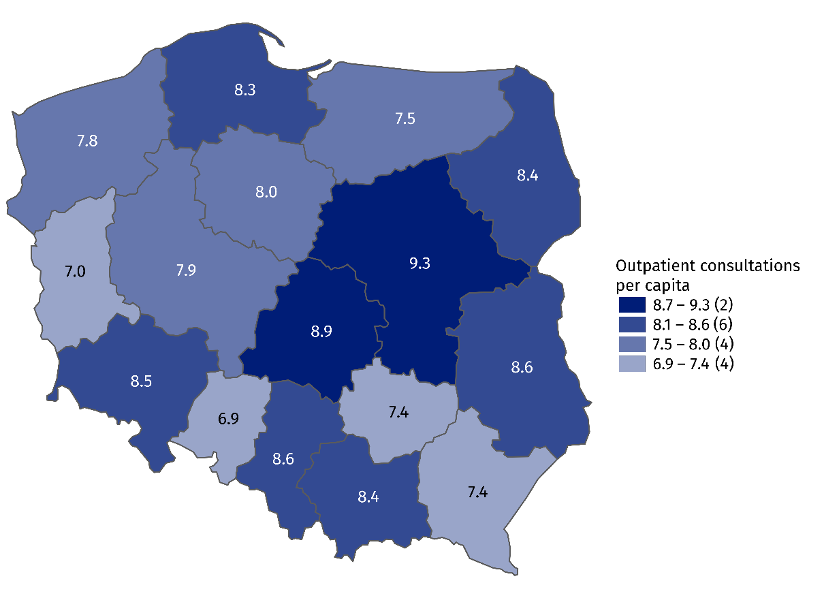
Map 2. Outpatient consultations per capita by voivodships in 2021

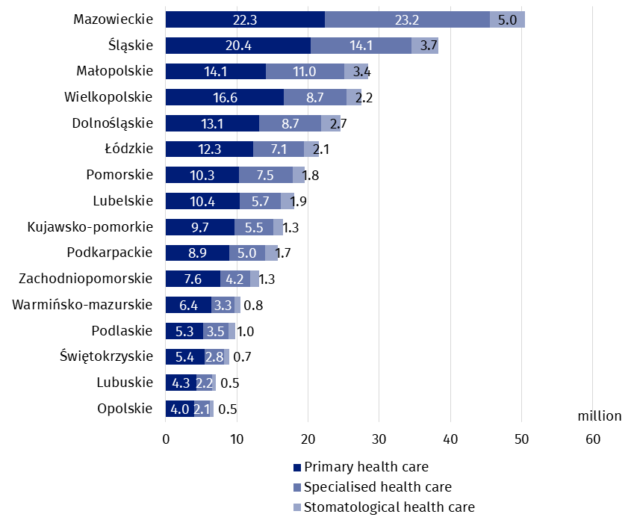
Chart 6. Outpatient consultations by type of consultation and voivodships in 2021
In the case of quoting data from the Statistics Poland, please provide information: "Statistics Poland data source", and in the case of publishing calculations made on data published by the Statistics Poland, please provide information: "Own study based on Statistics Poland data".

Prepared by:  Statistical Office in Kraków  Director Agnieszka Szlubowska  Phone: (+48 12) 420 40 50 | Issued by:  The Spokesperson for the President  of Statistics Poland  Karolina Banaszek  Phone: (+48) 695 255 011
Press Office  Phone: (+48 22) 608 38 04  e-mail: obslugaprasowa@stat.gov.pl | stat.gov.pl/en/
 | @StatPoland
 | @GlownyUrzadStatystyczny
 | gus_stat
 | glownyurzadstatystycznygus
 | glownyurzadstatystyczny
Related information
Health and health care in 2020
Methodological report. Health and health care statistics − Statistics Poland’s reports
Data available in databases
Local Data Bank -> Health care, social welfare and benefits to the family
Analytical Platform – SWAID – Knowledge Databases -> Health and Health care
Terms used in official statistics
Specialised out-patient services
Out-patient health care services
Primary health care
Consultation
Medical practice
An out-patient department

Including outpatient departments of the Ministry of National Defence and the Ministry of the Interior and Administration.
Including holiday and night time medical services. There are health care benefits in primary health care, provided from 6 pm to 8 am on the following day and 24 hours on public holidays. Including also holiday and night time medical services given as a subcontract with a hospital.
Telephone consultation - medical or psychological consultation provided by phone or with the use of other telecommunication technologies.

