Inland waterways transport in Poland in 2021

The layout and length of Poland's inland waterways have remained at a similar levels for years. The condition of waterways is a factor that has a direct impact on the volume of cargo transport and transport performance in inland navigation. Adverse navigational conditions determine the basic design parameters of the fleet, i.e. the relatively low load capacity
of barges. This is directly reflected in the volume of the cargo carried. The quantity of the cargo carried by Polish fleet owners by inland waterways is regularly decreasing year
by year. It concerns both the domestic and international carriages.
13.2%
A decrease in cargo transport against 2020

Inland waterwarways
The main factors determining the efficiency of inland waterway transport are the navigability of waterways and the adaptation of their navigational conditions to a level appropriate for waterways of international importance.

Chart 1. Breakdown of inland waterways in use in Poland in 2021

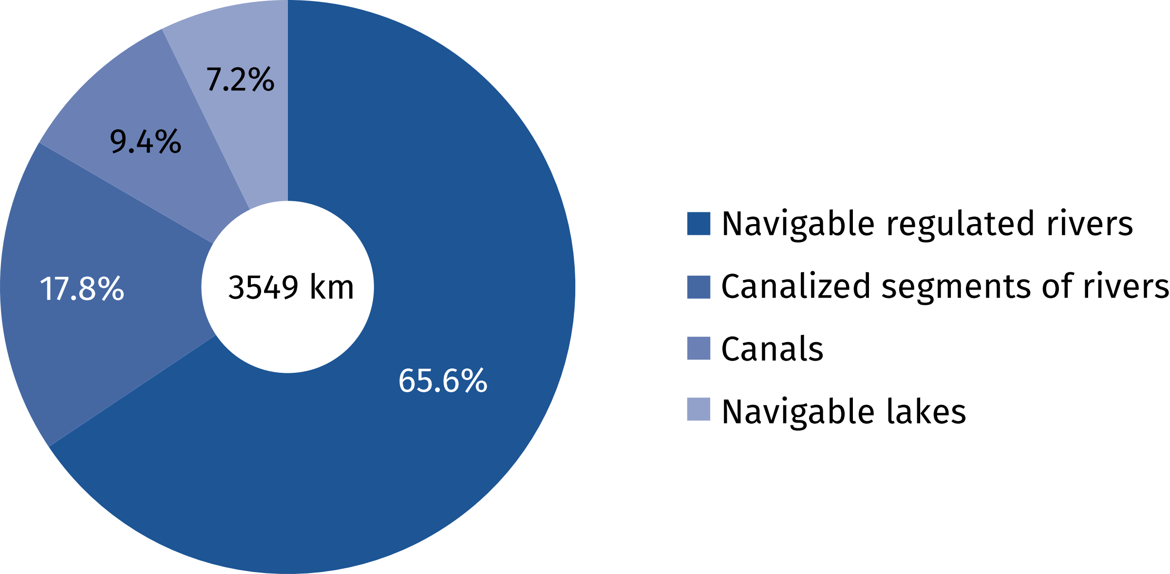

The inland waterways in Poland were 3768 km long in 2021 (and remained unchanged
in comparison to 2020), of which 2523 km represented navigable regulated rivers, 655 km
– canalized segments of rivers, 335 km – canals, and 255 km – navigable lakes. 3549 km (94.2%) of the waterways were in use. The requirements for roads of international importance (classes IV and V) in 2021 were met by 5.5% of the length of waterways (206 km)
in Poland. The rest of the waterway network consisted of waterways of regional importance (classes I, II and III), whose total length in 2021 was 3562 kilometers.

Inland waterway transport fleet
71% of barges is represented
by non-self-propelled vessels, and over half of them was manufactured in the years
1949-1979
The number of pushers and tugboats belonging to the inland waterway towing fleet
in Poland in 2021 amounted to 124, i.e. 6 more than in the previous year. The passenger fleet consisted of 120 vessels, i.e. 7 less than in the previous year. The number of self-propelled barges increased by 2 vessels (to the level of 71). However, the number of non-self-propelled barges (push barges) decreased by 8 vessels (to the level of 174). Push vessels prevailed
in the structure of the barges by type (71.0% of the barges), and they carried 2272.5 thousand tonnes of cargo (65.6% of total cargo transported with the inland waterways navigation)
in 2021. The barge fleet group was dominated by vessels of poorer construction parameters, requiring lower technical standards of water infrastructure.

Chart 2. Breakdown of inland waterway barges by load capacity groups in 2021

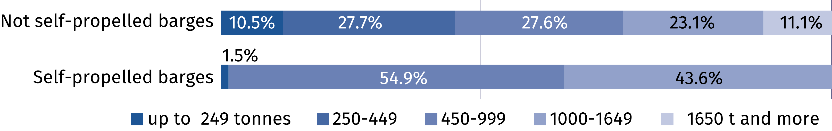

The majority of the inland waterway fleet has been decapitalized and needs to be replaced. Its age significantly exceeds its normative service life, and the fleet might continue its operation only thanks to regular repairs. According to 2021 data, the majority of used pushers (70.8%), over half of push barges (57.5%) and all self-propelled barges were manufactured during the years 1949–1979.

Chart 3. Breakdown of inland waterway fleet by age in 2021

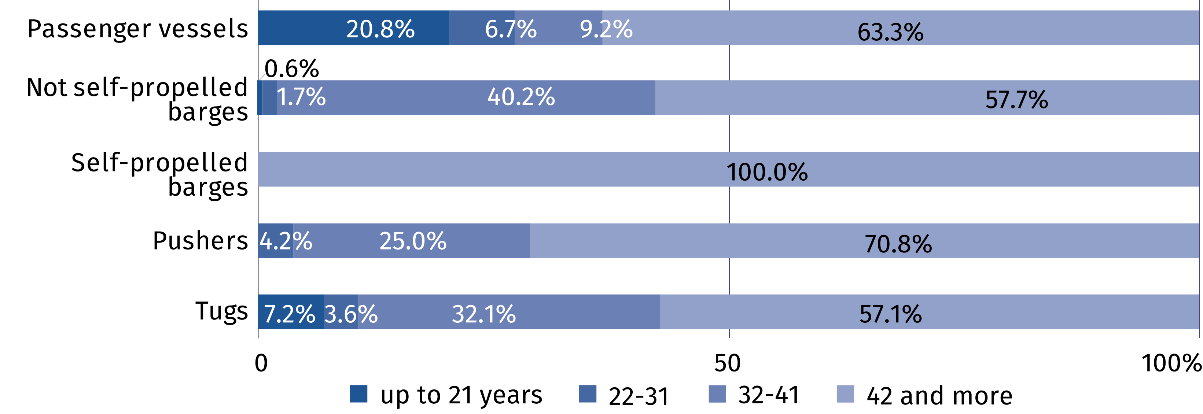

Inland waterway carriages
In 2021, the share of inland waterways transport in the
total cargo transport volume decreased from 0.18%
to 0.15% on an annual basis
Inadequate development of navigable waterways in Poland, both in terms of their character (canalized rivers, free-flowing rivers, canals) and navigational parameters (dimensions
of locks, depth and width of the route, heights of bridges) affect the specificity of inland navigation and cause it to play a minor role in the Polish transport system. Transportation volume carried by inland waterways in 2021 amounted to 3164.6 thousand tonnes of cargo and performance of 493.0 million tonne-kilometers. In comparison to the previous year these values were lower by 13.2% and 4.5%, respectively. The largest annual declines in the freight volume and transport performance were recorded in the fourth quarter by 24.6%
and 15.3% respectively.

Chart 4. Cargo carried with inland waterway transport, quarterly

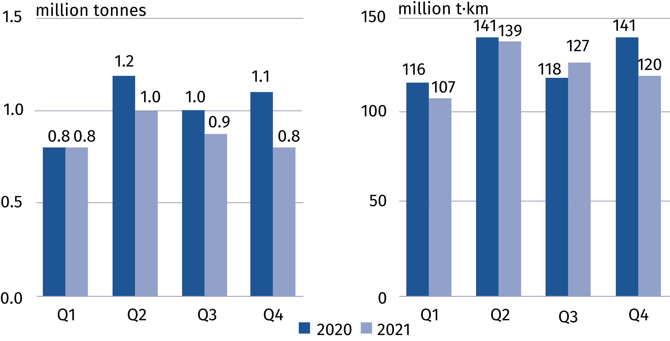
The average distance of 1 tonne of cargo carried in international transport slightly increased, while in domestic transport was lower than in the previous year
In 2021, the average distance of 1 tonne of cargo carried in international transport amounted to 259.7 km (241.4 km in the previous year), and 22.8 km in domestic transport (28.8 km,
respectively). In comparison to 2020, the domestic carriages volume decreased by 18.4%
(to the level of 1716.7 thousand tonnes) and transport performance – by 35.4% (to 39.1 million tonne-kilometres). Declines in the freight were recorded in almost all cargo groups, with
the most severe ones in the groups of: coke and refined petroleum products; basic metals, fabricated metal products, except machinery and equipment; other non-metallic mineral products. Growths concerned only the groups of: wood and products of wood and cork
(except furniture); machinery and equipment n.e.c. as well as products of agriculture, hunting, and forestry; fish and other fishing products.
In 2021 more than half of the freight carried by inland waterway transport by Polish fleet owners was carried in international transport (50.4%). The carriages between foreign ports decreased by 5.7% comparing to previous year. Nevertheless, their share in total international transport was still dominant and amounted to 79.5% in 2021 (increased by 1.5 percentage
points). Exported and imported cargo declined by 2.8% and 37.4% respectively. Exports
accounted to 15.6% of total international freight, with Germany as the main direction. The contribution of carriages on this route amounted to 81.4% of all exports of goods by inland waterways.
Chart 5. Breakdown of inland waterway carriages of cargo by directions 2021
and their developments against the previous year

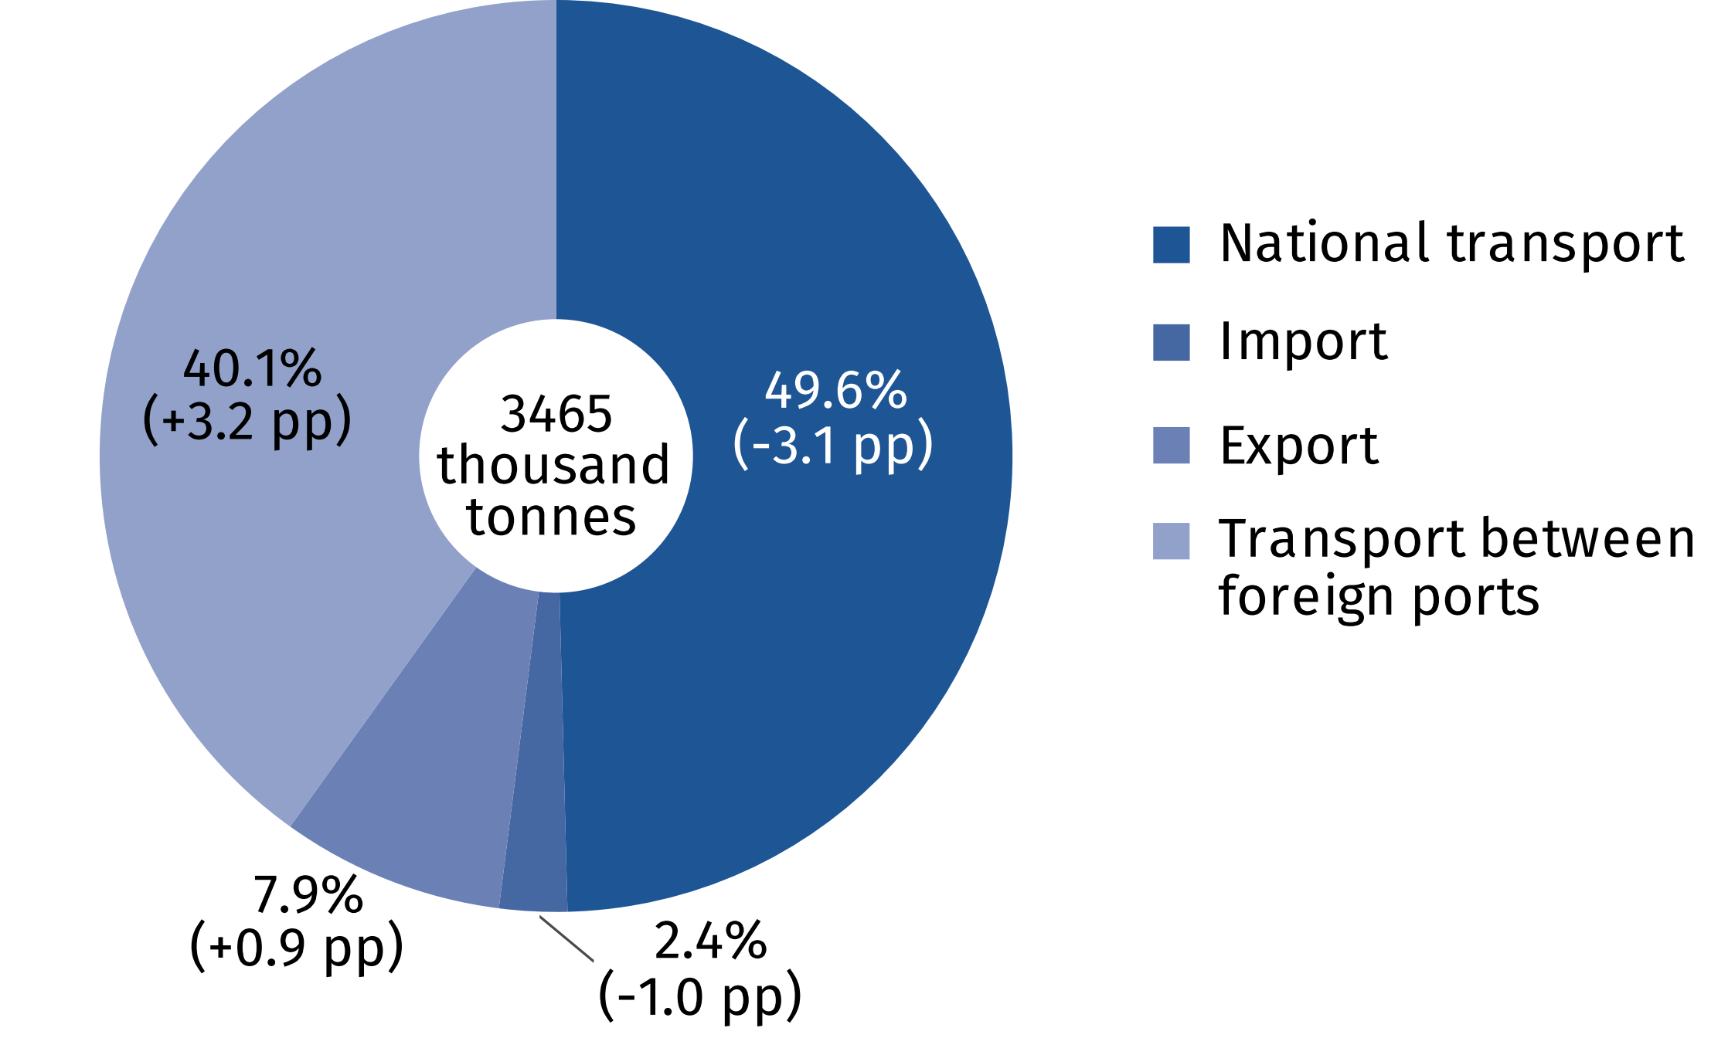

Similarly to the previous years, the breakdown of the freight in 2021 was dominated by metal ores and other mining and quarrying products, peat; uranium and thorium ores (40.3%).
Chart 6. Breakdown of inland waterway freight by main cargo groups in 2021
and their developments against the previous year

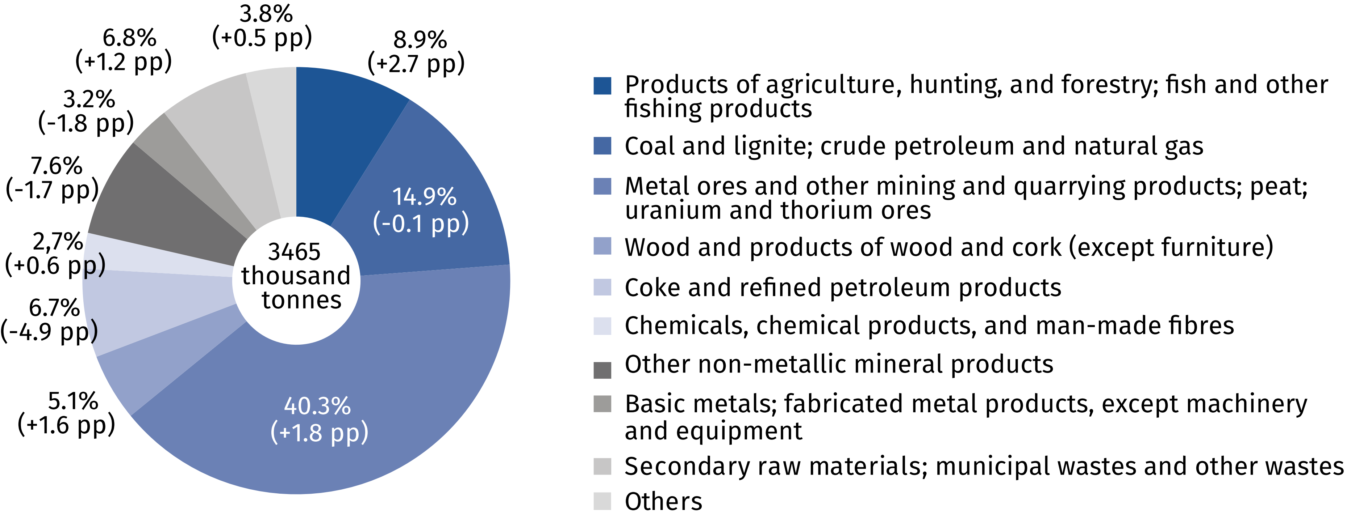
The number of persons carried by inland waterway fleet grew 44.6% on an annual basis
As part of tourist traffic, 120 inland waterway passenger vessels carried a total volume of 986.4 thousand persons, and transport performance of 12926.6 thousand passenger-kilometres in 2021, i.e. 33.5% more than last year.
Table 1. Inland waterway transport of passengers
Specification | 2020 | 2021
Number of passenger seats | 12 058 | 11 436
Number of passengers | 681 933 | 986 415
Number of passenger-kilometres | 9 686 441 | 12 926 572
Average distance travelled by 1 passenger in km | 14 | 13
Inland transportation remains one of the safest modes of transport. In 2021, navigation accident registers, kept by the competent inland waterway transport offices, recorded 4 accidents, none of which were related to the transportation of hazardous cargo.

When quoting data from the Central Statistical Office (CSO), please include the information: "Source of Statistics Poland" and when publishing calculations made on data published by the CSO, please include: "Own compilation based on Statistics Poland data".

Prepared by:  Statistical Office in Szczecin  Deputy director Katarzyna Dmitrowicz-Życka  Phone: (+48 91) 459 77 00 | Issued by:  The Spokesperson for the President  of Statistics Poland  Karolina Banaszek  Phone: (+48) 695 255 011
Press Office  Phone: (+48 22) 608 38 04  e-mail: obslugaprasowa@stat.gov.pl | stat.gov.pl/en/
 | @StatPoland
 | @GlownyUrzadStatystyczny
 | gus_stat
 | glownyurzadstatystycznygus
 | glownyurzadstatystyczny
Related information
Inland water transport in Poland in 2020
Inland waterways transport in Poland in 2018-2019
Transport – activity results in 2020
Data available in databases
Domain Knowledge Base Transport and Communications
Terms used inn official statistics
Inland waterways
Inland waterways transport fleet
Tugs fleet
Barges fleet
Inland waterways transport of goods
International inland waterways transport of goods
Inland waterways transport of passengers
Tonne-kilometresby inland waterways
Passenger-kilometresby inland waterways

Classification of inland waterways accepted by the European Economic Commission of the UN and ECMT in 1992.

