Information on entities of the national economy entered in the REGON register - January 2023
As at the end of January 2023 the REGON register included 4 999.5 thous. of national economy entities, i.e. by 0.1% more than a month before (3.4% more than in the corresponding period of the previous year).
24.9%
An increase in the number of newly registered entities in relation to the previous month

Newly registered entities in the REGON register
An increase in the number of newly registered commercial companies by 14.3% in relation to the previous month
An increase in the number of newly registered entities was recorded for natural persons conducting economic activity (by 27.9%) compared to the previous month. Natural persons conducting economic activity accounted for 80.9% of all newly registered entities in the REGON register. The number of newly registered companies increased (by 13.4%).

Table 1. Entities of the national economy in the REGON registerª
SPECIFICATION | January 2023 | December 2022=100
TOTAL entities of the national economy in the REGON register | 4 999 499 | 100.1
Newly registered entities | 35 456 | 124.9
Deregistered entities | 30 027 | 157.8
Entities with suspended activity | 680 257 | 103.4
ª applies to legal persons, organizational entities without legal personality and natural persons conducting economic activity (excluding persons tending private farm in agriculture).

Deregistered entities from the REGON register
The number of deregistered civil partnerships more than doubled in relation to the previous month
In January, 57.8% more entities were deregistered from the REGON register in relation to the previous month. An increase in the number of deregistered entities was recorded for natural persons conducting economic activity (by 59.6%) and companies (by 47.3%) compared to the previous month.

Entities with suspended activity in the REGON register
An increase in the number of entities with suspended activity by 3.4% in relation to the previous month
Entities with suspended activity as at the end of January 2023 accounted for 13.6% of the total number of registered entities in the REGON register. An increase in the number of entities with suspended activity compared to the previous month was noted in section of real estate activities (by 4.3%), trade; repair of motor vehicles (by 4.2%), construction (by 4.0%) and other service activities (by 4.0%).

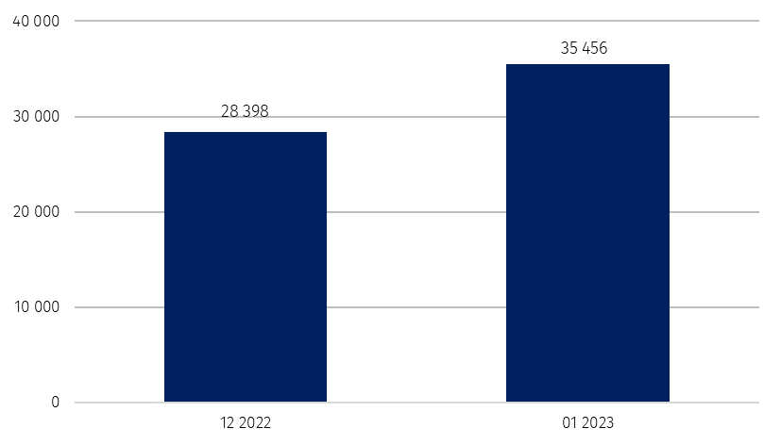
Chart 1. The number of newly registered entities entered in the REGON register

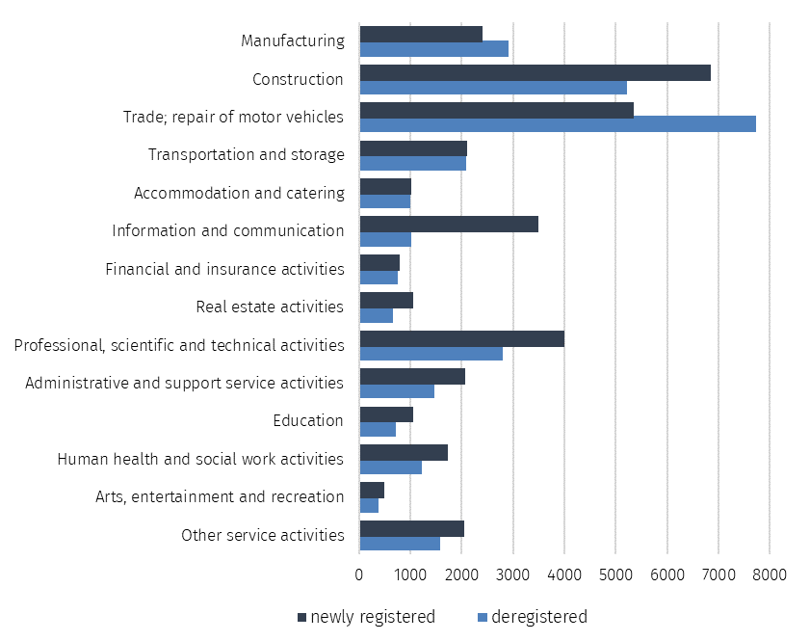
Chart 2. The number of newly registered and deregistered entities in the REGON register
by PKD sections

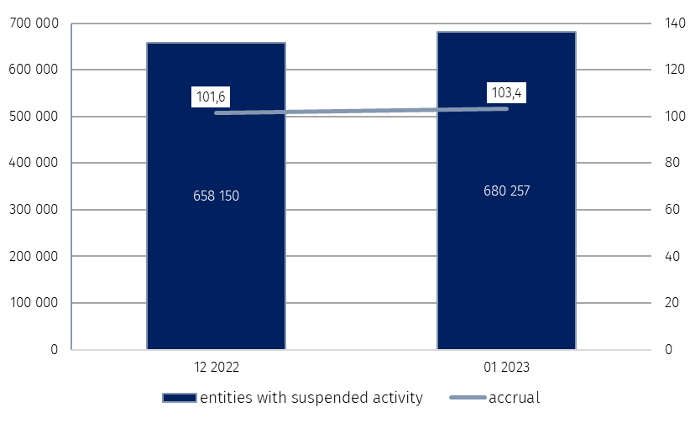
Chart 3. The number of entities with suspended activity in the REGON register
%

In case of quoting Statistics Poland data, please provide information: “Source of data: Statistics Poland”, and in case of publishing calculations made on data published by Statistics Poland, please include the following disclaimer: “Own study based on figures from Statistics Poland”.

Prepared by:  Standards and Registers Department  Director Ireneusz Budzyński  Phone: (+48 22) 608 31 15 | Issued by:  The Spokesperson for the President  of Statistics Poland  Karolina Banaszek  Phone: (+48) 695 255 011
Press Office  Phone: (+48 22) 608 38 04  e-mail: obslugaprasowa@stat.gov.pl | www.stat.gov.pl/en/
 | @StatPoland
 | @GlownyUrzadStatystyczny
 | gus_stat
 | glownyurzadstatystycznygus
 | glownyurzadstatystyczny
Related information
Monthly information on entities of the national economy entered in the REGON register
Quarterly information on entities of the national economy entered in the REGON register
Structural changes of groups of the national economy entities in the REGON register, 2021
Data available in databases
Local Data Bank (BDL)
Terms used in official statistics
Entity of the national economy
Legal Form
Activity executable
Principal kind of activity

