Information on entities of the national economy entered in the REGON register - July 2022

As at the end of July 2022 the REGON register included 4 921.6 thous. of national economy entities, i.e. by 0.3% more than a month before (3.3% more than in the corresponding period of the previous year).

 6.3%

A decrease in the number of newly registered entities in relation to the previous month

# **Newly registered entities in the REGON register**

A decrease in the number of newly registered civil partnerships by 32.4% in relation to the previous month

A decrease in the number of newly registered entities compared to the previous month was recorded for natural persons conducting economic activity (by 8.0%). Natural persons conducting economic activity accounted for 81.2% of all newly registered entities in the REGON register. While an increase in the number of newly registered entities compared to the previous month was recorded for commercial companies (by 8.2%), including limited liability companies (by 7.1%).

Table 1. Entities of the national economy in the REGON registera

|  |  |  |
| --- | --- | --- |
| SPECIFICATION | July 2022 | June 2022=100 |
| **TOTAL entities of the national economy in the REGON register** | **4 921 609** | **100.3** |
| Newly registered entities | 31 051 | 93.7 |
| Deregistered entities | 13 683 | 93.1 |
| Entities with suspended activity | 610 778 | 101.3 |

a applies to legal persons, organizational entities without legal personality and natural persons conducting economic activity (excluding persons tending private farm in agriculture).

# **Deregistered entities from the REGON register**

A decrease in the number of deregistered companies by 16.9% in relation to the previous month

In July, 6.9% less entities were deregistered from the REGON register than in the previous month. A decrease in the number of deregistered entities was recorded for commercial companies (by 19.9%) and civil partnerships (by 4.1%) in compare to the previous month.

# **Entities with suspended activity in the REGON register**

An increase in the number of entities with suspended activity by 1.3% in relation to the previous month

Entities with suspended activity as at the end of July 2022 accounted for 12.4% of the total number of registered entities in the REGON register. An increase in the number of entities with suspended activity compared to the previous month was noted in section of education (by 19.2%), human health and social work activities (by 3.8%), other service activities (by 2.3%).

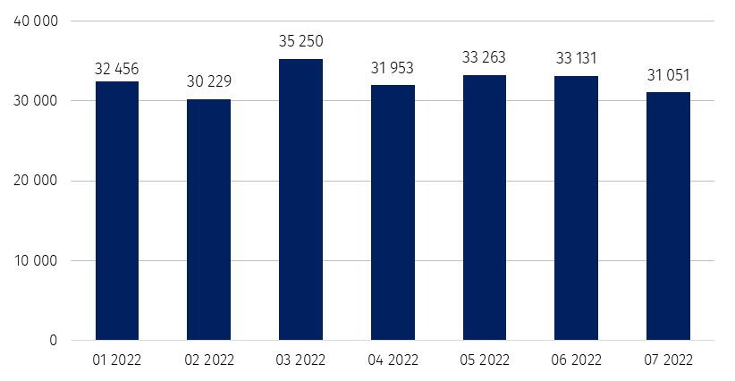Chart 1. The number of newly registered entities entered in the REGON register

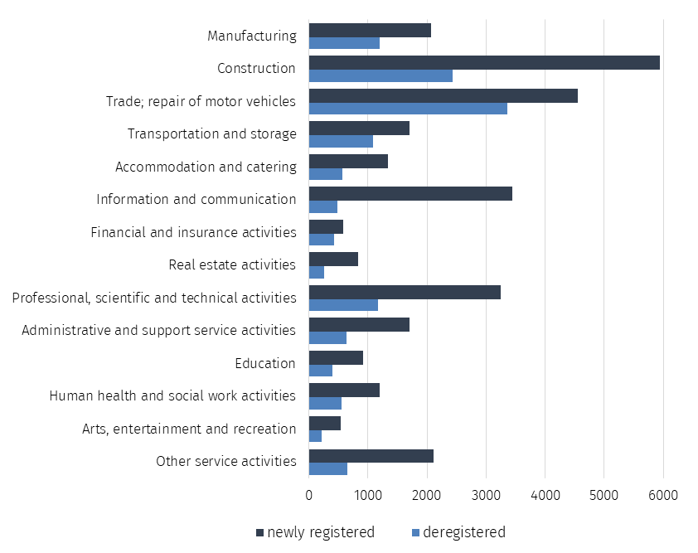Chart 2. The number of newly registered and deregistered entities in the REGON register   
 by PKD sections

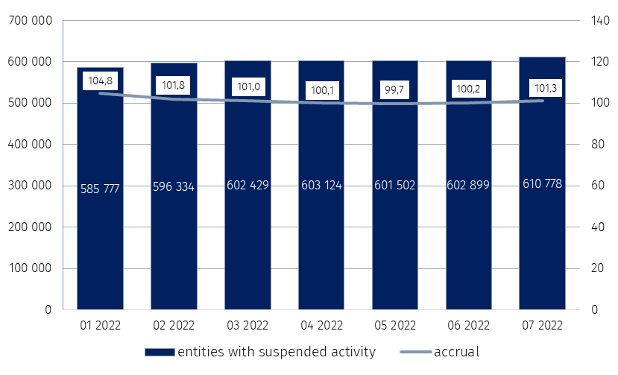Chart 3. The number of entities with suspended activity in the REGON register

%

In case of quoting Statistics Poland data, please provide information: “Source of data: Statistics Poland”, and in case of publishing calculations made on data published by Statistics Poland, please include the following disclaimer: “Own study based on figures from Statistics Poland”.

|  |  |
| --- | --- |
| Prepared by:  **Standards and Registers Department**  **Director Ireneusz Budzyński** Phone: (+48 22) 608 31 15 | Issued by: **The Spokesperson for the President of Statistics Poland** **Karolina Banaszek**Phone: (+48) 695 255 011 |
| **Press Office**  Phone: (+48 22) 608 38 04  **e-mail:** [**obslugaprasowa@stat.gov.pl**](mailto:obslugaprasowa@stat.gov.pl) | Ikonka strony wwwwww.stat.gov.pl/en/ |
| Ikonka twittera@StatPoland |
| Ikonka facebooka@GlownyUrzadStatystyczny |
|  | Ikonka instagramagus_stat |
|  | Ikonka Youtubaglownyurzadstatystycznygus |
|  | glownyurzadstatystycznyIkonka linkedin |
| **Related information**  [Monthly information on entities of the national economy entered in the REGON register](https://stat.gov.pl/obszary-tematyczne/podmioty-gospodarcze-wyniki-finansowe/zmiany-strukturalne-grup-podmiotow/kwartalna-informacja-o-podmiotach-gospodarki-narodowej-w-rejestrze-regon-rok-2021,7,9.html)  [Quarterly information on entities of the national economy entered in the REGON register](https://stat.gov.pl/obszary-tematyczne/podmioty-gospodarcze-wyniki-finansowe/zmiany-strukturalne-grup-podmiotow)  [Structural changes of groups of the national economy entities in the REGON register, 2021](https://stat.gov.pl/obszary-tematyczne/podmioty-gospodarcze-wyniki-finansowe/zmiany-strukturalne-grup-podmiotow/zmiany-strukturalne-grup-podmiotow-gospodarki-narodowej-w-rejestrze-regon-2021-r-,1,26.html)  **Data available in databases**  [Local Data Bank (BDL)](https://bdl.stat.gov.pl/BDL/dane/podgrup/temat)  **Terms used in official statistics**  [Entity of the national economy](https://stat.gov.pl/en/metainformation/glossary/terms-used-in-official-statistics/814,term.html)  [Legal Form](https://stat.gov.pl/en/metainformation/glossary/terms-used-in-official-statistics/97,term.html)  [Activity executable](https://stat.gov.pl/en/metainformation/glossary/terms-used-in-official-statistics/904,term.html)  [Principal kind of activity](https://stat.gov.pl/en/metainformation/glossary/terms-used-in-official-statistics/820,term.html) | |