Structural business statistics in 2019

23.08.2021

NEWS RELEASES

In 2019, the turnover of enterprises covered by the survey of structural business statistics reached 5,074.3 bn PLN (5.9% more than in 2018). Production value amounted to 3,339.5 bn PLN (5.4% more than in 2018).

 5.9%

Increase in the value of

turnover y/y

According to the survey of structural business statistics, in 2019 the number of active enterprises increased by 3.2% per annum and amounted to 2,022 thousand units. The increase in the number of enterprises was recorded in construction (by 9.2%), services (by 4.0%) and industry (by 1.6%). There was a decline only in trade; repair of motor vehicles (by 1.1%).

The number of persons employed increased by 2.1% in 2019 compared to the previous period and amounted to 10,033 thousand people, the largest increase in the number of persons employed was in construction (by 5.9%). The turnover of enterprises covered by the survey of structural business statistics in 2019 amounted to 5,074.3 bn PLN (i.e. 5.9% more than in 2018). The increase in the value of turnover was recorded in all distinguished kinds of activity, with the highest in construction (by 10.3%), and the lowest in trade; repair of motor vehicles (by 3.5%). The value of production amounted to 3,339.5 bn PLN (i.e. 5.4% more than in 2018). The highest increase in production value was observed in construction (by 11.8%), and the lowest in services (by 3.2%).

The largest increase in turnover was in construction (by 10.3% compared to 2018)

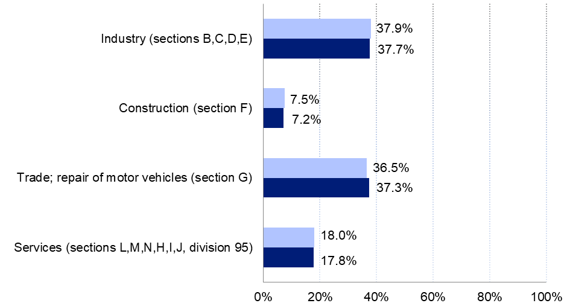**Chart 1. Structural business statistics** – **the structure of turnover by kinds of** **activity**

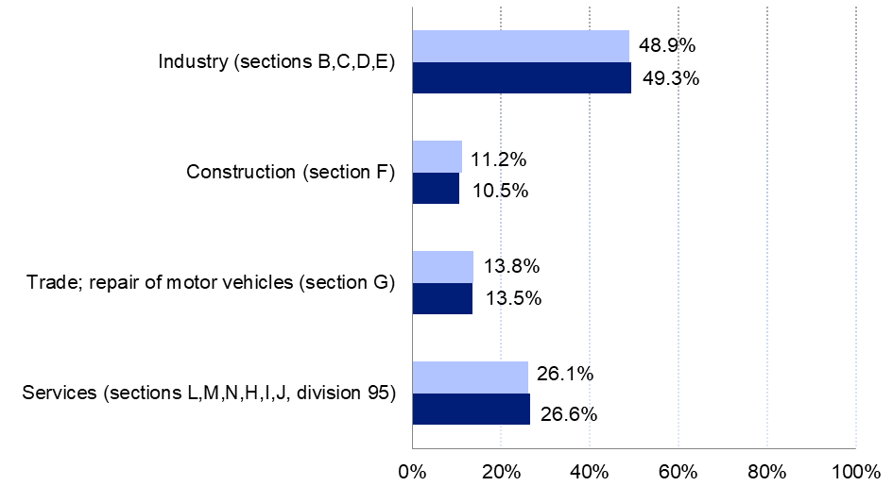Chart 2. Structural business statistics – the structure of production by kinds of activity



Table 1.1 Structural business statistics – basic data by kinds of activity

|  |  |  |  |  |
| --- | --- | --- | --- | --- |
| SPECIFICATION | 2018 | | 2019 | |
| Number of enterprises | Number of persons  employed | Number of enterprises | Number of persons  employed |
| **Total** | **1 960 361** | **9 822 046** | **2 022 248** | **10 033 174** |
| Industry (sections B,C,D,E) | 248 030 | 3 299 784 | 252 040 | 3 356 012 |
| Construction (section F) | 325 663 | 1 005 742 | 355 562 | 1 065 139 |
| Trade; repair of motor vehicles (section G) | 544 769 | 2 390 479 | 538 931 | 2 427 588 |
| Services (sections L,M,N,H,I,J, division 95) | 841 899 | 3 126 041 | 875 715 | 3 184 435 |

| SPECIFICATION | 2018 | | 2019 | |
| --- | --- | --- | --- | --- |
| Turnover | Production value | Turnover | Production value |
| in bn PLN | | | |
| **Total** | **4 793.5** | **3 168.3** | **5 074.3** | **3 339.5** |
| Industry (sections B,C,D,E) | 1 805.5 | 1 562.8 | 1 924.8 | 1 634.5 |
| Construction (section F) | 346.9 | 333.2 | 382.8 | 372.6 |
| Trade; repair of motor vehicles (section G) | 1 789.1 | 429.0 | 1 851.6 | 462.3 |
| Services (sections L,M,N,H,I,J, division 95) | 851.9 | 843.3 | 915.1 | 870.1 |

Table 1.2 Structural business statistics − basic data by kinds of activity

Table 2. Structural business statistics − dynamics by kinds of activity (2018 = 100)

| SPECIFICATION | 2019 | | | |
| --- | --- | --- | --- | --- |
| Number of enterprises | Number of persons  employed | Turnover | Production value |
| previous year = 100 | | | |
| **Total** | **103.2** | **102.1** | **105.9** | **105.4** |
| Industry (sections B,C,D,E) | 101.6 | 101.7 | 106.6 | 104.6 |
| Construction (section F) | 109.2 | 105.9 | 110.3 | 111.8 |
| Trade; repair of motor vehicles (section G) | 98.9 | 101.6 | 103.5 | 107.8 |
| Services (sections L,M,N,H,I,J, division 95) | 104.0 | 101.9 | 107.4 | 103.2 |

Structural business statistics − Poland compared to the European Union in 2018[1]

In 2018, enterprises operating in Poland accounted for 7.9% of all enterprises in the European Union, and their share in the turnover was 3.8%

In 2018, enterprises operating in Poland accounted for 7.9% of all enterprises in the Eu-ropean Union (EU), and their share in the turnover was 3.8%. The shares of the production value and the number of persons employed amounted to 3.6% and 6.6%, respectively. In particular kinds of activity, the highest shares of turnover and production value compared to the European Union countries were recorded in construction and they amounted to 4.3% and 4.1%, respectively. In terms of the number of enterprises and the number of persons employed, the largest shares were recorded in industry and amounted to 10.2% and 9.1%, respectively (with 4.1% turnover and 4.0% production share).

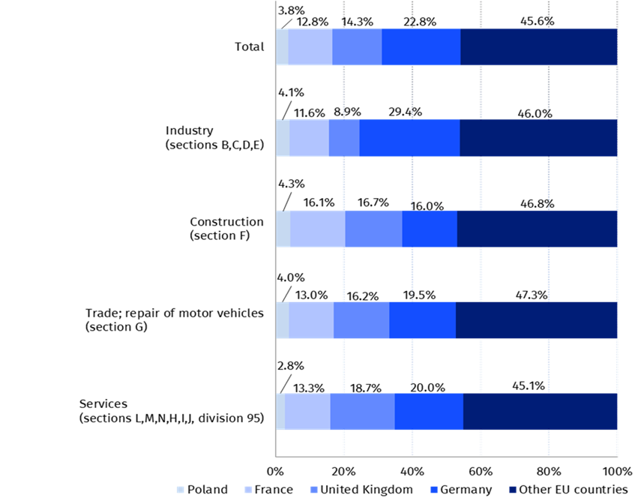**Chart 3. Share of turnover of enterprises operating in Poland compared to the EU in 2018**

**Chart 4. Share of the production value of enterprises operating in Poland compared to the EU   
in 2018**

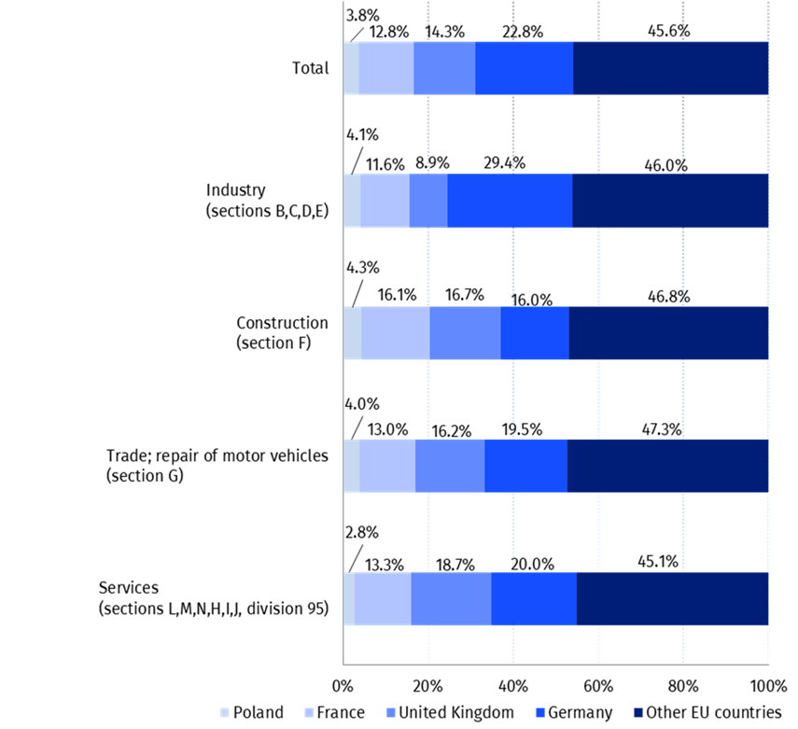

**Table 4.1 Enterprises operating in Poland compared to the European Union in 2018**

| SPECIFICATION | Poland | | European Union | |
| --- | --- | --- | --- | --- |
| Number of enterprises | Number of persons employed | Number of enterprises | Number of persons employed |
| **Total** | **1 960 361** | **9 822 046** | **24 900 207** | **149 633 435** |
| Industry (sections B,C,D,E) | 248 030 | 3 299 784 | 2 435 373 | 36 078 275 |
| Construction (section F) | 325 663 | 1 005 742 | 3 624 803 | 13 673 416 |
| Trade; repair of motor vehicles(section G) | 544 769 | 2 390 479 | 6 171 221 | 34 235 992 |
| Services (sections L,M,N,H,I,J, division 95) | 841 899 | 3 126 041 | 12 668 810 | 65 645 752 |

**Table 4.2 Enterprises operating in Poland compared to the European Union in 2018**

| SPECIFICATION | Poland | | European Union | |
| --- | --- | --- | --- | --- |
| Turnover | Production value | Turnover | Production value |
| in bn EUR | | | |
| **Total** | **1 124.8** | **743.5** | **29 926.6** | **20 641.3** |
| Industry (sections B,C,D,E) | 423.7 | 366.7 | 10 431.4 | 9 211.9 |
| Construction (section F) | 81.4 | 78.2 | 1 893.4 | 1 898.5 |
| Trade; repair of motor vehicles (section G) | 419.8 | 100.7 | 10 440.0 | 2 870.2 |
| Services (sections L,M,N,H,I,J, division 95) | 199.9 | 197.9 | 7 161.7 | 6 660.6 |

The data presented in this new release was prepared in accordance with the guidelines developed by Eurostat and they contain information on the number of enterprises, the number of persons employed, turnover, production value, calculated according to the definitions included in Commission Regulation (EC) No 250/2009 of 11 March 2009 implementing Regulation (EC) 295/2008 of the European Parliament and of the Council as regards the definitions of characteristics, the technical format for the transmission of data, the double reporting requirements for NACE Rev. 1.1 and NACE Rev. 2 and derogations to be granted for structural business statistics [2] ([link](https://op.europa.eu/en/publication-detail/-/publication/fac672e4-dad7-11e3-8cd4-01aa75ed71a1/language-pl/format-PDFA1A)).

The data refer to the statistical unit “enterprise”, which is the smallest combination of related legal units, i.e. an organizational unit producing goods and services that benefits from a certain degree of decision-making autonomy in particular as regards the allocation of its current resources. An enterprise may carry out one or more activities at one or more locations in particular, the enterprise may consist of a single legal unit. The definition of the statistical unit "enterprise" is included in Council Regulation (EEC) No 696/93 of March 15, 1993 on the statistical units for the observation and analysis of the production system in the Community ([link](https://op.europa.eu/pl/publication-detail/-/publication/1ea18a1a-95c2-4922-935c-116d8694cc40/language-pl)).

The values of the variables "turnover" and "production" were subject to the consolidation process, i.e. they were decreased by the value of internal transactions between the legal units making up the statistical unit "enterprise".

The scope of the presented data is specified in detail in Regulation (EC) No 295/2008 of the European Parliament and of the Council of 11 March 2008 concerning structural business statistics (Text with EEA relevance) ([link](https://eur-lex.europa.eu/legal-content/pl/TXT/?uri=CELEX%3A32008R0295)). In accordance with the above Regulation, the following kinds of activity have been distinguished in the new release (in accordance with the Polish Classification of Activities PKD):

* "Industry" which covers PKD sections from B (Mining and quarrying) to E (Water supply; sewerage, waste management and remediation activities);
* "Construction" - section F (Construction);
* "Trade; repair of motor vehicles ” - section G (Wholesale and retail trade; repair of motor vehicles and motorcycles);
* "Services", which include PKD sections from H (Transportation and storage) to J (Information and communication) and from L (Real estate activities) to N (Administrative and support services activities), as well as division 95 of section S (Repair and maintenance of computers and personal and household goods).

The sources of data for this study was information obtained within Statistics Poland surveys on the following reports: SP – annual business survey, SP-3 – report on business activity of enterprises, F-01/I-01 – quarterly report on revenues, costs and financial result and on outlays on fixed assets, DG-1 – report on economic activity, Z-06 – report on working wages and working time, GP – statistical report for enterprise groups. In the process of data preparation, data from the tax system of the Ministry of Finance and data on persons employed from the information system of the Social Insurance Institution was also used.

In the case of quoting Statistics Poland data, please provide information: "Source of data: Statistics Poland", and in the case of publishing calculations made on data published by Statistics Poland, please provide information: "Own elaboration based on Statistics Poland data".

|  |  |
| --- | --- |
| Prepared by:  **Enterprises Department**  **Director Katarzyna Walkowska** Office: tel. (+48 22): 608 31 25 | Issued by:  **The Spokesperson for the President**  **of Statistics Poland**  **Karolina Banaszek** Mobile: (+48) 695 255 011 |

|  |  |  |
| --- | --- | --- |
| **Press Office**  Office: tel. (+48 22) 608 34 91, 608 38 04  **e-mail: obslugaprasowa@stat.gov.pl** |  | www.stat.gov.pl/en/ |
|  | @StatPoland |
|  | @GlownyUrzadStatystyczny |

**Data available in databases**

<https://ec.europa.eu/eurostat/data/database>

1. The latest available data for the European Union (28 countries including United Kingdom of Great Britain and Northern Ireland) referred to the reference year 2018.
2. The legal status applies to 2018 and 2019, in accordance with the scope of the data presented.