Innovation activities of enterprises in Poland
in the years 2019-2021
In the years 2019-2021, 26.3%
of industrial enterprises and 22.2%
of service enterprises performed innovation activities. Expenditures
on innovation activities incurred in 2021 in industrial enterprises amounted
to PLN 19041.5 million, and in service enterprises – PLN 22348.6 million.
In 2021, the share of revenue from sales of new or improved products introduced to the market between 2019 and 2021
in total revenues from sales in industrial enterprises was 8.9%, and in service enterprises – 3.1%.
21.5%
An increase in expenditures on innovation
activities in service enterprises
6.6%
A decrease in expenditures on innovation
activities in industrial enterprises

An innovation-active enterprise is one that in the period under review introduced at least one product or business process innovation or carried out in that period at least one
innovation project, which was interrupted or abandoned during the period under review
(not successfully completed), has not been completed by the end of that period (i.e. is ongoing) or has been completed, but the innovation has not yet been implemented.
In the years 2019-2021, the share of innovation-active enterprises in the industrial enterprise sector amounted to 26.3% and in services 22.2%.

Chart 1. Innovation-active enterprises
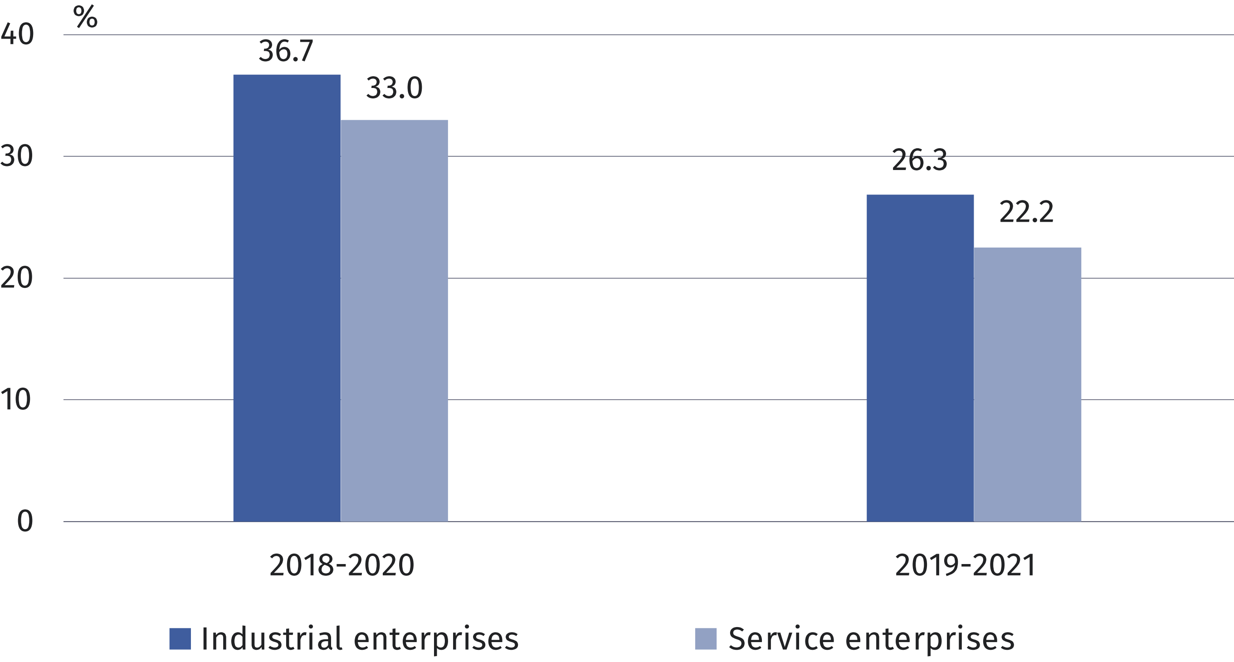

An innovative enterprise is one that has introduced one or more innovations during the observation period.
The share of enterprises that introduced innovations
in the years 2019-2021 was higher in industry than
in services
In the years 2019-2021, 22.0% of industrial enterprises and 19.7% of service enterprises introduced innovations (new or improved products or business processes), i.e. fewer than in the years 2018-2020, when innovations were introduced by 31.4% and 30.8% of surveyed enterprises, respectively.

Chart 2. Enterprises that introduced innovations
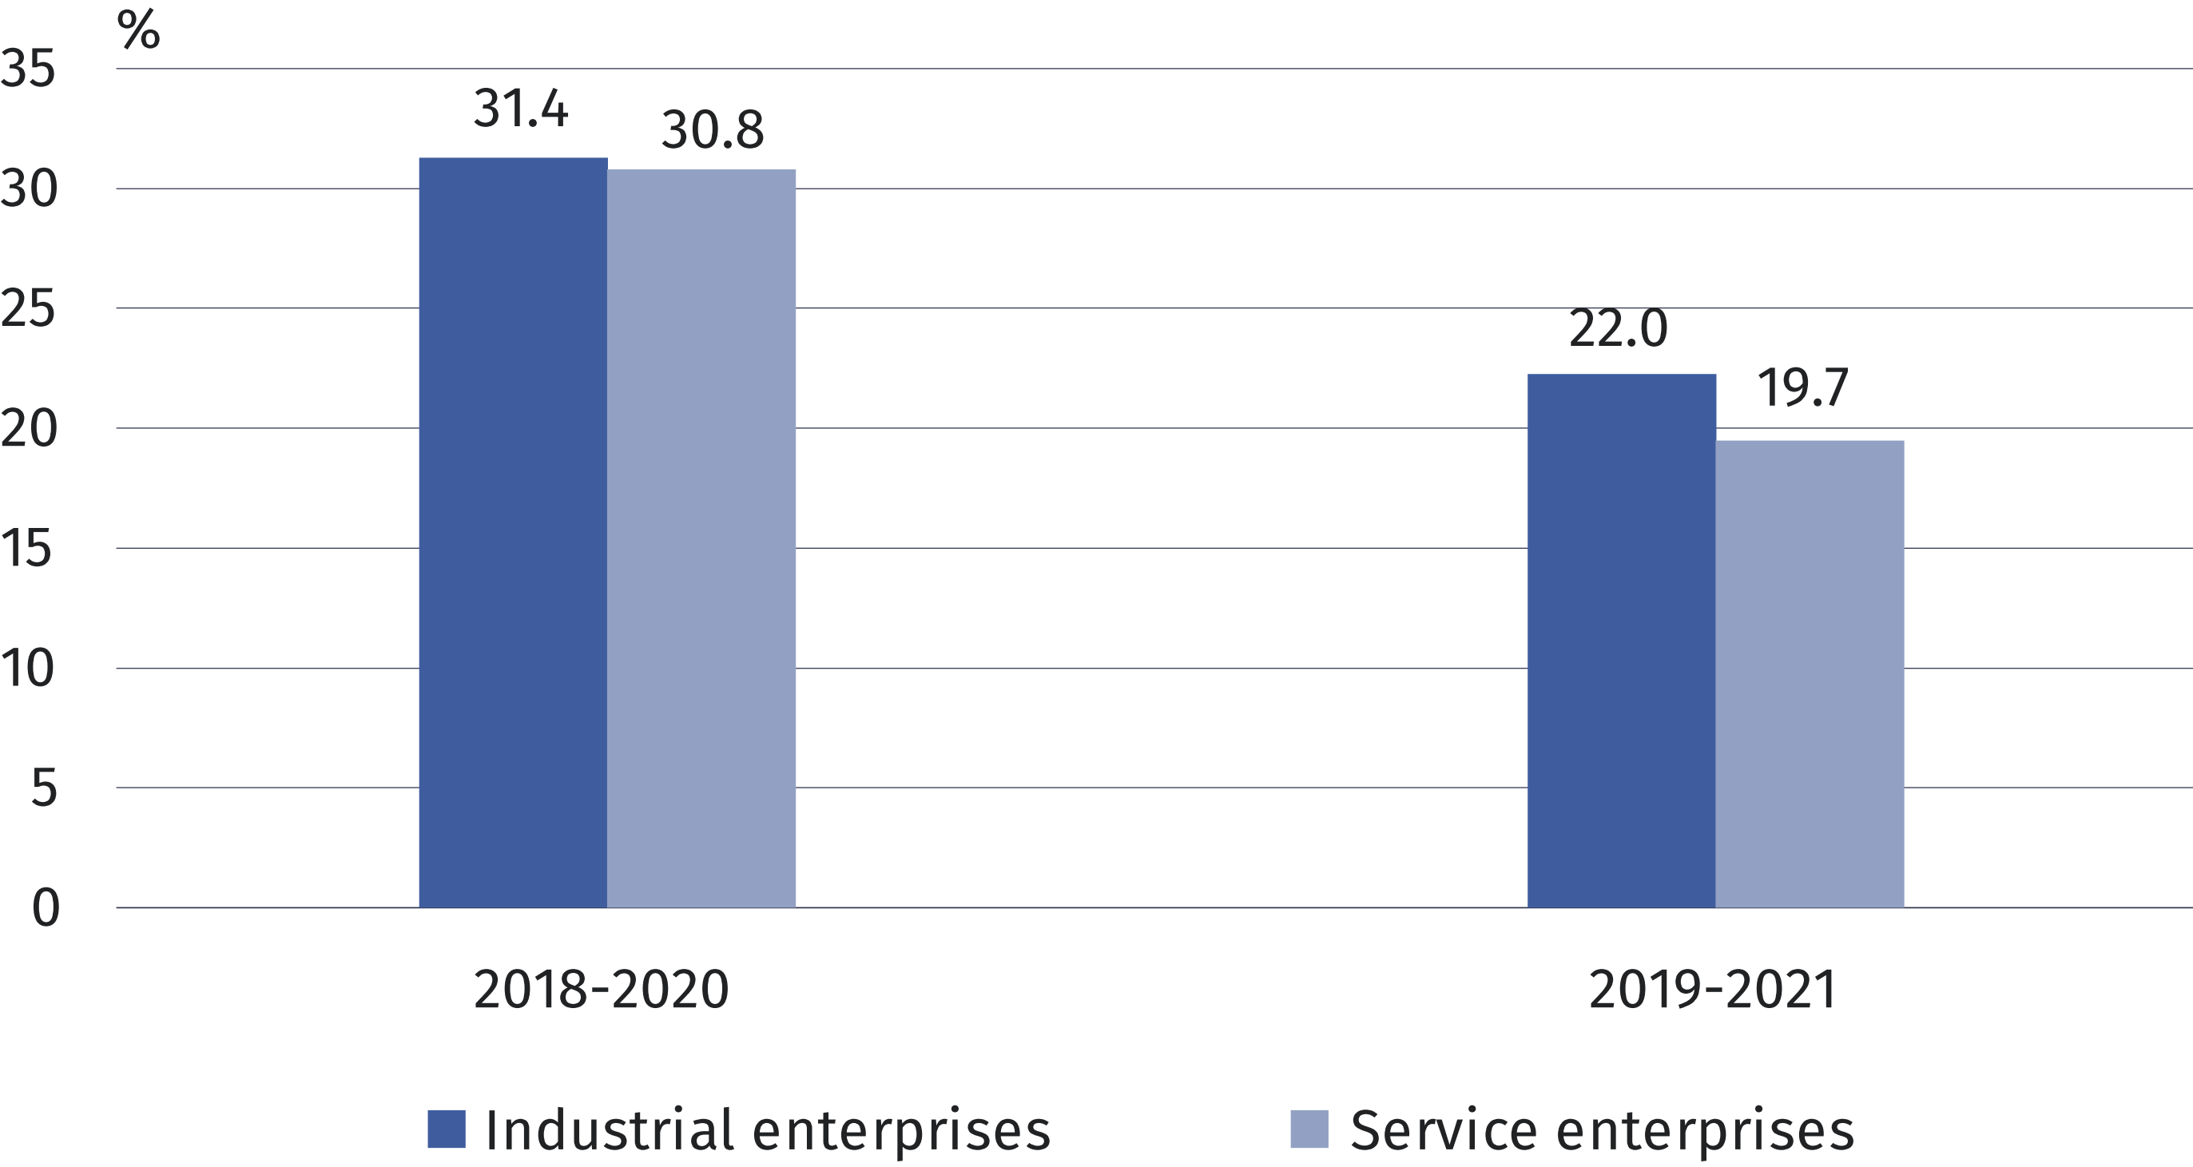
Product innovations were introduced more often by industrial enterprises than service enterprises (13.1% and 6.8%, respectively), whereas in the case of business process innovations, the shares of enterprises implementing them were at a similar level (18.0% and 18.1%, respectively).

Chart 3. Enterprises that introduced innovations in the years 2019-2021
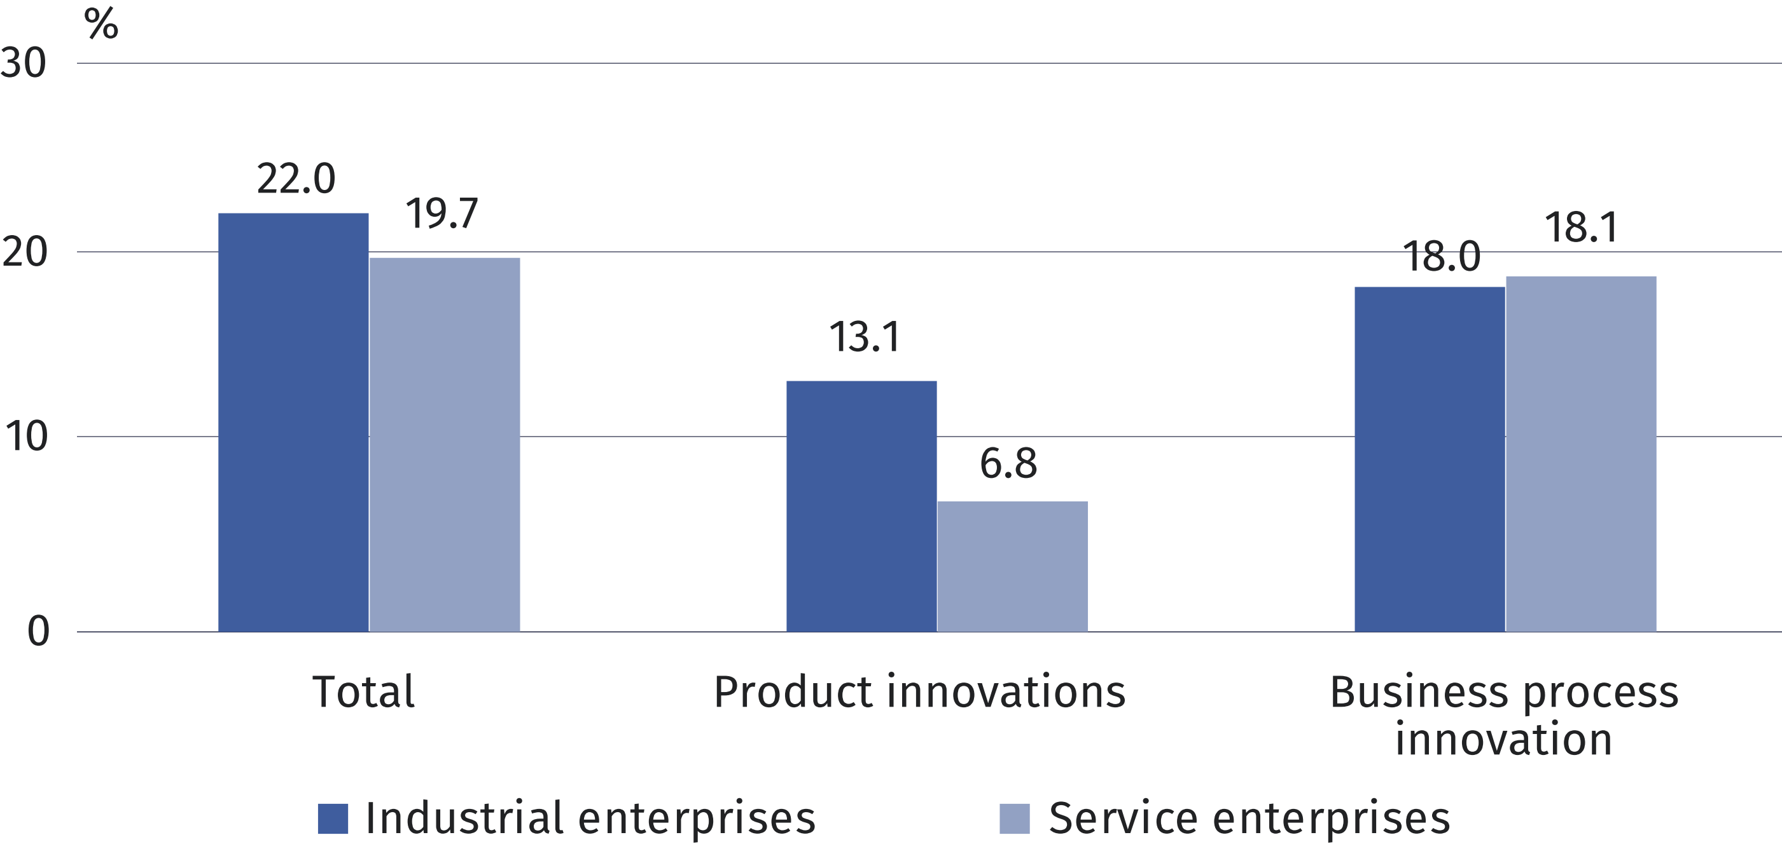
In the period 2019-2021, under product innovation, new or improved products were introduced by 12.0% of industrial enterprises and 3.5% of service enterprises, while new or improved services were introduced by 3.6% of industrial enterprises and 5.1% of service enterprises.

Chart 4. Enterprises that introduced product innovations in the years 2019-2021
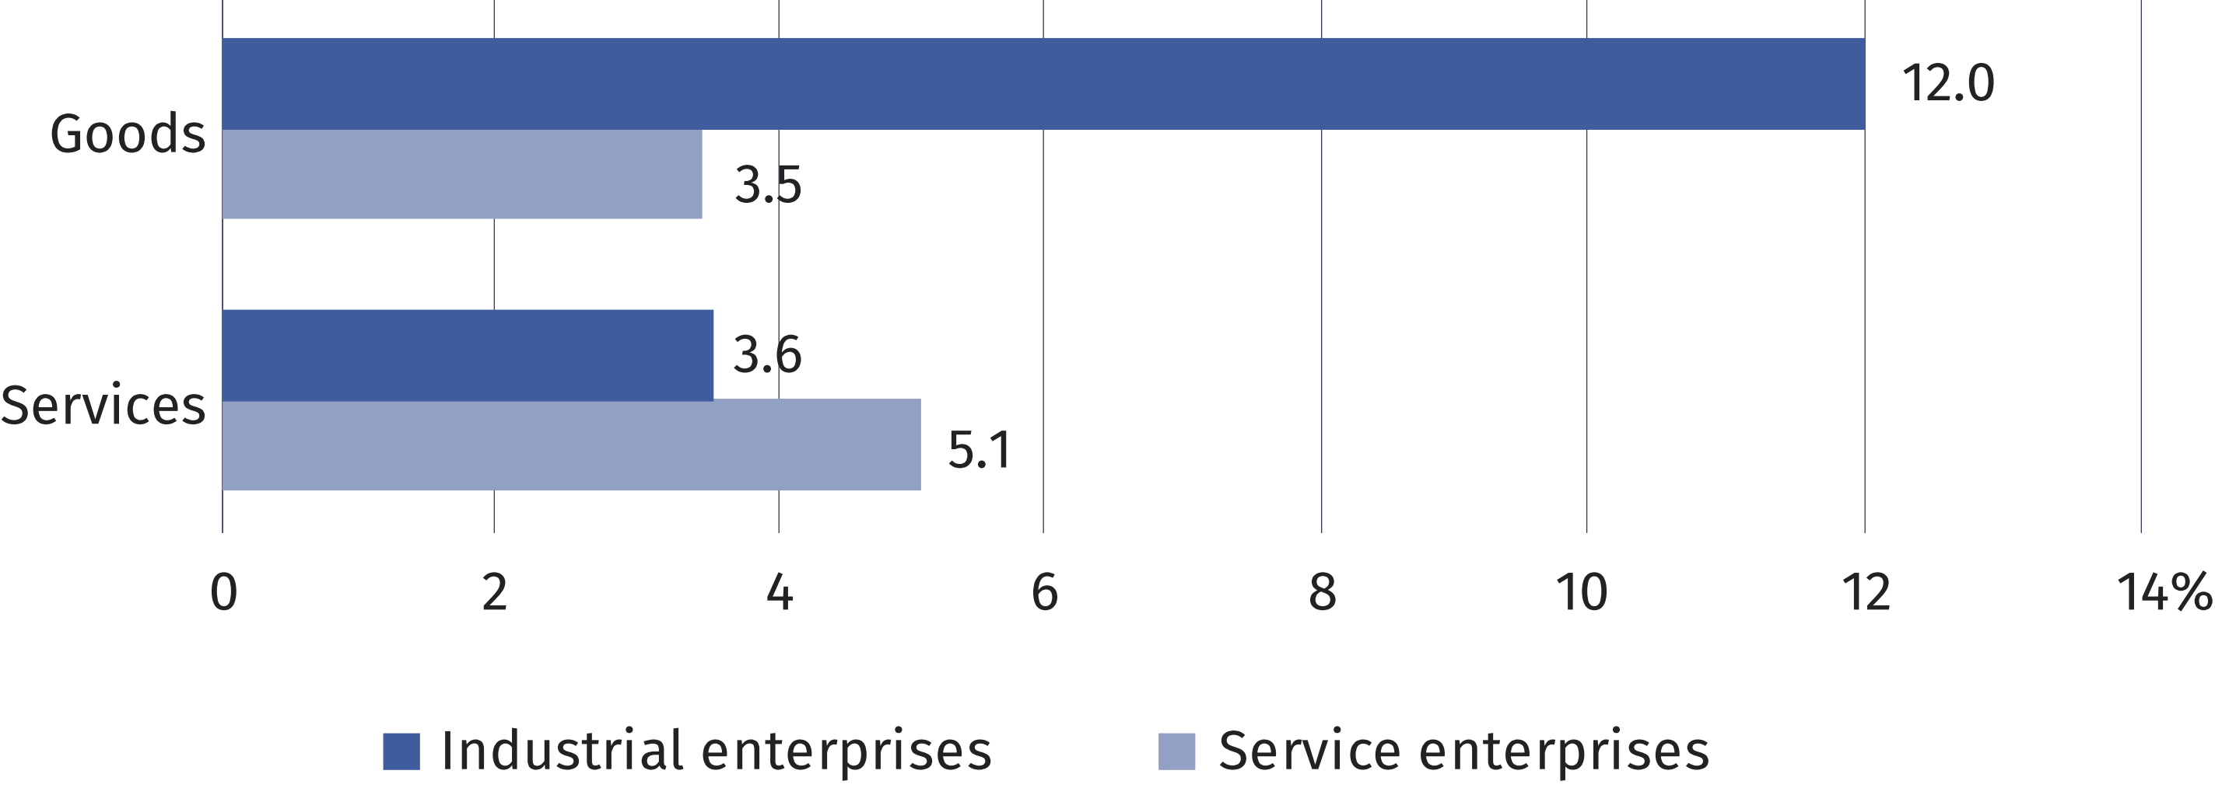
Among the types of business proces innovations, industrial enterprises most often introduced new or improved methods for producing goods or providing services (9.5%), while service entities introduced new or improved business practices for organising procedures or external relations (12.5%).

Chart 5. Enterprises that introduced business process innovations in the years 2019-2021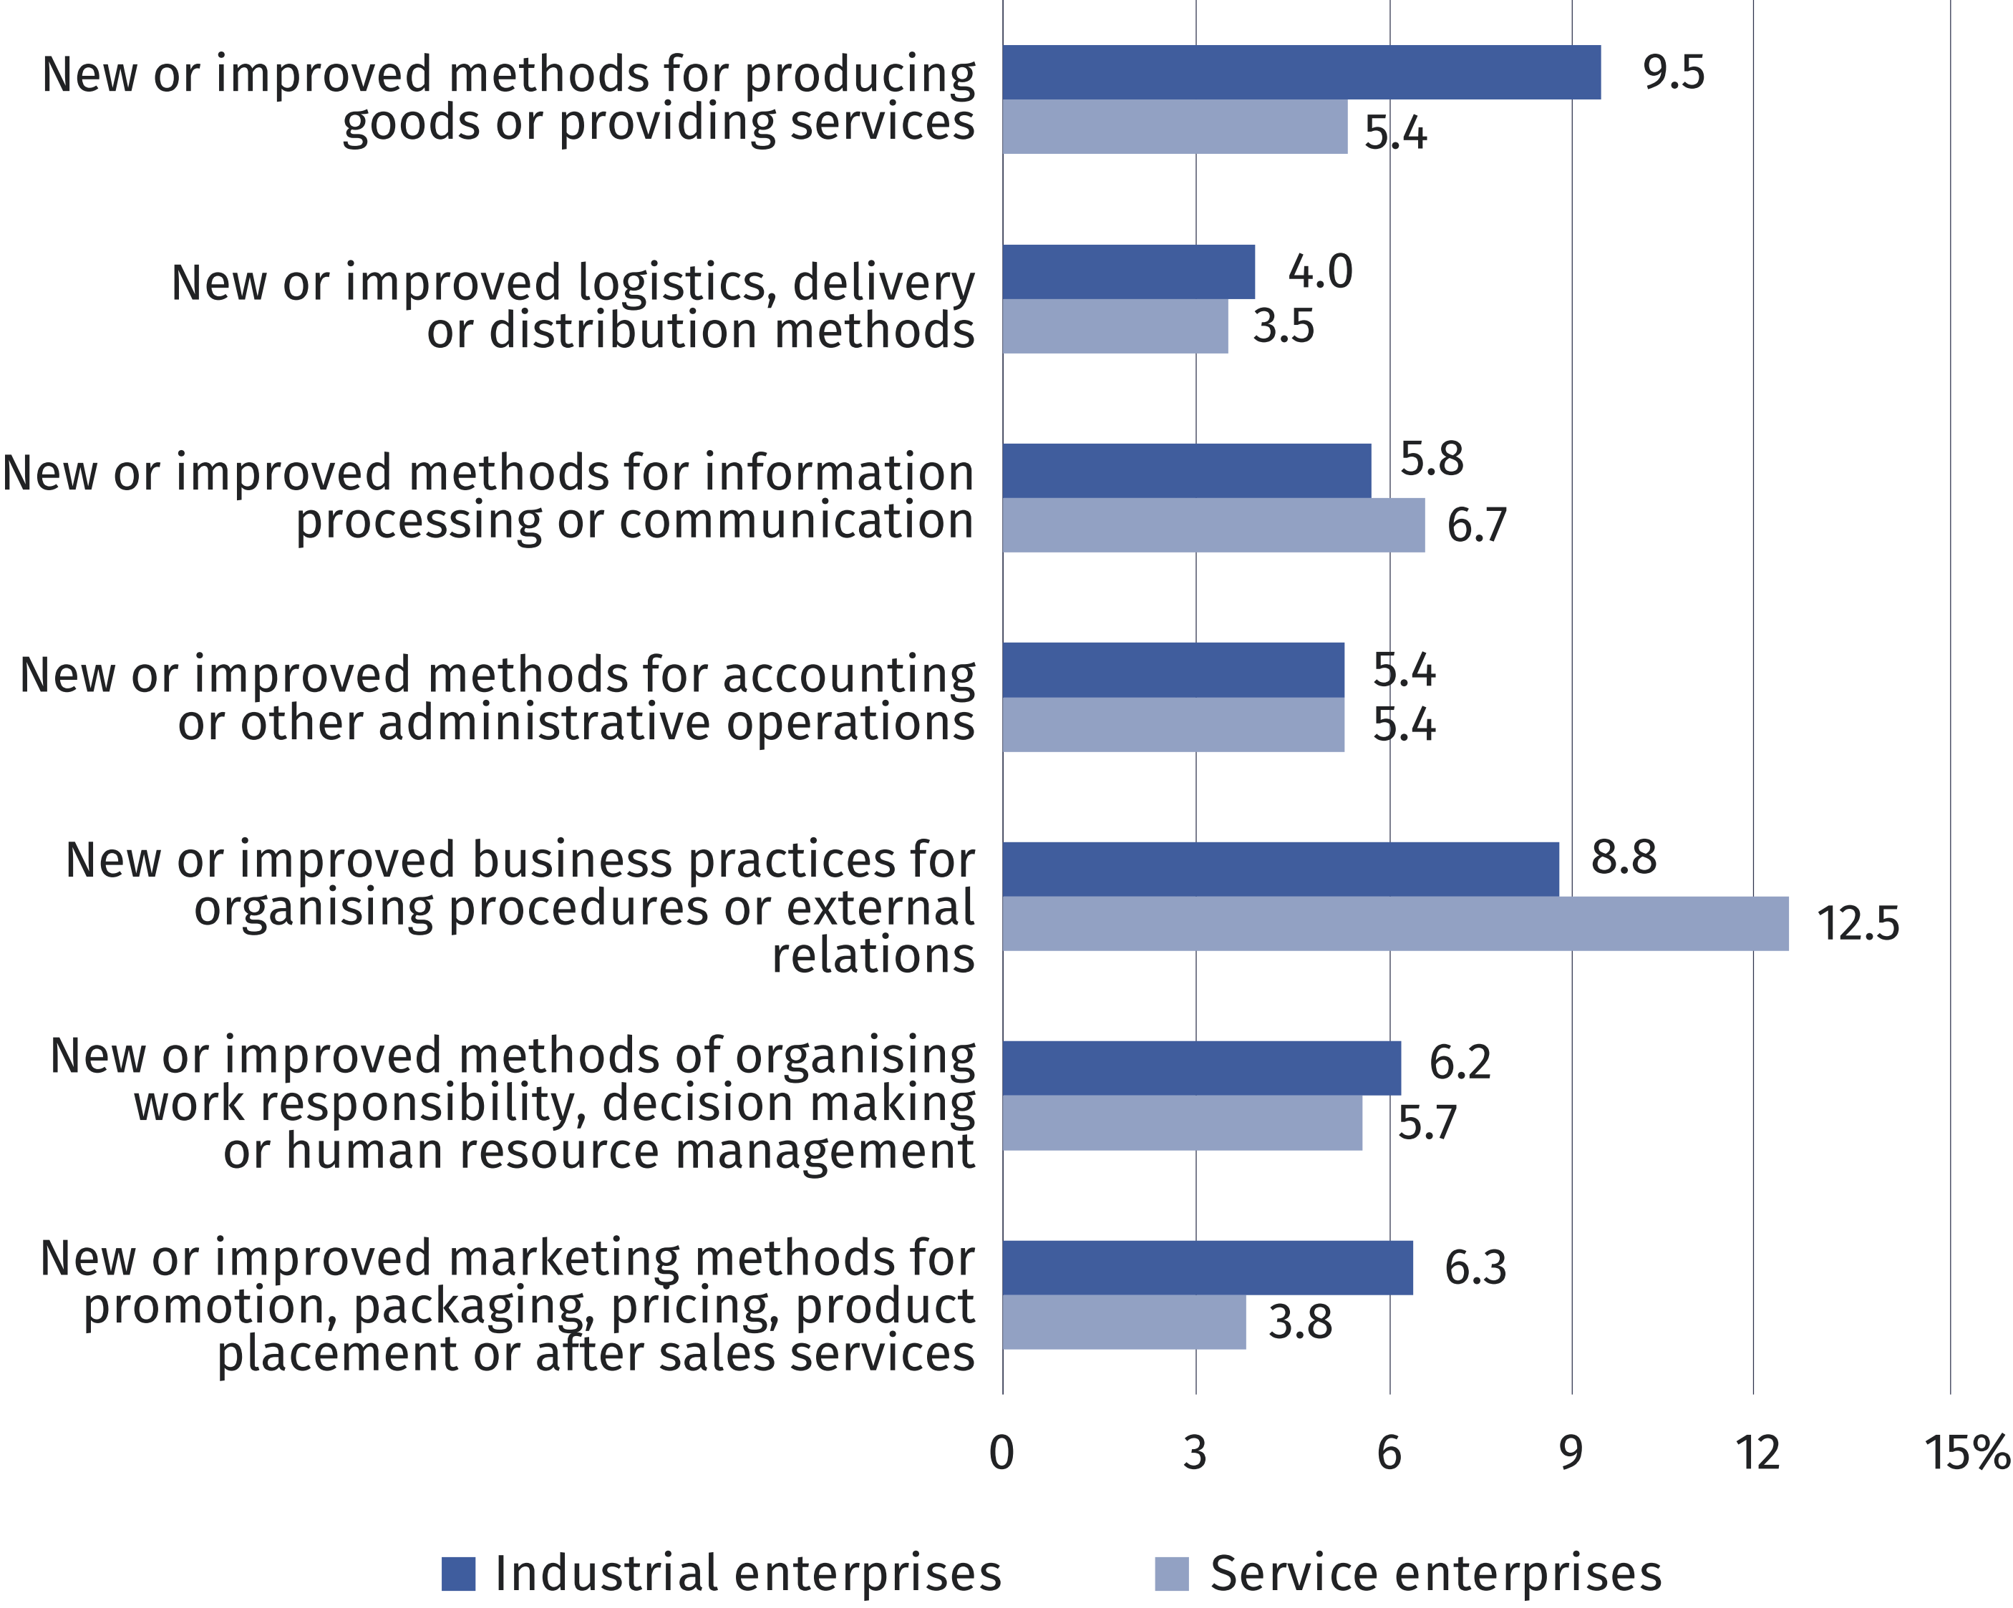

The highest percentage of industrial enterprises that introduced product or business process innovations was noted in the divisions: Extraction of crude petroleum and natural gas (75.0%), Mining of coal and lignite (68.8%) and Manufacture of basic pharmaceutical substances and medicines and other pharmaceutical products (63.6%), while in services – in the divisions Insurance, reinsurance and pension funding, excluding compulsory social security (81.3%) and Scientific research and development (56.0%).
Table 1. Innovative enterprises in the years 2019-2021 by selected types of activities
(divisions of the Polish Classification of Activities)
Specification |  | Enterprises that introduced innovations
 |  | total | product | business process
 |  | in %
Industrial enterprises | 22.0 |  | 13.1 | 18.0
Mining of coal and lignite | 68.8 |  | 18.8 | 56.3
Extraction of crude petroleum and natural gas | 75.0 |  | 50.0 | 75.0
Manufacture of food products | 15.0 |  | 9.1 | 12.2

Table 1. Innovative enterprises in the years 2019-2021 by selected types of activities
(divisions of the Polish Classification of Activities) (cont.)
Specification |  | Enterprises that introduced innovations
 |  | total | product | business process
 |  | in %
Industrial enterprises (cont.)
Manufacture of wearing apparel | 6.5 |  | 3.6 | 4.4
Manufacture of leather and related products | 13.0 |  | 8.3 | 10.0
Manufacture and processing of coke  and refined petroleum products | 55.6 |  | 44.4 | 53.7
Manufacture of chemicals and chemical  products | 44.9 |  | 30.3 | 38.6
Manufacture of basic pharmaceutical  substances and medicines and other  pharmaceutical products | 63.6 |  | 47.7 | 54.5
Manufacture of computer, electronic  and optical products | 50.8 |  | 39.1 | 39.0
Service enterprises | 19.7 |  | 6.8 | 18.1
Wholesale trade, excluding motor vehicles | 17.1 |  | 4.4 | 15.9
Land transport and transport via pipelines | 6.6 |  | 0.4 | 6.5
Water transport | 6.7 |  | – | 6.7
Computer programming, consultancy  and related activities | 48.4 |  | 26.4 | 43.5
Information service activities | 44.8 |  | 22.1 | 43.3
Insurance, reinsurance and pension funding, excluding compulsory social security | 81.3 |  | 60.9 | 76.6
Scientific research and development | 56.0 |  | 40.2 | 50.6
Among enterprises introducing innovations, the largest share was held by entities with 250 or more persons employed
Taking into account the number of persons employed, units with 250 or more persons employed had the largest share in the total number of enterprises introducing innovations. Both in industry and in services, enterprises of this size class most often introduced business process innovations (62.1% and 58.4% respectively).

Table 2. Innovative enteprises in the years 2019-2021 by numer of persons employed
Specification | Enterprises that introduced innovations
 | product | business process
 | in %
Industrial enterprises | 13.1 | 18.0
numer of persons employed:
10-49 | 6.8 | 9.4
50-249 | 25.9 | 36.0
250 and more | 47.4 | 62.1
Service enterprises | 6.8 | 18.1
numer of persons employed:
10-49 | 5.1 | 14.1
50-249 | 12.8 | 33.1
250 and more | 24.5 | 58.4

Expenditures on innovation activities
Expenditures on innovative activities in service enterprises were higher by 17.4% than
in industrial enterprises
Expenditures on innovation activities in industrial enterprises in 2021 amounted to PLN 19041.5 million (by 6.6% less than a year ago), while in service enterprises they amounted
to PLN 22348.6 million (by 21.5% more).
Expenditures on research and development predominated in both industrial and service
enterprises (they accounted for 50.9% and 60.7%, of all expenditures on innovation activities, respectively); expenditures on investment in fixed assets and intangible assets had also a significant share (36.0% and 14.3%, respectively).
In the structure of expenditures on innovative activities by source of funds, own funds had the highest share in in industrial and service enterprises (76.3% and 87.9%, respectively);
a much lower proportion was accounted for by funds obtained from abroad (9.7% and 5.6%, respectively), credits, loans and other financial liabilities from financial institutions (6.0% and 2.1%, respectively) and domestic funds received from institutions with public funds (3.8% and 2.5%, respectively).

Table 3. Expenditures on innovation activities
Specification | 2019 | 2020 | 2021
 | in PLN millions
Industrial enterprises | 23178.8 | 20378.2 | 19041.5
Service enterprises | 15400.8 | 18399.2 | 22348.6

Revenues from sales
In 2021, the share of revenues from sales of new or improved products introduced to the market between 2019 and 2021 in total revenues from sales amounted to 8.9% in industrial enteprises and 3.1% in service enteprises. The largest share of these revenues, both in industrial and service enterprises was recorded in enterprises with 250 or more persons
employed (11.5% and 5.2% respectively).

Table 4. The share of revenues from sales of new or improved products in total revenues from sales
Specification | Products introduced to the market
 | total |  | new to the market |  | only new  to the enterprise
 | 2018-2020 | 2019-2021 | 2018-2020 | 2019-2021 | 2018-2020 | 2019-2021
 | in %
Industrial  enterprises | 10.0 | 8.9 | 4.8 | 3.3 | 5.2 | 5.6
numer of persons employed:
10-49 | 3.7 | 2.3 | 1.4 | 1.0 | 2.4 | 1.3
50-249 | 5.7 | 4.4 | 2.4 | 1.9 | 3.2 | 2.5
250 and more | 12.6 | 11.5 | 6.2 | 4.1 | 6.4 | 7.4
Service  enterprises | 4.6 | 3.1 | 2.2 | 1.2 | 2.4 | 1.9
numer of persons employed:
10-49 | 4.0 | 0.8 | 2.6 | 0.3 | 1.3 | 0.5
50-249 | 3.2 | 2.4 | 1.9 | 0.8 | 1.3 | 1.5
250 and more | 5.9 | 5.2 | 2.1 | 2.0 | 3.8 | 3.1

In 2021, the share of revenues from sales of products new or improved to the market in revenues from sales of innovative products amounted to 36.9% in industry and 38.3% in services.

Prepared by:  Statistical Office in Szczecin  Director Magdalena Wegner  Phone: (+48 91) 459 77 00 | Issued by:  The Spokesperson for the President  of Statistics Poland  Karolina Banaszek  Phone: (+48) 695 255 011
Press Office  Phone: (+48 22) 608 38 04  e-mail: obslugaprasowa@stat.gov.pl | stat.gov.pl/en/
 | @StatPoland
 | @GlownyUrzadStatystyczny
 | gus_stat
 | glownyurzadstatystycznygus
 | glownyurzadstatystyczny
Related information
Innovation activities of enterprises in the years 2018-2020
Data available in databases
Local Data Bank – Science and technology. Information Society – Innovation activities
Terms used inn official statistics
Innovation activities
Innovation
Product innovation
Business process innovation
Innovative enterprise

