Tourist accommodation establishments and its occupancy in the 1st half of 2022
(concerns tourist accommodation establishments with 10 or more bed places)
In the 1st half of 2022, 14.7 million tourists were accommodated in tourist accommodation establishments and 37.5 million overnight stays were provided for them. Compared to the same period of 2021, this was an increase of 177.1% and 152.2% respectively. Compared to the 1st half of 2021, the occupancy rate also increased from 19.9% to 36.2%.
177.1%
Increase in the number of tourists accommodated in accommodation establishments in the 1st half of 2022 compared to the same period last year

In the 1st half of 2022, there was an increase in the occupancy of tourist accommodation establishments in Poland compared to the same period in 2021. The increase in the number of tourists and their overnight stays was largely influenced by the lack of restrictions on the operation of the accommodation base, which were in force in the first three months of last year due to the COVID-19 pandemic.

Occupancy of tourist accommodation establishments in the 1st half of 2022
In the period 01-06.2022,
14.7 million people were accommodated in tourist accommodation establishments, of which 2.3 million came from abroad
14.7 million people stayed in tourist accommodation establishments in the first half of 2022, 177.1% more than in the same period last year. The smallest number of tourists stayed in
accommodation establishments in January - 1.7 million, but there were more than eight times as many tourists as in the corresponding month of 2021. The highest number of tourists stayed in establishments in June - 3.5 million and there were 54.3% more tourists compared to June last year.
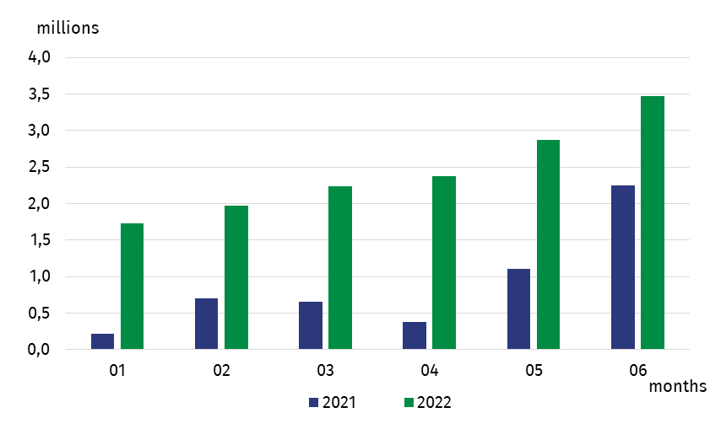
Chart 1. Tourists accommodated in tourist accommodation establishments
In the first half of 2022, the largest number of tourists stayed in hotels - 10.5 million. Among other types of establishments, 1.1 million tourists stayed overnight in other hotel establishments, while 690.0 thousand stayed in holiday centres. Tourists also stayed in large numbers in health establishments (375.3 thousand), training-recreational centres (346.8 thousand) and guest rooms/private accommodation (327.3 thousand).
In the first half of 2022, almost 6 times more foreign tourists were accommodated in accommodation establishments than in the corresponding period of 2021
Compared to the first half of 2021, an increase in the number of persons staying overnight was recorded in all types of establishments, with the largest increase, more than threefold, occurring in shelters, followed by hotels and youth shelters (nearly 3 times more).
Most tourists stayed overnight in establishments located in Mazowieckie Voivodship -
2.6 million. A large number of tourists also stayed in Małopolskie Voivodship (2.3 million), Dolnośląskie (1.7 million), Pomorskie and Zachodniopomorskie Voivodships (1.3 million each) and Śląskie Voivodship (1.2 million). Compared to the same period last year, an increase in the number of overnight visitors was recorded in all voivodships, with the largest increase, almost fourfold, occurring in Mazowieckie Voivodship. The smallest increase was recorded in accommodation establishments located in Podlaskie Voivodship - by 89.7%.
Table 1. Tourists in tourist accommodation establishments in the 1st half of 2022
Specification | Total |  | Domestic tourists |  | Foreign tourists
 | in thousands | 1st half of 2021=100 | in thousands | 1st half of 2021=100 | in thousands | 1st half of 2021=100
Poland | 14,673.9 | 277.1 | 12,351.0 | 252.9 | 2,322.9 | 564.4
Dolnośląskie | 1,660.4 | 293.3 | 1,447.5 | 279.7 | 213.0 | 436.7
Kujawsko  -Pomorskie | 588.3 | 253.5 | 557.4 | 250.5 | 30.9 | 323.3
Lubelskie | 487.5 | 240.1 | 417.7 | 215.2 | 69.8 | 785.8
Lubuskie | 263.5 | 198.0 | 210.2 | 181.6 | 53.3 | 308.0
Łódzkie | 523.6 | 256.3 | 468.6 | 249.8 | 55.0 | 329.7
Małopolskie | 2,276.2 | 342.1 | 1,828.6 | 291.9 | 447.6 | 1,148.0
Mazowieckie | 2,629.6 | 366.1 | 2,018.5 | 322.9 | 611.1 | 656.3
Opolskie | 143.8 | 246.6 | 131.2 | 238.6 | 12.6 | 379.6
Podkarpackie | 524.0 | 256.5 | 427.0 | 222.2 | 97.1 | 794.7
Podlaskie | 230.9 | 189.7 | 191.1 | 170.1 | 39.8 | 425.2
Pomorskie | 1,317.1 | 233.9 | 1,177.4 | 220.9 | 139.6 | 464.6
Śląskie | 1,166.6 | 270.9 | 1,016.8 | 257.0 | 149.8 | 428.5
Świętokrzyskie | 273.9 | 240.3 | 263.7 | 241.5 | 10.2 | 213.3
Warmińsko  -Mazurskie | 492.3 | 241.0 | 470.6 | 235.7 | 21.7 | 469.9
Wielkopolskie | 826.0 | 260.6 | 731.0 | 251.0 | 95.0 | 369.1
Zachodniopomorskie | 1,270.2 | 226.7 | 993.7 | 196.0 | 276.5 | 518.9

Among the total number of tourists staying overnight in the first six months of this year, 84.2% were domestic tourists (12.4 million), while 15.8% were foreign tourists (2.3 million), and compared to the same period in 2021, this was almost 3 times and 6 times more, respectively.
The total number of foreign tourists was dominated by tourists from Europe with 2.0 million (85.3% of total foreign tourists). Among them, 27.8% were Germans (550.1 thousand), 21.4% Ukrainians (424.3 thousand), and 8.5% were from the UK (167.6 thousand).
In the first half of 2022, 37.5 million overnight stays were provided, almost three times more than in the first half of last year. More than half of the overnight stays were provided in hotels - 20.8 million. Health establishments provided 4.7 million overnight stays, while holiday centres provided 3.2 million overnight stays.
Chart 2. Overnight stays provided in tourist accommodation establishments
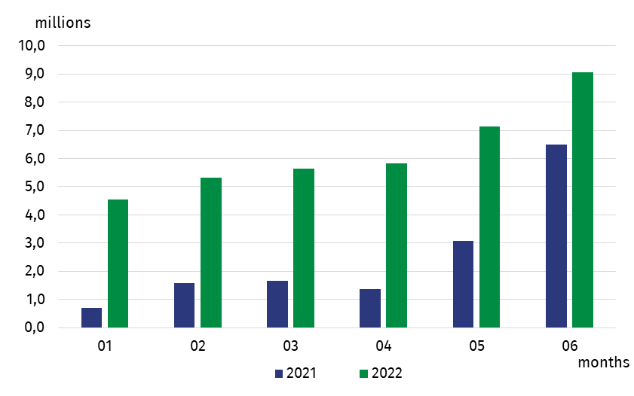
On average, tourists stayed 2.6 nights; the shortest stays were in shelters, motels and hotels (approx. 2 nights each), while they stayed the longest in health establishments, staying an average of 12.4 nights, followed by holiday youth centres (5.1 nights) and holiday centres
(4.7 nights).
In the first half of this year, tourists made 2.6 overnight stays on average
Domestic tourists were provided with 31.6 million overnight stays, more than two times the number from the previous year, while foreign tourists received 6.0 million overnight stays, almost five times the number.
Compared with the same period last year, an increase in the number of overnight stays was recorded in all voivodships. A more than threefold increase was recorded in Mazowieckie and Małopolskie Voivodships. A large increase in the number of overnight stays
(nearly 3-fold) was also recorded in establishments located in Dolnośląskie and Śląskie Voivodships. The smallest increase in the number of overnight stays provided was in Lubuskie Voivodship (by 67.6%).
Considering the country of permanent residence all voivodships saw an increase in the number of overnight stays provided to domestic and foreign tourists. An almost threefold
increase in the number of overnight stays by domestic tourists was recorded in Mazowieckie, Dolnośląskie and Małopolskie Voivodships. The smallest increase in the number of overnight stays by domestic tourists was recorded in establishments located in Lubuskie Voivodship (by 57.4%).
The largest increase, more than 12-fold, in the number of overnight stays provided to foreign tourists was in Małopolskie Voivodship. Large increases were also recorded in the following voivodships: Lubelskie (more than 6-fold), Mazowieckie (almost 6-fold) and Zachodniopomorskie (more than 5-fold). The smallest increase was recorded in establishments located in Świętokrzyskie Voivodship (by 31.7%).
Table 2. Overnight stays in tourist accommodation establishments in the 1st half of 2022
Specification | Total |  | Domestic tourists |  | Foreign tourists
 | in thousands | 1st half of 2021=100 | in thousands | 1st half of 2021=100 | in thousands | 1st half of 2021=100
Poland | 37,547.7 | 252.2 | 31,552.0 | 232.2 | 5,995.7 | 460.4
Dolnośląskie | 4,304.6 | 288.7 | 3,809.8 | 278.7 | 494.8 | 398.2
Kujawsko  -Pomorskie | 1,945.7 | 222.3 | 1,846.8 | 221.5 | 99.0 | 239.8
Lubelskie | 1,004.7 | 222.5 | 872.9 | 202.7 | 131.8 | 631.2
Lubuskie | 540.7 | 167.6 | 415.5 | 157.4 | 125.2 | 213.5
Łódzkie | 1,115.3 | 234.9 | 923.5 | 244.1 | 191.9 | 198.9
Małopolskie | 6,071.6 | 313.9 | 4,935.2 | 268.0 | 1,136.4 | 1,218.0
Mazowieckie | 4,712.7 | 328.2 | 3,416.9 | 282.8 | 1,295.8 | 568.7
Opolskie | 301.1 | 232.4 | 268.5 | 223.3 | 32.5 | 349.6
Podkarpackie | 1,431.8 | 234.8 | 1,229.9 | 217.3 | 201.8 | 460.1
Podlaskie | 527.4 | 201.9 | 470.4 | 192.1 | 56.9 | 350.1
Pomorskie | 3,564.2 | 209.2 | 3,194.4 | 199.2 | 369.8 | 370.1
Śląskie | 2,823.2 | 261.2 | 2,431.6 | 251.5 | 391.6 | 343.1
Świętokrzyskie | 821.8 | 199.5 | 792.2 | 203.5 | 29.7 | 131.7
Warmińsko  -Mazurskie | 1,110.1 | 219.7 | 1,055.2 | 215.0 | 54.9 | 378.6
Wielkopolskie | 1,586.4 | 245.1 | 1,328.4 | 241.6 | 257.9 | 265.5
Zachodniopomorskie | 5,686.4 | 222.7 | 4,560.7 | 195.7 | 1,125.7 | 507.5

In the first half of this year, the occupancy rate of bed places was 36.2%, which was 16.3 pp higher than in the previous year. As in previous periods, the highest occupancy rate was recorded in health establishments - the occupancy rate was 69.1%, while these establishments also saw an increase of 22.2 pp. The occupancy rate above the national average was also recorded in hostels - 43.9% and in hotels - 39.6%. In the other types of establishments, the occupancy rate ranged from 14.0% in agritourism lodgings to 32.6% in holiday centres.
In the first half of this year, the occupancy rate was 36.2%, 16.3 pp higher than in the same period last year

Map 1. Occupancy rate of bed places in tourist accommodation establishments in the first half
of 2022
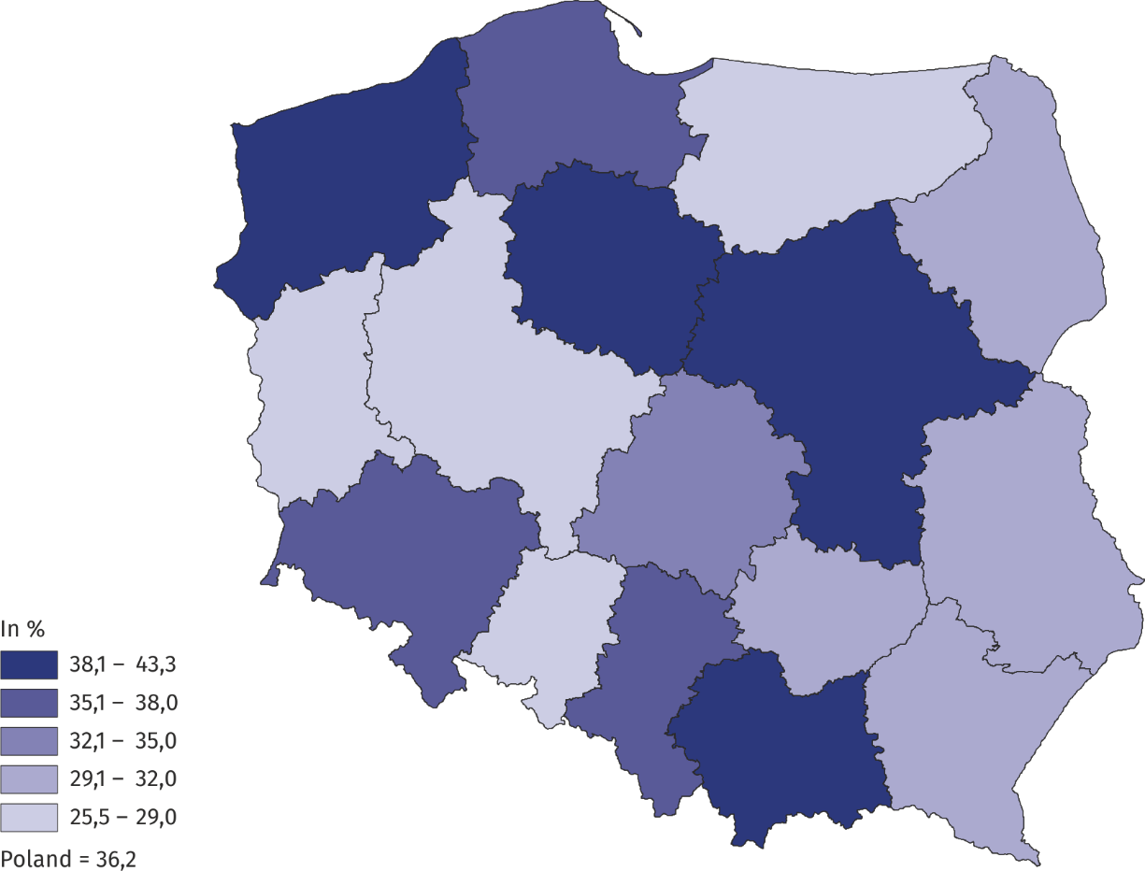

Tourist accommodation establishments – as of the end of July 2022
As of 31 July 2022, there were 9766 tourist accommodation establishments operating in Poland, with 779,9 bed places
At the end of July 2022, 9766 tourist accommodation establishments were operating in Poland, i.e. 1.8% less than a year ago. Among the establishments operating in July this year, the highest number was hotels (2,569), followed by guest rooms/private accommodation (1,937), other hotel establishments (933) and holiday centres (918).
The largest number of tourist accommodation establishments was located in Zachodniopomorskie Voivodship (1,397), followed by Pomorskie Voivodship (1,395), Małopolskie Voivodship (1,313) and Dolnośląskie Voivodship (914). These voivodships concentrated more than half of the country's accommodation establishments.
As of 31 July this year, 779.9 thousand bed places were prepared for tourists, including
220.8 thousand seasonal bed places. The largest number of bed places was provided by
hotels - 302.8 thousand, followed by holiday centres - 116.6 thousand. Compared to the end of July 2021, the number of bed places fell by 0.5% (4.2 thousand).
The largest number of bed places prepared to receive tourists was in Zachodniopomorskie Voivodship - 143.3 thousand, followed by Pomorskie Voivodship - 110.9 thousand and Małopolskie Voivodship - 97.9 thousand.
Tourist accommodation establishments in Poland are of medium size - on average they have almost 80 bed places. The largest are health establishments with an average of almost
194 bed places, holiday youth centres - over 145 bed places and camping sites – almost
141 bed places. Hotels have an average of almost 118 bed places and 57 rooms.
As at 31 July this year, there were 7,288 catering establishments in tourist accommodation establishments, i.e. 44 fewer than in the previous year. The largest group of establishments were restaurants – 3,124, i.e. 42.9% of the total number of establishments, followed by bars and cafés – 2,063 (28.3%).
Map 2. Bed places in tourist accommodation establishments in 2022
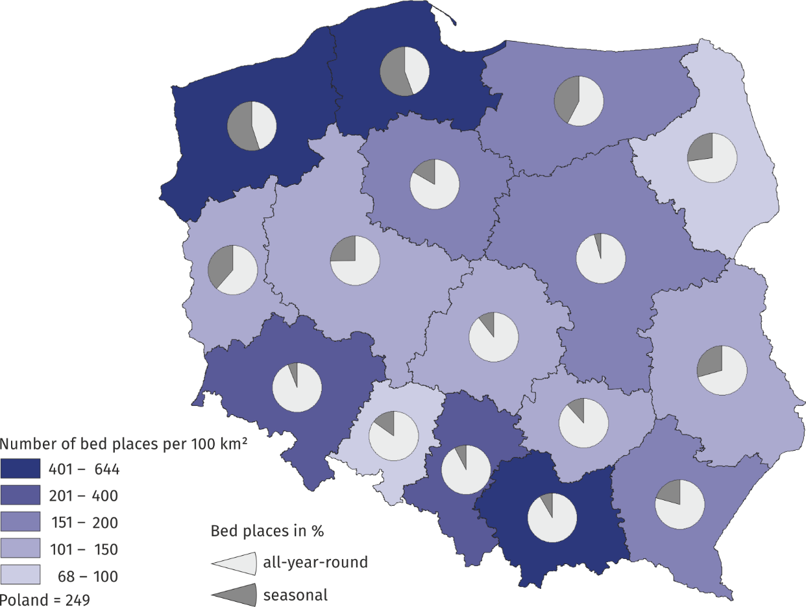
As of 31 July
When quoting Statistics Poland data, please provide information: “Source of data: Statistics Poland”, and when publishing calculations made on data published by Statistics Poland, please provide information: “Own study based on Statistics Poland data”.

Prepared by:  Statistical Office in Rzeszów  Director Marek Cierpiał-Wolan  Phone: (+48 17) 853 52 10 | Issued by:  The Spokesperson for the President  of Statistics Poland  Karolina Banaszek  Phone: (+48) 695 255 011
Press Office  Phone: (+48 22) 608 38 04  e-mail: obslugaprasowa@stat.gov.pl | stat.gov.pl/en/
 | @StatPoland
 | @GlownyUrzadStatystyczny
 | gus_stat
 | glownyurzadstatystycznygus
 | glownyurzadstatystyczny
Related information
Occupancy of tourist accommodation establishments in March 2022 in the face of the inflow of refugees from Ukraine and the absence of restrictions related to the COVID-19 pandemic.
Occupancy of tourist accommodation establishments in 2021.
Tourism in 2021.
Data available in databases
Local data bank
Terms used inn official statistics
Tourist
Tourist accommodation establishment
Bed places in tourist accommodation establishments
Foreign tourists in tourist accommodation establishments
Nights spent (overnight stays) in tourist accommodation establishments
Duration of the stay
Occupancy rate of bed places in tourist accommodation establishments

