Occupancy of tourist accommodation establishments in 2021
Concerns tourist accommodation establishments with 10 or more bed places
In 2021, 22.2 million tourists were accommodated in tourist accommodation establishments, with 62.8 million overnight stays. Compared to 2020, it was more by 24.2% and 22.3%, respectively. The occupancy rate of bed places in all tourist accommodation establishments in 2021 amounted to 32.3% and was higher by
5.5 percentage point compared to the previous year.
⇧ 24.2%
Increase in the number of tourists accommodated in tourist accommodation establishments compared to 2020

Tourism is one of the sectors directly affected by the COVID-19 pandemic. However, the restrictions on the operation of accommodation activities in force in 2021 were less restrictive than the year before, resulting in a higher total number of tourists in tourist accommodation establishments throughout the year, compared to 2020. The exception was the period January-March 2021, which saw a decrease in the number of tourists compared to the same period of the previous year. This was due to the fact that restrictions on the movement of people and the operation of accommodation establishments in 2020 did not take effect until April. In the remaining months of 2021, the number of tourists accommodated in accommodation establishments was higher than in 2020.

Tourist accommodation establishments
In July 2021, there were 9.9 thousand tourist accommodation establishments in Poland

As of 31 July 2021, 9,942 tourist accommodation establishments were operating in Poland,
i.e. 349 fewer (3.4%) than the year before. Apart from hotels (increase of 23 establishments), school youth shelters (increase of 14 establishments) and health establishments (increase
of 11 establishments), declines in the number of establishments operating in July 2021 were recorded in all types of establishments, with the highest one in rooms for guests and private lodgings (decrease of 142 establishments).
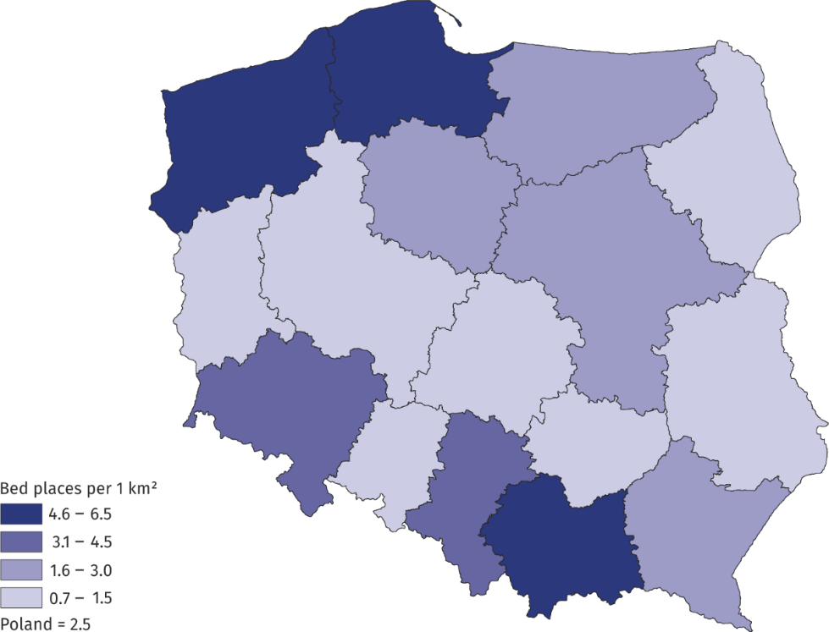
Map 1. Tourist accommodation establishments density rate in 2021
As of 31 July
Taking into account the standard of accommodation services provided, the accommodation establishments consisted of 3,949 hotel and similar establishments and 5,993 other establishments. Among hotels and similar establishments, the most numerous group, as in previous years, were hotels – 2,521 and other hotel establishments, which include guest houses and inns, among other things. At the end of July 2021 there were 957 such establishments,
i.e. by 2.6% less than in 2020.
In the group of other accommodation establishments, rooms for guests were the most numerous – 2,007 establishments (i.e. by 6.6% less than a year earlier) and holiday centres – 947 establishments, which in 2021 recorded a decrease of 7.2% compared to the previous year.
Chart 1. Tourist accommodation establishments by type

At the end of July 2021, tourist accommodation establishments offered 784.2 thousand bed places, of which all year round places constituting over 71.4%. In relation to the previous year, the number of bed places increased by 8.9 thousand (i.e. by 1.1%). Tourist accommodation establishments density rate measured by the number of bed places per 1 km² of area stood at the level of the previous year at 2.5.
One tourist accommodation establishment had 79 bed places on average (75 a year before). As in 2020, the largest number of bed places was offered by hotels (296.8 thousand) and
holiday centres (117.8 thousand).
The largest resources of tourist accommodation establishments were located in Zachodniopomorskie Voivodship – 144.2 thousand, followed by Pomorskie and Małopolskie Voivodships, which in 2021 offered 111.3 and 99.3 thousand bed places for tourists respectively, with the vast majority (91.6%) of bed places in Małopolskie Voivodship being all-year-round bed places, and seasonal bed places prevailing in two others voivodships.
Tourists in tourist accommodation establishments
In 2021, almost two-thirds
of tourists accommodated
in the accommodation establishments stayed in hotels
In 2021, 22.2 million tourists were accommodated in tourist accommodation establishments, which was 4.3 million more (24.2%) than in the previous year.
Over 16.6 million tourists were accommodated in hotels and similar establishments, including the most (14.4 million) staying in hotels (29.0% more than in 2020). In other tourist accommodation establishments, 5.6 million tourists were accommodated, with most people staying in holiday centres – 1.5 million tourists (19.0% more). Rooms for guests and training-recreational centres were also very popular, with 699.7 thousand (11.3% more) and 690.8 thousand (26.9% more) tourist respectively. In 2021, in health establishments, 599.8 thousand people were accommodated, i.e. 28.7% more than in 2020.
Chart 2. Tourists in tourist accommodation establishments by month
million
The largest number of tourists were accommodated in accommodation establishments located in Małopolskie Voivodship - 3.2 million, followed by Mazowieckie Voivodship – 3.0 million and with around 2.0 million in the following: Zachodniopomorskie, Dolnośląskie and Pomorskie Voivodships. Compared to 2020, an increase in the number of tourists accommodated
in accommodation establishments was recorded in all voivodships, with the highest in Mazowieckie Voivodship (by 43.0%) and the lowest in Warmińsko-Mazurskie Voivodship (by 7.3%).
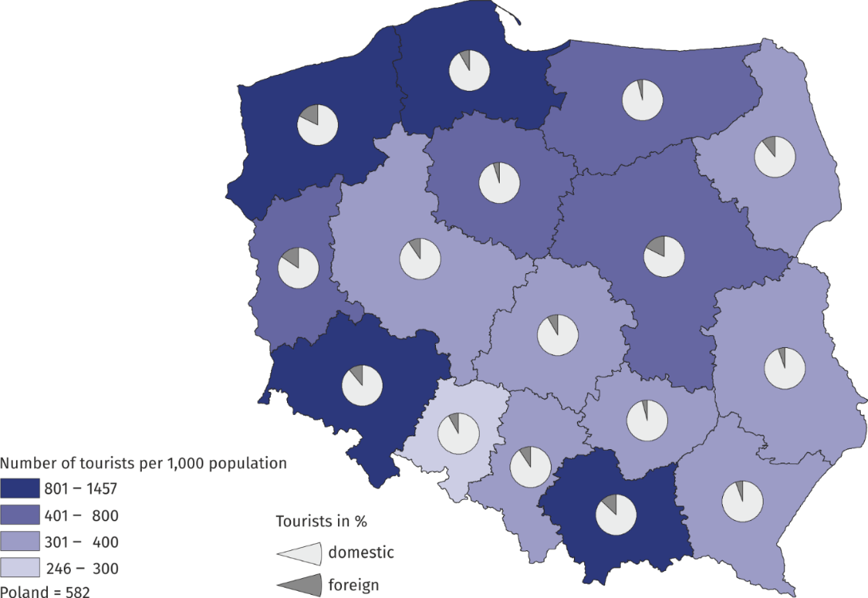
Map 2. Tourist traffic intensity rate by voivodship in 2021

Among the people accommodated in tourist accommodation establishments in 2021, there were 2.5 million foreign tourists, which accounted for 11.3% of the total number of tourists accommodated in accommodation establishments (in 2020 – 12.7%). The largest number
of foreign tourists was accommodated in Mazowieckie (527.5 thousand), followed by Zachodniopomorskie (434.3 thousand) and Małopolskie (409.7 thousand) Voivodships.
Table 1. Occupancy of tourist accommodation establishments by type of accommodation
in 2021
SPECIFICATION | Tourists accommodated |  | Overnight stays |  | Occupancy rate of bed places  (in %)
 | total | of which  foreign  tourists | total | of which  foreign  tourists
 | in thousands
TOTAL | 22 199.0 | 2 509.8 | 62 837.5 | 7 165.0 | 32.3
Hotels and similar  establishments | 16 601.9 | 2 184.6 | 34 891.8 | 5 493.6 | 30.7
hotels | 14 361.5 | 2 004.7 | 29 092.7 | 4 712.8 | 31.6
motels | 115.9 | 8.6 | 210.9 | 14.8 | 19.6
boarding houses | 397.1 | 20.9 | 1 130.2 | 69.3 | 25.2
other hotel  establishments | 1 727.4 | 150.2 | 4 458.0 | 696.7 | 27.6
Other establishments | 5 597.1 | 325.3 | 27 945.7 | 1 671.4 | 34.6
excursion hostels | 43.4 | 2.4 | 151.1 | 5.5 | 22.9
shelters | 131.3 | 1.7 | 211.6 | 4.5 | 24.4
youth hostels | 32.3 | 3.1 | 83.3 | 14.2 | 16.3
school youth hostels | 146.7 | 9.4 | 510.0 | 67.1 | 14.6
holiday centres | 1 478.2 | 42.6 | 7 858.0 | 227.0 | 38.9
holiday youth centres | 92.4 | 0.2 | 677.4 | 3.4 | 53.5
training-recreational centres | 690.8 | 16.2 | 2 754.5 | 108.2 | 29.9
creative arts centres | 30.8 | 0.6 | 96.4 | 2.7 | 22.6
complexes of tourist cottages | 348.9 | 12.3 | 1 422.9 | 51.9 | 32.6
camping sites | 246.6 | 47.5 | 765.3 | 128.5 | 26.5
tent camp sites | 88.9 | 3.7 | 320.0 | 10.4 | 19.6
hostels | 425.5 | 92.6 | 1 111.8 | 331.4 | 36.0
health establishments | 599.8 | 20.9 | 7 159.7 | 161.8 | 61.9
rooms for guests | 699.7 | 31.8 | 2 597.5 | 187.8 | 25.3
agritourism lodgings | 106.9 | 4.4 | 439.6 | 37.6 | 17.3
other not classified | 434.9 | 35.9 | 1 786.7 | 329.2 | 23.2
The majority of foreign tourists accommodated in accommodation establishments were from Germany (835.3 thousand), Ukraine (208.8 thousand) and Great Britain (132.9 thousand). Among other countries, the largest number of tourists came from the United States (117.7 thousand). A large group of foreign tourists were also tourists from Czechia (97.5 thousand), France (94.9 thousand), Latvia (92.7 thousand) and Italy (86.5 thousand). Compared to 2020, the largest increase in the number of foreign tourists accommodated in accommodation establishments occurred in Mazowieckie Voivodship (by 35.1%) and the highest decrease in Warmińsko-Mazurskie Voivodship (by 15.9%).
Chart 3. Foreign tourists accommodated in tourist accommodation establishments by country of residence in 2021

Despite restrictions in the operation of tourist accommodation establishments due to the pandemic, no significant changes in the seasonality of tourist traffic in Poland were observed in 2021. As in previous years, the peak tourist season fell on the summer months
(July and August), when 7.4 million people were accommodated in accommodation establishments, i.e. 33.5% of the total number of tourists (in 2020 it was 33.1%)
Overnight stays
In 2021, 0.5 million more overnight stays were provided to foreign tourists compared to 2020
In 2021, tourist accommodation establishments recorded 62.8 million overnight stays (22.3% more than in 2020), including those of foreign tourists – 7.2 million (8.2% more than in the previous year). Most overnight stays were provided to tourists staying in hotels – 29.1 million, i.e. 46.3% on the total; in holiday centres – 7.9 million (12.5%) and health establishments – 7.2 million (11.4%).
As in previous years, also in 2021, the largest number of overnight stays was recorded in Zachodniopomorskie Voivodship (11.9 million) followed by Małopolskie (8.8 million) and Pomorskie (8.0 million) Voivodships. Overnight stays in these voivodships constituted nearly half (45.7%) of the total number of overnight stays in tourist accommodation establishments in Poland.
Overnight stays in the summer season (July and August) accounted for 39.3% of overnight stays in 2021, and this was 24.9% more than the previous year.
An average duration of stay of both domestic and foreign tourists in tourist accommodation establishments in 2021 was 2.8 nights. Tourists stayed the longest in Zachodniopomorskie Voivodship (4.9 nights) and the shortest in Mazowieckie Voivodship (1.8) and Wielkopolskie Voivodship (2.0).
Chart 4. Overnight stays in tourist accommodation establishments by month
The highest occupancy rate of bed places was recorded in August with 52.4%
Occupancy rate of bed places
In 2021, the total occupancy rate of bed places in tourist accommodation establishments amounted to 32.3% (in 2020 – 26.8%). The highest rates were recorded in the summer months: in July – 49.9% and in August – 52.4%, and compared to the previous year they were higher by 11.6 pp and 7.9 pp respectively.
Chart 5. Occupancy rate of bed places by month
months
As in the previous year, the most occupied bed places were recorded in health establishments (61.9%), holiday youth centres (53.5%), holiday centres (38.9%) and hostels (36.0%). Among the voivodships, the highest values of the rate were observed in the following voivodships: Zachodniopomorskie (44.0%), Pomorskie (38.2%) and Kujawsko-Pomorskie (35.8.%) while the lowest in Wielkopolskie Voivodship (25,3%).
Table 2. Occupancy of tourist accommodation establishments by voivodship in 2021
In 2021, the most overnight stays were provided in Zachodniopomorskie Voivodship (11.9 million)
SPECIFICATION | Tourists accommodated |  | Overnight stays |  | Occupancy rate of bed places  (in %)
 | total | of which  foreign  tourists | total | of which of foreign  tourists
 | in thousands
POLAND | 22 199.0 | 2 509.8 | 62 837.5 | 7 165.0 | 32.3
Dolnośląskie | 2 424.9 | 271.8 | 6 453.5 | 667.8 | 30.3
Kujawsko-Pomorskie | 908.1 | 42.8 | 3 086.0 | 131.4 | 35.8
Lubelskie | 760.7 | 39.0 | 1 710.4 | 81.8 | 25.9
Lubuskie | 472.2 | 73.3 | 1 155.7 | 207.1 | 26.3
Łódzkie | 752.5 | 63.6 | 1 594.6 | 251.5 | 26.3
Małopolskie | 3 195.2 | 409.7 | 8 823.2 | 1 001.0 | 31.9
Mazowieckie | 3 027.3 | 527.5 | 5 475.9 | 1 108.7 | 27.5
Opolskie | 239.0 | 19.7 | 512.2 | 48.5 | 25.7
Podkarpackie | 803.9 | 44.0 | 2 413.8 | 118.6 | 28.8
Podlaskie | 440.3 | 47.1 | 1 022.9 | 70.9 | 27.8
Pomorskie | 2 370.9 | 201.3 | 7 989.5 | 578.9 | 38.2
Śląskie | 1 695.0 | 158.8 | 4 099.1 | 423.6 | 28.6
Świętokrzyskie | 441.3 | 17.2 | 1 403.3 | 55.7 | 28.1
Warmińsko-Mazurskie | 936.5 | 38.2 | 2 561.0 | 104.9 | 31.3
Wielkopolskie | 1 280.6 | 121.4 | 2 601.7 | 341.6 | 25.3
Zachodniopomorskie | 2 450.4 | 434.3 | 11 934.8 | 1 973.0 | 44.0

When quoting Statistics Poland data, please provide information: “Source of data: Statistics Poland”, and when publishing calculations made on data published by Statistics Poland, please provide information: “Own study based on Statistics Poland data”.
Prepared by:  Statistical Office in Rzeszów  Director Marek Cierpiał-Wolan  Office: tel. (+48 17) 853 52 10 | Issued by:  The Spokeperson for the President  of Statistics Poland  Karolina Banaszek  Mobile: (+48) 695 255 011
Press Office  Office: tel. (+48 22) 608 38 04  e-mail: obslugaprasowa@stat.gov.pl | stat.gov.pl/en/
 | @StatPoland
 | @GlownyUrzadStatystyczny
 | gus_stat
 | glownyurzadstatystycznygus
 | glownyurzadstatystyczny
Related information
Occupancy of tourist accommodation establishments in Poland in August and September 2021
Occupancy of tourist accommodation establishments in Poland in June and July 2021
Occupancy of tourist accommodation establishments in Poland in April and May 2021
Occupancy of tourist accommodation establishments in the first quarter of 2021
Occupancy of tourist accommodation establishments in Poland in February and March 2021
Occupancy of tourist accommodation establishments in Poland in January and February 2021
Tourism in 2020
Data available in databases
Local Data Bank
Terms used in official statistics
Tourist
Tourist accommodation establishment
Bed places in tourist accommodation establishments
Foreign tourists in tourist accommodation establishments
Nights spent (overnight stays) in tourist accommodation establishments.
Duration of stay
Occupancy rate of bed places or rooms

Hotels, motels, boarding houses and other hotel establishments.
Excursion hostels, shelters, youth hostels, school youth hostels, holiday centres, holiday youth centres, training-recreational centres, creative arts centres, complexes of tourist cottages, camping sites, tent camp sites, hostels, health establishments, rooms for guests (private lodgings), agritourism lodgings, other not classified.

