Occupancy of tourist accommodation establishments in 2020

(data concern tourist accommodation establishments with 10 or more bed places)

In 2020, 17.9 million tourists were accommodated in tourist accommodation establishments, with 51.4 million overnight stays. Compared to 2019, it was less by 49.9% and 45.0%, respectively. The occupancy rate of bed places in all tourist accommodation establishments in 2020 amounted to 26.8% and was lower by 13.8 percentage point compared to the previous year.

 **49.9%**

Decrease in the number of tourists accommodated in tourist accommodation establishments compared to 2019

Tourism was one of the sectors directly affected by the COVID-19 pandemic. The restrictions on the movement of people and the restrictions on the operation of hotel services introduced in 2020 resulted in a significant decrease in the number of persons accommodated in tourist accommodation establishments compared to the previous year.

Tourist accommodation establishments

In July 2020, there were 10.3 thousand tourist accommodation establishments in Poland

As of 31 July 2020, 10,291 tourist accommodation establishments were operating in Poland, i.e. 960 fewer (8.5%) than the year before. Apart from shelters, of which the same number operated as in 2019 (58), declines in the number of establishments operating in July 2020 were recorded in all types of establishments.

Taking into account the standard of accommodation services provided, the accommodation establishments consisted of 3,990 hotel and similar establishments[1] and 6 301 other establishments[2].

Among hotels and similar establishments, the most numerous group, as in previous years, were hotels – 2,498 (137 less than in 2019) and other hotel establishments, which include guest houses and inns, among other things. At the end of July 2020 there were 983 such establishments, i.e. by 7.6% less than in 2019.

In the group of other accommodation establishments, rooms for guests and private lodgings were the most numerous – 2,149 establishments (i.e. by 11.1% less than a year earlier) and holiday centres – 1,020 establishments - which in 2020 recorded a decrease by almost 7% compared to the previous year.

At the end of July 2020, tourist accommodation establishments offered 775.3 thousand bed places, with all year round places constituting over 70%. In relation to the previous year, the number of bed places decreased by 50.2 thousand (i.e. by 6.1%). Tourist accommodation establishments density rate measured by the number of bed places per 1 km2 of area was also slightly lower and amounted to 2.5 (2.6 in 2019).

On average, one tourist accommodation establishment had 75 bed places (73 a year before). As in 2019, the largest number of bed places was offered by hotels (276.4 thousand) and holiday centres (122.3 thousand).

The largest resources of tourist accommodation establishments were located in Zachodniopomorskie, Pomorskie and Małopolskie Voivodships, which in 2020 offered 141.1, 115.7 and 95.5 thousand bed places for tourists respectively, with the vast majority (over 90%) of bed places in Małopolskie Voivodship being all-year-round bed places, and seasonal bed places prevailing in two others voivodships.

**Map 1. Tourist accommodation establishments density rate in 2020**

As of 31 July

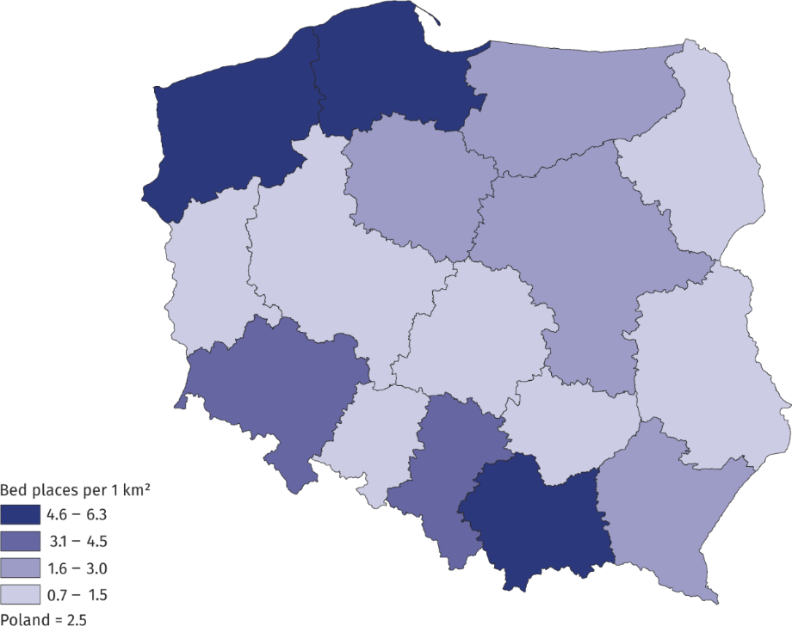

Tourists in tourist accommodation establishments

In 2020, 2/3 of total tourists accommodated stayed in hotels

In 2020, 17.9 million tourists were accommodated in tourist accommodation establishments, which was 17.8 million less (49.9%) than in the previous year.

Over 13 million tourists were accommodated in hotels and similar establishments, including the most (11.1 million) staying in hotels (23.5 million a year before). In other tourist accommodation establishments, 4.8 million tourists were accommodated, with most people in holiday centres – 1.2 million tourists. Rooms for guests and training-recreational centres were also very popular, with 628.6 and 544.4 thousand tourist accommodated in them respectively. In health establishments almost 466 thousand people were accommodated and over 300 thousand tourists in each of the following: boarding houses (376 thousand), hostels (350 thousand) and complexes of tourist cottages (311 thousand).

**Chart 1. Tourists in tourist accommodation establishments by month**

The largest number of tourists were accommodated in accommodation establishments located in Małopolskie Voivodship - 2.4 million, with around 2 million in the following: Ma-zowieckie, Dolnośląskie, Pomorskie and Zachodniopomorskie Voivodships. Compared to 2019, a decrease in the number of tourists accommodated in accommodation establishments was recorded in all voivodships, with the smallest decrease in Zachodniopomorskie Voivodship (by 34.4%) and Warmińsko-Mazurskie Voivodship (by 36.6%), and the largest in Mazowieckie Voivodship (by 61.8%).

**Map 2. Tourist traffic intensity rate by voivodship in 2020**

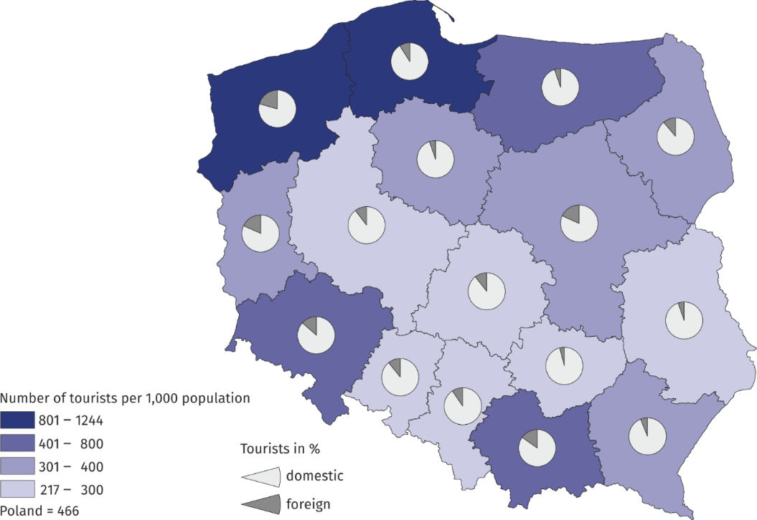

Among the people accommodated in tourist accommodation establishments in 2020, there were 2.3 million foreign tourists and they accounted for just under 13% of the total number of tourists accommodated in accommodation establishments (in 2019 - 21%). The largest number of foreign tourists was accommodated in Zachodniopomorskie (435.9 thousand), Mazowieckie (390.6 thousand) and Małopolskie (367.1 thousand) Voivodships.

The majority of foreign tourists accommodated in accommodation establishments were from Germany (797 thousand), Ukraine (206 thousand) and United Kingdom (186 thousand). Among other countries, the largest number of tourists came from Russia (75 thousand), Czechia (73 thousand), the United States (69 thousand) and France and Italy (64 thousand each). Compared to 2019, the largest decrease in the number of foreign tourists accommodated in accommodation establishments occurred in Małopolskie Voivodship - by more than 78%.

Despite restrictions in the operation of tourist accommodation establishments due to the pandemic, no significant changes in the seasonality of tourist traffic in Poland were observed in 2020. As in previous years, the peak tourist season fell on the summer months (July and August), when 5.9 million people were accommodated in accommodation establishments, i.e. 33.1% of the total number of tourists (in 2019 it was 25.5%).

Overnight stays

In 2020, tourist accommodation establishments recorded 51.4 million overnight stays (by 45.0% less than in 2019), including those of foreign tourists – 6.6 million (by 64.6% less than in the previous year). Most overnight stays were provided to tourists staying in hotels – 23.0 million, i.e. 45% of the total; in holiday centres – 6.7 million (13%) and health establishments – 5.3 million (10%).

In 2020, 6.6 million overnight stays were provided to foreign tourists

**Chart 2. Overnight stays in tourist accommodation establishments by month**

As in previous years, also in 2020, the largest number of overnight stays was recorded in Zachodniopomorskie (9.9 million) Małopolskie (6.8 million) and Pomorskie (6.7 million) Voivodships. Overnight stays in these voivodships constituted nearly half (45%) of the total number of overnight stays in tourist accommodation establishments in Poland.

Overnight stays in the summer season (July and August) 2020 accounted for 38.5% of overnight stays in 2020, but this was approximately 1/4 less than the previous year.

An average duration of stay of tourists in tourist accommodation establishments in 2020 was 2.9 nights. Tourists stayed the longest in Zachodniopomorskie Voivodship (nearly 5 nights) and the shortest in Mazowieckie and Wielkopolskie Voivodships (around 2 nights).

**Table 1. Occupancy of tourist accommodation establishments by type of accommodation in 2020**

|  |  |  |  |  |  |
| --- | --- | --- | --- | --- | --- |
| Type of establishment | Tourists accommodated | | Overnight stays | | Occupancy rate of bed places (in %) |
| total | of which  foreign  tourists | total | of which of foreign  tourists |
| in thousand | | | |
| **TOTAL** | **17 879.0** | **2 263.8** | **51 377.2** | **6 623.0** | **26.8** |
| Hotels and similar  establishments | 13 128.2 | 1 945.5 | 28 295.3 | 4 982.4 | 25.5 |
| hotels | 11 131.4 | 1 744.0 | 22 973.4 | 4 113.1 | 26.0 |
| motels | 106.6 | 10.9 | 182.5 | 17.0 | 16.1 |
| boarding houses | 376.4 | 25.2 | 1 045.5 | 70.7 | 22.3 |
| other hotel  establishments | 1 513.8 | 165.4 | 4 093.8 | 781.5 | 24.6 |
| Other establishments | 4 750.8 | 318.2 | 23 081.9 | 1 640.5 | 28.7 |
| excursion hostels | 42.4 | 1.9 | 143.7 | 5.8 | 20.1 |
| shelters | 123.3 | 2.0 | 205.3 | 2.9 | 23.4 |
| youth hostels | 30.8 | 3.9 | 84.1 | 15.6 | 16.8 |
| school youth hostels | 113.3 | 12.3 | 392.2 | 51.6 | 12.0 |
| holiday centres | 1 241.9 | 45.0 | 6 650.4 | 255.4 | 31.9 |
| holiday youth centres | 63.4 | 0.1 | 434.0 | 2.3 | 32.5 |
| training-recreational centres | 544.4 | 11.9 | 2155.5 | 81.5 | 24.0 |
| creative arts centres | 20.4 | 0.7 | 77.0 | 2.3 | 17.3 |
| complexes of tourist cottages | 310.6 | 6.4 | 1 303.4 | 43.7 | 28.9 |
| camping sites | 216.8 | 38.3 | 692.0 | 119.6 | 24.5 |
| tent camp sites | 104.8 | 8.5 | 283.1 | 23.6 | 17.1 |
| hostels | 350.0 | 86.8 | 987.4 | 328.7 | 30.7 |
| health establishments | 466.0 | 24.9 | 5 306.8 | 186.5 | 54.5 |
| rooms for guests | 628.6 | 34.6 | 2 345.9 | 167.5 | 21.8 |
| agrotourism lodgings | 99.9 | 3.7 | 400.0 | 26.8 | 14.2 |
| other not classified | 394.1 | 37.1 | 1 621.0 | 326.6 | 20.1 |

Occupancy rate of bed places

The highest occupancy rate of bed places was recorded in health establishments – 54.5%

In 2020, the total occupancy rate of bed places in tourist accommodation establishments amounted to 26.8% (in 2019 - 40.6%). The highest rates were recorded in the summer months: in July – 38.3% and in August – 44.5%, but compared to the previous year they were lower by 13.5 pp and 8.7 pp respectively.

Chart 3. Occupancy rate of bed places by month

As in the previous year, the most occupied bed places were recorded in health establishments (54.5%), holiday youth centres (32.5%), holiday centres (31.9%) and hostels (30.7%). Among the voivodships, the highest values of the rate were observed in the following voivodships: Zachodniopomorskie (37.8%), Pomorskie (31.7%) and Kujawsko-Pomorskie (29.9%) while the lowest in Wielkopolskie Voivodship (20.4%).

**Table 2. Occupancy of tourist accommodation establishments by voivodship in 2020**

In 2020, the most overnight stays were provided in Zachodniopomorskie   
and Małopolskie Voivodships, 9.9 million and 6.8 million respectively

|  |  |  |  |  |  |  |  |  |
| --- | --- | --- | --- | --- | --- | --- | --- | --- |
| VOIVODSHIPS | Tourists accommodated | | | | Overnight stays | | | Occupancy rate of bed places (in %) |
| total | | of which  foreign  tourists | | total | | of which of foreign  tourists |
| in thousand | | | | | | |
| **POLSKA** | **17 879.0** | **2 263.8** | | **51 377.2** | | **6 623.0** | | **26.8** |
| Dolnośląskie | 2 067.8 | 278.0 | | 5 515.5 | | 603.8 | | 26.3 |
| Kujawsko-Pomorskie | 716.2 | 37.9 | | 2 371.7 | | 106.5 | | 29.9 |
| Lubelskie | 628.3 | 33.4 | | 1 397.2 | | 65.1 | | 21.1 |
| Lubuskie | 399.8 | 73.2 | | 934.1 | | 157.0 | | 21.1 |
| Łódzkie | 610.3 | 64.2 | | 1 351.9 | | 251.7 | | 21.9 |
| Małopolskie | 2 389.1 | 367.1 | | 6 841.8 | | 928.4 | | 25.7 |
| Mazowieckie | 2116.5 | 390.6 | | 4 057.9 | | 872.4 | | 21.3 |
| Opolskie | 213.3 | 22.6 | | 467.3 | | 55.2 | | 22.2 |
| Podkarpackie | 710.3 | 44.8 | | 2 113.6 | | 97.4 | | 25.4 |
| Podlaskie | 377.4 | 42.8 | | 830.0 | | 62.8 | | 22.1 |
| Pomorskie | 1 972.6 | 176.7 | | 6 701.0 | | 552.4 | | 31.7 |
| Śląskie | 1 350.0 | 130.4 | | 3 342.0 | | 360.0 | | 23.3 |
| Świętokrzyskie | 335.2 | 14.3 | | 1 041.5 | | 47.0 | | 21.9 |
| Warmińsko-Mazurskie | 872.9 | 45.5 | | 2 372.7 | | 120.0 | | 27.5 |
| Wielkopolskie | 1012.1 | 106.4 | | 2 091.8 | | 307.8 | | 20.4 |
| Zachodniopomorskie | 2 106.9 | 435.9 | | 9 947.1 | | 2035.6 | | 37.8 |

When quoting Statistics Poland data, please provide information: “Source of data: Statistics Poland”, and when publishing calculations made on data published by Statistics Poland, please provide information: “Own study based on Statistics Poland data”.

|  |  |
| --- | --- |
| Prepared by:  [**Statistical Office in**](http://warszawa.stat.gov.pl/en/) **Rzeszów**  **Director Marek Cierpiał-Wolan** Office: tel. (+48 17) 853 52 10 | Issued by: **The Spokesperson for the President**  **of Statistics Poland** **Karolina Banaszek**Mobile: (+48) 695 255 011 |

|  |  |  |
| --- | --- | --- |
| **Press Office**  Office: tel. (+48 22) 608 34 91, 608 38 04  **e-mail:** [**obslugaprasowa@stat.gov.pl**](mailto:obslugaprasowa@stat.gov.pl) |  | www.stat.gov.pl/en/ |
|  | @StatPoland |
|  | @GlownyUrzadStatystyczny |

**Related information**

[Occupancy of tourist accommodation establishments in Poland in November and December 2020](https://stat.gov.pl/en/topics/culture-tourism-sport/tourism/occupancy-of-tourist-accommodation-establishments-in-poland-in-november-and-december-2020,5,26.html)

[Occupancy of tourist accommodation establishments in Poland in October and November 2020](https://stat.gov.pl/en/topics/culture-tourism-sport/tourism/occupancy-of-tourist-accommodation-establishments-in-poland-in-october-and-november-2020,5,25.html)

[Occupancy of tourist accommodation establishments in Poland in September and October 2020](https://stat.gov.pl/en/topics/culture-tourism-sport/tourism/occupancy-of-tourist-accommodation-establish-ments-in-poland-in-september-and-october-2020,5,24.html)

[Occupancy of tourist accommodation establishments in Poland in July and August 2020](https://stat.gov.pl/en/topics/culture-tourism-sport/tourism/occupancy-of-tourist-accommodation-establish-ments-in-poland-in-july-and-august-2020,5,22.html)

[Occupancy of tourist accommodation establishments in Poland in June and July 2020](https://stat.gov.pl/en/topics/culture-tourism-sport/tourism/occupancy-of-tourist-accommodation-establishments-in-poland-in-june-and-july-2020,5,21.html)

[Occupancy of tourist accommodation establishments in Poland in May and June 2020](https://stat.gov.pl/en/topics/culture-tourism-sport/tourism/occupancy-of-tourist-accommodation-establishments-in-poland-in-may-and-june-2020,5,20.html)

[Occupancy of tourist accommodation establishments in Poland in April and May 2020](https://stat.gov.pl/en/topics/culture-tourism-sport/tourism/occupancy-of-tourist-accommodation-establishments-in-poland-in-april-and-may-2020,5,19.html)

[Occupancy of tourist accommodation establishments in the first quarter of 2020](https://stat.gov.pl/en/topics/culture-tourism-sport/tourism/occupancy-of-tourist-accommodation-establishments-in-the-first-quarter-of-2020,5,17.html)

[Occupancy of tourist accommodation establishments in Poland in March and April 2020](https://stat.gov.pl/en/topics/culture-tourism-sport/tourism/occupancy-of-tourist-accommodation-establishments-in-poland-in-march-and-april-2020,5,16.html)

[Tourism in Poland in the face of COVID-19 pandemic](https://stat.gov.pl/en/topics/culture-tourism-sport/tourism/tourism-in-poland-in-the-face-of-covid-19-pandemic,6,1.html)

[Tourism in 2019](https://stat.gov.pl/obszary-tematyczne/kultura-turystyka-sport/turystyka/turystyka-w-2019-roku,1,17.html)

**Data available in databases**

[Local Data Bank](https://bdl.stat.gov.pl/BDL/dane/podgrup/temat)

**Terms used in official statistics**

[Tourist](https://stat.gov.pl/en/metainformations/glossary/terms-used-in-official-statistics/539,term.html" \o "Tourist)

[Tourist accommodation establishment](https://stat.gov.pl/en/metainformations/glossary/terms-used-in-official-statistics/245,term.html" \o "Tourist accommodation establishment)

[Bed places in tourist accommodation establishments](https://stat.gov.pl/en/metainformations/glossary/terms-used-in-official-statistics/1231,term.html" \o "Bed places in tourist accommodation establishments.)

[Nights spent (overnight stays) in tourist accommodation establishments.](https://stat.gov.pl/en/metainformations/glossary/terms-used-in-official-statistics/1233,term.html" \o "Nights spent (overnight stays) in tourist accommodation establishments.)

[Duration of stay](https://stat.gov.pl/en/metainformations/glossary/terms-used-in-official-statistics/3487,term.html" \o "Duration of the stay)

[Occupancy rate of bed places or rooms](https://stat.gov.pl/en/metainformations/glossary/terms-used-in-official-statistics/1239,term.html)

1. *Hotels, motels, boarding houses and other hotel establishments.*
2. *Excursion hostels, shelters, youth hostels, school youth hostels, holiday centres, holiday youth centres, training-recreational centres, creative arts centres, complexes of tourist cottages, camping sites, tent camp sites, hostels, health establishments, rooms for guests (private lodgings), agritourism lodgings, other not classified.*