Tourism in the European Union - data for 2020
54.0%
Decrease in the number of tourists accommodated in accommodation establishments located in the 27 countries of the European Union in 2020 compared to 2019
In 2020, in tourist accommodation establishments located in the 27 countries of the European Union 462.7 million people were accommodated, with 1.4 billion overnight stays provided to them. Compared to 2019, both the number of tourists and the number of overnight stays provided to them decreased - by 54.0% and 50.9% respectively.

Under current legislation, the scope of information provided by European Union (EU) member states to Eurostat includes at least all tourist accommodation establishments with 10 or more bed places. Transmission of data on establishments with 9 or fewer bed places is not mandatory and not all countries provide such data. The release does not include the United Kingdom due to the lack of data for that country in the Eurostat database.
In 2020, tourism was one of the economic sectors directly affected by the COVID-19 pandemic. With the exception of the first two months of the year, the volume of tourist traffic and the occupancy of tourist accommodation establishments in 2020 was determined primarily by mobility, border closures and restrictions on the availability of tourist accommodation, rather than seasonal factors (weather, holiday periods, school holidays, etc.) or tourists' willingness to travel, as in previous years. Due to the pandemic and the restrictions associated with it, there were significant declines in the indicators characterising the accommodation establishments and their occupancy.
The number of tourist accommodation establishments in 2020 down by 3.8% compared to 2019
According to estimates, in 2020 there were 594.5 thousand tourist accommodation establishments in the 27 countries of the European Union, of which more than one third of the establishments (226.9 thousand) were located in Italy. In Poland, at the same time 10.3 thousand establishments were ready to accommodate tourists, and they accounted for 1.7% of all accommodation establishments located in the EU.
The structure of EU accommodation establishments was dominated by holiday and other short-stay accommodation (NACE group 55.2), accounting for 69.7% of all establishments.
Hotels and similar accommodation (NACE group 55.1) accounted for 26.4% and camping grounds (NACE group 55.3) for 3.9%.
More than 60% of the total number of bed places were offered by establishments located in four European Union member states
In 2020, tourist accommodation establishments offered 27.9 million bed places to tourists. The largest number of bed places was in Italy and France (over 5 million each), followed by Spain and Germany (over 3 million each). The total number of bed places in these countries accounted for nearly two thirds of all bed places prepared for tourists in the EU in 2020. In Poland, tourist accommodation establishments had 775.3 thousand bed places, which accounted for 2.8% of the total places prepared for tourists in EU countries.
Hotels and similar accommodation had 11.9 million bed places, accounting for 42.6% of all places in the EU27 countries. More than 60% of them were located in Italy, Spain, Germany and France, where between 1.3 million and 2.2 million bed places were prepared for tourists. In Poland, hotels and similar accommodation had 354.6 thousand bed places, which accounted for 1.3% of the total number of bed places in the EU.
Chart 1. Tourists accommodated in accommodation establishments located in the 27 countries of the European Union
millions
More than 40% of the total number of bed places available in the EU were in establishments located in coastal areas. In Poland, this share was 28.0%. The distribution of tourist accommodation by degree of urbanization in the EU was as follows: in densely populated areas (cities) - 22.1%, medium populated areas (non-urban areas) - 34.0% and sparsely populated areas (rural areas) - 43.9%.
Chart 2. Share of foreign tourists in the total number of tourists in 2020
Average of EU member states

In 2020, 462.7 million tourists were accommodated in tourist accommodation establishments located in the 27 EU countries, 54.0% less than in 2019. Almost three quarters of tourists stayed overnight in hotels and similar accommodation. In Poland, 73.4% of tourists were accommodated in this type of establishments. Foreign tourists accounted for 25.0% of those accommodated in accommodation establishments located in the 27 EU countries in 2020. The highest share of foreign visitors in the total number of tourists was recorded in Luxembourg (80.1%), followed by Croatia (79.2%), and the lowest in Romania - 6.9%. In Poland, the share of foreign tourists amounted to 12.7%.
In 2020, 1414.2 million overnight stays were provided to tourists accommodated in accommodation establishments in the EU, 50.9% less than in 2019. Four countries accounted for more than half of the overnight stays provided in the 27 EU countries: Germany (18.4%), France (17.5%), Italy (14.4%) and Spain (10.2%). Compared to 2019, the number of overnight stays provided decreased in all Member States, with Cyprus falling the most (by 78.8%), followed by Greece (by 74.0%) and Malta (by 70.3%).
In 2020, 414.3 million overnight stays were provided to foreign tourists in tourist accommodation establishments in the 27 EU countries
Map 1. Share of overnight stays provided to foreign tourists in the total number of overnight stays in 2020 in the 27 countries of the European Union
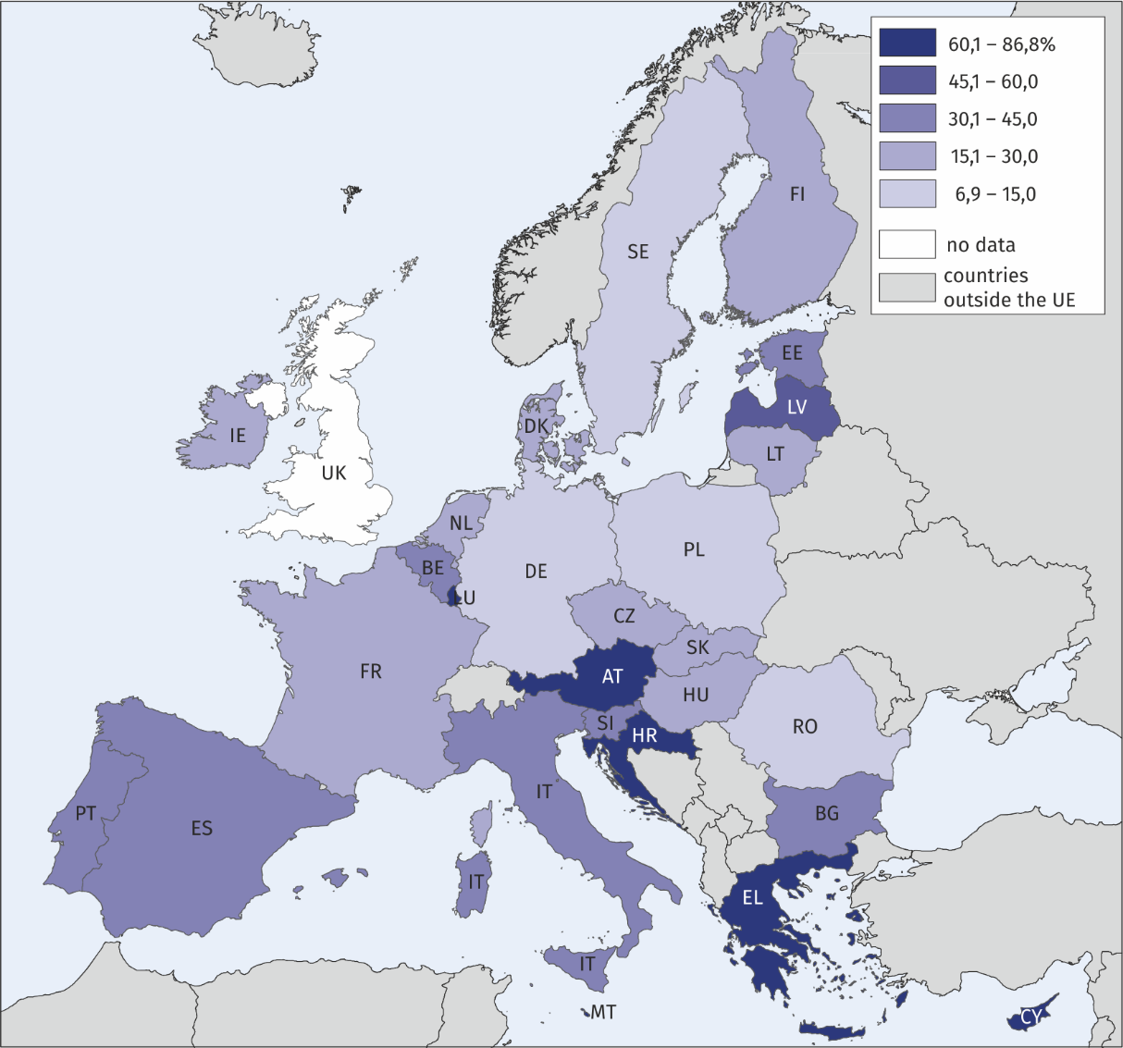

In 2020, the highest number of overnight stays in the EU was recorded in hotels and similar accommodation – 791.2 million (55.9%), and the lowest in camping grounds – 253.6 million (17.9%). On average, tourists stayed 3 nights. They stayed the longest in establishments located in Croatia, followed by Denmark - 5.8 and 4.6 overnight stays respectively. In Poland, the length of a stay at tourist accommodation establishments was slightly shorter than the EU average and amounted to 2.9 nights.
Chart 3. Number of overnight stays at accommodation establishments in the 27 EU countries
millions

The news release was prepared on the basis of data from the Eurostat database (accessed on 11.02.2022).
When quoting Statistics Poland data, please provide information: “Source of data: Statistics Poland”, and when publishing calculations made on data published by Statistics Poland, please provide information: “Own study based on Statistics Poland data”.
Prepared by:  Statistical Office in Rzeszów  Director Marek Cierpiał-Wolan  Office: tel. (+48 17) 853 52 10 | Issued by:  The Spokesperson for the President  of Statistics Poland  Karolina Banaszek  Mobile: (+48) 695 255 011
Press Office  Office: tel. (+48 22) 608 38 04  e-mail: obslugaprasowa@stat.gov.pl | www.stat.gov.pl
 | @GUS_STAT
 | @GlownyUrzadStatystyczny
 | gus_stat
 | glownyurzadstatystycznygus
 | glownyurzadstatystyczny
Related information
Tourism in 2020
Data available in databases
Eurostat database
Local Data Bank
Terms used in official statistics
Tourist
Tourist accommodation establishment
Bed places in tourist accommodation establishments
Nights spent (overnight stays) in tourist accommodation establishments.
Duration of the stay

https://eur-lex.europa.eu/LexUriServ/LexUriServ.do?uri=OJ:L:2011:192:0017:0032:PL:PDF
https://ec.europa.eu/eurostat/web/coastal-island-outermost-regions/methodology
https://ec.europa.eu/eurostat/web/degree-of-urbanisation/background

