Tourism in the European Union – data for 2018

The number of tourists accommodated in tourist accommodation establishments in EU countries has been steadily increasing for over 10 years and in 2018 reached 1 083.3 million.

3.3%



Increase in the number of tourists accommodated

# 

Capacity and occupancy of tourist accommodation establishments[1]

In 2018 there were 684.7 thousand tourist accommodation establishments in European Union countries

In 2018, in EU countries, there were 684.7 thousand operating tourist accommodation establishments, of which 29.6% was constituted by hotels and similar accommodation, 66.5% by holiday and other short-stay accommodation (e.g. youth hostels, holiday centres) and 4.1% by camping grounds, recreational vehicle parks and trailer parks.

Compared to the previous year, the number of tourist accommodation establishments increased by 4.3%, of which the highest grow, i.e. by 6.7%, concerned holiday and other short-stay accommodation.

The largest number of tourist accommodation establishments in 2018 was located in Italy –216.1 thousand (31.6% of all EU establishments), followed by Croatia – 108.2 thousand (15.8%), United Kingdom – 84.6 thousand (12.4%), Spain – 51.4 thousand (7.5%) and Germany – 50.0 thousand (7.3%). In Poland, there were 11.1 thousand tourist accommodation establishments and they constituted 1.6% of the total tourist accommodation establishments in the European Union.

The structure of tourist accommodation establishments in individual European Union countries was diversified. In 2018, in Cyprus and Malta, almost all tourist accommodation establishments belonged to the group of hotels and similar accommodation (99.8% and 91.9% respectively), while in Croatia such establishments accounted only for about 1% of the total tourist accommodation establishments.

In 2018, tourist accommodation establishments located in the European Union area offered 32.2 million bed places. The largest number of bed places was available in France and Italy –over 5 million, which accounted for almost 1/3 of all bed places in the EU. In 2018, in Poland tourist accommodation establishments offered 798.7 thousand bed places. Compared to 2017, the number of bed places in EU countries slightly increased (by 1.6%). The tourist accommodation establishments density rate measured by the number of bed places per 1 km2 of the EU area amounted to 7.4. The highest value of the rate was observed in Malta - 143.6. In Poland, such rate amounted to 2.6.

Tourist accommodation establishments located in five countries offered about 70% of EU bed places

The largest number of bed places was offered by hotels and similar accommodation (14.1 million, i.e. almost 43.7% of all bed places in the EU) and 2/3 of them was offered in five countries: Germany, Spain, France, Italy and United Kingdom, in which the number of bed places ranged from 1.3 to 2.3 million. In Poland, hotels and similar accommodation in 2018 offered 354 thousand bed places. Compared to 2017, the number of bed places in this type of accommodation in the EU slightly increased (by 1.2%). The highest increase was observed in Lithuania (by 6.8%), the Netherlands (5.9%), Belgium (5.4%), Slovakia (5.0%), Denmark (4.6%), Greece (3.5%) and Czechia (3.2%). In Poland, the number of bed places in hotels and similar accommodation increased by 5.3%. A decrease in the number of bed places in hotels and similar accommodation was recorded in Bulgaria (by 5%), Portugal (1.2%), France (1.1%), Lithuania (0.5%) and Estonia (0.1%).

**Table 1. Tourist accommodation establishments and their occupancy in 2018**

|  |  |  |  |  |  |  |
| --- | --- | --- | --- | --- | --- | --- |
| COUNTRY | Establishments | Bed places | Tourists  accommodated | | Nights  spent | |
| total | of which foreign | total | of which to foreign tourists |
| in thousand | | | | | |
| **Total** | 684.7 | 32 237.4 | 1 083 262.4 | 435 209.0 | 3 262 077.8 | 1 605 503.1 |
| Austria | 21.5 | 1 045.6 | 40 093.5 | 27 006.2 | 125 229.2 | 89 293.8 |
| Belgium | 9.2 | 389.8 | 17 559.9 | 9 118.9 | 41 320.3 | 20 564.7 |
| Bulgaria | 3.5 | 335.6 | 7 799.7 | 3 910.2 | 26 845.0 | 17 748.9 |
| Croatia | 108.2 | 1 115.7 | 18 648.9 | 16 635.0 | 89 567.7 | 83 139.9 |
| Cyprus | 0.8 | 87.2 | 3 177.2 | 2 665.7 | 17 164.2 | 16 247.3 |
| Czechia | 9.4 | 741.2 | 21 247.2 | 10 611.4 | 55 513.9 | 26 760.0 |
| Denmark | 1.2 | 426.1 | 7 966.7 | 3 031.5 | 33 280.4 | 12 594.6 |
| Estonia | 1.5 | 61.2 | 3 591.5 | 2 140.5 | 6 630.3 | 4 174.6 |
| Finland | 1.4 | 260.1 | 11 967.1 | 3 224.2 | 22 235.1 | 6 842.6 |
| France | 29.7 | 5 112.0 | 171 475.9 | 52 505.9 | 442 760.1 | 140 721.4 |
| Greece | 38.2 | 1 340.5 | 28 718.1 | 20 913.6 | 123 087.2 | 102 571.2 |
| Spain | 51.4 | 3 599.9 | 130 803.7 | 65 771.1 | 466 940.7 | 301 022.6 |
| Netherlands | 9.1 | 1 397.9 | 43 912.6 | 18 780.3 | 116 081.6 | 47 001.5 |
| Irelanda | 3.1 | 199.8 | 10 555.1 | 3 172.4 | 31 105.7 | 16 190.4 |
| Lithuania | 3.6 | 89.8 | 3 620.4 | 1 744.7 | 8 091.6 | 3 736.9 |
| Luxembourg*b* | 0.4 | 63.6 | 1 139.0 | 1 017.7 | 2 920.2 | 2 574.6 |
| Latvia | 1.1 | 53.9 | 2 808.8 | 1 925.4 | 5 368.7 | 3 743.0 |
| Malta | 0.2 | 45.2 | 1 982.6 | 1 798.0 | 10 114.2 | 9 685.2 |
| Germany | 50.0 | 3 473.6 | 179 242.2 | 38 747.7 | 419 556.3 | 86 961.9 |
| **Poland** | 11.1 | 798.7 | 33 895.9 | 7 082.2 | 88 860.5 | 17 742.7 |
| Portugal | 6.0 | 648.5 | 25 866.4 | 15 035.8 | 74 407.6 | 49 852.3 |
| Romania | 7.7 | 348.6 | 12 816.0 | 2 786.5 | 28 461.2 | 5 306.5 |
| Slovakia | 3.1 | 190.8 | 5 487.2 | 2 214.0 | 15 188.1 | 5 558.9 |
| Sloveniab | 3.7 | 117.1 | 4 892.0 | 3 543.0 | 12 460.1 | 8 478.0 |
| Sweden | 4.2 | 819.1 | 30 736.9 | 7 217.2 | 60 856.9 | 15 685.7 |
| Hungary | 4.6 | 419.2 | 13 116.1 | 5 945.1 | 32 830.1 | 15 340.4 |
| United Kingdom*a* | 84.6 | 3 943.5 | 122 041.1 | 43 469.6 | 476 356.1 | 279 453.1 |
| Italy | 216.1 | 5 113.2 | 128 100.9 | 63 195.2 | 428 844.9 | 216 510.5 |

a Data for 2016 , b Data for 2017.

In 2018, one tourist accommodation establishment in the EU had on average 47 bed places, and establishments with the largest number of bed places were located in Denmark (365), Malta (214) as well as in Sweden and Finland (about 190 bed places in each). Accommodation establishments in nine countries had a lower number of bed places than the average for the EU, including the lowest in Croatia (10 places). In Poland, one tourist accommodation establishment in 2018 had on average 72 bed places.

One hotel or similar accommodation in the EU had on average 70 bed places (in Poland 85). The smallest establishments of this type of accommodation – with less than 60 bed places – were located in Germany, Czechia and United Kingdom. On the other hand, in Malta, Finland, Denmark, Croatia, Portugal, Bulgaria, Sweden and Cyprus, one establishment had on average over 100 bed places (in Malta even 224).

In 2018, in the European Union, 1 083.3 million tourists were accommodated in tourist accommodation establishments, i.e. 3.3% more than a year ago. Most of them stayed in accommodation establishments located in Germany and France (over 170 million in each) as well as in Spain, Italy and United Kingdom (over 120 million in each). Among persons staying in tourist accommodation establishments in 2018, foreign tourists accounted for 40%, while in the case of Malta, Luxembourg and Croatia the percentage of foreign tourists was about 90%. In Poland, foreign tourists constituted 21%. The largest number of tourists per 1000 population visited Croatia and Austria (4.5 thousand), with the EU average of 2.1 thousand. In Poland, this indicator amounted to 882.

Chart 1. The share of foreign tourists in the total number of tourists in 2018

Almost ¾ of all tourists accommodated in tourist accommodation establishments of the European Union stayed in 2018 in hotels and similar accommodation, including almost all tourists visiting Cyprus and Malta. In Poland, 75% of tourists were accommodated in this type of accommodation.

In 2018, the number of nights spent in tourist accommodation establishments in the EU amounted to 3 262.1 million, i.e. by 2.2% more than in the previous year. Almost 2 billion (i.e. over 60% of the total) nights spent was provided to tourists in hotel and similar accommodation. On average, tourists spent 3 nights in tourist accommodation establishments, including the longest stay (5 overnights) in establishments located in Cyprus and Malta. In Poland the duration of stay in tourist accommodation establishments was at a similar level as the EU average.

Almost 3.3 billion nights were spent in tourist accommodation establishments in the EU

Chart 2. Number of tourists per 1 inhabitant in 2018

Trips of the European Union residents aged 15 and over

In 2018, more than 90% of Finland's residents aged 15 and over participated in at least one overnight stay

In 2018, 64% of the EU population aged 15 and over participated in domestic and outbound trips with at least one overnight stay and it was by 1.5 pp. more than a year earlier. The highest percentage of people aged 15 and over participating in trips was recorded in Finland (91%) as well as in the Netherlands and Sweden (about 85%), while the lowest in Romania (27%) and Bulgaria (34%). In Poland, 62% of the population aged 15 and over participated in 2018 in trips with at least one overnight stay, i.e. by 3 pp. more than in 2017.

In 2018, the largest number of trips among EU countries was made by residents of Germany - 288 million, of which 40% was constituted by outbound trips. Over 200 million trips were made also by residents of France and one quarter of them there were outbound trips.

When it comes to the number of trips made by residents, the highest increase was recorded in Estonia (by over 40%) and Italy (by over 20%), compared to 2017. In 2018, significantly fewer trips were made by residents of Denmark (by 29%).

Map 1. The share of overnight stays of foreign tourists in the total number of overnight stays in European Union countries in 2018

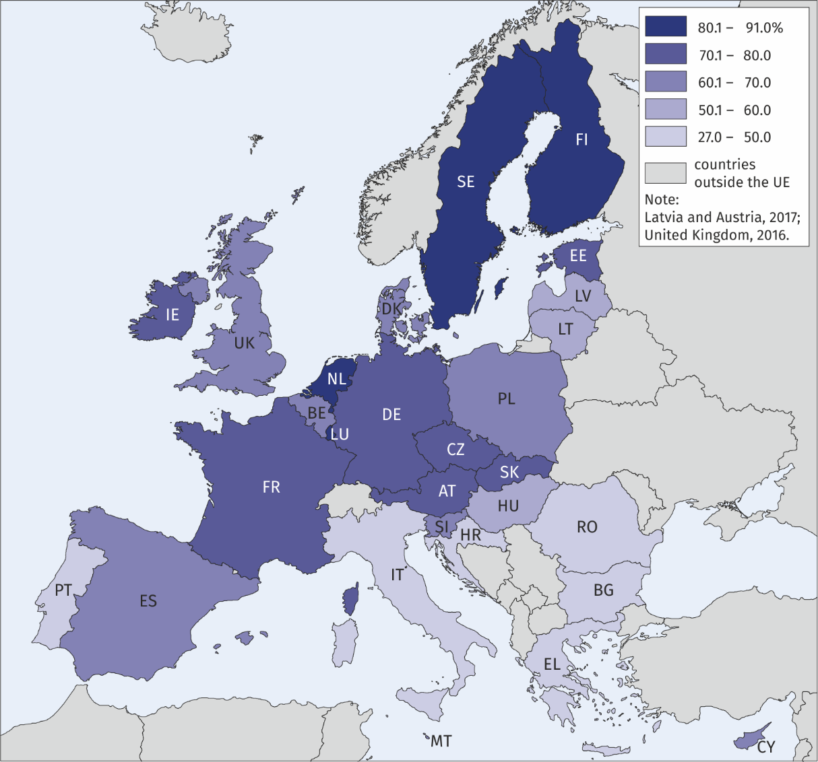

**The study was prepared on the basis of data from the Eurostat database (access date 31.01.2019).**

|  |  |
| --- | --- |
| Prepared by:  [**Statistical Office in**](http://warszawa.stat.gov.pl/en/) **Rzeszów**  **Director Marek Cierpiał-Wolan** Office: tel. (+48 17) 853 52 10 | Issued by: **The Spokeperson for the President**  **of Statistics Poland** **Karolina Banaszek**Mobile: (+48) 695 255 011 |

|  |  |  |
| --- | --- | --- |
| **Press Office**  Office: tel. (+48 22) 608 34 91, 608 38 04  **e-mail:** [**obslugaprasowa@stat.gov.pl**](mailto:obslugaprasowa@stat.gov.pl) |  | www.stat.gov.pl/en/ |
|  | @StatPoland |
|  | @GlownyUrzadStatystyczny |

**Related information**

[Tourism in 2018](https://stat.gov.pl/en/topics/culture-tourism-sport/tourism/tourism-in-2018,1,16.html)

**Data available in databases**

[Eurostat database](https://ec.europa.eu/eurostat/web/tourism/data/database)

[Local Data Bank](https://bdl.stat.gov.pl/BDL/dane/podgrup/temat)

**Terms used in official statistics**

[Tourist](https://stat.gov.pl/en/metainformations/glossary/terms-used-in-official-statistics/539,term.html" \o "Tourist)

[Tourist accommodation establishment](https://stat.gov.pl/en/metainformations/glossary/terms-used-in-official-statistics/245,term.html" \o "Tourist accommodation establishment)

[Bed places in tourist accommodation establishments](https://stat.gov.pl/en/metainformations/glossary/terms-used-in-official-statistics/1231,term.html" \o "Bed places in tourist accommodation establishments.)

[Nights spent (overnight stays) in tourist accommodation establishments.](https://stat.gov.pl/en/metainformations/glossary/terms-used-in-official-statistics/1233,term.html" \o "Nights spent (overnight stays) in tourist accommodation establishments.)

[Duration of the stay](https://stat.gov.pl/en/metainformations/glossary/terms-used-in-official-statistics/3487,term.html" \o "Duration of the stay)

1. The scope of information provided to Eurostat about tourist accommodation establishments varies between countries. It covers at least all tourist accommodation establishments with 10 or more bed places.