Mass events in 2020

In 2020, 1.6 thousand mass events were organised   
(77.5% less than in 2019). All together 4.9 million people participated in them (82.3% less than in 2019).

 77.5%

Decrease in the number of organised mass events in comparison to 2019

3.0 thousand people on average participated in 1 mass event

In 2020, due to the state of epidemic threat and in line with the recommendation of the World Health Organization aimed at minimizing the spread of SARS-CoV-2 virus, restrictions were introduced in organising mass events. For almost 6 months, it was not possible to conduct mass events with the participation of the public. Due to the ban on public participation in them, such events were not treated as mass events within the meaning of the Act on the Safety of Mass Events. Restrictions on the organisation of mass events in individual months of the year had a different scope depending on the current epidemic situation in the country.

Compared to 2019, the number of organised mass art and entertainment events decreased by 89.5%, and mass sports events - by 64.6%. The largest number of mass events took place in Kujawsko–Pomorskie Voivodeship (285). Altogether 0.7 million participants took part in them. The most numerous mass events were organized in Świętokrzyskie Voivodeship. On average, 5.6 thousand people participated in 1 event in this voivodship.

Map 1. Mass events in 2020

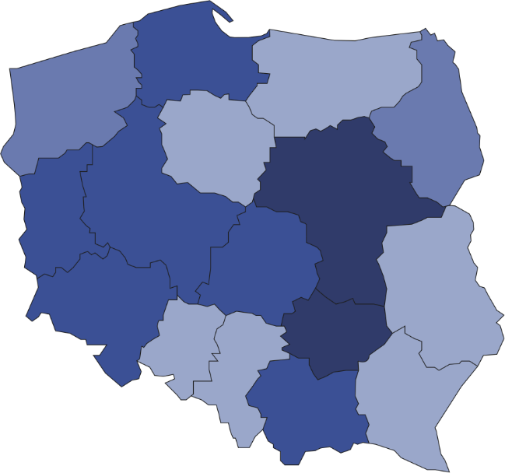

22

101

31

126

59

61

144

40

69

129

285

50

48

135

52

212

Mass events organised in Kujawsko–Pomorskie, Śląskie and Małopolskie Voivodships constituted 41.0% of the total number of mass events

1564



Number of participants   
per 1 mass event  
 4501–5566  
 3501–4500  
 2501–3500  
 1129–2500

Number of mass events

# The majority of events organised in 2020 were sport mass events (75.8% of the total number of mass events). More than 95% participants took part in paid mass events. Compared to 2019, the number of mass events organised in closed facilities decreased more than 3 times, and in open areas - over 8 times.

Chart 1. The structure of mass events by type in 2020

%

In 2020, the most mass events were organised by legal entities (92.9% of the total number of mass events). The remaining mass events were organised by natural persons (3.8%) and organisational units without legal personality (3.3%).

# In the case of quoting data from the Statistics Poland, please provide information: "Statistics Poland data source", and in the case of publishing calculations made on data published by the Statistics Poland, please provide information: "Own study based on Statistics Poland data".

|  |  |
| --- | --- |
| Prepared by:  [**Statistical Office in**](http://warszawa.stat.gov.pl/en/) **Kraków**  **Director Agnieszka Szlubowska** Office: tel. (+48 12) 420 40 50 | Issued by: **The Spokesperson for the President**  **of Statistics Poland** **Karolina Banaszek**Mobile: (+48) 695 255 011 |

|  |  |  |
| --- | --- | --- |
| **Press Office**  Office: tel. (+48 22) 608 34 91, 608 38 04  **e-mail:** [**obslugaprasowa@stat.gov.pl**](mailto:obslugaprasowa@stat.gov.pl) |  | www.stat.gov.pl/en/ |
|  | @StatPoland |
|  | @GlownyUrzadStatystyczny |

**Related information**

[Culture in 2019](https://stat.gov.pl/en/topics/culture-tourism-sport/culture/culture-in-2019,1,12.html)

[Mass events in 2019](https://stat.gov.pl/en/topics/culture-tourism-sport/culture/mass-events-in-2019,6,2.html)

**Terms used in official statistics**

[Mass event](https://stat.gov.pl/en/metainformations/glossary/terms-used-in-official-statistics/3512,term.html)

[Event participant](https://stat.gov.pl/en/metainformations/glossary/terms-used-in-official-statistics/3616,term.html)