Activity of art galleries in 2021
In 2021, exhibition activities were conducted by 313 art galleries (1.9% more in comparison to 2020). Art galleries organised 3.1 thousand exhibitions in Poland, visited by 3.4 million people.
28.5%
Increase of the number of organised exhibitions in Poland in comparison to 2020

In 2021, due to the ongoing state of epidemic in Poland, cultural entities continued to operate under the conditions of temporary constraints. The restrictions on the activity of cultural entities had different scope and forms, but were less restrictive compared to the previous year.
Exhibition activities were conducted by 313 art galleries (307 in 2020). Due to COVID-19, 29.1% entities limited their cultural activities (35.4 percentage points less than in 2020). Around 20% units introduced restriction in the period from January to May, while in the following months more than 90% art galleries carried out cultural activity without any restrictions.
Visitors in Małopolskie, Świętokrzyskie and Mazowieckie Voivodships accounted for 62.8% of all visitors
The largest number of entities operated in Małopolskie Voivodship (58), and the least in Opolskie Voivodship (2). The most visited art galleries were also located in Małopolskie (759.9 thousand visitors) and the least in Lubuskie Voivodship (20.9 thousand). Most people visited art galleries organised by public sector (92.0%). Outdoor exhibitions represented 8.2% of the total number of exhibitions and were visited by 52.9% of all visitors. On average there were 11,006 thousand visitors per one art gallery and one exhibition was visited by on average of 1,128 people.
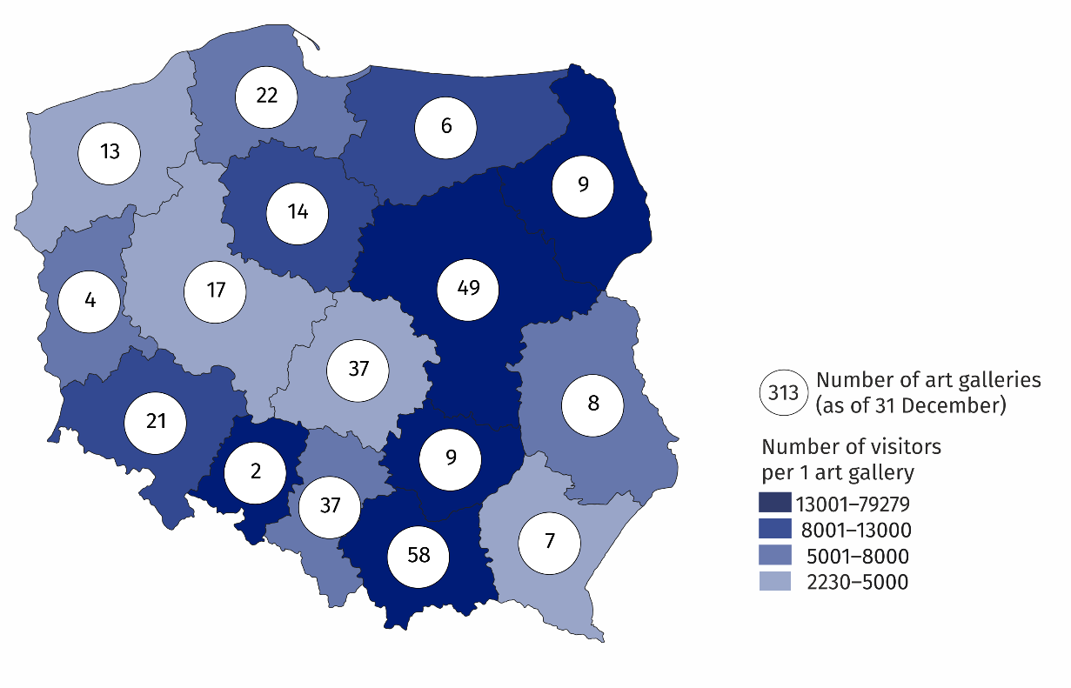
Map 1. Art galleries in 2021

Art galleries organised 3,054 exhibitions (677 more than in 2020), which included: national exhibitions (2,682), international (217) and exhibitions from abroad (155).
Due to the ongoing COVID-19 pandemic in Poland, art galleries have expanded their activities on the Internet - 46.6% of galleries presented 755 on-line exhibitions. Moreover, 29.4% of entities made available 1,718 virtual events and educational activities.
Chart 1. The structure of own collections of art galleries belonging to the state and self-government units in 2021
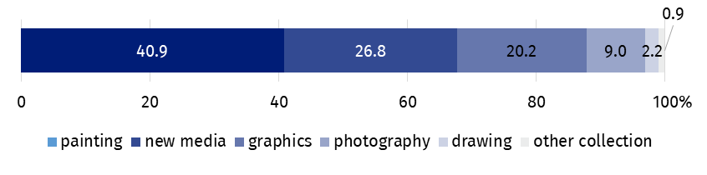
As of 31 December
34.2% of the total number of art galleries were operating in Małopolskie and Mazowieckie Voivodships
A significant part of art galleries belonged to the public sector (63.3%), of which the majority of units were organised by local government units. The remaining art galleries belonged to the private sector, including those owned by natural persons or non-profit organisations. The largest part of the own collection of state and local government galleries was represented by painting collections (40.9%).
In the case of quoting data from the Statistics Poland, please provide information: "Statistics Poland data source", and in the case of publishing calculations made on data published by the Statistics Poland, please provide information: "Own study based on Statistics Poland data".

Prepared by:  Statistical Office in Kraków  Director Agnieszka Szlubowska  Phone: (+48 12) 420 40 50 | Issued by:  The Spokesperson for the President  of Statistics Poland  Karolina Banaszek  Phone: (+48) 695 255 011
Press Office  Phone: (+48 22) 608 38 04  e-mail: obslugaprasowa@stat.gov.pl | stat.gov.pl/en/
 | @StatPoland
 | @GlownyUrzadStatystyczny
 | gus_stat
 | glownyurzadstatystycznygus
 | glownyurzadstatystyczny
Related information
Culture in 2020
Activity of art galleries in 2020
Terms used in official statistics
Art gallery
Unit’s organiser
Exhibition
Open-air exhibition in the galleries
Exposition
Visitor

