Activity of centres of culture, cultural centres   
and establishments, clubs and community centres   
in 2019

As of the end of 2019, 4255 centres of culture, cultural establishments, cultural centres, clubs and community centres were operating. During the year entities organised 243.8 thousand events, in which took part   
37.5 million participants.

 5.0%

Decrease in the number of participants of events in comparison to 2018

Most centres of culture, cultural establishments, cultural centres, clubs and community centres were operating in Małopolskie Voivodship (459), and the least in Lubuskie Voivodship (84). Taking into account the type of entities, most numerous group constituted community centres (32.2% of the total number of entities), whereas the least numerous were clubs (7.9%). Most of the entities (63.2%) were located in the countryside.

79

313

348

203

228

342

333

163

284

214

372

123

452

Map 1. Centres of culture, cultural establishments, cultural centres, clubs and community centres   
 in 2019

4255



Number of population   
per 1 entity  
 12001–17271  
 9001–12000  
 7001– 9000  
 4657– 7000

Number of centres of culture, cultural establishments, cultural centres, clubs and community centres (as of 31st December)

163

329

184

314

229

366

459

121

204

314

226

336

84

342

211

373

10.8% of the total number of entities were operating in Małopolskie Voivodship

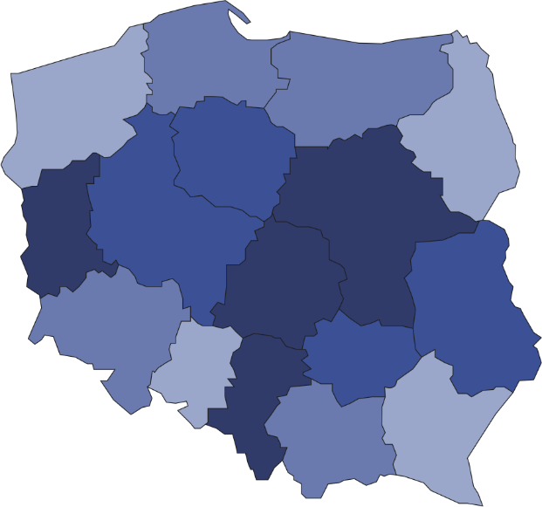

The prevalent part of centres of culture, cultural establishments, cultural centres, clubs and community centres (92.8%) belonged to the public sector. Local government units at the level of gmina played dominant role organising the activity of 90.7% of all public entities.

# In 2019 centres of culture, cultural establishments, cultural centres, clubs and community centres organised a total of 243.8 thousand events, in which 37.5 million people took part. In comparison to 2018 the number of organised events increased by 0.6%, whereas number of participants decreased by 5.0%. Workshops were most frequently organised (21.1% of the total number of events). On average 154 people took part in 1 event. Festivals and artistic reviews were the most numerous in this respect – on average 640 people attended 1 event.

As of the end of 2019, 27.4 thousand various types of groups (clubs/sections) were operating in centres of culture, cultural establishments, cultural centres, clubs and community centres, gathering 575.5 thousand members. In the form of groups (clubs/sections) mostly were organised art and technical classes (6.0 thousand). The largest number of participants gathered senior clubs and The Third Age Universities (122.4 thousand people).

In 2019 entities conducted a total of 6.6 thousand courses. 101.0 thousand people obtained the graduated status of the course. Mostly were conducted dance courses (20.4% of the total number of courses) and language courses (19.0%).

# **Chart 1. The structure of groups (clubs, sections) and their participants in centres of culture, cultural establishments, cultural centres, clubs and community centres in 2019**

# As of 31st December

%

As of the end of 2019, 16.2 thousand artistic groups were operating in centres of culture, cultural establishments, cultural centres, clubs and community centres, among which most numerous were dance groups (4.3 thousand). From the total number of 276.0 thousand artistic groups participants, 64.9% were school children and youth. Every fifth artistic groups participants was person above 60 years old.

**Chart 2. The structure of artistic groups and their participants in centres of culture, cultural establish  
ments, cultural centres, clubs and community centres in 2019**

As of 31st December

%

In the case of quoting data from the Statistics Poland, please provide information: "Statistics Poland data source", and in the case of publishing calculations made on data published by the Statistics Poland, please provide information: "Own study based on Statistics Poland data".

|  |  |
| --- | --- |
| Prepared by:  **Statistical Office in Kraków**  **Director Agnieszka Szlubowska** Office: tel. (+48 12) 420 40 50 | Issued by: **The Spokeperson for the President**  **of Statistics Poland** **Karolina Banaszek**Mobile: (+48) 695 255 011 |

|  |  |  |
| --- | --- | --- |
| **Press Office**  Office: tel. (+48 22) 608 34 91, 608 38 04  **e-mail:** [**obslugaprasowa@stat.gov.pl**](mailto:obslugaprasowa@stat.gov.pl) |  | www.stat.gov.pl/en/ |
|  | @StatPoland |
|  | @GlownyUrzadStatystyczny |

**Related information**

[Culture in 2018](https://stat.gov.pl/en/topics/culture-tourism-sport/culture/culture-in-2018,1,11.html)

**Terms used in official statistics**

[Cultural establishment](https://stat.gov.pl/en/metainformations/glossary/terms-used-in-official-statistics/65,term.html)

[Show (event)](https://stat.gov.pl/en/metainformations/glossary/terms-used-in-official-statistics/3613,term.html)

[Club](https://stat.gov.pl/en/metainformations/glossary/terms-used-in-official-statistics/1456,term.html)

[Group in cultural institution](https://stat.gov.pl/en/metainformations/glossary/terms-used-in-official-statistics/161,term.html)

[Unit’s organizer](https://stat.gov.pl/en/metainformations/glossary/terms-used-in-official-statistics/3665,term.html)

[Cultural centre](https://stat.gov.pl/en/metainformations/glossary/terms-used-in-official-statistics/286,term.html)

[Performance hall](https://stat.gov.pl/en/metainformations/glossary/terms-used-in-official-statistics/3678,term.html)

[Community centre](https://stat.gov.pl/en/metainformations/glossary/terms-used-in-official-statistics/526,term.html)

[Event participant](https://stat.gov.pl/en/metainformations/glossary/terms-used-in-official-statistics/3616,term.html)