Public libraries in 2020

As of the end of 2020, there were 7,782 public libraries, including 5,169 library branches. Public libraries carried 873 branches for children and youths and 867 libraries points. During the year 4,919.3 thousand readers[1] borrowed 77.5 million volumes of collection.

 17.8%

Decrease in the number of readers in comparison to 2019

In connection with the declaration of an epidemic emergency in Poland, the possibility of conducting activities by public libraries was limited, and they had to close their facilities to readers overnight. The introduced temporary restrictions resulted in changes in the functioning of libraries. Some of the units only processed returns and issued reservations at designated locations, while others provided services using, among other, the Internet. Restrictions on the activities of public libraries varied in scope and form from month to month, depending on the current epidemic situation in the country.

The largest number of libraries (including branches) were operating in Mazowieckie Voivodship (12.2% of the total number of entities). Most entities (65.0%) were active in rural areas in Poland.

On average, there were 4,917 inhabitants per 1 public library, the most in Pomorskie Voivodship (7,426), and the least in Podkarpackie Voivodship (3,175).

Map 1. Public libraries (including branches) in 2020

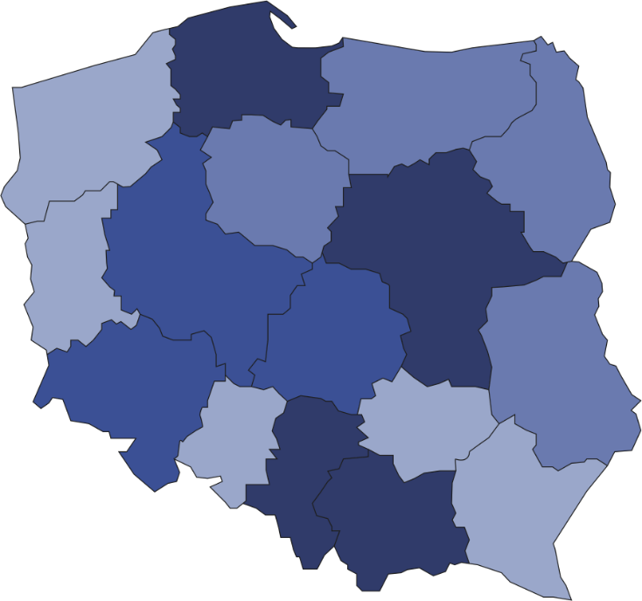

290

316

229

946

571

668

709

263

486

660

397

357

244

582

302

762

On average, there were 632 readers per 1 public library

7782

Number of readers  
per 1 library   
 701–982  
 601–700  
 501–600  
 403–500

Number of libraries

(As of 31st December)



Accessibility of libraries for readers

More than a half (60.4%) of active public libraries offered their services 5 days a week. On Saturday, 15.0% of the total number of active entities were available and on Sunday 0,4%. On average, 1 library was open for 32 hours per week.

Library collection

Within special collection, audio-visual materials were the most numerous (54.7% of the total number of special collection)

As of the end of 2020 public libraries had 125.0 million volumes of collection, of which 98.5% were books. Libraries dispose also almost 6 million materials forming special collection, among which most numerous category constituted audio-visual materials (3.2 million). On average, 1 public library offered readers 10 current magazines titles.

Readers and loans

In 2020 almost 5 million readers were registered. They borrowed 77.5 million volumes of collection and 2.4 million library materials constituting special collection. In comparison to 2019 the number of readers decreased by 17.8% and loans by 24.5%

The most numerous group of readers in public libraries by age category were people aged 25–44 years (1.3 million). In terms of occupation, the majority of readers were persons employed (39.0% of the total number of readers), followed by studying people (34.9%).

Chart 1. The structure of readers in public libraries by age in 2020

The largest group of readers were people aged 25-44 years

On average, there were 16 borrowed volumes of collection per 1 reader. The highest rate was recorded in Wielkopolskie Voivodship (18.4), the lowest – in Pomorskie Voivodship (12.4).

**Chart 2. Loans of collection in volumes per 1 reader in public libraries in 2020**

Facilities for people with special needs

As of the end of 2020 public libraries had 606 specially adapted places in reading rooms for people with special needs. Libraries in cities were better equipped with facilities for users with disabilities (68.3%). For the blind, visually impaired and seniors, the institutions made available 1,042 “talking books”, i.e devices enabling the reproduction of spoken books. Audio-players for readers had 4.7% libraries.

Electronic services in public libraries

Public libraries are expanding their offer with services provided with help of new technologies. 5,789 libraries made available on-line catalogues (2.2% more in comparison to 2019). Access to licensed collection (electronic books and magazines, data bases and other electronic collections) was offered by 2,343 libraries. Public libraries have websites, on which they provide digitized content, e-books or links to materials of other libraries or websites. More than half of the libraries (51.4%) additionally had accounts on social networks and posted entries about current events, photos, and information about their services.

# The possibility of providing services online meant that nearly 56% of public libraries did not limit the availability of their services. Of these, 46.9% allowed readers to access e-books remotely, 26.9% allowed on-line registration of new readers, and 21.2% allowed readers to order scans or digitization of indicated articles/publications free of charge. In addition, libraries also offered the possibility of remote use of audio books or remote access to the press (current and archive issues).

# Other forms of public libraries activity

On average, 32 people participated in 1 event organised by library

In 2020 public libraries organised, among others 112.7 thousand various type of meetings and events attended by 3.6 million participants. Compared to the previous year, the number of events organised by public libraries decreased by 59.0%, and the organised events were much more virtual (15.9 thousand in 2020 compared to 0.8 thousand in 2019).

In the case of quoting data from the Statistics Poland, please provide information: "Statistics Poland data source", and in the case of publishing calculations made on data published by the Statistics Poland, please provide information: "Own study based on Statistics Poland data".

|  |  |
| --- | --- |
| Prepared by:  **Statistical Office in Kraków**  **Director Agnieszka Szlubowska** Office: tel. (+48 12) 420 40 50 | Issued by: **The Spokesperson for the President**  **of Statistics Poland** **Karolina Banaszek**Mobile: (+48) 695 255 011 |

|  |  |  |
| --- | --- | --- |
| **Press Office**  Office: tel. (+48 22) 608 34 91, 608 38 04  **e-mail:** [**obslugaprasowa@stat.gov.pl**](mailto:obslugaprasowa@stat.gov.pl) |  | www.stat.gov.pl/en/ |
|  | @StatPoland |
|  | @GlownyUrzadStatystyczny |

**Related information**

[Culture in 2019](https://stat.gov.pl/en/topics/culture-tourism-sport/culture/culture-in-2019,1,12.html)

[Public libraries in 2019](https://stat.gov.pl/en/topics/culture-tourism-sport/culture/public-libraries-in-2019,3,4.html)

**Terms used in official statistics**

[Library](https://stat.gov.pl/en/metainformation/glossary/terms-used-in-official-statistics/16,term.html)

[Branch](https://stat.gov.pl/en/metainformation/glossary/terms-used-in-official-statistics/3677,term.html)

[Library service point](https://stat.gov.pl/en/metainformation/glossary/terms-used-in-official-statistics/2143,term.html)

[Library collection](https://stat.gov.pl/en/metainformation/glossary/terms-used-in-official-statistics/653,term.html)

[Collection](https://stat.gov.pl/en/metainformation/glossary/terms-used-in-official-statistics/167,term.html)

[Audio-visual materials](https://stat.gov.pl/en/metainformation/glossary/terms-used-in-official-statistics/2140,term.html)

[Readers (users actively borrowing books)](https://stat.gov.pl/en/metainformation/glossary/terms-used-in-official-statistics/49,term.html)

[Library visits](https://stat.gov.pl/en/metainformation/glossary/terms-used-in-official-statistics/3629,term.html)

1. A registered user who borrowed at least one item of collection in the reporting period.