Cinematography in 2021
As of the end of 2021, there were 523 indoor cinemas operating in Poland. 1.4 million screenings were shown in indoor cinemas, watched by 27.5 million viewers. 302 films intended for cinema and television screenings were produced in Poland in 2021.
40.9%
Increase of the audience in indoor cinemas in comparison to 2020
In 2021, due to the ongoing state of epidemic in Poland, cinemas and film production entities continued to operate under the conditions of temporary constraints but the restrictions were less restrictive compared to the previous year.

Cinemas activity
There were 1.5 thousand screens with 294.3 thousand seats for the audience in indoor cinemas. Compared to 2020, there were 23.3% more film screenings and 40.9% more audience. Mazowieckie Voivodship prevalied in terms of the number of screenings and audience in indoor cinemas. The largest number of screenings per 1 indoor cinema was recorded in Kujawsko-Pomorskie and Śląskie Voivodeships (3.7 thousand screenings each). The largest number of audience per 1 cinema was recorded in Kujawsko-Pomorskie Voivodeship (71.0 thousand).

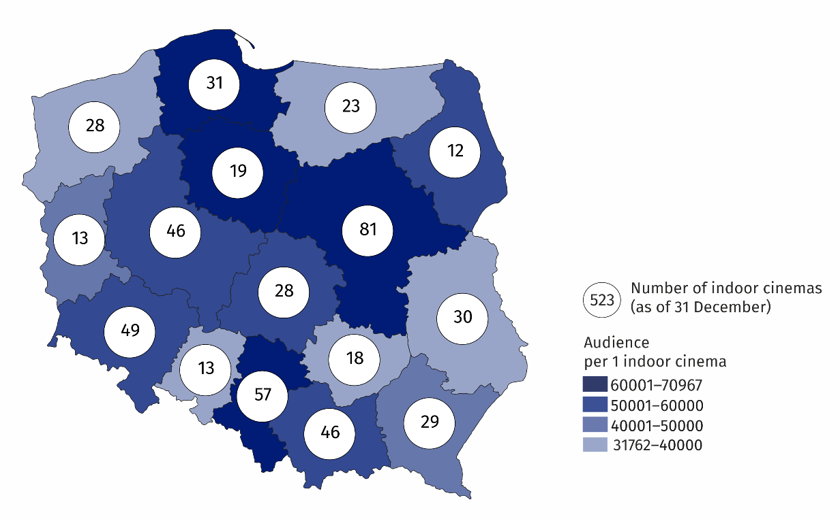
Map 1. Indoor cinemas in 2021
19.2% of the total number of audience in indoor cinemas watched films in Mazowieckie Voivodship
In the year under review there were 358 indoor cinemas with one or two screens, 104 miniplexes (with 3 to 7 screens) and 61 multiplexes (with 8 or more screens). The multiplexes displayed 48.2% of the total number of screenings, watched by 47.5% of the total audience. The miniplexes displayed 37.5% of the total screenings, watched by 37.3% of the total audience. One multiplex had an average of 2.0 thousand seats for the audience and displayed 10.7 thousand screenings.
68.4% of total number of cinemas had 1–2 screens

Chart 1. The structure of indoor cinemas by number of screens in 2021

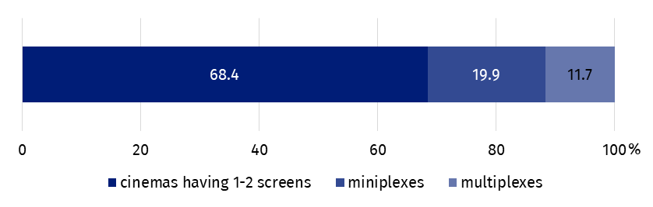
As of 31 December
82.5% of indoor cinemas limited their cultural activities due to the epidemic situation related to COVID-19. Most cinemas reduced their activities in January (51.4%), while the least in October (6.3%). Due to the epidemic situation related to COVID-19, the cinemas made available online 11.3 thousand film screenings.

Film production
In 2021, 85 full-length films and 217 medium- and short-length films (intended for cinemas and television) were produced in Poland (72 and 205 respectively in 2020). Over the year, the number of full-length feature films intended for cinemas increased by 17.1% (from 35 to 41), while the production of full-length documentary films decreased (from 26 to 22).

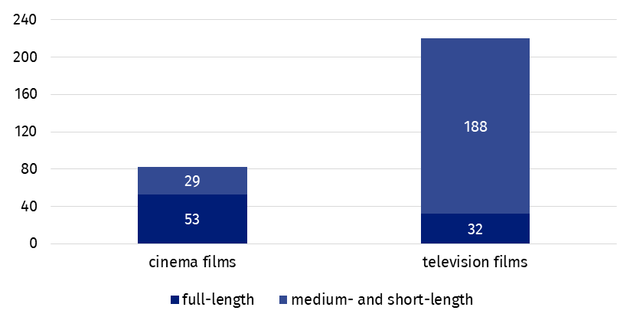
Chart 2. Films produced in 2020
Documentary films accounted for 55.0 % of the total number of films
The most frequently produced type of full-length films were feature films (70.6% of the total number of cinema and television feature films), while documentary films dominated among medium- and short-length films (66.4% of the total number of cinema and television medium- and short-length films).

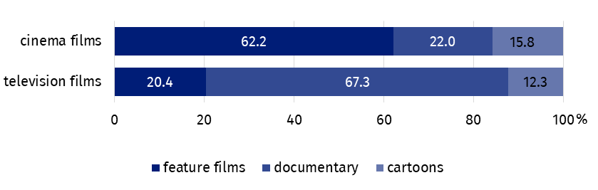
Chart 3. The structure of films by type in 2021
Due to the epidemic situation related to COVID-19, 11.5% of film production units (that showed film production in 2021) reduced their activities – most in the first quarter of the year. Of the productions scheduled for production for 2021, 10 full-length films and 37 medium- and short-length films have not been made.
In the case of quoting data from the Statistics Poland, please provide information: "Statistics Poland data source", and in the case of publishing calculations made on data published by the Statistics Poland, please provide information: "Own study based on Statistics Poland data".

Prepared by:  Statistical Office in Kraków  Director Agnieszka Szlubowska  Phone: (+48 12) 420 40 50 | Issued by:  The Spokesperson for the President  of Statistics Poland  Karolina Banaszek  Phone: (+48) 695 255 011
Press Office  Phone: (+48 22) 608 38 04  e-mail: obslugaprasowa@stat.gov.pl | stat.gov.pl/en/
 | @StatPoland
 | @GlownyUrzadStatystyczny
 | gus_stat
 | glownyurzadstatystycznygus
 | glownyurzadstatystyczny
Related information
Culture in 2020
Cinematography in 2020
Terms used in official statistics
Indoor cinema
Audience
Film

