Cinematography in 2020

At the end of 2020, there were 511 indoor cinemas operating in Poland (2.3% less than in 2019). In 2020,   
19.5 million viewers watched films during 1.1 million screenings in indoor cinemas.

 68.4%

Decrease in the number of spectators in indoor cinemas compared to 2019

During this year in Poland, 277 films (intended for cinema and television screenings) were produced.

In 2020, due to the epidemic situation related to COVID-19, the operation of cinemas and film production entities was temporarily limited. While closed, some entities did not undertake any activities related to the preparation and sharing of the cultural offer, and some tried to reach the public by making their offer available on the Internet. Some of the planned full-, medium- and short-lenght films were not produced.

Cinemas activity

In 2020, there were 1.5 thousand screens with 290.7 thousand seats in the audience. Compared to 2019, the indoor cinemas had 50.1% fewer film screenings and 68.4% fewer members of audience. Mazowieckie Voivodship dominated in terms of the number of screenings and spectators. The largest number of screenings per 1 indoor cinema was recorded in Śląskie Voivodeship (3.2 thousand screenings), and the largest number of spectators per 1 cinema was recorded in Kujawsko-Pomorskie Voivodeship (53.2 thousand).

Map 1. Indoor cinemas in 2020

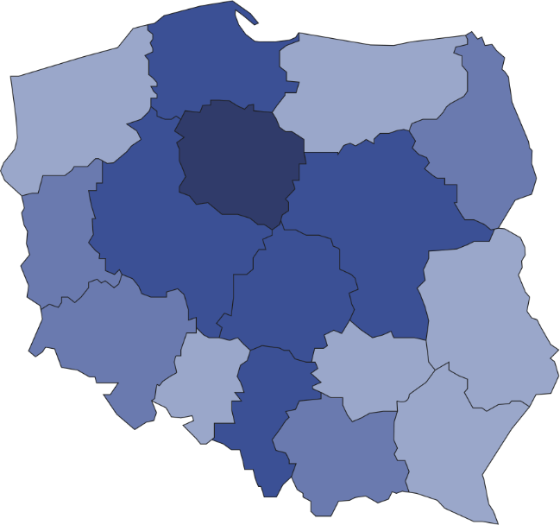

21

28

12

86

31

29

43

18

27

46

18

26

13

48

12

19.1% of the total number of spectators in indoor cinemas watched films in Mazowieckie Voivodship

511



Number of spectators per 1 indoor cinema

50001–53231  
40001–50000  
30001–40000  
23944–30000

Number of indoor cinemas (as of 31 December)

53

68.7% of total number of cinemas had 1–2 screens

# In 2020 there were 351 indoor cinemas with one or two screens, 98 miniplexes (with 3 to 7 screens) and 62 multiplexes (with 8 or more screens). Multiplexes showed 52.1% of the total screenings, watched by 46.1% of the total audience members. Miniplexes showed 34.7% of the total screenings, accounting for 36.4% spectators. One multiplex had an average of 2.1 thousand seats in the audience and displayed 9.2 thousand screenings.

Chart 1. The structure of indoor cinemas by number of screens in 2020

As of 31 December

%

In 2020, 86.1% of indoor cinemas limited their cultural activities due to the epidemic situation related to COVID-19. Most cinemas reduced their activities in April (85.4%), while the least in September (23.7%). Due to the epidemic situation related to COVID-19, the cinemas made 22.6 thousand film screenings available online.

Film production

In 2020, 72 full-length films and 205 medium- and short-length films (intended for cinemas and television) were produced in Poland (76 and 207 respectively in 2019). Compared to 2019, the number of full-length feature films decreased by nearly 1/4(from 41 to 35), while the production of full-length documentary films increased (from 16 to 26).

Chart 2. Films produced in 2020

Documentary films accounted for 60.3% of the total number of films

The most frequently produced type of full-length films were feature films (59.7% of the total number of cinema and television feature films), while documentary films dominated among medium- and short-length films (68.8% of the total number of cinema and television medium- and short-length films).

**Chart 3. The structure of films by type in 2020**

%

In 2020, due to the epidemic situation related to COVID-19, 60.0% of film production units (that showed any film production in 2020) reduced their activities – most in April (every second unit) and least in the months from July to September (one in five units). Of the productions scheduled for production for 2020, 18 full-length films and 182 medium- and short-length films have not been made.

In the case of quoting data from the Statistics Poland, please provide information: "Statistics Poland data source", and in the case of publishing calculations made on data published by the Statistics Poland, please provide information: "Own study based on Statistics Poland data".

|  |  |
| --- | --- |
| Prepared by:  [**Statistical Office in**](http://warszawa.stat.gov.pl/en/) **Kraków**  **Director Agnieszka Szlubowska** Office: tel. (+48 12) 420 40 50 | Issued by: **The Spokesperson for the President**  **of Statistics Poland** **Karolina Banaszek**Mobile: (+48) 695 255 011 |

|  |  |  |
| --- | --- | --- |
| **Press Office**  Office: tel. (+48 22) 608 34 91, 608 38 04  **e-mail:** [**obslugaprasowa@stat.gov.pl**](mailto:obslugaprasowa@stat.gov.pl) |  | www.stat.gov.pl/en/ |
|  | @StatPoland |
|  | @GlownyUrzadStatystyczny |

**Related information**

[Culture in 2019](https://stat.gov.pl/en/topics/culture-tourism-sport/culture/culture-in-2019,1,12.html)

[Cinematography in 2019](https://stat.gov.pl/en/topics/culture-tourism-sport/culture/cinematography-in-2019,15,1.html)

**Terms used in official statistics**

[Indoor cinema](https://stat.gov.pl/en/metainformations/glossary/terms-used-in-official-statistics/2115,term.html)

[Spectators](https://stat.gov.pl/en/metainformations/glossary/terms-used-in-official-statistics/566,term.html)

[Film](https://stat.gov.pl/en/metainformations/glossary/terms-used-in-official-statistics/96,term.html)