Financial results of cultural institutions during the period January–December 2021
In 2021, the financial results of cultural institutions increased compared to those obtained in the corresponding period of the previous year. Total revenues increased by 8.6% during this period. Investment outlays increased by 5.0%.
8.6%
Increase of total revenues y/y
Total revenues of cultural institutions in 2021 were higher by 8.6% than revenues generated in the previous year and amounted to PLN 10,494.8 million. In the structure of the revenues 90.2% constituted net revenues from sales of products, goods and materials, 9.7% - other operating revenues and 0.1% - financial revenues. Over 26% of the total revenues were generated by cultural institutions from Mazowieckie Voivodship.
On average, the total revenues per one cultural institution amounted to PLN 2.2 million. The highest total revenues per one unit were achieved by cultural institutions in Mazowieckie Voivodeship - PLN 4.4 million, while the lowest in Lubelskie Voivodeship - PLN 1.1 million.
Total costs in the analysed period were higher by 9.7% than in the previous year and amounted to PLN 10,385.8 million. In the structure of these costs, 98.7% were operating costs, 1.2% - other operating costs, and 0.1% - financial costs. Over 26% of the total costs were incurred by cultural institutions from Mazowieckie Voivodship.
Total revenues of gminas cultural institutions in 2021 amounted to PLN 5,899.5 million
National cultural institutions in 2021 achieved total revenues of PLN 2,104.3 million, while the total revenues of local government cultural institutions amounted to PLN 8,390.5 million.

Table 1. Financial results of cultural institutions
Specification | Jan.–Dec. 2020 | Jan.–Dec. 2021 | Jan.–Dec. 2020=100
 | in million PLN
Total revenues | 9,661.0 | 10,494.8 | 108.6
Total costs | 9,465.8 | 10,385.8 | 109.7
Gross financial result | 195.2 | 109.0 | 55.8
Net financial result | 194.1 | 107.6 | 55.5
Net profit | 262.3 | 210.3 | 80.2
Net loss | 68.2 | 102.7 | 150.7
Investment outlays | 1,463.0 | 1,536.1 | 105.0
Outlays on intangible fixed assets | 33.4 | 53.7 | 160.8
Gross financial result amounted to PLN 109.0 million (profit PLN 211.4 million, loss PLN 102.4 million).
Net financial result of cultural institution in 2021 amounted to PLN 107.6 million
Net financial result amounted to PLN 107.6 million (PLN 194.1 million in the previous year), with a decrease of net profit (by 19.8%) and increase of net loss (by 50.7%).
In 2021 investment outlays of cultural institutions were 5.0% higher than in the previous year and amounted to PLN 1,536.1 million. The greatest share in investment outlays had cultural institutions from Mazowieckie Voivodship (27.4%).
Investment outlays incurred by local government cultural institutions amounted to PLN 1,070.4 million, i.e. 69.7% of the total amount of investment outlays.

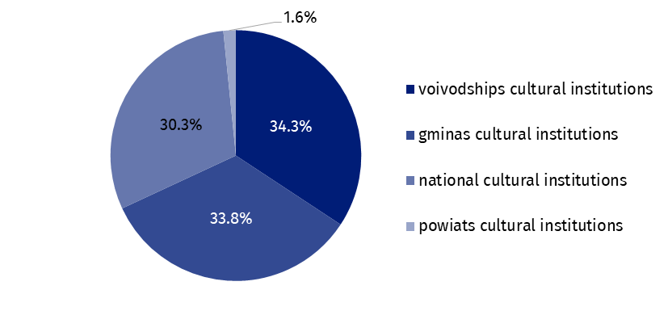
Chart 1. The structure of investment outlays of cultural institutions by legal forms in 2021
Outlays on intangible fixed assets increased in comparison to 2020 by 60.8% and amounted to PLN 53.7 million. The greatest share (34.6%) in outlays on intangible fixed assets had cultural institutions from Mazowieckie Voivodship.

Table 2. Total revenues and total costs of cultural institutions by selected divisions and classes of PKD classification in 2021
Specification | Number of  cultural  institutions | Total  revenues | Total  costs
 |  | in million PLN
Grand total | 4,694 | 10,494.8 | 10,385.8
local government units property | 4,624 | 8,390.5 | 8,332.8
government property | 70 | 2,104.3 | 2,053.0
of which:
creative, arts and entertainment activities | 2,312 | 6,194.6 | 6,156.4
of which:
performing arts activities | 153 | 1,903.8 | 1,904.5
operation of arts facilities | 2,149 | 4,140.4 | 4,100.3
libraries, archives, museums and other cultural activities | 2,376 | 4,133.5 | 4,066.0
of which
library and archives activities | 1,982 | 1,848.3 | 1,843.8
museums activities | 385 | 2,177.2 | 2,118.8
Out of 4,694 cultural institutions that responded to the COVID-19 pandemic impact assessment question, more than half (53.3%) estimated in the fourth quarter that they had experienced negative effects (in the third quarter of 2021, 50.2% out of 4,692 cultural institutions). Negative effects were more often described by cultural institutions as minor rather than major (1,935 and 569 respectively).
The highest percentage of responses indicating negative effects was among voivodship cultural institutions (64.6% of the total number of voivodship cultural institutions), while the lowest was among gminas cultural institutions (52.4% of the total number of gminas cultural institutions).
In the fourth quarter of 2021, 86.0% (2,154) of cultural institutions which experienced negative effects of the pandemic, in their assessment estimated the scale of the decline in business activity revenues to be up to 50.0%. 29 cultural institutions (6 less than in the previous quarter) indicated a decline in revenues from business activity above 90.0% - these were mainly gminas cultural institutions (26).
In the case of quoting data from the Statistics Poland, please provide information: "Statistics Poland data source", and in the case of publishing calculations made on data published by the Statistics Poland, please provide information: "Own study based on Statistics Poland data".

Issued by:
The Spokesperson for the President
of Statistics Poland
Karolina Banaszek

Phone: (+48) 695 255 011
Related information
Financial results of cultural institutions in the period January - September 2021
Methodological report. Non-financial enterprises surveys 2019
Terms used in official statistics
Total revenues
Total costs
Gross financial result
Net financial result
Investment outlays
Outlays on intangible fixed assets
Cultural institution
Press Office
Phone: (+48 22) 608 38 04
e-mail: obslugaprasowa@stat.gov.pl
www.stat.gov.pl/en/
@StatPoland
@GlownyUrzadStatystyczny
gus_stat
glownyurzadstatystycznygus
glownyurzadstatystyczny
Prepared by:
Statistical Office in Kraków
Director Agnieszka Szlubowska
Phone: (+48 12) 420 40 50

