Economic aspects of environmental protection 2020

The amount of outlays on fixed assets for environmental protection in 2020 amounted to approx. PLN 11.4 billion (compared to PLN 12.4 billion in 2019), and outlays on fixed assets for water management reached the level of approx. PLN 2.7 billion (PLN 3.2 billion in 2019). In 2020, outlays on environmental protection and water management accounted for 0.49% and 0.11% of GDP, respectively (0.55% and 0.14% in 2019, respectively).
9.8%
Outlays on environmental protection and water management in relation to 2019.

As in previous years, enterprises are the main investor in outlays on fixed assets for environmental protection, followed by gminas, and then budgetary units. The group of investors with the highest share of outlays in the field of water management were enterprises, then budgetary units and gminas.
In 2020, outlays on fixed assets for environmental protection amounted to approx. PLN 11.4 billion, and on water management to approx. PLN 2.7 billion
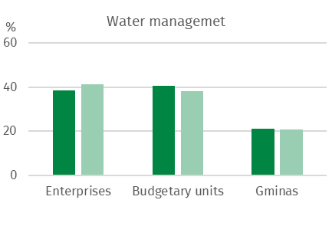
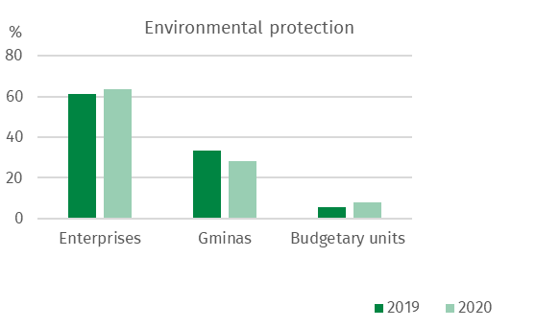
Chart 1. Structure of outlays on fixed assets for environmental protection and water management by groups of investors

The highest outlays on fixed assets for environmental protection were incurred in the following voivodships: Mazowieckie (14.2% of total outlays on fixed assets for environmental protection), Śląskie (13.4%) and Wielkopolskie (9.0%), while the lowest in Warmińsko-Mazurskie (2.2%), Lubuskie (2.4%) as well as Opolskie and Podlaskie (2.6% each).
In water management, the highest outlays were incurred in the following voivodships: Śląskie (17.3% of total expenditure), Dolnośląskie (16.4%) and Mazowieckie (14.8%), while the lowest in Lubuskie (1.1%) and Warmińsko-Mazurskie (1.4%).

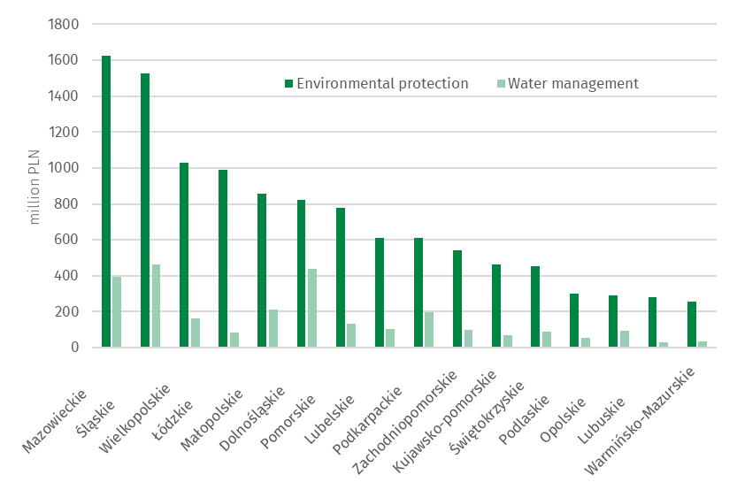
Chart 2. Outlays on fixed assets for environmental protection and water management by voivodship in 2020

Outlays on fixed assets for environmental protection

Outlays on fixed assets for environmental protection are classified according to 9 areas of environmental protection: 1. air and climate protection; 2. wastewater management and protection of water; 3. waste management; 4. protection and restoration of the utility value of soils and protection of groundwater and surface waters; 5. noise and vibration reduction; 6. protection of biodiversity and landscape; 7. protection against ionising radiation; 8. research and development activities and 9. other environmental protection activities (mainly administration and environmental management, education, training).
The structure of outlays on fixed assets for environmental protection in Poland in 2020 was dominated by outlays on wastewater management and protection of water, as well as on air and climate protection, with a share of 48.3% and 32.7%, respectively. The remaining 19.0% of outlays is outlays on waste management (6.5%), protection of soil and ground and surface waters (1.8%), protection of biodiversity and landscape (1.5%), noise and vibration reduction (1.2%), and other environmental protection activities (7.9%), respectively.
In 2020, outlays on fixed assets for wastewater management and protection of water amounted to PLN 5.5 billion
In 2020, outlays on fixed assets for wastewater management and protection of water amounted to PLN 5.5 billion. The highest outlays for this purpose were incurred in the following voivodships: Mazowieckie (15.2%), Śląskie (11.0%) and Wielkopolskie (9.2%), the lowest in Opolskie (1.6%), Warmińsko-Mazurskie (2.1%) and Podlaskie (2.8% each).

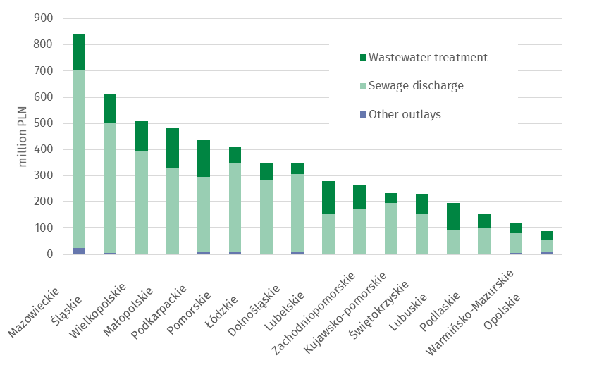
Chart 3. Outlays on fixed assets for wastewater management and protection of water by amount and voivodship in 2020

In 2020, outlays on fixed assets for air and climate protection amounted to PLN 3.7 billion
Outlays on fixed assets for the protection of air and climate amounted to PLN 3.7 billion. The highest outlays were incurred in the following voivodships: Śląskie (14.9%), Mazowieckie (13.9%) and Wielkopolskie (12.0%), the lowest in Lubuskie (0.9%), Podkarpackie and Podlaskie (1.7% each).
The largest part of outlays on air and climate protection were outlays on pollution reduction equipment (57.3% of the total expenditure) and pollution prevention equipment (41.0%), including modern fuel combustion technologies along with the modernisation of boiler and thermal energy plants (23.7%) and unconventional energy sources (12.2%). The highest outlays on pollution reduction equipment were in the following voivodships: Śląskie (PLN 380 million) and Wielkopolskie (PLN 320 million), for pollution prevention in the following voivodships: Mazowieckie (PLN 306 million) and Pomorskie (PLN 226 million). In addition, outlays on modern fuel combustion technologies , along with the modernisation of boiler and thermal energy plants in the following voivodships: Mazowieckie (PLN 279 million) and Pomorskie (PLN 161 million), while outlays on unconventional energy sources were the highest in the following voivodships: Wielkopolskie (PLN 75 million) and Lubelskie (PLN 60 million).

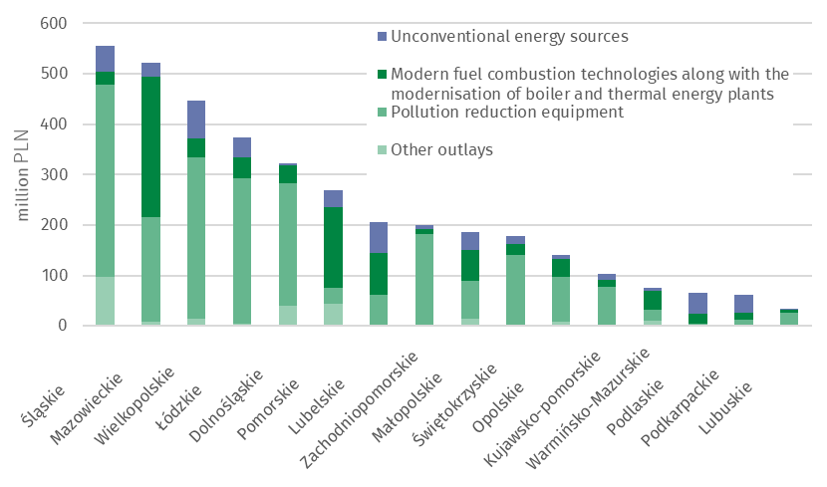
Chart 4. Outlays on fixed assets for air and climate protection by voivodship in 2020

Outlays on waste management amounted to PLN 0.7 billion, PLN 0.2 billion on soil, ground and surface water protection, PLN 0.2 billion on biodiversity and landscape protection, PLN 0.1 billion on noise and vibration reduction, and on other activities PLN 0.9 billion was spent in total.

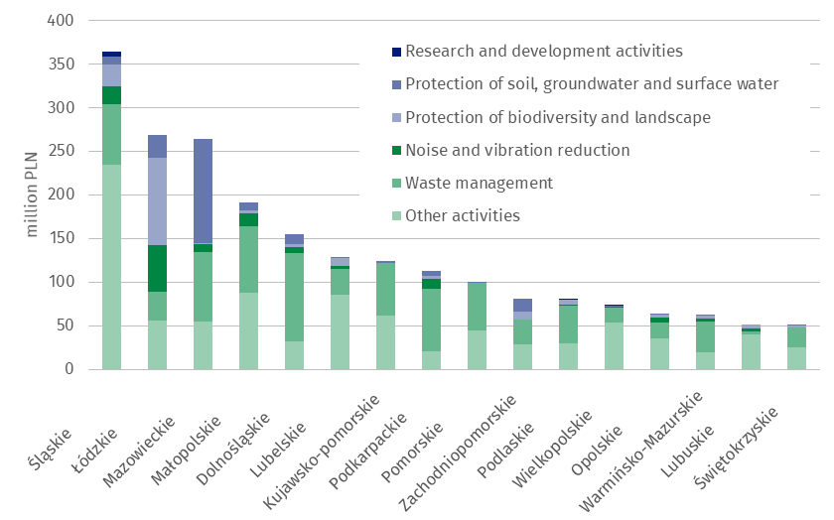
Chart 5. Outlays on fixed assets for environmental protection in selected domains by voivodship in 2020

Outlays on fixed assets for water management
Investments related to water management include water intakes and systems (including the main and distribution water network and construction of water quality control laboratories, including automatic water quality measurement stations), construction and modernization of water treatment plants, construction of water reservoirs (except fire and daily equalisation reservoirs), water, sailing and energy falls, as well as locks and weirs, regulation and management of rivers and mountain streams, construction of flood embankments and construction of pump stations behind embankments and in depression areas.
In 2020, the amount of outlays on water management amounted to approximately PLN 2.7 billion. The main stream of outlays were directed to the construction of drinking water infrastructure. Investments in water intakes and systems accounted for 47.7% of all outlays in water management.

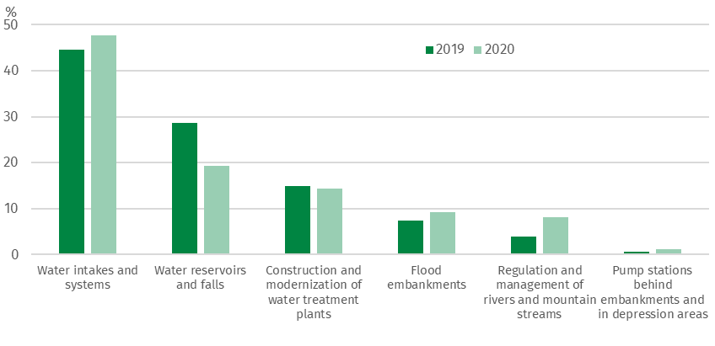
Chart 6. Structure of outlays on fixed assets for water management

The largest outlays on water intakes and systems were incurred in Mazowieckie (PLN 220 million) and Śląskie (PLN 183 million) Voivodships. On the other hand, on water reservoirs and falls in Śląskie (PLN 262 million) and Dolnośląskie (PLN 156 million) Voivodships . For the construction and modernization of water treatment plants, the greatest amount of funds was allocated in the Mazowieckie Voivodship (PLN 140 million).

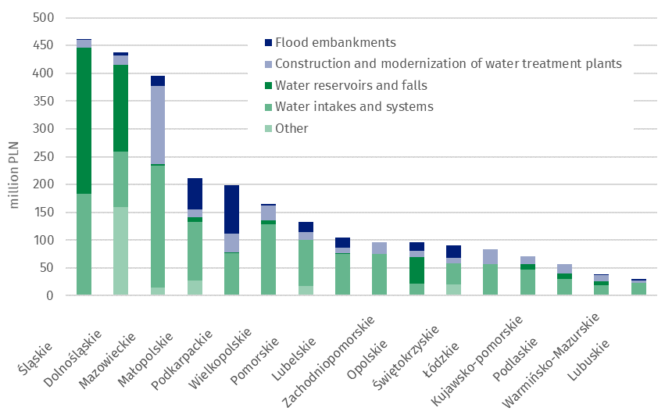
Chart 7. Outlays on fixed assets for water management by investment directions and voivodship in 2020

Tangible effects of investments in environmental protection and water management
In 2020, as a result of the implementation of environmental protection investments, 39 wastewater treatment plants with a total capacity of 55 thousand m³/day (including 39 municipal wastewater treatment plants with a total capacity of 43 thousand m³/day) were completed. 3.4 thous. km of sewage network discharging of wastewater and approx. 0.6 thous. km of sewage network discharging of precipitation water were completed.
In the field of air protection, devices for reducing gaseous pollutants with a capacity of approx. 99 thousand tons/year and equipment for neutralisation of particulates pollutants with a capacity of approx. 6 thousand tons/year were completed.
In 2020, waste neutralisation equipment and installations with a total capacity of approx. 859 thousand tons/year (of which approx. 62% was waste treatment by landfilling) were completed.
In 2020, in terms of the tangible effects of water management investments, water supply devices (i.e. water intakes and water treatment) with a total capacity of approx. 149 thousand m³/day were completed. The capacity of the water treatment plants amounted to approx. 95 thousand m³/day, and the capacity of newly completed water intakes approx. 54 thousand m³/day. Two water reservoirs were built with a total capacity of approx. 186 million m³. In addition, 3 thousand kms of the water supply network were built, approx. 52 km of rivers and mountain streams were regulated and management, and approx. 69 km of flood embankments were built or modernised.

When citing data from Statistics Poland (GUS), please include the information: "Source of GUS data", and when publishing calculations made on the data published by GUS, please include the following information: "Own study based on GUS data”.

Content-related works:  Spatial and Environmental Surveys Department  Deputy Director  Wiesława Domańska  Tel: 22 608 31 16 | Dissemination:  Spokesperson of the President of Statistics Poland (GUS)  Karolina Banaszek  Tel: 695 255 011

Media Cooperation Department  Tel: 22 608 34 91, 22 608 38 04  e-mail: obslugaprasowa@stat.gov.pl |  | www.stat.gov.pl
 |  | @GUS_STAT
 |  | @GlownyUrzadStatystyczny

Related works
Infographic - Economic aspects of environmental protection
Economic aspects of environmental protection 2020

Subject available in databases
Local Data Bank Environmental protection

More important terms available in the dictionary
Tangible effects of environmental protection and water management investments

In accordance with the Polish Statistical Classification of Activities and Facilities Related to Environmental Protection, introduced by the Regulation of the Council of Ministers of March 2, 1999 (Journal of Laws 1999, No. 25, pos. 218).

