General government deficit and debt in 2021
1 1,8%
General government deficit in 2021 in relation to GDP

According to the EDP notification, in 2021 the general government deficit was equal 48 195 mln zl (1,8% of GDP), while the general government debt amounted to 1 410 500 mln zl (53,8% of GDP).

On 30 September 2022, in accordance with the Council Regulation (EC) No. 479/2009 of 25 May 2009 on the application of the Protocol on the excessive deficit procedure annexed to the Treaty establishing European Community with amendments, the President of the Statistics Poland provided the general government deficit and debt data for years 2018-2021 (EDP notification) to the European Commission (Eurostat).
The data have been developed in accordance with the methodology of the European System of National and Regional Accounts in the European Union introduced by the Regulation (EU) No. 549/2013 of the European Parliament and of the Council of 21 May 2013 (ESA2010) and the guidelines contained in the Manual on Government Deficit and Debt, Implementation of ESA2010 (MGDD, 2019 edition).

Table 1. General government deficit and debt in years 2018-2021 (mln zl)
Specification | 2018 | 2019 | 2020 | 2021
Gross domestic product (GDP) | 2 126 506* | 2 288 492* | 2 337 672* | 2 623 948*
General government deficit/surplus | -5 305* | -17 009* | -161 834* | -48 195*
% GDP | -0,2% | -0,7% | -6,9% | -1,8%*
Central government deficit/surplus | -11 839* | -25 208* | -183 725* | -49 006*
% GDP | -0,6% | -1,1% | -7,9%* | -1,9%
Local government deficit/surplus | -6 719* | -4 686* | 4 463* | 14 918*
% GDP | -0,3% | -0,2% | 0,2% | 0,6%
Social security funds deficit/surplus | 13 253 | 12 885 | 17 428 | -14 107*
% GDP | 0,6% | 0,6% | 0,7% | -0,5%
General government debt | 1 035 797* | 1 046 022* | 1 336 558 | 1 410 500*
% GDP | 48,7%* | 45,7%* | 57,2%* | 53,8%

Chart 1. General government deficit in % of GDP
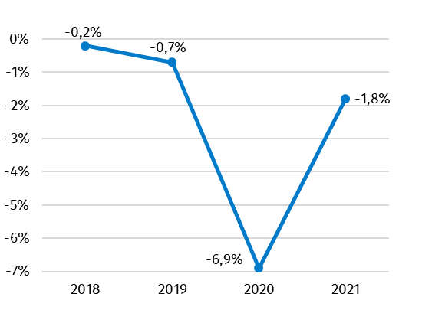

Chart 2. General government debt in % of GDP
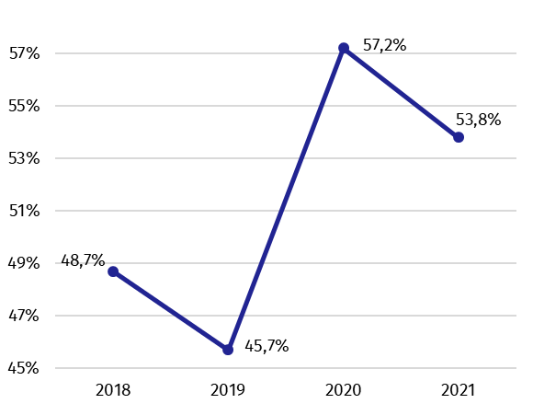

Data for years 2018-2021 year have been revised in relation to the previously published (April 2022) mainly due to reclassification of public units into the general government sector, updated data sources and revision of national accounts.
Together with the EDP data, a table containing data on measures taken in context of the COVID-19 epidemic was submitted to Eurostat. According to the final data, the general government expenditures aimed at stopping the consequences of the epidemic COVID-19 and combating these effects as well as supporting the entities affected by them amounted in 2021 year 63 281 mln zl.
Along with the EDP notification, the Statistics Poland sent to the European Commission information about revenues and expenditures of the general government sector divided into transactions, according to the European System of National and Regional Accounts (ESA2010).

Table 2. Total revenues and expenditures of the general government sector according to ESA2010 in years 2018-2021 (mln zl)
Specification | 2018 | 2019 | 2020 | 2021
Total revenues | 876 067* | 941 316* | 966 031* | 1 111 886*
% GDP | 41,2%* | 41,1%* | 41,3% | 42,4%*
Total expenditures | 881 373* | 958 326* | 1 127 866* | 1 160 081*
% GDP | 41,4%* | 41,9%* | 48,2% | 44,2%

Chart 3. Total revenues and expenditures of the general government sector in % of GDP
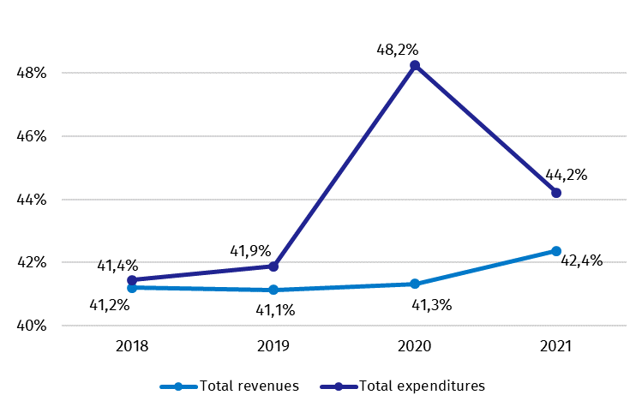

Similarly, as in case of deficit and debt, data on the general government revenues and expenditures for years 2018-2021 have been revised in relation to the previously published (April 2022).
The revision of the general government revenues caused their growth in years 2018-2021, respectively of 61 mln zl (0,1 percentage point in relation to GDP), 298 mln zl (0,1 percentage point in relation to GDP), 14 mln zl ( without change in relation to GDP) and of 1 901 mln zl (0,1 percentage point in relation to GDP). The biggest changes of revenues concerned transactions capital transfers ( in 2018 and 2019 year), market output and output for own final use (in 2020 year). The increase of revenues in 2021 year was observed mainly in transactions: payments for non-market output, net social contributions and other current transfers. The growths in expenditures in years 2018-2021 were respectively of 174 mln zl (0,1 percentage point in relation to GDP), 408 mln zl (0,1 percentage point in relation to GDP), 174 mln zl (without change in relation to GDP) and of 1 088 mln zl (without change in relation to GDP). The biggest changes of expenditures were in transactions gross capital formation ( in years 2018-2020), other taxes on production ( in years 2019-2021) and social transfers in kind (in 2021 year).
Detailed data on revenues and expenditures of the general government sector divided into ESA2010 transactions are presented in Annex 1.
Information on the general government deficit and debt of all EU Member States will be available on 21 October 2022 at 11 a.m. on the Eurostat website:
http://epp.eurostat.ec.europa.eu/portal/page/portal/eurostat/home.
Inventory of the methods, procedures and sources used for the compilation of deficit and debt data and the underlying government sector accounts according to ESA2010 prepared according to the European Commission’s guidelines in English version is available on Eurostat website:

http://ec.europa.eu/eurostat/web/government-finance-statistics/excessive-deficit-procedure/edp-inventories.

In case of quoting Statistics Poland data, please provide information: “Source of data: Statistics Poland”, and in case of publishing calculations made on data published by Statistics Poland, please include the following disclaimer: “Own study based on figures from Statistics Poland”.

Prepared by:  National Accounts Department  Director Anita Perzyna  Phone: (+48 22) 608 31 17 | Issued by:  The Spokesperson for the President  of Statistics Poland  Karolina Banaszek  Phone: (+48) 695 255 011
Press Office  Phone: (+48 22) 608 38 04  e-mail: obslugaprasowa@stat.gov.pl | www.stat.gov.pl/en/
 | @StatPoland
 | @GlownyUrzadStatystyczny
 | gus_stat
 | glownyurzadstatystycznygus
 | glownyurzadstatystyczny
Related studies
General government deficit and debt in 2021.

Subject available in databases
Knowledge Databases – National Accounts

Important concepts available in the dictionary
Gross domestic product

* Data have been revised in relation to the previously published on 22.04.2022. The manual is available on the website: https://ec.europa.eu/eurostat/documents/3859598/10042108/KS-GQ-19-007-EN-N.pdf/5d6fc8f4-58e3-4354-acd3-a29a66f2e00c
The document on revision Information of the Statistics Poland on the revision of national accounts in 2010-2020. Impact of changes on the main macroeconomic aggregates, is available on Statistics Poland website https://stat.gov.pl/en/topics/national-accounts/annual-national-accounts/information-of-the-statistics-poland-on-the-revision-of-national-accounts-in-2010-2020,10,1.html

