Flash estimate of Gross Domestic Product in the 4th quarter of 2021
According to the flash estimate, gross domestic product (GDP) in volume terms seasonally unadjusted was higher by 7.3% in the 4th quarter of 2021 year-to-year against 2.5% decrease in the corresponding period of 2020
107.3
GDP growth rate in the 4th quarter of 2021 according to the flash estimate

In the 4th quarter of 2021 seasonally adjusted GDP (constant prices, reference year 2015) was higher by 1.7% than in the previous quarter and 7.7% higher than in the 4th quarter of the previous year.

Seasonally unadjusted GDP (constant average prices of the previous year) was higher by 7.3% than in the corresponding quarter of the previous year.
The data is preliminary and can be subject to revision, in accordance with the revision policy of quarterly national accounts, in the first regular estimate of GDP for the 4th quarter of 2021 which will be released on February 28, 2022.

Table 1. Seasonally adjusted GDP; constant prices, reference year 2015
Specification | 2019 |  |  |  |  |  |  | 2020 |  |  |  |  |  |  |  | 2021
 | Q1 | Q2 |  | Q3 |  | Q4 |  | Q1 |  | Q2 |  | Q3 |  | Q4 |  | Q1 |  | Q2 |  | Q3 |  | Q4
 | previous quarter = 100
GDP growth rate of 30 November 2021 | 101.9 |  | 100.7 |  | 101.1 |  | 100.4 |  | 100.1 |  | 90.8 |  | 107.5 |  | 99.8 |  | 101.6 |  | 101.8 |  | 102.3 |  | -
GDP growth rate of 15 February 2022 | 101.9 |  | 100.7 |  | 101.1 |  | 100.3 |  | 100.1 |  | 90.8 |  | 107.6 |  | 99.7 |  | 101.6 |  | 101.8 |  | 102.3 |  | 101.7
Differences | 0.0 |  | 0.0 |  | 0.0 |  | -0.1 |  | 0.0 |  | 0.0 |  | +0.1 |  | -0.1 |  | 0.0 |  | 0.0 |  | 0.0 |  | -
 | corresponding quarter of previous year = 100
GDP growth rate of 30 November 2021 | 105.5 |  | 104.9 |  | 104.6 |  | 104.0 |  | 102.2 |  | 92.2 |  | 98.1 |  | 97.5 |  | 98.9 |  | 110.9 |  | 105.5 |  | -
GDP growth rate of 15 February 2022 | 105.5 |  | 104.9 |  | 104.6 |  | 104.0 |  | 102.2 |  | 92.2 |  | 98.1 |  | 97.4 |  | 98.9 |  | 110.9 |  | 105.5 |  | 107.7
Differences | 0.0 |  | 0.0 |  | 0.0 |  | 0.0 |  | 0.0 |  | 0.0 |  | 0.0 |  | -0.1 |  | 0.0 |  | 0.0 |  | 0.0 |  | -

Table 2. Seasonally unadjusted GDP; constant average prices of the previous year

Specification | 2019 |  |  |  |  |  |  | 2020 |  |  |  |  |  |  |  | 2021
 | Q1 | Q2 |  | Q3 |  | Q4 |  | Q1 |  | Q2 |  | Q3 |  | Q4 |  | Q1 |  | Q2 |  | Q3 |  | Q4
 | corresponding quarter of previous year = 100
GDP growth rate of 30 November 2021 | 105.5 |  | 105.4 |  | 104.6 |  | 103.7 |  | 102.2 |  | 91.8 |  | 98.5 |  | 97.5 |  | 99.2 |  | 111.2 |  | 105.3 |  | -
GDP growth rate of 15 February 2022 | 105.5 |  | 105.4 |  | 104.6 |  | 103.7 |  | 102.2 |  | 91.8 |  | 98.5 |  | 97.5 |  | 99.2 |  | 111.2 |  | 105.3 |  | 107.3
Differences | 0.0 |  | 0.0 |  | 0.0 |  | 0.0 |  | 0.0 |  | 0.0 |  | 0.0 |  | 0.0 |  | 0.0 |  | 0.0 |  | 0.0 |  | -

Chart 1. Gross domestic product volume growth rate

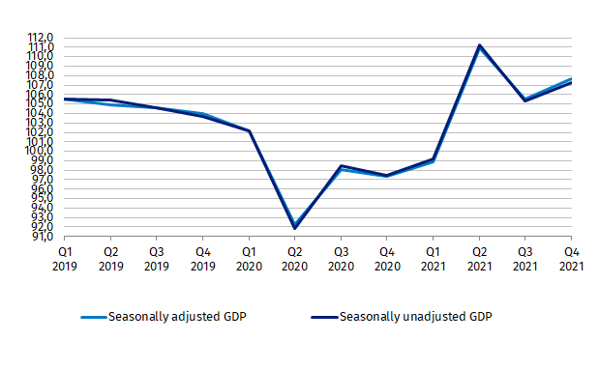
(corresponding period of the previous year = 100)

Chart 2. Gross domestic product seasonally adjusted volume growth rate

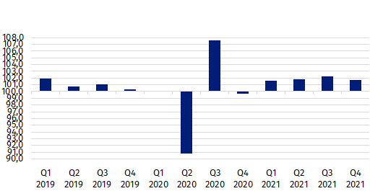
(the previous quarter = 100)

In the case of quoting data from the Statistics Poland, please provide information: “Source of Statistics Poland data”, and in the case of publishing calculations made using data published by the Statistics Poland, please provide information: “Own study based on Statistics Poland data”.

Prepared by:  National Accounts Department  Director Anita Perzyna  Phone: (+48 22) 608 31 17 | Issued by:  The Spokesperson for the President  of Statistics Poland  Karolina Banaszek  Phone: (+48) 695 255 011
Press Office  Phone: (+48 22) 608 38 04  e-mail: obslugaprasowa@stat.gov.pl | www.stat.gov.pl/en/
 | @StatPoland
 | @GlownyUrzadStatystyczny
 | gus_stat
 | glownyurzadstatystycznygus
 | glownyurzadstatystyczny
Related information
Gross Domestic Product in the third quarter of 2021. Preliminary estimate
Data available in databases
Knowledge database-National Accounts
Terms used inn official statistics
Gross domestic product
Gross value added
Gross capital formation

