Index numbers of construction and assembly production in August 2022
Acording to preliminary data construction and assembly production (in constant prices) carried out carried out domestically by construction enterprises employing more than 9 persons was in August 2022 by 6.1% higher than a year before (an increase of 10.2% the year before) and by 5.1% higher compared with July 2022 (an increase of 3.2% the year before).
106.1
Index number of construction and assembly production as compared to August of 2021

Table 1. Index numbers of construction and assembly production (constant prices)
SPECIFICATION | 08 2022 |  | 01-08 2022
 | 07 2022=100 | 08 2021=100 | 01-08 2021=100
CONSTRUCTION | 105.1 | 106.1 | 110.1
Construction of buildings ^{Δ} | 101.4 | 125.7 | 122.9
Civil engineering works ^{Δ} | 108.9 | 98.4 | 103.7
Specialised construction activities | 104.2 | 98.7 | 105.0

^{Δ} Abbreviated form according PKD 2007.

Sales of construction and assembly production in August 2022, compared to the corresponding period of 2021, increased in entities dealing mainly with construction of buildings (25.7%), whereas decreases were noted in performing specialised construction activities (1.3%) and in whose basic type of activity were civil engineering works (1.6%).
Compared with July 2022, increases in the value of works carried out were noted in entities dealing mainly with civil engineering works by 8.9%, performing specialised construction activities by 4.2% and in whose basic type of activity was construction of buildings by 1.4%.
In period of January-August 2022, sales of construction and assembly production, compared to the corresponding period of 2021, increased in all division of contruction, in entities whose basic type of activity was construction of buildings (22.9%), performing specialised construction activities (5.0%) and dealing mainly with civil engineering works (3.7%).
Sales of construction and assembly production in August 2022, compared to the corresponding period of 2021 increased for investment works by 1.3% and for restoration works by 13.2% (increases of 9.0% and of 12.2% in the year before).
In the period of January-August 2022, in relation to the same period of previous year, there were increases of 5.2% in the value of investment works (a decrease of 4.5% in 2021) and of 17.6% in the value of works with a restoration character (an increase of 8.4% in 2021).
Chart 1. Index numbers of construction and assembly production (constant prices; average monthly base 2015=100)
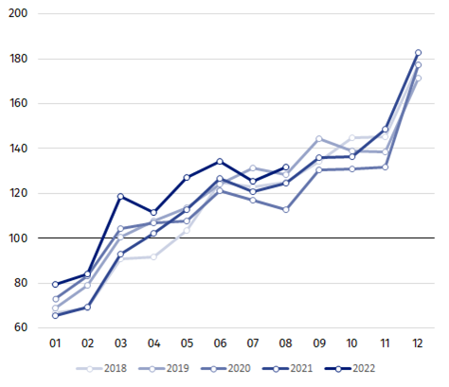

Index number of construction and assembly production in August 2022 (in constant prices), compared to the average monthly value of 2015, was 131.9.
After eliminating the seasonal factors, construction and assembly production reached the level by 7.2% higher than in August 2021 and by 1.1% higher in comparison to July 2022.

In case of quoting Statistics Poland data, please provide information: “Source of data: Statistics Poland” and in case of publishing calculations made on data published by Statistics Poland, please include the following disclaimer: “Own study based on figures from Statistics Poland”.

Prepared by:  Statistical Office in Lublin  Director Krzysztof Markowski  Phone: (+48 81) 533 20 52 | Issued by:  The Spokesperson for the President of Statistics Poland  Karolina Banaszek  Phone: (+48) 695 255 011
Press Office  Phone: (+48 22) 608 38 04  e-mail: obslugaprasowa@stat.gov.pl | www.stat.gov.pl/en/
 | @StatPoland
 | @GlownyUrzadStatystyczny
 | gus_stat
 | glownyurzadstatystycznygus
 | glownyurzadstatystyczny
Related information
Statistical Bulletin
Socio-economic situation of the country
Data available in databases
Knowledge Database - Construction
Macroeconomic Data Bank
Macroeconomic indicators
Local Data Bank
Terms used in official statistics
Sale of construction and assembly production
Seasonally unadjusted index of sale of construction and assembly production in constant prices
Seasonally adjusted index of sale of construction and assembly production
Sale of construction works with an investment character
Sale of construction works with a restoration character and other works

Reported data; comprise enterprises employing over 9 persons, whose the main type of activity is included in the section F “Construction” in accordance with the Polish Classification of Activities (PKD 2007).
² Data including final information on production and prices in July and reported data in August.
Reported data for August 2022.

