Non-residential construction in the I-III quarter of 2018

In the I-III quarter of 2018 the number of new non-residential buildings completed increased compared to the corresponding period of the previous year and a decrease of their total useful floor area was recorded[1]. The number of new non-residential buildings for which permits have been granted or which have been registered with a construction project decreased however an increase of their useful floor area was recorded.

100.2

The index of the number of new non-residential buildings completed

Material effects of non-residential buildings construction

The largest share (45.2%)  
in useful floor area of non-residential buildings completed was held by industrial buildings and warehouses.

In the I-III quarter of 2018, 16,950 new non-residential buildings were completed and 2,729 were expanded (respectively by 0.2% more and 1.5% less than in the corresponding period of the previous year). The total useful floor area of new and expanded non-residential buildings completed amounted to 11,558.6 thous. sq m, 1.2% less than a year before. The largest increases in the useful floor area were recorded for office buildings (29.2%) and hotels and similar buildings (18.5%). In terms of the useful floor area in the three quarters of 2018 predominated industrial buildings and warehouses (45.2%). Significant shares were also held by other non-residential buildings (21.0%) and wholesale and retail trade buildings (13.7%).

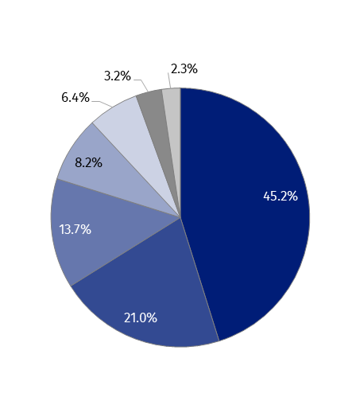

Chart 1. The structure of useful floor area of non-residential buildings completed in the  
I-III quarter of 2018

* industrial buildings and warehouses (PKOB 125)
* other non-residential buildings (PKOB 127)
* wholesale and retail trade buildings (PKOB 123)
* office buildings (PKOB 122)
* buildings for public entertainment, education, hospital  
  and institutional care and sport halls (PKOB 126)
* hotels and similar buildings (PKOB 121)
* traffic and communication buildings (PKOB 124)

The useful floor area of  
non-residential buildings completed in voivodships: mazowieckie, wielkopolskie and śląskie accounted for over 40% of the total useful floor area in the country

The largest useful floor area of non-residential buildings in the I-III quarter of 2018 was completed in the following voivodships: mazowieckie (1,803.0 thousand sq m), wielkopolskie (1,592.6 thousand sq m) and śląskie (1,247.5 thousand sq m), the smallest in opolskie (280.6 thousand sq m), świętokrzyskie (281.0 thousand sq m) and lubuskie (343.2 thousand sq m). In relation to the same period of the previous year the largest increase in area was recorded in the voivodships: świętokrzyskie (increase by 44.1%), lubuskie (26.0%), pomorskie (17.8%) and małopolskie (17.6%).

Chart 2. Useful floor area of non-residential buildings completed in the I-III quarter of 2018 by voivodships

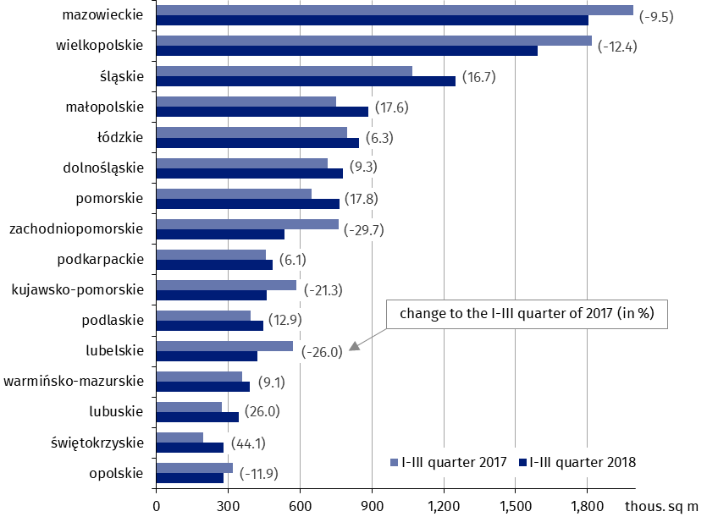

Building permits of new non-residential buildings

The largest share (45.5%)  
in useful floor area of non-residential buildings for which permits have been granted was held by industrial buildings and warehouses.

In the I-III quarter of 2018 building permits have been granted for 27,387 of new non-residential buildings with a total useful floor area of 16,707.9 thous. sq m. In comparison to the same period of the previous year the useful floor area increased by 6.2%, while the number of buildings decreased by 5.2%. The increase in the planned useful floor area of new non-residential buildingswas recorded for hotels and similar buildings (more by 82.4%), industrial buildings and warehouses (14.5%), wholesale and retail trade buildings (2.2%). In the structure of the useful floor area of new non-residential buildings, for which building permits have been granted dominated industrial buildings and warehouses (45.5%), other non-residential buildings (22.0%) and wholesale and retail trade buildings (12.5%).

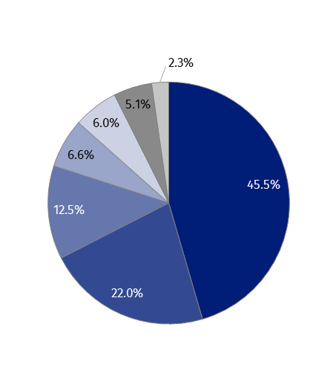

Chart 3. The structure of the useful floor area of new non-residential buildings for which permits have been granted in the I-III quarter of 2018

* industrial buildings and warehouses (PKOB 125)
* other non-residential buildings (PKOB 127)
* wholesale and retail trade buildings (PKOB 123)
* hotels and similar buildings (PKOB 121)
* buildings for public entertainment, education, hospital  
  and institutional care and sport halls (PKOB 126)
* office buildings (PKOB 122)
* traffic and communication buildings (PKOB 124)

According to building permits which have been granted for construction in the I-III quarter of 2018, the largest useful floor area of new non-residential buildings is planned to be built in the following voivodships: mazowieckie (2,599.1 thousand sq m), wielkopolskie (2,414.5 thousand sq m) and łódzkie (1,602.9 thousand sq m), and the smallest in opolskie (243.6 thousand sq m), lubuskie (419.9 thousand sq m) and świętokrzyskie (421.4 sq m). The largest increase in the planned area to be built compared to the same period of the previous year was recorded in voivodships: świętokrzyskie (by 48.0%), pomorskie (by 37.1%) and łódzkie (by 36.8%).

Useful floor area of new non-residential buildings for which permits have been granted in mazowieckie, wielkopolskie and łódzkie voivodships amounted to nearly 40% of the total useful floor area planned for construction

Chart 4. Useful floor area of new non-residential buildings for which permits have been granted in the I-III quarter of 2018 by voivodships

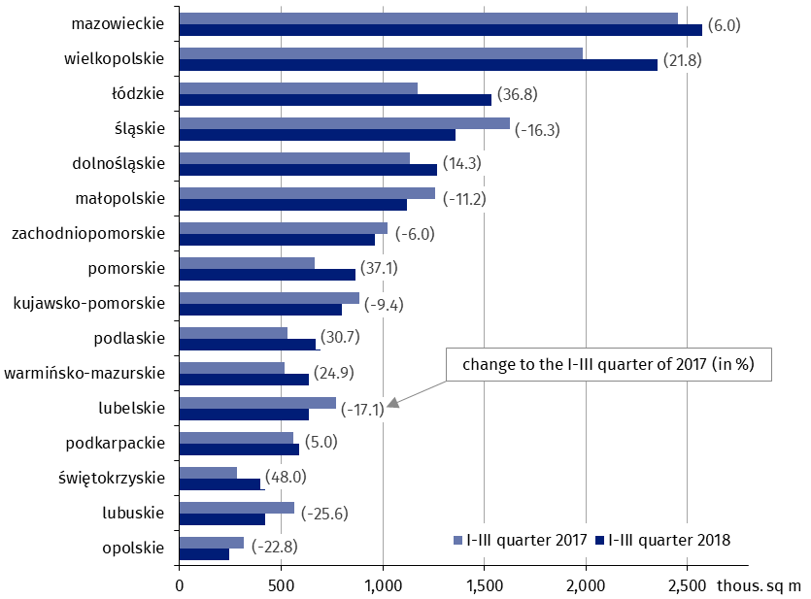

In the I-III quarter of 2018, 36,619 permits have been granted or which have been registered with a construction project for the construction of new civil engineering works, which is an increase of 5.6% compared to three quarters of 2017.

|  |  |
| --- | --- |
| Prepared by:  **Statistical Office in Lublin** **Zofia Kurlej**Tel: +48 81 533 23 01 **e-mail:** [Z.Kurlej@stat.gov.pl](mailto:Z.Kurlej@stat.gov.pl) | Issued by: **The Spokeperson for the President**  **of the Statistic Poland**  **Karolina Dawidziuk**  Tel: +48 22 608 34 75, +48 22 608 30 09  **e-mail:** [rzecznik@stat.gov.pl](mailto:rzecznik@stat.gov.pl) |

|  |  |  |
| --- | --- | --- |
| **Press Office**  **tel.:** +48 22 608 34 91, +48 22 608 38 04  **fax:** +48 22 608 38 86  **e-mail:** [obslugaprasowa@stat.gov.pl](mailto:obslugaprasowa@stat.gov.pl) |  | www.stat.gov.pl/en/ |
|  | @StatPoland |
|  | @GlownyUrzadStatystyczny |

**Related information**

[Construction results in 2017](http://stat.gov.pl/en/topics/industry-construction-fixed-assets/construction/construction-results-in-2017,1,11.html)

**Data available in databases**

[Knowledge Databases Construction](http://swaid.stat.gov.pl/en/SitePagesDBW/Budownictwo.aspx)

[Local Data Bank](https://bdl.stat.gov.pl/BDL/start)

**Terms used in official statistics**

[Building](http://stat.gov.pl/en/metainformations/glossary/terms-used-in-official-statistics/26,term.html)

[Non-residential building](http://stat.gov.pl/en/metainformations/glossary/terms-used-in-official-statistics/1021,term.html)

[Non-residential building completed](http://stat.gov.pl/en/metainformations/glossary/terms-used-in-official-statistics/3176,term.html)

[Civil engineering works](http://stat.gov.pl/en/metainformations/glossary/terms-used-in-official-statistics/1743,term.html)

[Building permit and registration with a construction project](http://stat.gov.pl/en/metainformations/glossary/terms-used-in-official-statistics/329,term.html)

1. Whenever the note refers to **the useful floor area of non-residential buildings completed** - it should be understood as the sum of useful floor area of new buildings and new parts of extended buildings