Non-residential construction in the first half of 2018

In the first half of 2018 the number of new non-residential buildings completed decreased compared to the corresponding period of the previous year however an increase of their total useful floor area was recorded.The number of new non-residential buildings for which permits have been granted or which have been registered with a construction project also decreased however an increase of their useful floor area was recorded.
101.7
The index of the size of useful floor area of non-residential buildings completed

Material effects of non-residential buildings construction
The largest share (44.9%) in useful floor area of non-residential buildings completed was held by industrial buildings and warehouses.
In the first half of 2018, 11,204 new non-residential buildings were completed and 1,780 were expanded (respectively by 3.3% and 0.4% less than in the corresponding period of the previous year). The total useful floor area of new and expanded non-residential buildings completed amounted to 7,714.1 thous. sq m, 1.7% more than a year before. The largest increases in the useful floor area were recorded for office buildings (94.6%) and wholesale and retail trade buildings (33.5%). In terms of the useful floor area of non-residential buildings in the first half of 2018, predominated (44.9% of the useful floor area) industrial buildings and warehouses. Significant shares were also held by other non-residential buildings (21.8%) and wholesale and retail trade buildings (14.5%).
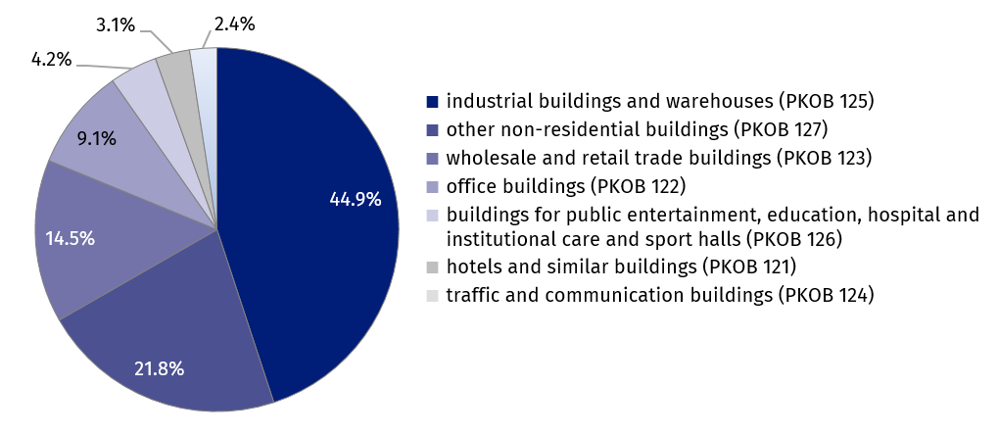
Chart 1. The structure of useful floor area of non-residential buildings completed in the first half of 2018
The useful floor area of non-residential buildings completed in voivodships: mazowieckie, wielkopolskie and śląskie accounted for over 41% of the total useful floor area in the country
The largest useful floor area of non-residential buildings in the first half of 2018 was completed in the following voivodships: mazowieckie (1,244.3 thousand sq m), wielkopolskie (991.5 thousand sq m) and śląskie (956.8 thousand sq m), the smallest in lubuskie (147.8 thousand sq m), opolskie (183.4 thousand sq m) and świętokrzyskie (208.1 thousand sq m). The largest increase in area in relation to the same period of the previous year was recorded in the voivodships: świętokrzyskie (increase by 70.4%), śląskie (38.3%), pomorskie (30.2%) and małopolskie (27.1%).
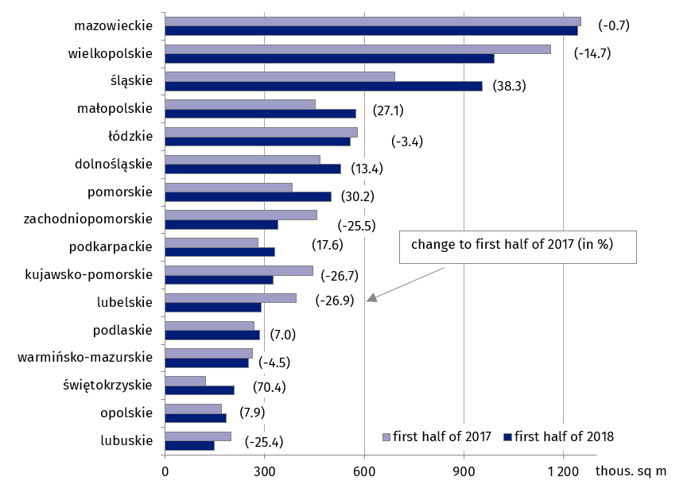
Chart 2. Useful floor area of non-residential buildings completed in the first half of 2018 by voivodships
Building permits of new non-residential buildings
In the first half of 2018 building permits have been granted for 17,474 of new non-residential buildings with a total useful floor area of 11,029.3 thous. sq m. In comparison to the same period of the previous year for the number of buildings there was a decrease of 7.6%, while for the useful floor area - an increase of 7.2%. The increase in the planned useful floor area of new non-residential buildings was recorded for hotels and similar buildings (more by 79.8%), industrial buildings and warehouses (22.4%), wholesale and retail trade buildings (11.7%) and buildings for public entertainment, education, hospital and institutional care and sport halls (4.1%). In the structure of the useful floor area of new non-residential buildings, for which building permits have been granted dominated industrial buildings and warehouses (43.3%) and other non-residential buildings (21.9%).
More than 43% of the useful floor area of new non-residential buildings for which permits have been granted concerned industrial buildings and warehouses

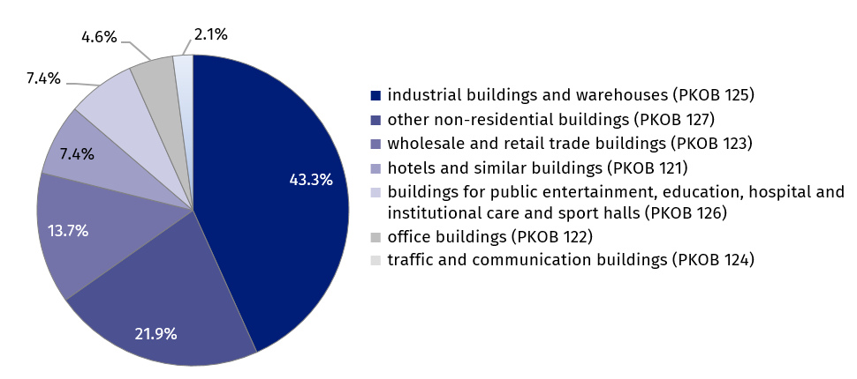
Chart 3. The structure of the useful floor area of new non-residential buildings for which permits have been granted in the first half of 2018
Useful floor area of new non-residential buildings for which permits have been granted in mazowieckie, wielkopolskie and łódzkie voivodships amounted to nearly 42% of the total useful floor area planned for construction

According to building permits which have been granted for construction in the first half of 2018, the largest useful floor area of new non-residential buildings is planned to be built in the following voivodships: mazowieckie (1,833.8 thousand sq m), wielkopolskie (1,675.7 thousand sq m) and łódzkie (1,102.1 thousand sq m), and the smallest in opolskie (158.3 thousand sq m), lubuskie (258.8 thousand sq m) and świętokrzyskie (263.5 sq m). The largest increase in the planned area to be built compared to the same period of the previous year was recorded in voivodships: łódzkie (by 62.9%), warmińsko-mazurskie (37.0%) and podlaskie (by 32.8%).
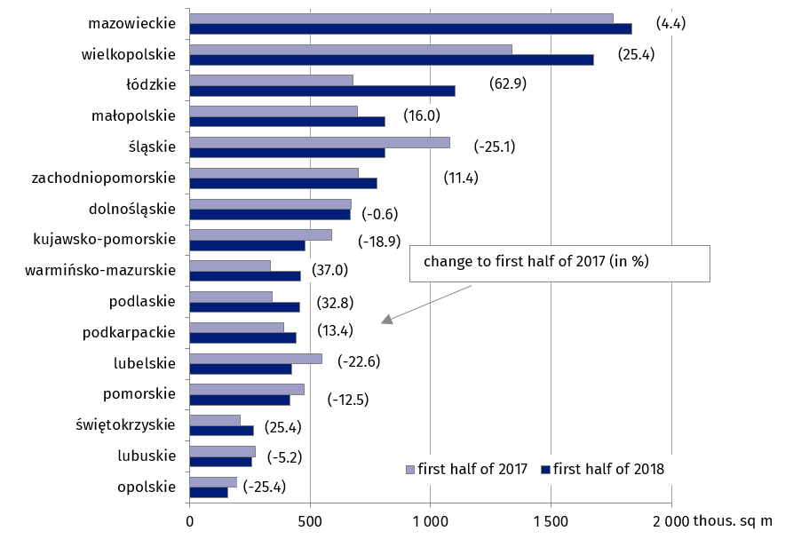
Chart 4. Useful floor area of new non-residential buildings for which permits have been granted in the first half of 2018 by voivodships

Additionally, in the first half of 2018, 23152 permits have been granted or which have been registered with a construction project for the construction of new civil engineering works, which is an increase of 4.7% compared to the first half of 2017.

Prepared by:  Statistical Office in Lublin  Zofia Kurlej  Tel: 81 533 2301  e-mail: Z.Kurlej@stat.gov.pl | Issued by:  The Spokeperson for the President  of the Statistic Poland  Karolina Dawidziuk  Tel: +48 22 608 3475, +48 22 608 3009  e-mail: rzecznik@stat.gov.pl
Press Office  tel.: +48 22 608 34 91, +48 22 608 38 04  fax: +48 22 608 38 86  e-mail:obslugaprasowa@stat.gov.pl |  | www.stat.gov.pl/en/
 |  | @StatPoland
 |  | @GlownyUrzadStatystyczny

Related information
Construction results in 2017
Data available in databases
Knowledge Databases Construction
Local Data Bank
Terms used in official statistics
Building
Non-residential building
Non-residential building completed
Civil engineering works
Building permit and registration with a construction project

Whenever the note refers to the useful floor area of non-residential buildings completed - it should be understood as the sum of useful floor area of new buildings and new parts of extended buildings

