Non-residential construction in the first quarter of 2018
The number of new non-residential buildings completed decreased in the first quarter of 2018

In the first quarter of 2018 the number of new non-residential buildings completed and their useful floor area decreased compared to corresponding period of previous year. The number of non-residential buildings for which permits have been granted or which have been registered with a construction project also decreased however an increase of their useful floor area was recorded.
The largest demand of investors was concerned reservoirs, silos and warehouses, but their useful floor area decreased in comparison to the previous year
10,9
Decrease of useful floor area of new non-residential buildings completed

In the first quarter of 2018, 5604 new non-residential buildings were completed (against 5679 with comparison to the same period of 2017) with useful floor area 3118 thous. m² (i.e. by 10.9% less). Nearly 90% of the total area applied to five types of buildings (reservoirs, silos and warehouses; non-residential farm buildings; wholesale and retail trade buildings; industrial buildings and office buildings). Among them the largest demand of investors was observed for reservoirs, silos and warehouses (but their useful floor area decreased in comparison to the first quarter of 2017 by 22.0%), non-residential farm buildings (drop of the useful floor area of 9.8%) and industrial buildings (drop of 37.5%). More demand for office buildings and wholesale and retail trade buildings was reflected in the growth of their useful floor area – by 67.0% and 45.6% respectively. Area of other types of non-residential buildings not mentioned above (among others hotels; garage buildings; sports halls) was by 6.7% smaller than a year before.

Chart 1. Useful floor area of new non-residential buildings completed by types of construction
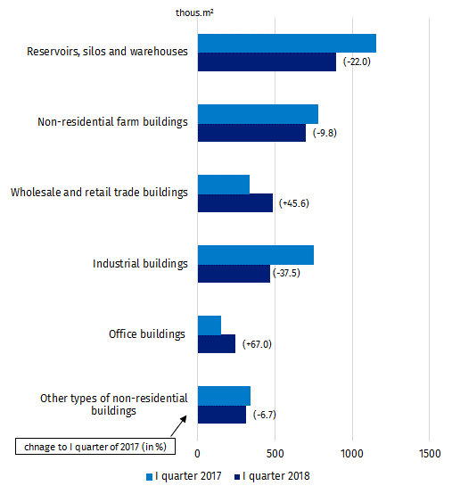

The useful floor area of new non-residential buildings completed in the area mazowieckie, wielkopolskie and śląskie voivodships in the first quarter of 2018 amounted 41.7% of the total useful floor area completed (against 39.2% a year ago). However, among them an increase in the useful floor area (in comparison to the first quarter of 2017) was observed only in mazowieckie voivodship (of 4.4%), while a decrease in wielkopolskie (of 11.6%) and śląskie (of 9.2%). Reservoirs, silos and warehouses as well as non-residential farm buildings dominated in mazowieckie voivodship (their share amounted to 33.5% and 26.3% of useful floor area completed respectively). In wielkopolskie voivodship also non-residential farm buildings (34.3%) and reservoirs, silos and warehouses (26.7% useful floor area completed) constituted the largest share, while in śląskie voivodship – reservoirs, silos and warehouses and wholesale and retail trade buildings (31.4% and 27.4%).
Useful floor area of new non-residential buildings completed in the area mazowieckie, wielkopolskie and śląskie voivodships accounted for nearly 42% of total useful floor area constructed

Chart 2. Useful floor area of new non-residential buildings completed by voivodships
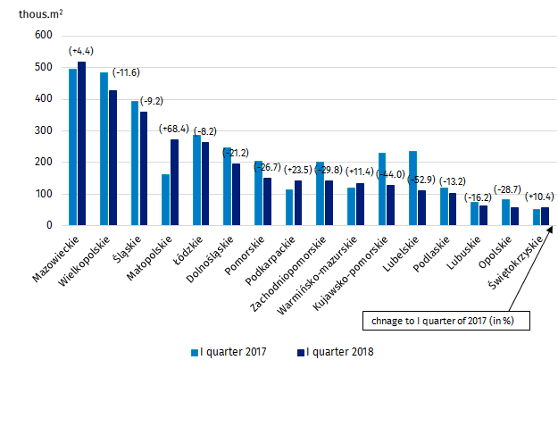
Nearly 44% of the useful floor area of new non-residential buildings for which permits have been granted concerned industrial buildings and warehouses

In the first quarter of 2018 the number of new non-residential buildings for which permits have been granted or which have been registered with a construction project was lower than a year before (6034) against (6335), but their useful floor area increased by 21.1%. The largest share of the area concerned industrial buildings and warehouses – 43.5% (at its increase of useful floor area of 45.2%). Area of other non-residential buildings (i.e. non-residential farm buildings and warehouses for agricultural activity) accounted for 20.4% of the total area (at its decrease of 13.3%); wholesale and retail trade buildings – 11.8% (a rise of 17.3%); hotels and similar buildings – 9.5% (more than 2.5-fold increase of area); buildings for public entertainment, education, hospital and institutional care and sport halls – 7.7% (a rise of 12.9%), and office buildings – 5.2% of useful floor area, for which permits have been granted, at its decrease of 21.4% in comparison to the first quarter of 2017. Additionally, in the first quarter of 2018, 10473 permits have been granted for construction of civil engineering works (against 10038 in the first quarter of 2017).

Chart 3. Useful floor area of new non-residential buildings for which permits have been granted or which have been registered with a construction project by voivodships

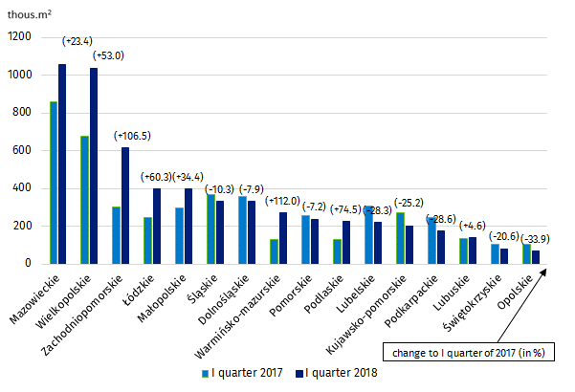

Useful floor area of new non-residential buildings for which permits have been granted in mazowieckie, wielkopolskie and zachodniopomorskie voivodships amounted to nearly 47% of the total useful floor area planned for construction

The investors showed the largest demand for permits for non-residential buildings in mazowieckie, wielkopolskie and zachodniopomorskie voivodships, where in the first quarter of 2018 permits have been granted for construction of 46.8% of total useful area to be constructed in Poland. Among them the largest increase in demand for newly build useful floor area was observed, in comparison to corresponding period of previous year, in zachodniopomorskie voivodship – of 106.5%, in wielkopolskie – of 53.0% and mazowieckie voivodships – of 23.4%. In mazowieckie voivodship the granted permits concerned mainly construction of the useful floor area of industrial buildings and warehouses (31.3%); other non-residential buildings (30.3%); wholesale and retail trade buildings (15.9%); office buildings (9.0%) and hotels and similar buildings (8.6%). In wielkopolskie voivodship also the area of industrial buildings and warehouses (61.9%) and other non-residential buildings (27.2%) prevailed, and on the territory of the zachodniopomorskie voivodship – hotels and similar buildings (49.9%); industrial buildings and warehouses (31.1%) and buildings for public entertainment, education, hospital and institutional care and sport halls (10.7%).

Prepared by:  Production Department  Janusz Kobylarz  Tel: +48 22 608 37 67  e-mail: J.Kobylarz@stat.gov.pl | Issued by:  The Spokeperson for the President  of the Statistic Poland  Karolina Dawidziuk  Tel: +48 22 608 3475, +48 22 608 3009  e-mail: rzecznik@stat.gov.pl

Press Office  tel.: +48 22 608 34 91, +48 22 608 38 04  fax: +48 22 608 38 86  e-mail: obslugaprasowa@stat.gov.pl |  | www.stat.gov.pl/en/
 |  | @StatPoland
 |  | @GlownyUrzadStatystyczny

Related information
Construction – Activity results in 2016

Data available in databases
Knowledge Databases Construction
Local Data Bank

Terms used in official statistics
Building
Non-residential building completed
Civil engineering works
Usable floor space of building
Building permit and registration with a construction project

