

21.05.2018 r.

NEWS RELEASES

**Residential construction a)  in the period I-IV of 2018**

Residential construction

In the period of four months of 2018 there were more dwellings completed than the year before. The number of dwellings for which permits have been granted or which have been registered with a construction project and the number of dwellings in which construction has begun also increased.

 100,5

Lorem ipsum dolor sit amet, consectetur adipiscing elit

 99112.2

An increase in the number of dwellings completed

Dwellings completed

According to preliminary data, in the period January-April of 2018, 58095 dwellings were completed, i.e. by 12.2% more than the year before (when an increase was noted by 1.3%). Among two main forms of constructions in the housing market better results were recorded by **developers** who completed 32714 dwellings, i.e. by 15.9% more than the year before (when an increase was recorded by 2.4%) and **private investors** – 23869 dwellings, i.e. by 6.1% more (against an increase by 2.1% the year before ). The share of these forms of construction amounted to 97.4% of the total number of dwellings completed in January-April of 2018 (of which developers – 56.3% and private investors – 41.1%). More dwellings, in comparison with January-April of 2017, were completed by the **housing cooperatives** (703 dwellings against 579), in the public building society construction 405 dwellings (against 199 dwellings the year before), in the municipal construction 380 dwellings (against 291), in the company construction 24 dwelling (against 13).

Dwellings for which permits have been granted or which have been registered with a construction project

In January-April of 2018 permits and registrations with a construction project have been granted for construction of 87475 dwellings i.e. by 4.8% more than in January-April of 2017 (when an increase was noted by 36.8%). Permits for construction of the biggest number of dwellings were given to investors in the form **construction for sale or rent** - 56226 dwellings and to **private investors** - 28870 dwellings. **Housing** **cooperatives** were given permits for 418 dwellings (against 711 dwellings the year before) while **other investors** (the public building society, the municipal and company construction) - 1961 dwellings, i.e. by 24,0% more than the year before.

Dwellings in which construction has begun

The number of dwellings in which construction has begun increased in the period of four months of 2018 to 70902 dwellings, i.e. by 14.6% (against an increase by 12,9% the year before). The developers have started construction of 42873 dwellings, private investors - 26818 dwellings, the housing cooperatives - 668 dwellings (against 787 dwellings in January-April of 2017) and other investors - 543 dwellings (against 767 dwellings the year before).

1. Residence data – subject to change upon developing quarterly reports

**Chart 1. Construction activity in the scope of construction of dwellings**

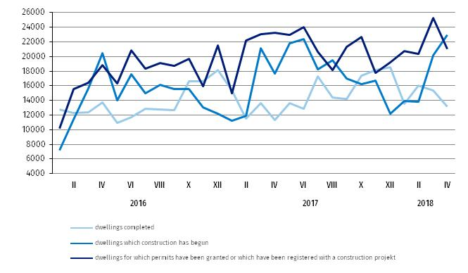

**Table 1. Residential construction results *b*)**

Residential construction results

|  |  |  |  |  |  |
| --- | --- | --- | --- | --- | --- |
| Forms of construction | 2018 | | | | |
| IV | | | I-IV | |
| number | IV 2017=100 | III 2018=100 | number | I-IV 2017=100 |
| **Dwellings completed** | | | | | |
| **Total** | **13187** | **116.7** | **86.0** | **58095** | **112.2** |
| Private | 4902 | 95.6 | 76.3 | 23869 | 106.1 |
| For sale or rent | 7816 | 128.2 | 91.8 | 32714 | 115.9 |
| Cooperative | 212 | more than 21-fold | 151.4 | 703 | 121.4 |
| Restc) | 257 | more than 4-fold | 99.6 | 809 | 160.8 |
| **Dwellings in which construction has begun** | | | | | |
| **Total** | **22924** | **130.0** | **113.6** | **70902** | **114.6** |
| Private | 10675 | X **d)** | 133.5 | 26818 | X **d)** |
| For sale or rent | 12141 | X **d)** | 104.6 | 42873 | X **d)** |
| Cooperative | 62 | 27.2 | 17.7 | 668 | 84.9 |
| Restc) | 46 | 24.7 | 20.9 | 543 | 70.8 |
| **Dwellings for which permits have been granted or which have been registered**  **with a construction project** | | | | | |
| **Total** | **21043** | **90.7** | **83.4** | **87475** | **104.8** |
| Private | 8475 | x ***d*)** | 108.1 | 28870 | x ***d*)** |
| For sale or rent | 12309 | x ***d*)** | 74.0 | 56226 | x ***d*)** |
| Cooperative | 111 | 53.9 | 142.3 | 418 | 58.8 |
| Restc) | 148 | 34.3 | 21.7 | 1961 | 124.0 |

b) Since January of 2018 data regarding the effects of „the individual construction” concern only dwellings realized for the investor’s own needs; dwellings for sale or rent (included into this form of construction so far) have been included into the form of “construction designated for sale or rent” .c) The company, municipal and public building society construction. d) According to the revised scope of forms of construction, indices in relation to the corresponding period of the previous year will be presented from January of 2019.

|  |  |
| --- | --- |
| Prepared by:  **Departament Produkcji** **Janusz Kobylarz**Tel: 22 6083767**e-mail:** [**J.Kobylarz@stat.gov.pl**](mailto:J.Kobylarz@stat.gov.pl) | Issued by: **The Spokeperson for the President**  **of the Statistic Poland** Tel: 22 608 3475, 22 608 3009**e-mail:** [**rzecznik@stat.gov.pl**](mailto:rzecznik@stat.gov.pl) |

|  |  |  |
| --- | --- | --- |
| **Press Office**  **tel.:** +48 22 608 34 91, +48 22 608 38 04  **faks:** +48 22 608 38 86  **e-mail:** [obslugaprasowa@stat.gov.pl](mailto:obslugaprasowa@stat.gov.pl) |  | www.stat.gov.pl |
|  | @StatPoland |
|  | @GlownyUrzadStatystyczny |

**Related information**

[Statistical Bulletin No 3/2018](https://stat.gov.pl/en/topics/other-studies/informations-on-socio-economic-situation/statistical-bulletin-no-32018,4,86.html)

[Information on socio-economic situation of the country in the first quarter of 2018](https://stat.gov.pl/en/topics/other-studies/informations-on-socio-economic-situation/socio-economic-situation-of-the-country-in-the-first-quarter-of-2018,1,83.html)

[Construction – Activity results in 2017](http://stat.gov.pl/en/topics/industry-construction-fixed-assets/construction/construction-activity-results-in-2016,1,10.html)

[Housing construction I-IV quarter 2017](http://stat.gov.pl/en/topics/industry-construction-fixed-assets/construction/housing-construction-i-iv-quarter-2017,2,26.html)

**Data available in databases**

[Knowledge Databases Construction](http://swaid.stat.gov.pl/EN/SitePagesDBW/Budownictwo.aspx)

[Local Data Bank](https://bdl.stat.gov.pl/BDL/start)

**Terms used in official statistics**

[Dwelling completed](http://stat.gov.pl/en/metainformations/glossary/terms-used-in-official-statistics/201,term.html)

#### [Dwellings in which construction has begun](http://stat.gov.pl/en/metainformations/glossary/terms-used-in-official-statistics/945,term.html)