Residential construction in the period of January-November 2022

From January to the end of November this year, there were more dwellings completed than the year before. Whereas the number of dwellings for which permits have been granted or which have been registered with a construction project as well as dwellings in which construction has begun decreased.
101.7
Index number of dwellings
completed y/y

Dwellings completed
Developers and private investors completed respectively: 60.5% and 38.0% of the total number of dwellings
According to the preliminary data, 214.2 thousand dwellings were completed in the period of January-November 2022, i.e. 1.7% more than in the previous year. Developers completed 129.6 thousand dwellings – by 1.5% more than in 2021, whereas private investors completed 81.4 thousand dwellings, i.e. by 3.4% more. Within these forms of construction, 98.5% of the total number of newly completed dwellings was built. Within other forms of construction, i.e. cooperative, municipal, public building society and company construction 3.2 thousand dwellings were completed (4.3 thousand in the previous year).
The total useful floor area of dwellings completed amounted to 19.7 million m², i.e. by 1.3% more than a year ago and the average useful floor area of 1 dwelling was 92.2 m².

Table 1. Dwellings completed
SPECIFICATION | 11 2022 |  |  | 01-11 2022
 | Number  of dwellings | 11 2021=100 | 10 2022=100 | Number  of dwellings | 01-11  2021=100
TOTAL | 25 135 | 102.7 | 115.4 | 214 234 | 101.7
Private | 8 473 | 111.6 | 110.3 | 81 430 | 103.4
For sale or rent | 16 070 | 97.7 | 117.9 | 129 558 | 101.5
of which for rent | 258 | 496.2 | 215.0 | 1 925 | 104.8
Cooperative | 413 | 195.7 | 444.1 | 1 450 | 75.0
Municipal | 20 | 26.3 | 17.1 | 477 | 38.9
Public building society | 159 | 120.5 | 60.7 | 1 283 | 125.0
Company | - | . | . | 36 | 48.0

Dwellings for which permits have been granted or which have been registered with
a construction project
The number of dwellings for which permits have been granted or which have been registered with a construction project decreased in the period of 01-11 2022 by 9.9% y/y
In the period of eleven months of 2022, permits and registrations have been granted for construction of 277.4 thousand dwellings, i.e. by 9.9% less than in the corresponding period of 2021. Permits for construction of the biggest number of dwellings were given to developers (188.8 thousand, a decrease of 0.5% y/y) and to private investors (84.3 thousand, a decrease of 26.5%). Within these forms of construction, permits have been granted and registrations with a construction project were made for 98.5% of dwellings in total. In other forms of construction 4.3 thousand dwellings for which permits have been granted or which have been registered with a construction project were noted (3.5 thousand dwellings in the previous year).

Table 2. Dwellings for which permits have been granted or which have been registered with a construction project
SPECIFICATION | 11 2022 |  |  | 01-11 2022
 | Number  of dwellings | 11 2021=100 | 10 2022=100 | Number  of dwellings | 01-11  2021=100
TOTAL | 19 363 | 80.9 | 94.1 | 277 434 | 90.1
Private | 5 652 | 59.6 | 88.5 | 84 315 | 73.5
For sale or rent | 13 148 | 92.3 | 94.3 | 188 849 | 99.5
Cooperative | 26 | 216.7 | 46.4 | 639 | 86.6
Municipal | 251 | 557.8 | 456.4 | 1939 | 215.7
Public building society | 280 | 186.7 | 200.0 | 1 643 | 98.4
Company | 6 | 100.0 | . | 49 | 26.5

Dwellings in which construction has begun
From January to November 2022, the number of dwellings in which construction has begun was 190.4 thousand, i.e. by 26.8% less than a year ago. Developers have started construction of 108.3 thousand dwellings (by 29.5% less), and private investors of 79.3 thousand (by 21.8% less). Altogether the share of these forms of construction was 98.5% of the total number of dwellings. In other forms of construction the number of dwellings in which construction has begun was 2.8 thousand (5.0 thousand in the previous year).

Table 3. Dwellings in which construction has begun
SPECIFICATION | 11 2022 |  |  | 01-11 2022
 | Number  of dwellings | 11 2021=100 | 10 2022=100 | Number  of dwellings | 01-11  2021=100
TOTAL | 12 117 | 57.2 | 89.3 | 190 444 | 73.2
Private | 4 528 | 60.7 | 72.5 | 79 323 | 78.2
For sale or rent | 7 367 | 57.1 | 103.2 | 108 336 | 70.5
of which for rent | 28 | over 20-fold less | 200.0 | 412 | 28.2
Cooperative | 85 | 23.7 | 472.2 | 687 | 35.9
Municipal | 6 | over 30-fold less | 25.0 | 817 | 82.0
Public building society | 130 | 43.2 | 92.2 | 1 197 | 63.1
Company | 1 | . | . | 84 | 44.4
It is estimated that at the end of November 2022, there were 847.5 thousand dwellings under construction, i.e. by 3.5% less than in the corresponding period of 2021.

Chart 1. Construction activity in the scope of residential construction in Poland
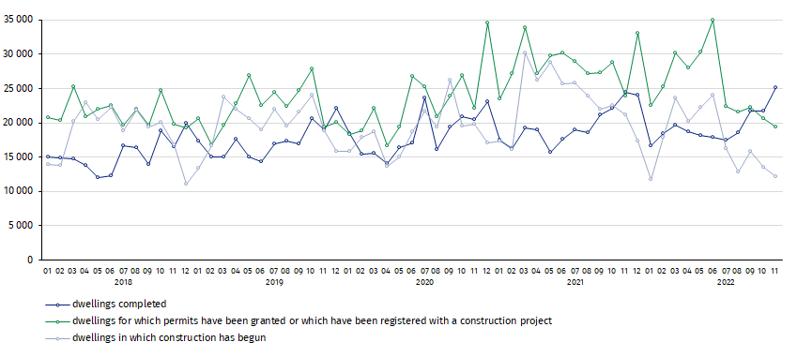
In November, compared to October 2022, the number of dwellings completed increased (by 15.4%), whereas the number of dwellings for which permits have been granted or which have been registered with a construction project decreased and the number of dwellings in which construction has begun decreased (respectively by 5.9% and 10.7%)

In the period of January-November 2022, the highest values of dwellings completed, as well as dwellings in which construction has begun and dwellings for which permits have been granted or which have been registered with a construction project, were recorded in Mazowieckie voivodship (respectively: 37.7 thousand, 34.3 thousand and 49.6 thousand). High values were also noted in Wielkopolskie (23.1 thousand, 18.5 thousand and 26.6 thousand) and Małopolskie (21.7 thousand,17.7 thousand and 25.0 thousand).

Chart 2. Construction activity in the scope of residential construction by voivodships
(January- November 2022)
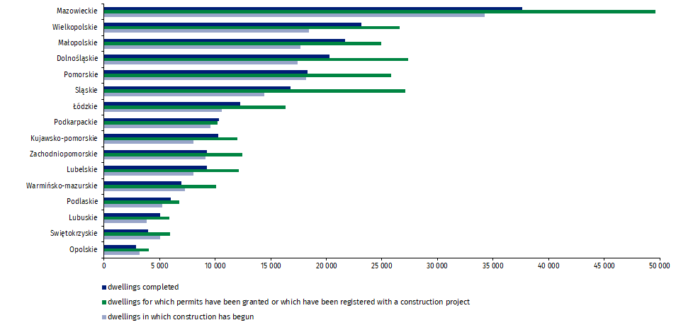

In case of quoting Statistics Poland data, please provide information: “Source of data: Statistics Poland” and in case of publishing calculations made on data published by Statistics Poland, please include the following disclaimer: “Own study based on figures from Statistics Poland”.
Prepared by:  Statistical Office in Lublin  Director Krzysztof Markowski  Phone: (+48) 695 255 301 | Issued by:  The Spokesperson for the President  of Statistics Poland  Karolina Banaszek  Phone: (+48) 695 255 011
Press Office  Phone: (+48 22) 608 38 04  e-mail: obslugaprasowa@stat.gov.pl | www.stat.gov.pl/en/
 | @StatPoland
 | @GlownyUrzadStatystyczny
 | gus_stat
 | glownyurzadstatystycznygus
 | glownyurzadstatystyczny
Related information
Statistical Bulletin
Socio-economic situation of the country
Construction results
Data available in databases
Knowledge Databases Construction
Local Data Bank
Terms used in official statistics
Dwellings for which permits have been granted or which have been registered with a construction project
Dwellings in which construction has begun
Dwellings completed

Reported data – subject to change upon developing quarterly reports.

