Residential construction in the period of January-October 2022

From January to the end of October this year, there were more dwellings completed than the year before. Whereas the number of dwellings for which permits have been granted or which have been registered with a construction project as well as dwellings in which construction has begun decreased.
101.4
Index number of dwellings
completed y/y

Dwellings completed
Developers and private investors completed respectively: 59.9% and 38.7% of the total number of dwellings
According to the preliminary data, 188.8 thousand dwellings were completed in the period of January-October 2022, i.e. 1.4% more than in the previous year. Developers completed 113.0 thousand dwellings – by 1.7% more than in 2021, whereas private investors completed 73.1 thousand dwellings, i.e. by 2.7% more. Within these forms of construction, 98.6% of the total number of newly completed dwellings was built. Within other forms of construction, i.e. cooperative, municipal, public building society and company construction 2 672 dwellings were completed (3 841 in the previous year).
The total useful floor area of dwellings completed amounted to 17.6 million m², i.e. by 1.0% more than a year ago and the average useful floor area of 1 dwelling was 93.0 m².

Table 1. Dwellings completed
SPECIFICATION | 10 2022 |  |  | 01-10 2022
 | Number  of dwellings | 10 2021=100 | 09 2022=100 | Number  of dwellings | 01-10  2021=100
TOTAL | 21 783 | 98,6 | 101.5 | 188 775 | 101.4
Private | 7 681 | 101.0 | 104.7 | 73 072 | 102.7
For sale or rent | 13 630 | 97.5 | 99.1 | 113 031 | 101.7
of which for rent | 120 | 235.3 | 461.5 | 1 629 | 91.3
Cooperative | 93 | 26.9 | 54.7 | 1 059 | 61.5
Municipal | 117 | 67.2 | 141,0 | 453 | 39.4
Public building society | 262 | . | 218.3 | 1 124 | 125.7
Company | - | . | . | 36 | 48.0

Dwellings for which permits have been granted or which have been registered with
a construction project
The number of dwellings for which permits have been granted or which have been registered with a construction project decreased in the period of 01-10 2022 by 9.4% y/y
In the period of ten months of 2022, permits and registrations have been granted for construction of 257.5 thousand dwellings, i.e. by 9.4% less than in the corresponding period of 2021. Permits for construction of the biggest number of dwellings were given to developers (175.1 thousand, a decrease of 0.2% y/y) and to private investors (78.7 thousand, a decrease of 25.2%). Within these forms of construction, permits have been granted and registrations with a construction project were made for 98.6% of dwellings in total. In other forms of construction 3 659 dwellings for which permits have been granted or which have been registered with a construction project were noted (3 279 dwellings in the previous year).

Table 2. Dwellings for which permits have been granted or which have been registered with a construction project
SPECIFICATION | 10 2022 |  |  | 01-10 2022
 | Number  of dwellings | 10 2021=100 | 09 2022=100 | Number  of dwellings | 01-10  2021=100
TOTAL | 20 584 | 71.4 | 93.2 | 257 461 | 90.6
Private | 6 388 | 56.9 | 92.8 | 78 713 | 74.8
For sale or rent | 13 945 | 81.4 | 93.6 | 175 089 | 99.8
Cooperative | 56 | . | 116.7 | 613 | 84.4
Municipal | 55 | 53.9 | 30.7 | 1 688 | 197.7
Public building society | 140 | 45.2 | 318.2 | 1 315 | 86.5
Company | - | . | . | 43 | 24.0

Dwellings in which construction has begun
From January to October 2022, the number of dwellings in which construction has begun was 178.3 thousand, i.e. by 25.3% less than a year ago. Developers have started construction of 101.0 thousand dwellings (by 28.3% less), and private investors of 74.8 thousand (by 20.4% less). Altogether the share of these forms of construction was 98.6% of the total number of dwellings. In other forms of construction the number of dwellings in which construction has begun was 2 563 (4 153 in the previous year).

Table 3. Dwellings in which construction has begun
SPECIFICATION | 10 2022 |  |  | 01-10 2022
 | Number  of dwellings | 10 2021=100 | 09 2022=100 | Number  of dwellings | 01-10  2021=100
TOTAL | 13 569 | 60.2 | 85.5 | 178 327 | 74.7
Private | 6 244 | 67.0 | 87.8 | 74 795 | 79.6
For sale or rent | 7 142 | 55.6 | 82.0 | 100 969 | 71.7
of which for rent | 14 | 155.6 | 155.6 | 384 | 42.6
Cooperative | 18 | . | . | 602 | 38.7
Municipal | 24 | 18.6 | 342.9 | 811 | 99.6
Public building society | 141 | 61.6 | 361.5 | 1 067 | 66.9
Company | - | . | . | 83 | 43.9
It is estimated that at the end of October 2022, there were 860.9 thousand dwellings under construction, i.e. by 2.3% less than in the corresponding period of 2021.

Chart 1. Construction activity in the scope of residential construction in Poland
In October, compared to September 2022, the number of dwellings completed increased (by 1.5%), whereas the number of dwellings for which permits have been granted or which have been registered with a construction project decreased and the number of dwellings in which construction has begun decreased (respectively by 6.8% and 14.5%)
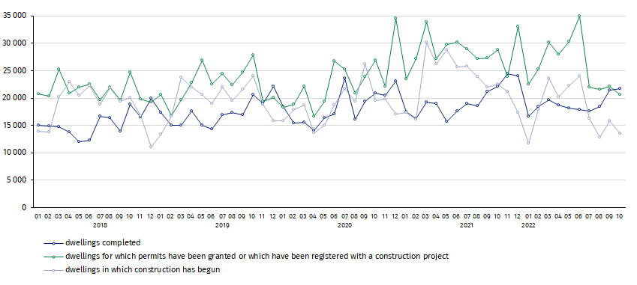

In the period of January-October 2022, the highest values of dwellings completed, as well as dwellings in which construction has begun and dwellings for which permits have been granted or which have been registered with a construction project, were recorded in Mazowieckie voivodship (respectively: 33.5 thousand, 31.9 thousand and 46.4 thousand). High values were also noted in Wielkopolskie (20.3 thousand, 17.0 thousand and 24.3 thousand) and Małopolskie (19.6 thousand,16.7 thousand and 21.8 thousand).

Chart 2. Construction activity in the scope of residential construction by voivodships
(January- October 2022)
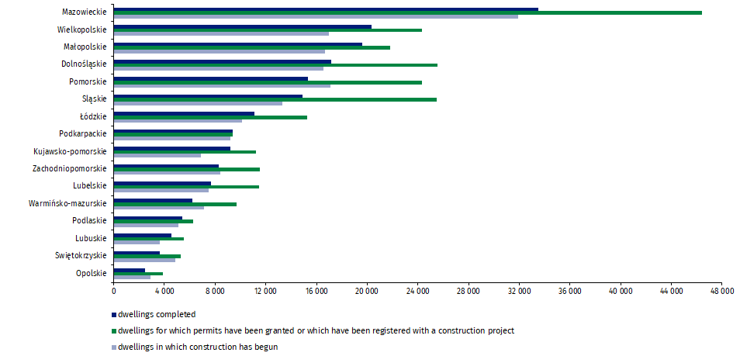

In case of quoting Statistics Poland data, please provide information: “Source of data: Statistics Poland” and in case of publishing calculations made on data published by Statistics Poland, please include the following disclaimer: “Own study based on figures from Statistics Poland”.
Prepared by:  Statistical Office in Lublin  Director Krzysztof Markowski  Phone: (+48 81) 533 20 52 | Issued by:  The Spokesperson for the President  of Statistics Poland  Karolina Banaszek  Phone: (+48) 695 255 011
Press Office  Phone: (+48 22) 608 38 04  e-mail: obslugaprasowa@stat.gov.pl | www.stat.gov.pl/en/
 | @StatPoland
 | @GlownyUrzadStatystyczny
 | gus_stat
 | glownyurzadstatystycznygus
 | glownyurzadstatystyczny
Related information
Statistical Bulletin
Socio-economic situation of the country
Construction results
Data available in databases
Knowledge Databases Construction
Local Data Bank
Terms used in official statistics
Dwellings for which permits have been granted or which have been registered with a construction project
Dwellings in which construction has begun
Dwellings completed

Reported data – subject to change upon developing quarterly reports.

