Production of industrial products in 2021⁾
The value of sold production of own products by producers in 2021 increased in relation to 2020 by 23.0% and amounted to 1 435 610.3 million PLN.
123.0
Index of value of sold production of own products by manufacturers

Sold production of industrial products
Compared to 2020, the value of sold production of products increased in all divisions of the sections Products of mining and quarrying and Manufactured products, except for the Metal ores division (a decrease by 4.5% was recorded), Tobacco products (by 3.0%), Printing and reproduction services of recorded media (by 0.1%).
Compared to the previous year, in 2021 the largest increase in the share in the value of sold production of products was recorded for the divisions Basic metals (by 1.2 percentage points) and Coke, briquettes and similar solid fuels manufactured from coal or peat and refined petroleum products (by 1.0 percentage points). The largest decrease in the share was recorded for the divisions Food products (by 1.6 percentage points) and Motor vehicles, trailers and semi-trailers (by 0.6 percentage points).
Chart 1. Share in the value of sold production in 2021, by groupings of divisions of the Polish Classification of Goods and Services (PKWiU)

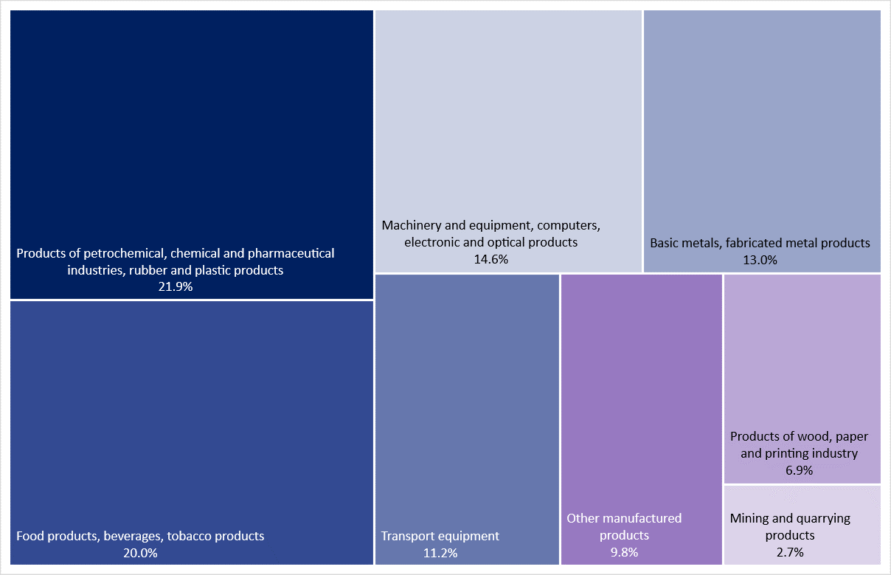

Table 1. Sold production of products by PKWiU sections and divisions (current prices)
The largest share in the value of sold production was recorded for section Food products (16.3%)

Sections and divisions | 2021
 | in milion PLN | in percent | 2020=100
Total | 1 435 610.3 | 100.0 | 123.0
Products of mining and quarrying | 38 216.5 | 2.7 | 133.5
of which Hard coal and lignite | 21 339.7 | 1.5 | 123.1
Manufactured products | 1 397 393.8 | 97.3 | 122.8
of which:
Food products | 233 379.5 | 16.3 | 111.8
Beverages | 36 371.0 | 2.5 | 109.7
Tobacco products | 17 248.20 | 1.2 | 97.0
Textiles | 10 964.0 | 0.8 | 114.4
Wearing apparel | 4 656.0 | 0.3 | 107.4
Leather and leather products | 3 010.4 | 0.2 | 103.8
Wood and products of wood and cork, except furniture; articles of straw and plaiting materials | 38 843.8 | 2.7 | 136.1
Paper and paper products | 52 919.1 | 3.7 | 124.1
Coke, briquette and similar solid fuels from coal and peat, refined petroleum products | 107 234.2 | 7.5 | 143.1
Chemicals and chemical products | 89 626.3 | 6.2 | 131.1
Basic pharmaceutical products, medicaments and pharmaceutical preparations | 12 064.7 | 0.8 | 105.7
Rubber and plastic products | 105 612.2 | 7.4 | 124.9
Other non-metallic mineral products | 60 108.4 | 4.2 | 114.4

Table 1. Sold production of products by PKWiU sections and divisions (current prices) (cont.)
Sections and divisions | 2021
 | in milion PLN | in percent | 2020=100
Fabricated metal products, except machinery and equipment | 84 052.0 | 5.9 | 122.8
Computers, electronic and optical products | 47 490.7 | 3.3 | 131.2
Electrical equipment | 106 063.2 | 7.4 | 129.7
Machinery and equipment n.e.c. | 55 459.2 | 3.9 | 123.5
Motor vehicles, trailers and semi-trailers | 141 259.8 | 9.8 | 116.9
Other transport equipment | 19 309.9 | 1.3 | 102.0
Furniture | 49 515.9 | 3.4 | 118.4
Other manufactured goods | 12 534.6 | 0.9 | 127.6

Out of 4471 products and assortment groups of products covered by observation in physical units of measure according to the PRODPOL nomenclature, entities of the national economy reported sold production for 3545 headings. Increase in sold production was noted in the case of 2209 products and decrease – 1210 products.
The following were among the products with largest value of sold production: gas oils for high-speed compression ignition engines (diesel fuel); parts and accessories for motor vehicles; lithium-ion accumulators; hot rolled products (excluding semi-finished products); television receivers with built-in digital TV tuner; motor gasoline, unleaded; hard coal; prepared feeds for farm animals; cigarettes; seats, primarily with wooden frames; pig meat, fresh or chilled.

Manufactured production of industrial products
Out of 4471 products and assortment groups of products covered by observation in physical units of measure according to the PRODPOL nomenclature, entities of the national economy reported manufactured production for 3578 headings. Increase in manufactured production was noted in the case of 2234 products and decrease – 1239 products.

Table 2. Manufactured production of major industrial products in 2021
Specification | Volume unit | Volume | 2020=100
Hard coal | thousand  tonnes | 55 361 | 101.1
Lignite | thousand  tonnes | 52 356 | 113.9
Natural gas | cubic  hectometres | 5 274 | 99.5
Slaughter products of cattle and calves and pigs included in slaughter capacity | tonnes | 1 588 374 | 116.2
Poultry meat | tonnes | 3 157 624 | 96.1
Milk | hectolitres | 36 721 268 | 99.0
Butter | tonnes | 241 205 | 94.7
Fresh bread | tonnes | 1 351 548 | 97.4
Sugar in terms of white sugar | tonnes | 2 151 076 | 108.0
Prepared feeds for farm animals | thousand  tonnes | 10 725 | 92.6
Vodka in terms of 100% | hectolitres | 1 080 221 | 109.8
Beer from malt | hectolitres | 38 832 155 | 99.4
Cigarettes | million p/st | 215 776 | 96.7
Footwear (including rubber footwear) | thousand pairs | 25 776 | 89.4
Sawnwood | cubic  decametres | 5 031 | 107.8
Fibreboard | thousand m² | 766 561 | 112.4
Paper and paperboard | thousand  tonnes | 5 324 | 103.8
Coke | tonnes | 9 283 699 | 119.3
Motor gasoline (including aviation gasoline) | tonnes | 4 172 806 | 96.1
Diesel oils | tonnes | 13 639 996 | 101.1
Ethylene | tonnes | 348 592 | 71.6
Mineral or chemical fertilizers in terms of pure component, including multi-ingredient fertilizers | tonnes | 2 943 658 | 100.4
Plastics in primary forms | tonnes | 3 692 253 | 99.9
Pesticides | tonnes | 109 133 | 112.7

Table 2. Manufactured production of major industrial products in 2021 (cont.)
Specification | Volume unit | Volume | 2020=100
Tires (excluding retreaded) | thousand  p/st | 59 444 | 140.1
Builders’ ware of plastic | tonnes | 1 272 195 | 122.1
Cement | thousand  tonnes | 19 625 | 103.0
Bricks | thousand bricks | 591 623 | 102.6
Crude steel | tonnes | 8 552 506 | 107.5
Hot rolled products (excluding semi-finished products) | tonnes | 9 239 557 | 108.8
Steel tubes | tonnes | 954 321 | 118.2
Unwrought, unalloyed refined copper | tonnes | 579 249 | 103.1
Computers | p/st | 3 511 716 | 104.4
Television receivers | thousand  p/st | 19 326 | 115.7
Accumulators for starting piston engines for motor vehicles | thousand  p/st | 7 531 | 117.5
Refrigerators and freezers, including combined refrigerators-freezers | thousand  p/st | 3 943 | 112.1
Dish washing machines | thousand  p/st | 5 886 | 119.1
Washing machines (including machines which both wash and dry) | thousand  p/st | 7 013 | 103.6
Electric cookers, including gas-electric cookers | thousand  p/st | 1 603 | 113.6
Agricultural tractors | p/st | 3 084 | 175.2
Machinery and equipment for construction, road and drainage work | tonnes | 11 433 | 91.5
Passenger cars | p/st | 260 796 | 93.5
Public transport vehicles | p/st | 5 250 | 87.0
Lorries and road tractors for semi-trailers | p/st | 174 821 | 105.0
Bicycles (including children's bicycles) | p/st | 1 226 306 | 124.6
Upholstered seats with wooden frames | p/st | 15 637 430 | 107.6
Wooden furniture for dining and living room | thousand  p/st | 33 723 | 105.1
Table 3. Manufactured production of products related to the prevention of spreading / combating COVID-19 in 2021
974 million p/st face masks used in medicine were produced
Specification | Volume unit | Volume
Protective clothing (overalls, aprons) | p/st | 3 294 155
Face masks used in medicine | p/st | 973 967 860
Other protective face masks | p/st | 193 791 382
Rubber gloves | pairs | 55 253
Disposable plastic film gloves | p/st | 693 880
Protective head caps | p/st | 38 721 965
Protective face shields | p/st | 837 094
Protective shoe covers | pairs | 2 187 395
Disinfectant liquids and gels | kilograms | 9 583 399
Disinfectant wipes | kilograms | 206 746
Solid disinfectants (powders, granules, tablets, etc.) for preparing solutions | kilograms | 196 430
Soap with disinfectant properties | tonnes | 33 594
Denatured alcohol | hectolitres 100% | 56 988
Swab test kits | p/st | 203 736

In the case of quoting data from the Statistics Poland, please provide information: "Statistics Poland data source", and in the case of publishing calculations made on data published by the Statistics Poland, please provide information: "Own study based on Statistics Poland data".

Prepared by:  Enterprises Department  Director Katarzyna Walkowska  Phone: (+48 22) 608-31-25 | Issued by:  The Spokesperson for the President  of Statistics Poland  Karolina Banaszek  Phone: (+48) 695 255 011
Press Office  Phone: (+48 22) 608 38 04  e-mail: obslugaprasowa@stat.gov.pl | www.stat.gov.pl/en/
 | @StatPoland
 | @GlownyUrzadStatystyczny
 | gus_stat
 | glownyurzadstatystycznygus
 | glownyurzadstatystyczny
Related information
Production of industrial products in 2020
Production of major industrial products
Production of industrial products in 2016–2020
Production of industrial products related to the prevention of spreading / combating COVID-19 in December 2021
Data available in databases
Knowledge Databases Industrial Production

Terms used inn official statistics
Sold production of industry products
Manufactured production
Finished products

Data refer to enterprises in which the number of persons employed is 10 and more

