Index numbers of sold production of industry in December 2022^{a)}
In December 2022, sold production of industry was by 1.0% higher than in December 2021, when an increase was recorded by 16.3% as compared to the corresponding period of 2020, whereas in comparison with November 2022, it decreased by 6.4%. In the period January-December of 2022, sold production of industry was by 10.2% higher than in the corresponding period of 2021, which saw an increase by 14.8% as compared to the corresponding period of 2020.
1.0%
Increase in sold production of industry as compared to December 2021

After seasonal adjustment, an increase in sold industrial production in December 2022 amounted to 5.6% per year

After eliminating the seasonal factors, in December 2022 sold production of industry reached the level higher by 5.6% than in the corresponding month of 2021 and by 0.7% higher as compared to November 2022.
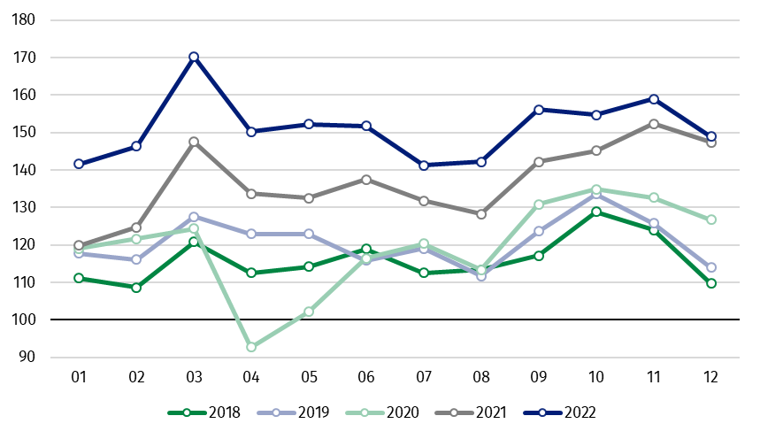
Chart 1. Sold production of industry (average monthly level in 2015=100)

In December 2022, among the main industrial groupings there was an increase per year in the production of capital goods by 10.7% and non-durable consumer goods – by 8.9%. A decrease was observed in production of energy – by 11.9%, durable consumer goods – by 7.9% and intermediate goods – by 2.5%.

^{a)} Reported data; comprise enterprises with 10 or more persons employed.
Table 1. Index numbers of sold production of industry ^{a)} (constant prices)
SPECIFICATION | 2022
 | 11 | 12 | 11 | 12 | 01-12 | 11 | 12
 | previous month =100 |  | previous year =100 |  |  | monthly average  of 2015 =100
INDUSTRY | 102.8* | 93.6 | 104.5* | 101.0 | 110.2 | 159.0* | 148.9
Mining and quarrying | 99.8 | 90.5 | 100.6 | 93.1 | 113.0 | 95.2 | 86.2
Manufacturing | 101.8* | 92.0 | 106.4* | 103.4 | 110.6 | 163.1* | 150.0
Electricity, gas, steam and air conditioning supply | 118.1* | 110.5 | 87.4* | 83.7 | 106.5 | 148.6* | 164.1
Water supply; sewerage waste management and remediation activities | 98.9* | 105.2 | 100.6* | 101.8 | 105.9 | 149.7* | 157.5

^{a)} Data including final information on production and prices in November and reported data in December.
* Data revised.
Share of production value of industry divisions, which saw an increase in comparison to December 2021, stood at 56.3%

According to the preliminary data, in December 2022 as compared to December 2021, an increase in sold production (in constant prices) was reported in 17 (out of 34) industry divisions, among others, in manufacture of motor vehicles, trailers and semi-trailers – by 18.2%, manufacture of machinery and equipment – by 18.1%, manufacture of electrical equipment – by 12.6%, manufacture of metal products – by 8.3%, manufacture of food products – by 8.0%, manufacture of rubber and plastic products – by 5.1%, in repair and installation of machinery and equipment – by 4.0%.
A decrease in sold production of industry, as compared to December 2021, was recorded in 17 divisions, among others, in manufacture of basic metals – by 21.8%, in electricity, gas, steam and air conditioning supply – by 16.3%, in manufacture of chemicals and chemical products – by 10.7%, manufacture of other non-metallic mineral products – by 10.3%, manufacture of paper and paper products – by 9.5%, manufacture of furniture – by 7.2%, manufacture of products of wood, cork, straw and wicker – by 7.1%.

Chart 2. Index numbers of sold production of industry by selected NACE divisions (constant prices;
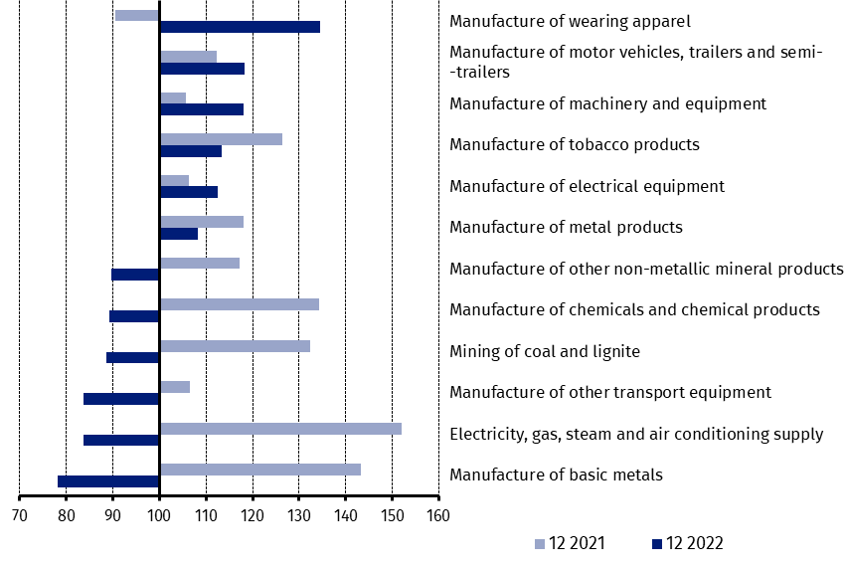
previous year =100)
As compared to November 2022, a decrease in sold production (in constant prices) in December 2022 was recorded in 20 industry divisions, among others, in manufacture of computer, electronic and optical products – by 27.7%, manufacture of other non-metallic mineral products – by 21.1%, manufacture of basic metals – by 19.4%, manufacture of products of wood, cork, straw and wicker – by 17.3%, manufacture of metal products – by 14.1%, manufacture of paper and paper products – by 13.2%, manufacture of motor vehicles, trailers and semi-trailers – by 13.0%, manufacture of rubber and plastic products – by 11.9%.
An increase in sold production of industry, as compared to November 2022, was recorded in 14 divisions, among others, in repair and installation of machinery and equipment – by 58.1%, in manufacture of beverages – by 14.7%, in electricity, gas, steam and air conditioning supply – by 10.5%, in manufacture of other transport equipment – by 8.6%.

Chart 3. Index numbers of sold production of industry by selected NACE divisions (constant prices;
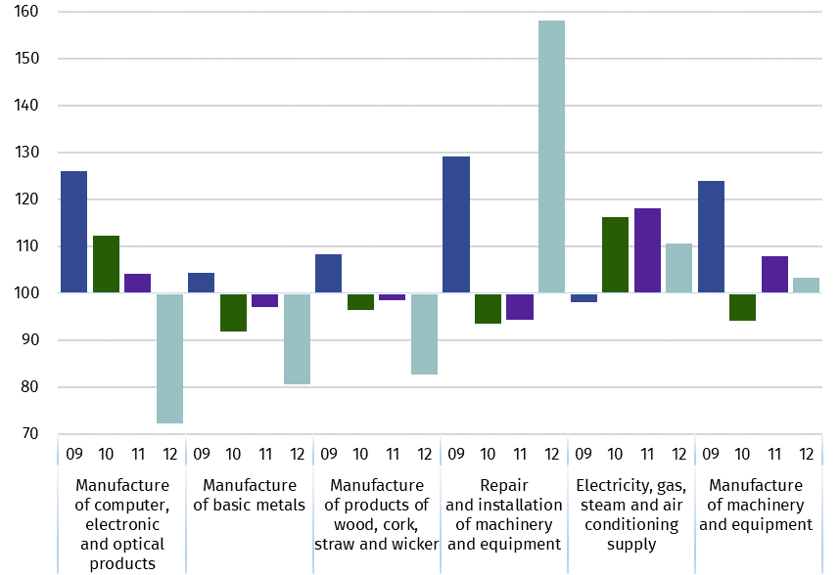
previous month =100)

In case of quoting Statistics Poland data, please provide information: “Source of data: Statistics Poland”, and in case of publishing calculations made on data published by Statistics Poland, please include the following disclaimer: “Own study based on figures from Statistics Poland”
Prepared by:  Enterprises Department  Director Katarzyna Walkowska  Phone: (+48 22) 608 31 25 | Issued by:  The Spokesperson for the President  of Statistics Poland  Karolina Banaszek  Phone: (+48) 695 255 011
Press Office  Phone: (+48 22) 608 38 04  e-mail: obslugaprasowa@stat.gov.pl | www.stat.gov.pl/en/
 | @StatPoland
 | @GlownyUrzadStatystyczny
 | gus_stat
 | glownyurzadstatystycznygus
 | glownyurzadstatystyczny

Related information
Statistical Bulletin
Socio-economic situation of the country

Data available in databases
Knowledge Database - Industrial Production
Macroeconomic Data Bank
Macroeconomic indicators
Local Data Bank

Terms used in official statistics
Sold production of industry
Seasonally un-adjustedindex of sold production of industry
Seasonally adjustedindex of sold production of industry
Production of capital goods
Production of non-durable consumer goods
Production of durable consumer goods
Production of intermediate goods
Production of goods related to energy

