Employed, unemployed and economically inactive persons (preliminary results of the LFS)

In the first quarter of 2022, economically active persons accounted for 58.0% of the population aged 15–89 years. Compared with the fourth quarter of 2021, the rate stayed at the same level, while compared with the first quarter of 2021, it increased by 0.7 pp.
58.0%
Activity rate of persons aged 15-89 years

Economic activity of the population aged 15-89 years by the LFS
Economic activity rate for persons aged 15–89 years stayed at the same level compared with the previous quarter among both men and women, whereas it increased compared with the first quarter of 2021
In the first quarter of 2022, the number of economically active persons aged 15–89 years comprised 17250 thousand persons, of which: 16714 thousand constituted employed persons, while 536 thousand – the unemployed. The population of economically inactive persons in the same age group amounted to 12511 thousand persons.
Compared to the fourth quarter of 2021, the number of economically active persons decreased by 28 thousand, i.e. by 0.2% (which was also influenced by seasonal changes in the labour market), while compared with the same period of the last year, population of the economically active increased (by 130 thousand, i.e. by 0.8%).
In the first quarter of 2022, the share of economically active persons in the total number of persons aged 15-89 years was higher among men and accounted for 66.1%, while in the population of women this percentage was at the level of 50.5% (the respective figures for persons at working age comprised 83.5% and 76.0%). The corresponding indicators for urban and rural areas respectively accounted for 58.0% and 57.8% (at working age: 82.2% and 76.9%).
The index describing the relations of jobless persons to the number of employed persons increased compared to the previous quarter, whereas it decreased over the year
The indicator defining the ratio of the number of not working persons (the unemployed aged 15-74 years and the economically inactive aged 15-89 years) to the number of employed persons (aged 15-89 years) increased compared with the previous period, while it decreased compared to the same period of 2021. In the first quarter of 2022, there were 781 jobless persons aged 15-89 years per 1000 employed persons (in the fourth quarter of 2021 and in the first quarter of 2021 there were respectively 776 and 819 persons).

In the first quarter of 2022, employed persons accounted for 56.2% of the population aged
15–89 years. Compared with the fourth quarter of 2021, employment rate decreased by 0.1 pp., while compared with the same period of the last year it increased by 1.2 pp. It was higher in the male population (64.0%,) than among women (48.9 %).
56.2%
Employment rate
of persons aged 15-89 years

Employed persons aged 15 - 89 years by the LFS
The population of employed persons decreased compared with the previous quarter, whereas it increased compared with the corresponding period of 2021
In the first quarter of 2022, the population of employed persons aged 15-89 years comprised 16714 thousand persons and it decreased compared with the previous period (by 66 thousand, i.e. by 0.4%), whereas it increased compared with the first quarter of 2021 (by 281 thousand, i.e. 1.7%). As regards division by sex, the number of employed persons decreased over the quarter among both men (a drop by 45 thousand, i.e. by 0.5%) and women (a drop by 21 thousand, i.e. 0.3%). As regards the place of residence, a decline in the number of employed persons occurred among urban residents – by 0.7% (by 75 thousand persons), while in rural areas the number of employed population stayed at a similar level. Compared with corresponding period of the last year, a growth in the number of the employed was observed irrespective of both: sex and the place of residence.
The dominant among the employed were still men, who constituted 54.6% (i.e. 9127 thousand) of this population. Whereas, as regards the place of residence, the share of urban residents accounted for 59.7% (i.e. 9980 thousand persons).
Over the quarter, a drop in unemployment rate was observed among all analysed groups, with the exception of rural areas where the rate stayed at the same level (a drop: among men by 0.2 percentage point, in the female population by 0.1 percentage point, in urban areas by 0.3 percentage point). Whereas, over the year, a growth in the indicator was recorded regardless of sex and the place of residence (the highest growth – by 1.4 percentage point occurred among women, while regarding the place of residence – among persons living in urban areas – by 1.3 percentage point).
The number of persons employed full-time decreased compared with the previous quarter, whereas it increased compared with the same period of the last year
In the first quarter of 2022, 15641 thousand persons performed full-time work, while 1073 thousand worked part-time. Compared with the fourth quarter of 2021, the number of persons employed full-time decreased by 154 thousand, i.e. by 1.0%, while the number of persons employed part-time increased by 88 thousand, i.e. by 8.9%. Over the year, a growth by 293 thousand, i.e. by 1.9% was observed in the number of persons employed full-time, while the number of persons employed part-time stayed at a similar level.
The average number of hours worked during the reference in the main job comprised 39.6 hours and was slightly higher than the one recorded in the fourth quarter of 2021, as well as compared with the first quarter of 2021 (respectively by 0.7 hour and 0.3 hour).
The share of employees employed in a public company/institution of by a private employer in the total number of the employed accounted for 80.2% (13409 thousand persons) and it decreased over the quarter by 0.2 percentage point, while compared with the first quarter of 2021 it increased – by 0.2 percentage point. Whereas, the share of self-employed persons increased over the quarter as well as over the year: respectively by 0.2 percentage point and 0.3 percentage point and it comprised 18.7% (3125 thousand persons). The share of contributing family workers stayed at the same level as in the previous quarter, while it decreased (by 0.4 percentage point) compared with the first quarter of 2021 and accounted for 1.1% of the total number of the employed.
A decided majority of employees employed in public companies/institutions or by a private employer performed their work on the basis of a contract for unlimited duration (85.0%, i.e. 11395 thousand). The share decreased over the quarter by 0.4 percentage point, while over the year it increased by 1.2 percentage point.
As regards the kind of activity of the main job, in the first quarter of 2022, the highest growth in the number of the employed compared with the previous quarter was observed in manufacturing (by 85 thousand), human health and social work activities (by 55 thousand), and in financial and insurance activities (by 24 thousand). The highest drop concerned the number of the employed in public administration and defence; compulsory social security (by 72 thousand), education (by 53 thousand), and wholesale and retail trade; repair of motor vehicles including motorcycles (by 36 thousand).
Compared with the first quarter of 2021, the highest growth in the number of the employed occurred in manufacturing (by 95 thousand), accommodation and catering (by 50 thousand), and in human health and social work activities (by 40 thousand), while the highest drop concerned agriculture, forestry, hunting and fishing (by 58 thousand), mining and quarrying (by 41 thousand), and education (by 32 thousand).
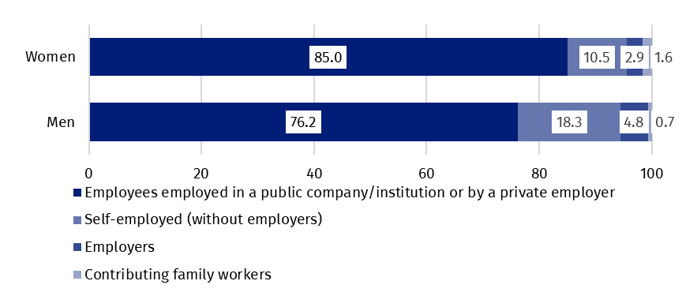
Chart 1. Structure of employed women and men aged 15–89 years by employment status in the main job in the first quarter of 2022 (in %)
In the first quarter of 2022, 822 thousand persons had a job, but were not performing work in the reference week, which accounted for 4.9% of the total number of the employed (the corresponding population in the previous quarter comprised 872 thousand, i.e. 5.2%, while a year ago it was 994 thousand, i.e. 6.0%). Among these persons, 67 thousand (i.e. 8.2%) indicated that it was directly related to the COVID-19 pandemic (in the previous quarter it was 77 thousand persons, which accounted for 8.8 %, while in the first quarter of 2021 it comprised 235 thousand, i.e. 23.6%).
The impact of the COVID-19 pandemic was observed in the data regarding the place of performing work to a similar extent as in the previous quarter. In the first quarter of 2022, the number of persons performing their work usually or sometimes at home comprised 2450 thousand, which accounted for 14.7% of the total number of the employed (in the fourth quarter of 2021, the respective figure was 2206 thousand, i.e. 13.1%, while in the first quarter of 2021 it was 3224 thousand, i.e. 19.6%). Among this population, 975 thousand persons (i.e. 39.8%) worked at home because of the situation connected to the COVID-19 pandemic (in the fourth quarter of 2021, it was 755 thousand, i.e. 34.2%, while in the first quarter of 2021 – 2003 thousand, i.e. 62.1%). In the first quarter of 2022, there were 1564 thousand persons (which accounted for 9.4% of the total number of the employed) who performed their work-related responsibilities in a form of remote work (the place of performing work is not considered here), among them 70.6% performed work in this form due to the COVID-19 pandemic (in the fourth quarter of 2021, remote work performed 1139 thousand, i.e. 6.8% of the total number of the employed, among whom 69.2% - due to the pandemic, while in the first quarter of 2021 it was 2422 thousand, i.e. 14.7% of the total number of the employed, of which 89.7% - due to the pandemic).
9.4% of the employed worked in a form of remote work – for over 2/3 of them it was directly connected with the pandemic

In the first quarter of 2022, unemployed persons accounted for 3.1% of the economically active population aged 15–89. Compared with the fourth quarter of 2021, unemployment rate increased by 0.2 pp., while compared with the same period of the last year it decreased by 0.9 pp. Its intensity was lower in female population than among men (respectively 3.0% vs. 3.2%).
3.1%
Unemployment rate

Unemployed persons by the LFS
Unemployment rate by the LFS in female population was lower than in male population

In the first quarter of 2022, population of the unemployed aged 15–74 years comprised 536 thousand persons and it increased compared with the fourth quarter of 2021 (by 39 thousand, i.e. by 7.8%), while it decreased compared with the same period of 2021 (by 151 thousand, i.e. by 22.0%). The growth in the number of the unemployed compared with the previous quarter occurred regardless of sex, while it was higher among men (by 32 thousand, i.e. by 12.1%) than among women (by 6 thousand, i.e. by 2.6%). Regarding the place of residence, a higher increase was observed among urban residents (by 31 thousand, i.e. by 11.2%), than among rural ones (by 6 thousand, i.e. by 2.7%). Over the year, declines in unemployment were observed in all analysed subpopulations, while as regards division by sex, a decrease was higher among men (a drop by 86 thousand, i.e. by 22.5%), while regarding the place of residence – among urban residents (a drop by 102 thousand, i.e. by 24.8%).
The majority of the unemployed population constituted men – 55.4%, i.e. 297 thousand. As regards the place of residence, urban residents constituted 57.6%, i.e. 309 thousand of this group.
Unemployment rate increased over the quarter in most of the analysed age groups, only among persons aged 25-34 years a minimal drop was observed. Compared with the first quarter of 2021, unemployment rate decreased in all age groups. Still the highest unemployment was observed among youngest persons (aged 15-24 years) for whom unemployment rate comprised 10.2%. Among persons aged 25–34 years unemployment intensity was at the level 3.6%, 35-44 years - 2.6%, 45-89 years – 2.2 %. Among persons at the working age (18– 59/64 years) unemployment rate comprised 3.2 %.
The highest intensity of unemployment is still observed among persons aged 15–24 years
Compared with the fourth quarter of 2021, an increase in unemployment rate was observed for most groups specified according to the level of education: among persons with lower secondary, primary, incomplete primary and without school education (by 2.4 percentage points to 9.3%), post-secondary and vocational secondary (by 0.3 percentage point to 3.1%), basic vocational/sectoral (by 0.2 percentage point do 3.9%), tertiary (by 0.1 percentage point to 1.5%). Only among persons with general secondary education unemployment rate stayed the same and comprised 4.4%. Over the year, a drop in unemployment rate was observed in all groups specified by level of education. The highest drop was recorded among persons with general secondary education and among persons with lower secondary, primary, incomplete primary and without school education (respectively by 1.8 percentage point and 1.2 percentage point).
To the greatest extent, unemployment affected persons with the lowest level of education

The largest population of the unemployed constituted persons who lost a job (45.3%, i.e. 243 thousand). The share of persons re-entering work after a break accounted for 27.4% (147 thousand), the share of persons taking up their first job accounted for 14.2% (76 thousand), while the share of persons who resigned from work was the lowest – 13.1% (70 thousand).

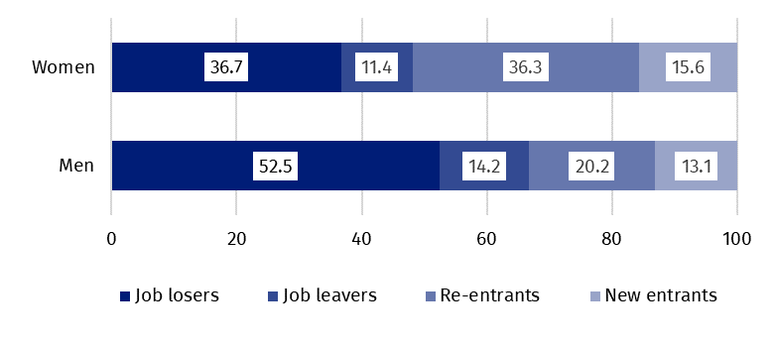
Chart 2. Structure of unemployed persons by the source of unemployment and sex in the first quarter of 2022 (in %)
In the first quarter of 2022, among 402 thousand unemployed persons previously employed, 20 thousand persons (5.0%) declared the situation caused by the COVID-19 pandemic as the reason for termination of the last performed work (in the previous quarter it was 68 thousand persons, i.e. 18.1%, while a year ago – 142 thousand persons, i.e. 27.3%). Among this group, 15 thousand persons (i.e. 75.0%) indicated liquidation of an establishment or a work position as a direct reason for termination of the last performed work.
Every twentieth person previously employed indicated the loss or termination of work due to the pandemic
In the analysed period, the average duration of a job search comprised 8.2 months (in the previous quarter it was 8.3 months, while a year ago – 7.4 months). Persons who were seeking a job for the longest duration were the ones aged 55–74 years (10.0 months), aged 35– 44 years and 45–54 years (8.7 months each), while the shortest job search duration was observed for the youngest persons, in the age group 15–19 years (5.0 months).

In the first quarter of 2022, economically inactive persons accounted for 42.0 % of the total number of the populating aged 15–89 years. The percentage stayed at the same level compared to the previous quarter, while it decreased over the year (a drop by 0.7%).
42.0%
The share of economically inactive persons in the total number of the population aged 15–89 years

Economically inactive persons aged 15–89 by the LFS
In the first quarter of 2022, the population of economically inactive persons aged 15-89 years comprised 12511 thousand. It reached a slightly lower level compared with the fourth quarter of 2021 (by 18 thousand, i.e. by 0.1%), whereas compared with the first quarter of 2021, a much higher decline in the number of this population was observed (by 267 thousand, i.e. by 2.1%).
A significant decrease in the number of the population observed over the year was irrespective of both: sex and the place of residence (the highest drop – by 2.5 percentage points was observed among women, while regarding the place of residence – in urban areas – by 2.3 percentage points).
Women still constitute the majority of the economically inactive population
Over a half of economically inactive persons constituted women – 61.4%, i.e. 7683 thousand. As regards the place of residence, urban residents constituted 59.4% of this population (i.e. 7436 thousand).
The economically inactive population is a specific one in respect to the labour market resources, as its scope includes persons who have not entered the labour market yet (including the majority of the youth still participating in education), persons who have definitely left the labour market or will never enter the labour market (some retirees, pensioners, persons maintaining themselves from other sources than work), but also persons who entered the labour market, then partially deactivated and who will want to re-enter the labour market after a break.
In the first quarter of 2022, over a half of the economically inactive persons aged 15-74 years comprising 10331 thousand (the reason for inactivity was determined for this age group) constituted retirees (51.5%), while the second largest group were students (21.6%). Whereas, in the case of economically inactive persons at the working age (4132 thousand), the most often reasons for inactivity were: education and training (29.8%), illness and disability (24.3%), family responsibilities (19.2%), discouragement with unsuccessful job search (1.4%), and retirement (9.9%).
Chart 3. Structure of economically inactive persons aged 15-74 years by sex and reasons for inactivity in the first quarter of 2022 (in %)

Prepared by:  Labour Market Department  Director Agnieszka Zgierska  Phone: (+48 22) 608 30 15 | Issued by:  The Spokesperson for the President  of Statistics Poland  Karolina Banaszek  Phone: (+48) 695 255 011
Press Office  Phone: (+48 22) 608 38 04  e-mail: obslugaprasowa@stat.gov.pl | www.stat.gov.pl/en/
 | @StatPoland
 | @GlownyUrzadStatystyczny
 | gus_stat
 | glownyurzadstatystycznygus
 | glownyurzadstatystyczny
Related information
Methodological report. Labour Force Survey (the methodology valid until the end of 2020)
Labour Force Survey in Poland
Other publications containing the results of LFS and its module surveys
stat.gov.pl → Topics → Labour Market
Data available in databases
Strateg → Topics → Labour Market
Local Data Bank → labour Market
Terms used in official statistics
Economic activity by LFS
Economically active population by LFS
Employed persons by LFS
Unemployed persons by LFS
Economically inactive population according to the LFS

Activity rate by LFS
Employment rate by LFS
Unemployment rate by LFS

The LFS results concern the population staying or planning to stay in the country’s territory for at least 12 months, living in private households. The main information concerning the population covered by the survey and applied definitions is available in the quarterly publication Labour Force Survey in Poland

