Employed, unemployed and economically inactive persons (preliminary results of the Polish Labour Force Survey)
In the second quarter of 2022, economically active persons accounted for 57.9% of the population aged 15–89 years. Compared with the first quarter of 2022, the rate decreased by 0.1 pp., while compared with the second quarter of 2021, it increased by 0.3 pp.
57.9%
Activity rate of persons aged 15-89 years

Economic activity of the population aged 15-89 years by the LFS
Compared with the previous quarter as well as over the year, activity rate for persons aged 15–89 years increased among women, while it decreased among men
In the second quarter of 2022, the number of economically active persons aged 15–89 years comprised 17224 thousand, of which: 16770 thousand constituted employed persons, while 454 thousand – unemployed persons. The economically inactive population in this age group comprised 12508 thousand persons.
A small changes were recorded in the group of economically active persons. Compared with the first quarter of 2022, the number of this population decreased by 26 thousand, i.e. by 0.2%, while compared with the corresponding period of the last year it increased by 21 thousand, i.e. by 0.1%.
In the second quarter of 2021, the share of economically active persons in the total number of persons aged 15-89 years was higher among men and accounted for 65.7%, while in the population of women it stayed at a lower level – 50.8% (respective figures for persons at the working age are 83.0% and 76.6%). Corresponding indicators for urban residents and rural residents respectively accounted for: 57.8% and 58.1% (at the working age: 81.9% and 77.4%).
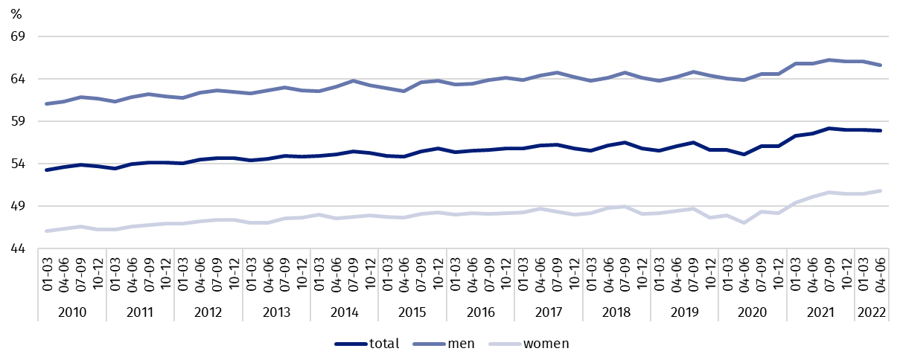
Chart 1. Activity rate of persons aged 15-89 years
The index describing the
relation of jobless persons to the number of employed persons decreased compared to the previous quarter as well as over the year
The indicator defining the ratio of the number of not working persons (the unemployed aged 15-74 years and the economically inactive aged 15-89 years) to the number of employed persons (aged 15-89 years) decreased compared with both: the previous quarter and the same period of 2021. In the second quarter of 2022, there were 773 jobless persons aged 15-89 years per 1000 employed persons (in the first quarter of 2022 there were 781 persons, while in the second quarter of 2021 there were 799 persons).

In the second quarter of 2021, employed persons accounted for 56.4% of the population aged 15–89 years. Compared with the previous quarter of 2022 as well as the same period of 2021, the employment rate increased by 0.2 pp. and 0.8 pp. respectively. It was higher in the population of men (64.1%) than women (49.3%).
56.4%
Employment rate
of persons aged 15-89 years

Employed persons aged 15-89 years by the LFS
The population of employed persons increased compared with both: the previous quarter as well as the corresponding period of 2021
In the second quarter of 2022, the population of employed persons aged 15-89 years comprised 16770 thousand persons and it increased compared with the previous quarter (by 56 thousand, i.e. by 0.3%) as well as compared with the second quarter of 2021 (by 173 thousand, i.e. 1.0%).
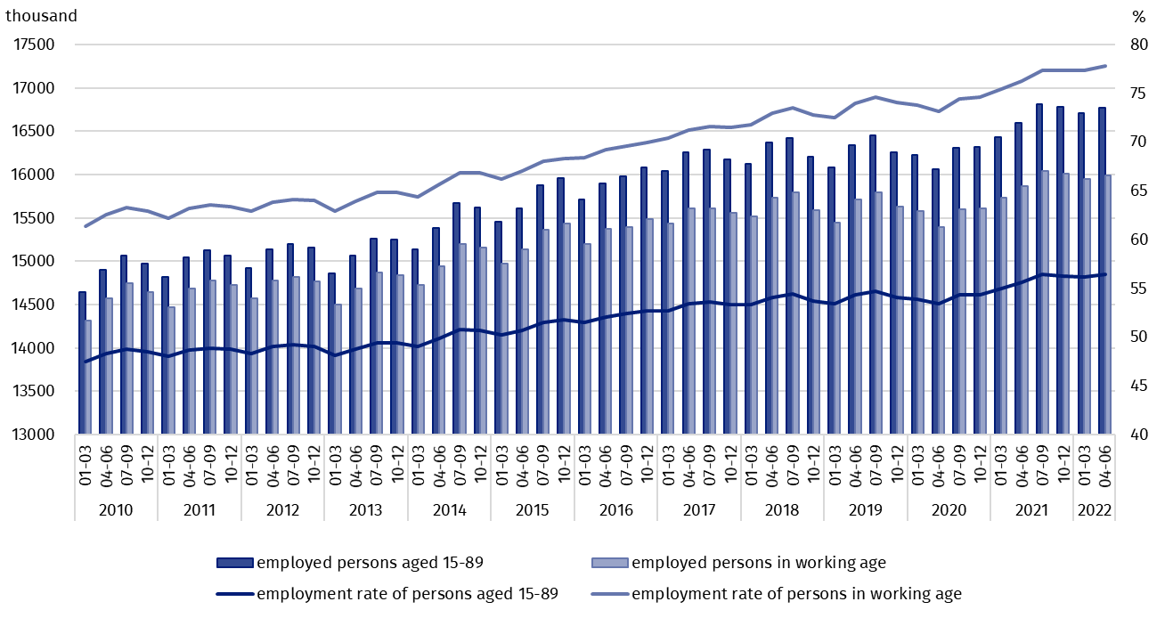
Chart 2. Employed persons and employment rate of persons aged 15-89 years and in the working age

As regards division by sex, the number of the employed increased over the quarter among women (a growth by 50 thousand, i.e. by 0.7%), while among men it stayed at a similar level. Taking into account the place of residence, a growth in the number of the employed occurred among rural residents – by 0.8% (by 54 thousand persons), whereas in urban areas the number of the employed did not change significantly.
Over the year, the number of employed women increased (by 113 thousand, i.e. by 1.5%) as well as the number of men (by 60 thousand, i.e. by 0.7%). A growth in the number of employed persons was recorded among rural residents (by 169 thousand, i.e. by 2.6%), while among urban residents the population of the employed stayed at a similar level.
The dominant among the employed were still men, who constituted 54.5% (i.e. 9133 thousand) of this population. While, as regards the place of residence, the share of urban residents accounted for 59.5% (i.e. 9982 thousand persons).
In the second quarter of 2022, the employment rate total accounted for 56.4% and was higher among men (64.1%) than among women (49.3%). A similar level of the rate was re-corded in urban areas (56.4%) as well as in rural areas (56.5%). Compared with the previous quarter, as well as over the year, a growth in the indicator occurred irrespective of both: sex and the place of residence.
The LFS results indicate that in the second quarter of 2022:
The number of persons employed full-time decreased compared with the previous quarter, albeit it increased compared with the corresponding period of the last year
- 15633 thousand persons performed full-time work, while 1136 thousand worked part-time,
- average number of hours worked in the main job in the reference week comprised 38.9 hours,
- among the total number of employed persons, the share of employees employed in public companies/institutions or by a private employer accounted for 79.8% (13379 thousand persons), self-employed persons 19.0%, while contributing family workers 1.2%,
- a decided majority of employees employed in public companies/institutions or by a private employer performed their work on the basis of a contract for unlimited duration (84.1%, i.e. 11253 thousand),
- most persons were employed in manufacturing – 3251 thousand (i.e. 19.4% of the total number of the employed). Over 13% (2253 thousand persons) were employed in wholesale and retail trade; repair of motor vehicles and motorcycles. The next place occupied persons employed in section agriculture, forestry and fishing - 8.5% of the employed (1430 thousand persons), while 8.1% (1354 thousand persons) were employed in construction.
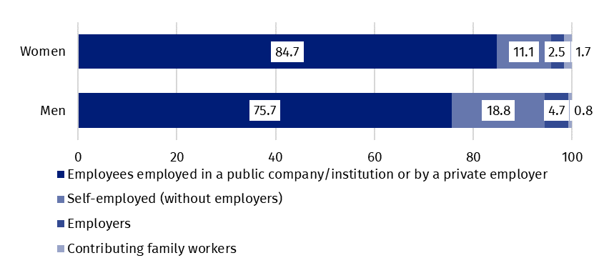
Chart 3. Structure of employed women and men aged 15–89 years by employment status in the main job in the second quarter of 2022 (in %)
In the second quarter of 2022, the highest growth in the number of the employed compared with the previous quarter was recorded in public administration and defence; compulsory social security (by 59 thousand), agriculture, forestry and fishing (by 58 thousand), and in administrative and support service activities (by 55 thousand). Whereas, the highest drop occurred in manufacturing (by 84 thousand), transportation and storage (by 54 thousand) and financial and insurance activities (by 45 thousand).
Compared with the second quarter of 2021, the highest growth in the number of the employed took place in agriculture, forestry and fishing (by 65 thousand), in administrative and support service activities (by 50 thousand) and in manufacturing (by 48 thousand), while the highest drop in wholesale and retail trade; repair of motor vehicles and motorcycles (by 79 thousand), and information and communication (by 21 thousand).
In the second quarter of 2022, 713 thousand persons had a job, but were not performing work in the reference week, which accounted for 4.3% of the total number of the employed (the corresponding population in the previous quarter comprised 822 thousand, i.e. 4.9%, while a year ago it was 839 thousand, i.e. 5.1%). Among these persons, 711 thousand (i.e. 99.7%) indicated that it was not directly related to the COVID-19 pandemic.
The COVID-19 pandemic influenced the place of performing work to a similar extent as in the previous quarter. In the second quarter of 2022, the number of persons performing their work usually or sometimes at home comprised 2078 thousand, which accounted for 12.4% of the total number of the employed. Among this population, 287 thousand persons (i.e. 13.8%) worked at home because of the situation connected to the COVID-19 pandemic. In the se-cond quarter of 2022, there were 926 thousand persons (which accounted for 5.5% of the total number of the employed) who performed their work-related responsibilities in a form of remote work (the place of performing work is not considered here), among them 31.0% performed work in this form due to the COVID-19 pandemic.
5.5% of employed persons were employed in a form of remote work – for almost 1/3 it had a direct conne-ction with the pandemic

In the second quarter of 2022, unemployed persons accounted for 2.6% of the economically active population aged 15–89 years. Compared with both: the previous quarter and the corresponding period of the last year, unemployment rate decreased respectively by 0.5 pp. and 0.9 pp. The intensity of unemployment was lower among the population of men than women (respectively 2.3% vs. 3.0%).
2.6%
Unemployment rate of persons aged 15-89 years

Unemployed persons by the LFS
In the second quarter of 2022, population of unemployed persons aged 15-74 years comprised 454 thousand and it decreased compared with the first quarter of 2022 (by 82 thousand, i.e. by 15.3%), as well as compared with the second quarter of 2021 (by 152 thousand, i.e. by 25.1%).
In the second quarter of 2022, the majority of the unemployed population constituted women – 52.6%, i.e. 239 thousand, while regarding the place of residence, urban residents (56.8% of this group, i.e. 258 thousand).
A drop in the number of unemployed persons compared with the previous quarter was caused by a decrease in the number of unemployed men (by 82 thousand, i.e. by 27.6%), while the number of unemployed women stayed at a similar level. As regards the place of residence, a drop occurred among both: urban residents (by 51 thousand, i.e. by 16.5%) as well as in rural areas (by 30 thousand, i.e. by 13.3%).
Reduction in unemployment over the year was observed in all analysed subpopulations, while according to the division by sex it occurred to a greater extent among men (a drop by 118 thousand, i.e. by 35.4%), while taking into account the place of residence – among urban residents (a drop by 109 thousand, i.e. by 29.7%).
Unemployment rate by the LFS in the male population was lower than in the female population

In the second quarter of 2022, the unemployment rate comprised 2.6%. The lower unemployment rate was among men than women and it respectively accounted for 2.3% and 3.0%.
Compared with the previous quarter, the unemployment intensity decreased by 0.5 pp., while in the population of men by 0.9 pp., albeit in the population of women it did not change. In the case of urban residents, a drop in this indicator comprised 0.5 pp., while in the rural areas – 0.4 pp.
A drop in unemployment rate by 0.9 pp. occurred also over the year, among men by 1.2 pp., while among women by 0.5 pp. Taking into account the place of residence, a drop was observed in both: urban areas (by 1.0 pp.) and rural areas (by 0.7 pp.).
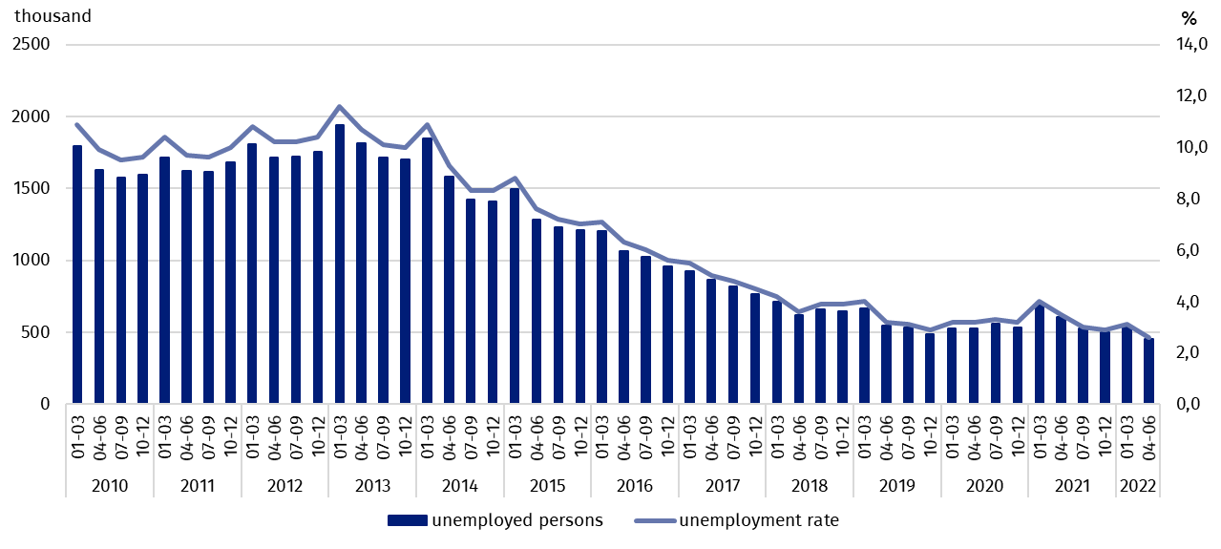
Chart 4. Unemployed persons aged 15-74 years and unemployment rate of persons aged 15-89 years

Unemployment rate decreased over both: the quarter and year for most of the analysed age groups. Still the highest unemployment was observed among the youngest persons (aged 15–24 years), whose unemployment rate comprised 8.9%. Among persons aged 25–34 years, unemployment intensity was at the level of 3.0%, 35–44 years – 2.0%, 45–89 years – 2.0 %. Among persons at the working age (18–59/64 years) the unemployment rate accounted for 2.7%.
To the greatest extent, unemployment affected persons with the lowest level of education

Compared with the previous quarter as well as the corresponding period of the last year, a drop in unemployment rate was observed in all groups specified according to the level of education, while over the quarter the highest decrease in this indicator was recorded among persons with lower secondary, primary, incomplete primary and without school education (a drop from 9.3% to 6.8%). Over the year, unemployment rate decreased most among persons with post-secondary and vocational secondary education (a drop from 4.1% to 2.7%).
The largest population of the unemployed constituted persons who lost a job (43.9%, i.e. 199 thousand). The share of persons re-entering employment after a break comprised 27.6% (125 thousand), taking up work for the first time 14.4% (65 thousand), while the share of persons who resigned from work was the lowest – 14.1% (64 thousand).
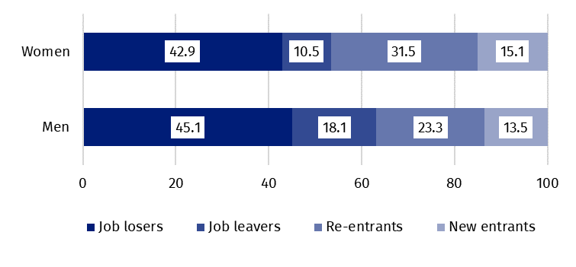
Chart 5. Structure of unemployed persons by the source of unemployment and sex in the second quarter of 2022 (in %)
In the second quarter of 2022, among 344 thousand unemployed persons previously employed, 19 thousand persons (5.5%) declared the situation caused by the COVID-19 pandemic as the reason for termination of the last performed work (in the previous quarter it was 20 thousand persons, i.e. 5.0%, while a year ago – 110 thousand persons, i.e. 23.6%). Among this group, 14 thousand persons (i.e. 73.7%) indicated liquidation of an establishment or a work position as a direct reason for termination of the last performed work.
Every eighteenth person previously employed indicated the loss or termination of work due to the pandemic
In the analysed period, the average duration of a job search comprised 8.7 months (in the previous quarter it was 8.2 months, while a year ago – 8.1 months). Persons who were seeking a job for the longest duration were the ones aged 55 – 74 years (10.5 months) and aged 45 – 54 years (10.1 months), while the ones whose job search duration was the shortest were the youngest persons, aged 15 – 19 years (2.5 months).

In the second quarter of 2022, economically inactive persons accounted for 42.1% of the total number of the population aged 15–89 years. The percentage stayed at the slightly higher level compared with the previous quarter (an increase by 0.1 pp.), while it decreased over the year (a drop by 0.3 pp.).
42.1%
The share of economically ina-ctive persons in the total number of the population aged 15–89 years

Economically inactive persons aged 15–89 by the LFS
In the second quarter of 2022, the population of economically inactive persons aged 15-89 years comprised 12508 thousand and it was at a similar level as in the first quarter of 2022 and evidently lower than a year ago (compared with the second quarter of 2021, a drop was observed by 143 thousand, i.e. 1.1%).
Women still constitute the majority of the economically inactive population
Over a half of the economically inactive persons constituted women – 60.9%, i.e. 7618 thousand. As regards the place of residence, urban residents accounted for 59.7% of this population (i.e. 7469 thousand).
Over the quarter, the number of economically inactive women decreased (by 65 thousand, i.e. by 0.8%), while a growth was observed among men – by 62 thousand, i.e. by 1.3%. In the case of rural residents, there was recorded a drop in the number of economically inactive persons (by 36 thousand, i.e. by 0.7%), while among urban residents a growth was observed – by 33 thousand, i.e. by 0.4%.
Recorded over the year a significant decrease in this population was caused mainly by a drop in the number of economically inactive women (by 139 thousand, i.e. by 1.8%), while among men the number of this group stayed at a similar level. Taking into account the place of residence, a decidedly higher drop in the number of economically inactive persons occurred among rural residents (by 132 thousand, i.e. by 2.6%), than among urban residents (a drop by 11 thousand, i.e. by 0.1%).
The economically inactive population is a specific one in respect to the labour market resources, as its scope includes persons who have not entered the labour market yet (including the majority of the youth still participating in education), persons who have definitely left the labour market or will never enter the labour market (some retirees, pensioners, persons maintaining themselves from other sources than work), but also persons who entered the labour market, then partially deactivated and who will want to re-enter the labour market after a break.
In the second quarter of 2022, over a half of the economically inactive persons aged 15-74 years comprising 10297 thousand (the reason for inactivity was determined for this age group) constituted retirees (51.2%), while the second largest group were students (21.5%).
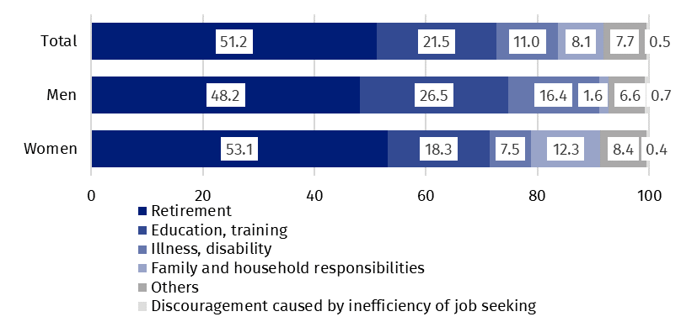
Chart 6. Structure of economically inactive persons aged 15-74 years by sex and reasons for inactivity in the second quarter of 2022 (in %)
In the case of economically inactive persons at the working age (4114 thousand), the most often reasons for inactivity were: education and training (29.3%), illness and disability (24.1%), family responsibilities (19.3%), retirement (9.2%), and discouragement with unsuccessful job search (1.2%).

Methodological notes

The presented news release was prepared on the basis of the generalised results of the sample survey Badanie Aktywności Ekonomicznej Ludności/BAEL (the Polish equivalent of the European survey on the labour force - Labour Force Survey/LFS) in the second quarter of 2022.
Badanie Aktywności Ekonomicznej Ludności has been carried out in Poland quarterly since May 1992 and it has been improved in accordance with the Eurostat recommendations.
From the first quarter of 2021 onwards, the base of the EU-LFS methodology are definitions of the employed, the unemployed and economically inactive persons in accordance with the Resolution concerning statistics of work, employment and labour underutilization adopted in 2013 on the 19th International Conference of Labour Statisticians in Geneva (ICLS) and recommended by the International Labour Organization (ILO) for the use in all countries. The survey object is the situation within the scope of economic activity of the population, i.e. the fact of performing work, being unemployed or economically inactive persons in the reference week. In the European Union, the implementation of the provisions of the above mentioned Resolution was carried out through introduction of new legal acts. From 2021 onwards, EU-LFS has been one of the key surveys embraced by the framework regulation for social statistics (the so-called IESS FR). Accompanying IESS FR implementing regulations in the domain of the labour force specify the range of the core survey and module surveys, determine survey organisation and define in detail particular populations specified according to the status of persons in the labour market.
Due to the implementation of the methodological changes, from the first quarter of 2021, the BAEL data cannot be compared with the previous periods (with the exception of the recalculated data). For the purposes of carrying out comparative analyses for longer time series, Statistics Poland prepared historical data from the BAEL for the years 2010–2020 compiled in accordance with definitions of the main population categories specified according to their labour market status, i.e. the employed, the unemployed and economically inactive persons, obligatory from 2021 onwards. The data are available on the Statistics Poland website: recalculated LFS data for the years 2010-2020
Detailed results of the survey as well as the up-dated methodology – obligatory from the first quarter of 2021, are included in the quarterly publication “Labour Force Survey in Poland” available on the Statistics Poland website:
https://stat.gov.pl/en/topics/labour-market/working-unemployed-economically-inactive-by-lfs/labour-force-survey-in-poland-quarter-12022,2,45.html
Prepared by:  Labour Market Department  Director Agnieszka Zgierska  Phone: (+48 22) 608 30 15 | Issued by:  The Spokesperson for the President  of Statistics Poland  Karolina Banaszek  Phone: (+48) 695 255 011
Press Office  Phone: (+48 22) 608 38 04  e-mail: obslugaprasowa@stat.gov.pl | www.stat.gov.pl/en/
 | @StatPoland
 | @GlownyUrzadStatystyczny
 | gus_stat
 | glownyurzadstatystycznygus
 | glownyurzadstatystyczny
Related information
Methodological report. Labour Force Survey (the methodology valid until the end of 2020)
Labour Force Survey in Poland
Other publications containing the results of LFS and its module surveys
stat.gov.pl → Topics → Labour Market
Data available in databases
Strateg → Topics → Labour Market
Local Data Bank → labour Market
Terms used in official statistics
Economic activity by LFS
Economically active population by LFS
Employed persons by LFS
Unemployed persons by LFS
Economically inactive population according to the LFS

Activity rate by LFS
Employment rate by LFS
Unemployment rate by LFS

The LFS results refer to the population staying or intending to stay in the country’s territory for at least 12 months, living in private households.
Men aged 18-64 years and women aged 18-59 years.
The data from the first quarter of 2010 to the fourth quarter of 2020 were recalculated in accordance with the definitions obligatory in the LFS from 2021 onwards.
The data from the first quarter of 2010 to the fourth quarter of 2020 were recalculated in accordance with the definitions obligatory in the LFS from 2021 onwards.

