Prices of agricultural products in July 2022
Procurement prices of basic agricultural products increased in July 2022 in comparison with the previous month (by 1.0%) as well as while compared to the corresponding month of the previous year (by 51.6%).
51.6%
an increase in procurement prices of basic agricultural products in comparison with July 2021

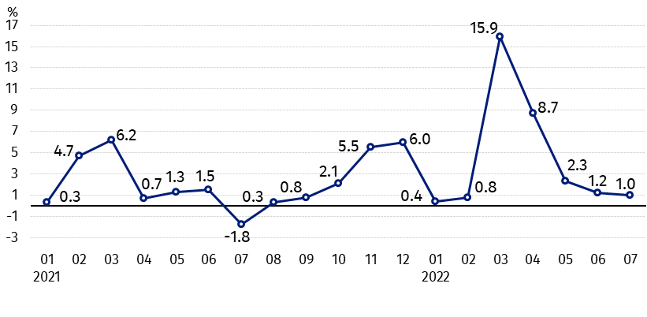
Chart 1. Changes in procurement prices of basic agricultural products in relation to the previous month
In July 2022 compared to June 2022 procurement prices of pigs for slaughter, poultry and cows’ milk increased

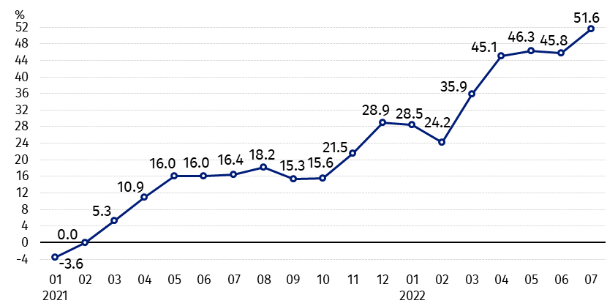
Chart 2. Changes in procurement prices of basic agricultural products in relation to the corresponding month of the previous year
Procurement prices of all basic agricultural products in July 2022 were much higher than a year ago

Procurement prices and marketplace prices received by farmers
In July 2022 compared to the previous month, both in procurement and on marketplaces, prices of cereal, potatoes and cattle for slaughter decreased. However, procurement prices of pigs for slaughter, poultry and cows’ milk were higher than in June this year.
In comparison with the corresponding month of the previous year, in July 2022, much higher growth in procurement prices and marketplaces prices of all agricultural products was recorded. The prices of cereal and cows’ milk in procurement increased the most.

Table 1. Prices of agricultural products (excluding VAT) in July 2022
Specification | Procurement prices |  |  | Marketplaces prices
 | 07 2022 |  |  | 07 2022
 | in zloty | 06 2022=100 | 07 2021=100 | in zloty ª | 06 2022=100 | 07 2021=100
Cereal grain – per 1 dt
Wheat | 155.68 | 93.4 | 181.7 | 174.33 | 97.1 | 164.7
Rye | 126.99 | 92.5 | 183.5 | 130.03 | 97.9 | 170.0
Barley | 125.02 | 88.9 | 178.4 | 152.29 | 96.6 | 165.4
Triticale | 135.09 | 89.6 | 180.7 | 149.88 | 99.0 | 174.0
Oat | 110.31 | 94.8 | 172.1 | 128.73 | 98.1 | 171.3
Maize | 136.10 | 98.8 | 134.5 | 172.68 | 99.9 | 149.8
Potatoes– per 1 dt | 82.50 | 87.9 | 106.9 | 138.94 | 90.7 | 134.7
Animals for slaughter – per kg
Cattle (excl. calves) | 10.74 | 98.2 | 144.9 | 9.58 | 88.5 | 134.9
of which young cattle | 10.79 | 98.3 | 142.9 | 10.05 | 89.7 | 136.7
Pigs | 7.21 | 104.1 | 141.4 | 6.93 | 93.1 | 110.4
Poultry | 6.60 | 100.7 | 143.0 | . | . | .
Cows’ milk – per 1 hl | 233.67 | 102.9 | 156.4 | . | . | .
a – No data.
Data on procurement prices were calculated on the basis of information on value and quantity of procurement by legal persons and independent organizational entities without legal personality (without natural persons).
Indices of procurement prices and prices received by farmers on marketplaces were calculated on the basis of absolute data expressed with more precision than In the tables.

Prices of major agricultural products in July 2022
In July 2022 procurement prices of wheat (155.68 PLN per dt) decreased as related to the previous month (by 6.6%), but it was higher than a year ago (by 81.7%). On marketplaces, 174.33 PLN was paid per 1 dt of wheat, i.e. by 2.9% less than in June this year, while by 64.7% more than in July last year.
The price of rye in procurement amounted to 126.99 PLN per dt, and was lower by 7.5% than in June this year, while higher by 83.5% than a year ago. In marketplace transactions, rye prices (130.03 PLN per dt) decreased compared to the previous month (by 2.1%), but increased in comparison with the corresponding period of the previous year (by 70.0%).
In July 2022 the price of potatoes in procurement (82.50 PLN per dt) was decreased by 12.1% compared to June this year, but it was increased by 6.9% in an annual terms. On marketplaces, 138.94 PLN was paid per 1 dt of potatoes, i.e. by 9.3% less than in the previous month, but by 34.7% more than a year ago.

The procurement price of cattle for slaughter (10.74 PLN per kg) decreased by 1.8% as related to the previous month, but increased by 44.9% than a year ago. On marketplaces 9.58 PLN per kg was paid for cattle for slaughter, i.e. by 11.5% less than in June this year, while more than in July 2021 by 34.9%.
In July 2022 the price of pigs for slaughter in procurement amounted to 7.21 PLN per kg and was higher in comparison with the previous month as well as in relation to the corresponding period of the last year - respectively by 4.1% and by 41.4%. On marketplaces, 6.93 PLN was paid per 1 kg of this livestock, i.e. by 6.9% less than in June this year, but by 10.4% more than in July 2021.
The procurement price of poultry for slaughter (6.60 PLN per kg) increased in relation to the previous month (by 0.7%), as well as in comparison with July last year (by 43.0%).
233.67 PLN was paid in procurement per 1 hl of cows’ milk, i.e. by 2.9% more than in June 2022 and by 56.4% more than a year ago.

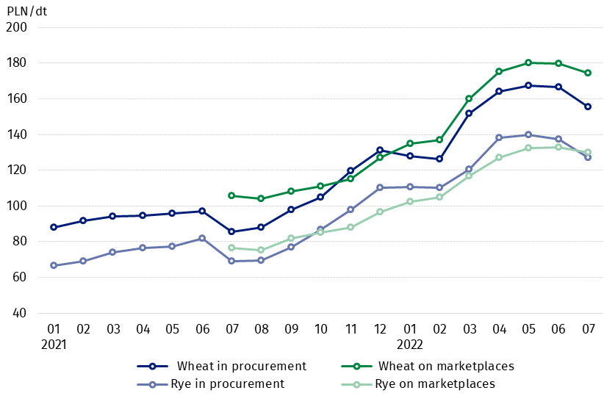
Chart 3. Procurement and marketplaces prices of wheat and rye

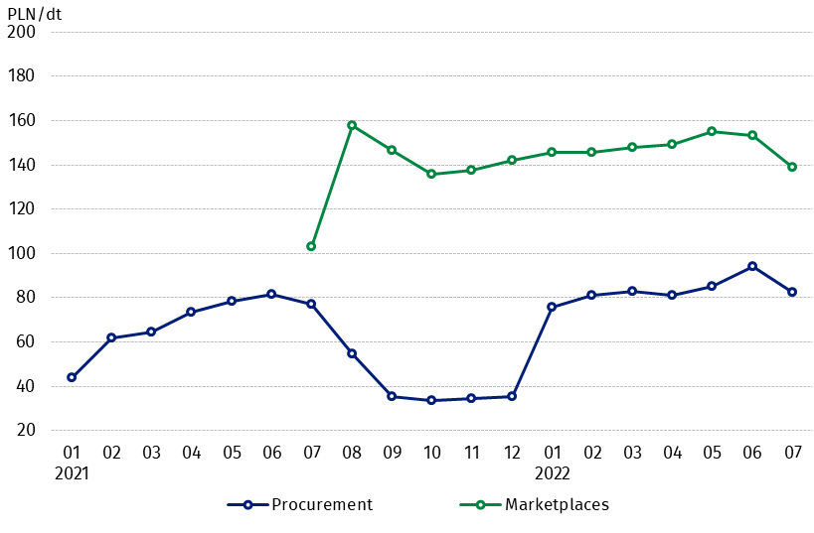
Chart 4. Procurement and marketplaces prices of potatoes

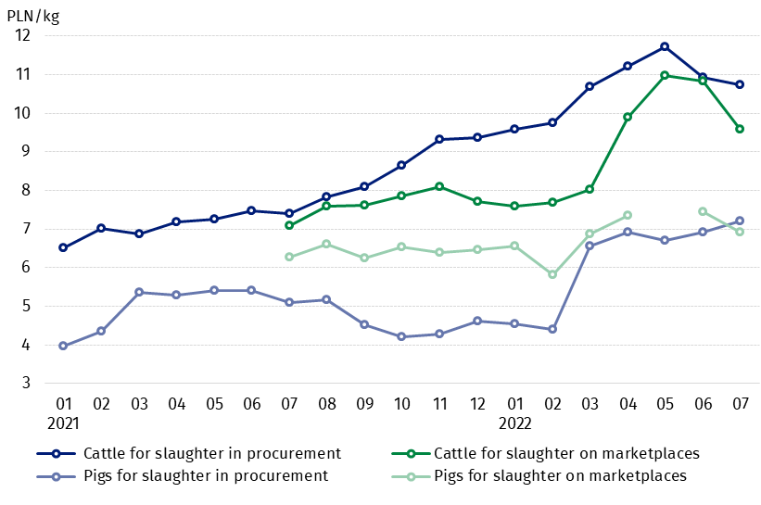
Chart 5. Procurement and marketplaces prices of cattle for slaughter and pigs for slaughter

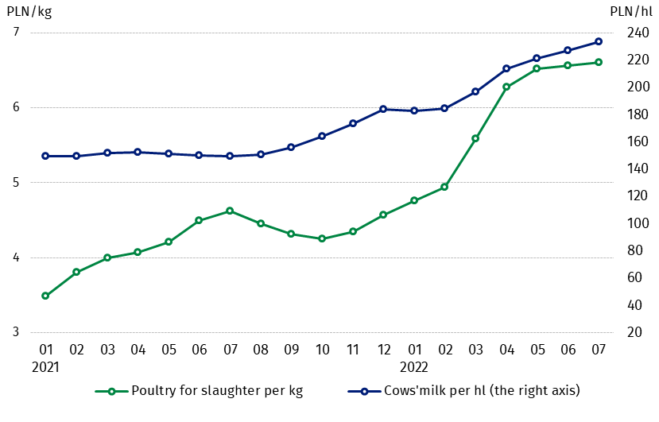
Chart 6. Procurement prices of poultry for slaughter and cows’ milk

The differentiation of the level of prices of basic agricultural products in particular voivodships is presented in Table 2 for procurement prices and in Table 3 for prices obtained by farmers on marketplaces (Excel sheet).
In case of quoting Statistics Poland data, please provide information: “Source of data: Statistics Poland”, and in case of publishing calculations made on data published by Statistics Poland, please include the following disclaimer: “Own study based on figures from Statistics Poland”.

Prepared by:  Trade and Services Department  Director Ewa Adach-Stankiewicz  Phone: (+48 22) 608 31 24 | Issued by:  The Spokesperson for the President  of Statistics Poland  Karolina Banaszek  Phone: (+48) 695 255 011
Press Office  Phone: (+48 22) 608 38 04  e-mail: obslugaprasowa@stat.gov.pl | www.stat.gov.pl/en/
 | @StatPoland
 | @GlownyUrzadStatystyczny
 | gus_stat
 | glownyurzadstatystycznygus
 | glownyurzadstatystyczny
Related information
Socio-economic situation of the country in 2022
Procurement and prices of agricultural products in 2021
Prices in the national economy in 2020

Data available in databases
BDL - Prices in agriculture (monthly and annual data)
DBW - Prices in agriculture (monthly and annual data)

Terms used in official statistics
Procurement of agricultural products
Procurement prices
Marketplace
Marketplace prices

Wheat, rye, cattle for slaughter, pigs for slaughter, poultry, cows’ milk
Procurement prices – excluding sowing seed.
Procurement prices – total (of which: edible early kinds, seeds, edible late, industrial, of which starch). Marketplaces prices – edible excluding early kinds.
Marketplaces prices – average weighted price of cattle for slaughter calculated with the adoption of the structure of procurement quantity of young cattle and cows for slaughter.

