Price indices of sold production of industry in January 2023

According to preliminary data, the prices of sold production of industry in January 2023 increased compared to December 2022 by 0.8% and compared to that recorded in the corresponding month of the previous year - by 18.5%.
18.5%
the growth of producer prices in industry compared to January 2022

Table 1. Price indices of sold production of industry in December 2022 and January 2023

 | 12 2022 |  | 01-12 2022 | 01 2023
Specification | 11 2022=100 | corresponding period 2021=100 |  | 01 2022=100 | 12 2022=100
Total | 100.6* | 120.5* | 122.4 | 118.5 | 100.8
Mining and quarrying | 100.6 | 123.2 | 126.2 | 127.8 | 108.6
Manufacturing | 99.4* | 115.2* | 118.8 | 113.5 | 99.6
Electricity. gas. steam and air conditioning supply | 107.7* | 168.6* | 154.0* | 158.7 | 104.1
Water supply; sewerage. waste management and remediation activities | 100.1 | 104.7 | 105.6 | 105.0 | 100.9

* Data revised.

Prices changes of sold production of industry in January 2023 compared to December 2022
Among divisions of manufacturing in January 2023 in comparison with the previous month, the highest prices growth was recorded in manufacture of beverages, however the deepest drop - in manufacture of coke and refined petroleum products
According to preliminary data, the prices of sold production of industry in January 2023 increased by 0.8% compared to December 2022. The highest prices growth was recorded in the section mining and quarrying by 8.6%, of which in mining of coal and lignite by 11.5% and in mining of metal ores - by 6.7%. The prices in the section electricity, gas, steam and air conditioning supply grew by 4.1% and in the section water supply; sewerage, waste management and remediation activities - by 0.9%. However, the prices were lower than in December 2022 In the section manufacturing - by 0.4%. Among divisions of manufacturing the deepest prices drop was noticed in manufacture of coke and refined petroleum products (by 8.6%). The prices also decreased, among other things, in manufacture: of computer, electronic and optical products (by 1.1%), of tobacco products (by 0.8%), of paper and paper products (by 0.2%), of wearing apparel as well as of basic metals (by 0.1% each). However, the prices higher than in December 2022 were, among other things, in manufacture: of textiles as well as of electrical equipment (by 0.1% each), of furniture (by 0.2%), of printing and reproduction of recorded media as well as of machinery and equipment (by 0.3% each), of chemicals and chemical products (by 0.4%), of food products as well as of rubber and plastic products (by 0.5% each), of metal products and also of other transport equipment (by 0.6% each), of other non-metallic mineral products (by 0.8%), of products of wood, cork, straw and wicker (by 0.9%), of motor vehicles, trailers and semi-trailers (by 1.0%), of pharmaceutical products (by 1.5%), of leather and related products (by 1.9%). The prices the most increased in manufacture of beverages (by 2.2%).

Prices changes of sold production of industry in January 2023 compared to January 2022
In January 2023 in comparison with the corresponding month of the previous year the most increased the prices in manufacture of coke and refined petroleum products
In January 2023 the prices of sold production of industry compared to the corresponding month of the previous year increased by 18.5%. The prices were higher than in the previous year in all sections of the industry. The prices the most increased in the section electricity, gas, steam and air conditioning supply – by 58.7%. The prices in the section mining and quarrying rose by 27.8%, of which in mining of coal and lignite - by 45.9% and in mining of metal ores - by 6.8%. The prices in manufacturing increased by 13.5%, of which the most in manufacture of coke and refined petroleum products (by 24.9%). The prices were also higher than in the year before in manufacture: of food products (by 23.1%), of other non-metallic mineral products (by 18.6%), of beverages (by 17.1%), of paper and paper products (by 15.5%), of chemicals and chemical products (by 14.6%), of electrical equipment (by 11.9%), of tobacco products (by 11.5%), of products of wood, cork, straw and wicker (by 11.4%), of leather and related products (by 10.2%), of motor vehicles, trailers and semi-trailers (by 10.0%), of furniture (by 8.7%). The prices increased also, among other things, in manufacture: of metal products (by 7.8%), of printing and reproduction of recorded media (by 7.3%), of machinery and equipment (by 6.7%), of other transport equipment (by 6.6%), of rubber and plastic products (by 6.4%), of pharmaceutical products (by 6.0%), of basic metals (by 5.8%), of wearing apparel (by 5.6%) as well as of computer, electronic and optical products (by 4.0%), and also of textiles (by 1.4%). The prices in the section water supply; sewerage, waste management and remediation activities increased in annual terms by 5.0%.

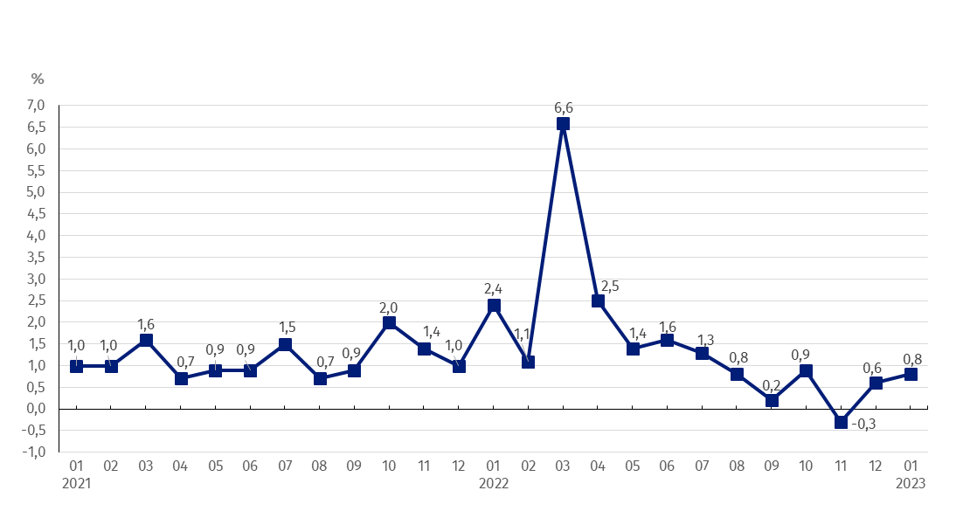
Chart 1. Prices changes of sold production of industry in 2021-2023 in relation to the previous period
In January 2023 in relation to December 2022 the prices growth of sold production of industry was recorded by 0.8%

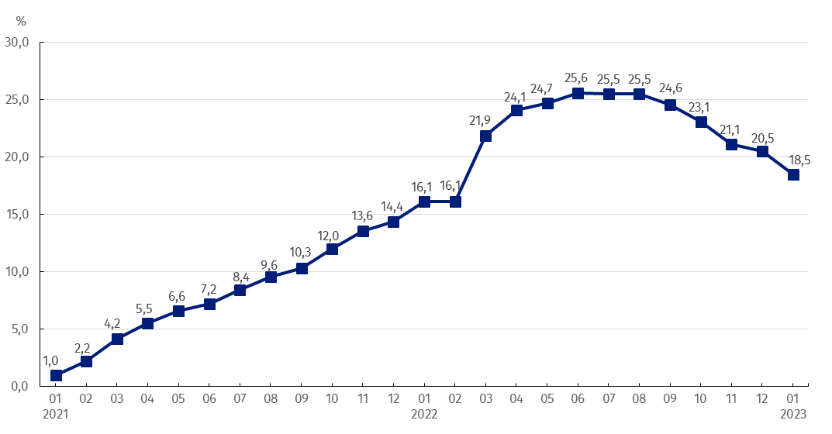
Chart 2. Prices changes of sold production of industry in 2021-2023 in relation to the same period of the previous year
In January 2023 dynamics of prices growth in annual terms amounted to 18.5%

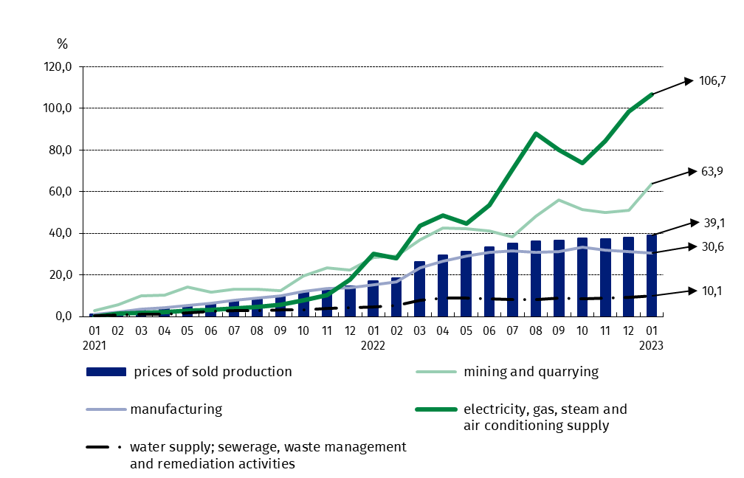
Chart 3. Prices changes of sold production of industry by sections NACE in 2021-2023 in relation to December 2020

In case of quoting Statistics Poland data, please provide information: “Source of data: Statistics Poland”, and in case of publishing calculations made on data published by Statistics Poland, please include the following disclaimer: “Own study based on figures from Statistics Poland”.

Prepared by:  The Trade and Services Department  Director Ewa Adach-Stankiewicz  Phone: (+48 22) 608 31 24 | Issued by:  The Spokesperson for the President  of Statistics Poland  Karolina Banaszek  Phone: (+48) 695 255 011
Press Office  Phone: (+48 22) 608 38 04  e-mail: obslugaprasowa@stat.gov.pl | www.stat.gov.pl/en/
 | @StatPoland
 | @GlownyUrzadStatystyczny
 | gus_stat
 | glownyurzadstatystycznygus
 | glownyurzadstatystyczny
Related information
Statistical Bulletin
News Releases
Data available in databases
Analytical Platform - Knowledge Databases
Macroeconomic Data Bank
Prices indices (Topics: Prices, Trade)
Terms used inn official statistics
Price index of sold production of industry

