Price indices of sold production of industry in December 2021

According to preliminary data, the prices of sold production of industry in December 2021 increased compared to November 2021 by 0.8% and compared to that recorded in the corresponding month of the previous year - by 14.2%.

14.2%



producer prices in industry increased compared to December 2020

# 

**Table 1. Price indices of sold production of industry in December 2021**

|  |  |  |  |  |  |
| --- | --- | --- | --- | --- | --- |
|  | 11 2021 | | 12 2021 | | 01-12 2021 |
| SPECIFICATION | 10 2021=100 | corresponding period 2020=100 | | 11 2021=100 | 01-12  2020=100 |
| **TOTAL** | **101.4\*** | **113.6\*** | **114.2** | **100.8** | **107.9** |
| Mining and quarrying | 103.1* | 126.1* | 122.5 | 99.3 | 119.9 |
| Manufacturing | 101.3* | 113.7* | 113.7 | 100.2 | 107.8 |
| Electricity. gas. steam and air conditioning supply | 102.0* | 110.4* | 116.2 | 105.4 | 105.5 |
| Water supply; sewerage. waste management and remediation activities | 100.7* | 104.3* | 104.0 | 100.2 | 103.8 |

* Data revised.

According to preliminary data, **the prices of sold production of industry** in December 2021 were higher by 0.8% compared to November 2021. The largest prices growth was observed in the section **electricity, gas, steam and air conditioning supply** - by 5.4%. The prices in the section **manufacturing** were also increased by 0.2%, including the most in manufacture of chemicals and chemical products (by 3.0%). The prices growth was recorded also, among others, in manufacture: of food products (by 1.8%), of paper and paper products (by 1.1%), of tobacco products (by 0.9%), of other non-metallic mineral products (by 0.8%), of motor vehicles, trailers and semi-trailers (by 0.7%), of rubber and plastic products (by 0.6%), of machinery and equipment (by 0.4%), of electrical equipment and of furniture (by 0.3% each), of beverages (by 0.2%), of textiles as well as of metal products (by 0.1% each). The prices in manufacture of products of wood, cork, straw and wicker remained at a level similar to that recorded in the previous month. However, the prices decreased, among other things, in manufacture: of printing and reproduction of recorded media (by 0.1%), of pharmaceutical products (by 0.2%), of wearing apparel as well as other transport equipment (by 0.3% each), of basic metals (by 0.8%), of leather and related products as well as of computer, electronic and optical products (by 0.9% each), of coke and refined petroleum products (by 5.7%). The prices in the section **water supply; sewerage, waste management and remediation activities** increased by 0.2%, while in the section **mining and quarrying** theydropped-by 0.7%, of which in mining of metal ores - by 3.3%, with the prices growth in mining of coal and lignite - by 0.7%.

Among divisions of manufacturing in December 2021 in comparison with the previous month the most increased the prices in manufacture of chemicals and chemical products

In December 2021 **the prices of sold production of industry**  compared to December 2020 increased by 14.2%. The prices were higher than in the previous year in all sections of the industry. The prices the most increased in the section **mining and quarrying** - by 22.5%, of which in mining of metal ores - by 27.9% and in mining of coal and lignite - by 21.5%. The prices in the section **electricity, gas, steam and air conditioning supply** rose in annual term by 16.2%. The prices in **manufacturing**  increased by 13.7%, with multidirectional prices movements in individual divisions. The prices the most increased in manufacture of coke and refined petroleum products (by 65.1%). The prices were also higher than in the year before, among other things, in manufacture: of basic metals (by 37.8%), of chemicals and chemical products (by 27.7%), of products of wood, cork, straw and wicker (by 19.9%), of paper and paper products (by 16.0% ), of food products (by 13.3%), of rubber and plastic products (by 12.2%), of metal products (by 11.6%), of other non-metallic mineral products (by 8.0%), of furniture (by 7.6%), of electrical equipment (by 5.7%), of computer, electronic and optical products (by 4.1%), of beverages (by 3.6%), of motor vehicles, trailers and semi-trailers (by 3.2%), of textiles (by 3.1%), of other transport equipment (by 2.7%), of leather and related products (by 2.1%), of tobacco products as well as of machinery and equipment (by 1.9% each), of pharmaceutical products (by 1.5%). However, the prices decreased, among other things, in manufacture: of printing and reproduction of recorded media (by 1.7%) as well as of wearing apparel (by 3.4%). The prices in the section **water supply; sewerage, waste management and remediation activities** increased - by 4.0%.

Among divisions of manufacturing in December 2021 in comparison with the corresponding month of the previous year the most increased the prices in manufacture of coke and refined petroleum products

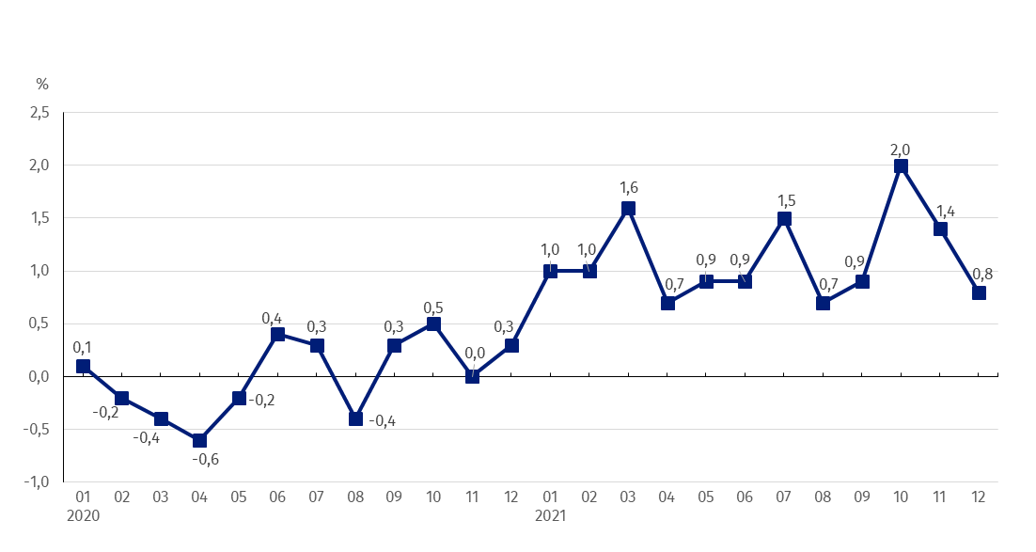 **Chart 1. Prices changes of sold production of industry in 2020-2021 in relation to the previous period**

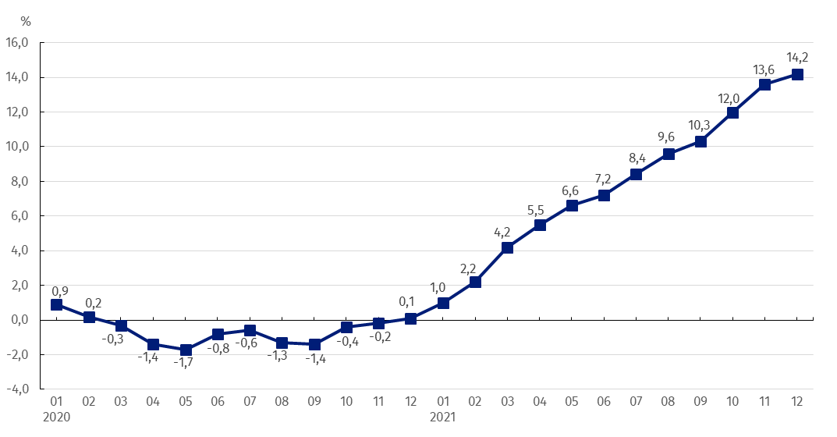**Chart 2. Prices changes of sold production of industry in 2020-2021 in relation to the same period of the previous year**

Starting from December 2020 the growing trend in prices dynamics of sold production of industry is observed in annual terms

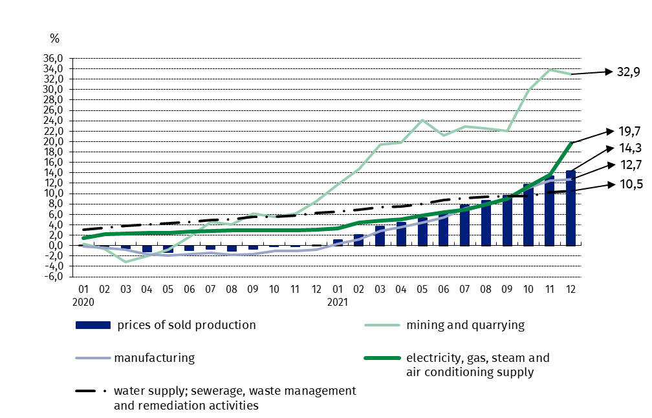Chart 3. Prices changes of sold production of industry by sections NACE in 2020-2021 in relation to December 2019

In case of quoting Statistics Poland data, please provide information: “Source of data: Statistics Poland”, and in case of publishing calculations made on data published by Statistics Poland, please include the following disclaimer: “Own study based on figures from Statistics Poland”.

|  |  |
| --- | --- |
| Prepared by:  **The Trade and Services Department** **Director Ewa Adach-Stankiewicz**Office: tel. (+48 22) 608 31 24 | Issued by: **The Spokesperson for the President**  **of Statistics Poland** **Karolina Banaszek**Mobile: (+48) 695 255 011 |

|  |  |  |
| --- | --- | --- |
| **Press Office**  Office: tel. (+48 22) 608 34 91, 608 38 04  **e-mail:** [**obslugaprasowa@stat.gov.pl**](mailto:obslugaprasowa@stat.gov.pl) |  | www.stat.gov.pl/en/ |
|  | @StatPoland |
|  | @GlownyUrzadStatystyczny |

**Related information**

[Statistical Bulletin](https://stat.gov.pl/en/topics/other-studies/informations-on-socio-economic-situation/statistical-bulletin-no-112021,4,131.html)

[News Releases](http://stat.gov.pl/en/latest-statistical-news/news-releases/)

**Data available in databases**

[Analytical Platform - Knowledge Databases](http://swaid.stat.gov.pl/EN/SitePagesDBW/Ceny.aspx)

[Macroeconomic Data Bank](http://bdm.stat.gov.pl/)

[Prices indices (Topics: Prices, Trade)](http://stat.gov.pl/en/topics/prices-trade/price-indices/)

**Terms used in official statistics**

[Price index of sold production of industry](http://stat.gov.pl/en/metainformations/glossary/terms-used-in-official-statistics/708,term.html)