Price indices of sold production of industry in March 2021

According to preliminary data, in March 2021 the prices of sold production of industry increased compared to February 2021 by 1.3 % and compared to that recorded in the corresponding month of the previous year - by 3.9%.

3.9%



producer prices in industry increased compared to March 2020

# 

**Table 1. Price indices of sold production of industry in March 2021**

|  |  |  |  |  |  |  |
| --- | --- | --- | --- | --- | --- | --- |
|  | II 2021 | | III 2021 | | | I-III 2021 |
| SPECIFICATION | I 2021=100 | corresponding period 2020=100 | | II 2021=100 | XII 2020=100 | I-III 2020=100 |
| **TOTAL** | **101.0\*** | **102.2\*** | **103.9** | **101.3** | **103.3** | **102.3** |
| Mining and quarrying | 102.6* | 115.4* | 123.3 | 104.1 | 110.0 | 116.6 |
| Manufacturing | 100.9* | 101.6* | 103.3 | 101.3 | 103.3 | 101.8 |
| Electricity, gas, steam and air conditioning supply | 101.1* | 102.2* | 102.3 | 100.2 | 101.5 | 102.1 |
| Water supply; sewerage, waste management and remediation activities | 100.3* | 103.3* | 103.5 | 100.5 | 101.1 | 103.4 |

* Data revised.

According to preliminary data, **the prices of sold production of industry** in March 2021 increased by 1.3% compared to February 2021. Prices growth was recorded in all sections of the industry. The highest growth of prices was recorded in the section **mining and quarrying** - by 4.1%, of which in mining of metal ores- by 8.7% and in mining of coal and lignite - by 0.5%. The prices increased in the section **manufacturing** by 1.3%, with multidirectional price changes in individual divisions. The prices the most increased in manufacture of coke and refined petroleum products (by 8.8%). The prices growth was recorded also, among others, in manufacture: of basic metals (by 3.2%), of chemicals and chemical products (by 1.4%), of food products (by 1.3%), of rubber and plastic products as well as of metal products (by 1.0% each), of computer, electronic and optical products (by 0.8%), of paper and paper products (by 0.7%), of furniture (by 0.6%), of products of wood, cork, straw and wicker as well as of electrical equipment and of motor vehicles, trailers and semi-trailers (by 0.5% each), of machinery and equipment as well as of other transport equipment (by 0.4% each), of textiles as well as of other non-metallic mineral products (by 0.3% each), of printing and reproduction of recorded media (by 0.2%). However, the prices decreased, among other things, in manufacture: of tobacco products and of pharmaceutical products (by 0.1% each), of beverages (by 0.2%), of wearing apparel (by 0.3% ) as well as of leather and related products (by 0.8%). The prices in section **water supply; sewerage, waste management and remediation activities**  increased by 0.5% and in section **electricity, gas, steam and air conditioning supply** – by 0,2%.

Among divisions of manufacturing in March 2021 in comparison with the previous month as well as compared to March 2020, the prices the most increased in manufacture of coke and refined petroleum products

In March 2021 **the prices of sold production of industry**  compared to March 2020 increased by 3.9%. Prices growth was recorded in all sections of the industry. The prices the most increased in the section **mining and quarrying -** by 23.3%, of which in mining of metal ores - by 63.4%, with the prices drop in mining of coal and lignite - by 1.4%. The prices in the section **water supply; sewerage, waste management and remediation activities** also increased - by 3.5% .The prices in **manufacturing**  increased by 3.3%, with multidirectional prices movements in individual divisions. The prices the most increased in manufacture of coke and refined petroleum products (by 41.9%). The prices were also higher than in the year before, among other things, in manufacture: of basic metals (by 12.0%), of chemicals and chemical products (by 4.2%), of products of wood, cork, straw and wicker (by 3.0%), of pharmaceutical products (by 2.8%), of motor vehicles, trailers and semi-trailers (by 2.7%), of other transport equipment (by 2.6%), of metal products (by 2.2%), of computer, electronic and optical products (by 1.6%), of electrical equipment (by 1.2%), of machinery and equipment (by 0.8%), of leather and related products as well as of paper and paper products as well as of rubber and plastic products (by 0.7% each), of beverages (by 0.6%), of tobacco products (by 0.5%), of other non-metallic mineral products as well as of furniture (by 0.2% each). The prices in manufacture of food products remained at a level similar to that recorded in the previous year. However, the prices decreased, among other things, in manufacture: of textiles (by 0.9%), of printing and reproduction of recorded media (by 2.0%). The deepest drop of prices compared to March 2020 was recorded in manufacture of wearing apparel (by 2.2%). Prices in the section **electricity, gas, steam and air conditioning supply** increased by 2.3%.

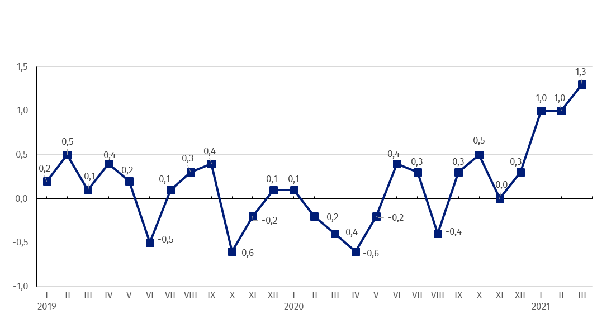 **Chart 1. Prices changes of sold production of industry in 2019-2021 in relation to the previous period (in %)**

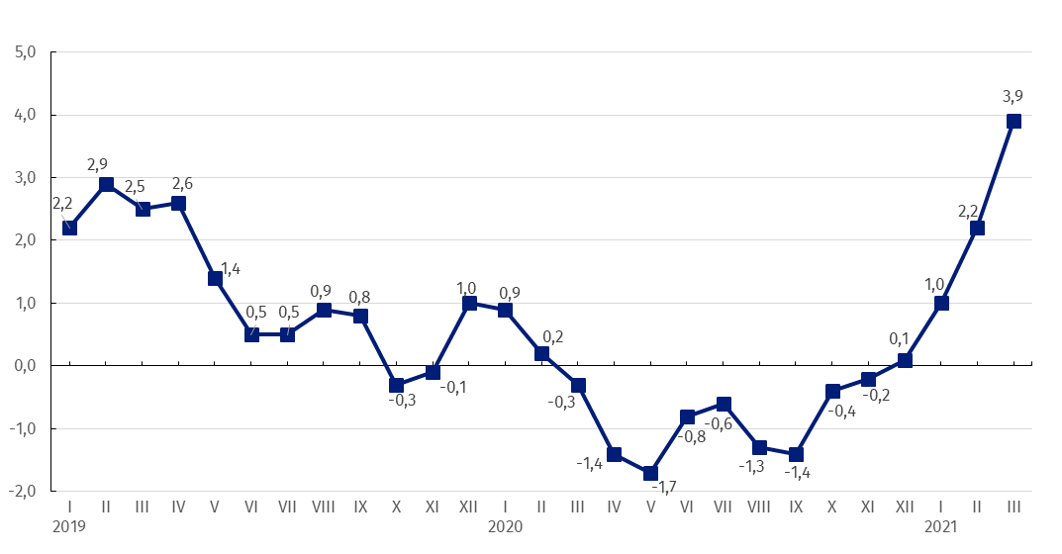**Chart 2. Prices changes of sold production of industry in 2019-2021 in relation to the same period of the previous year (in %)**

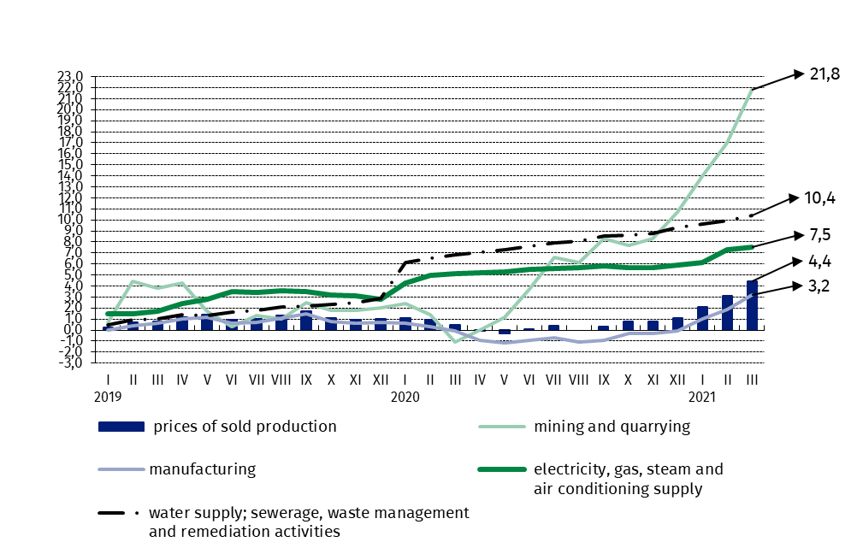Chart 3. Prices changes of sold production of industry by sections NACE in 2019-2021 in relation to December 2018 (in %)

In case of quoting Statistics Poland data, please provide information: “Source of data: Statistics Poland”, and in case of publishing calculations made on data published by Statistics Poland, please include the following disclaimer: “Own study based on figures from Statistics Poland”.

|  |  |
| --- | --- |
| Prepared by:  **The Trade and Services Department** **Director Ewa Adach-Stankiewicz**Office: tel. (+48 22) 608 31 24 | Issued by: **The Spokesperson for the President**  **of Statistics Poland** **Karolina Banaszek**Mobile: (+48) 695 255 011 |

|  |  |  |
| --- | --- | --- |
| **Press Office**  Office: tel. (+48 22) 608 34 91, 608 38 04  **e-mail:** [**obslugaprasowa@stat.gov.pl**](mailto:obslugaprasowa@stat.gov.pl) |  | www.stat.gov.pl/en/ |
|  | @StatPoland |
|  | @GlownyUrzadStatystyczny |

**Related information**

[Statistical Bulletin](https://stat.gov.pl/en/topics/other-studies/informations-on-socio-economic-situation/statistical-bulletin-no-22021,4,122.html)

[News Releases](http://stat.gov.pl/en/latest-statistical-news/news-releases/)

**Data available in databases**

[Analytical Platform - Knowledge Databases](http://swaid.stat.gov.pl/EN/SitePagesDBW/Ceny.aspx)

[Macroeconomic Data Bank](http://bdm.stat.gov.pl/)

[Prices indices (Topics: Prices, Trade)](http://stat.gov.pl/en/topics/prices-trade/price-indices/)

**Terms used in official statistics**

[Price index of sold production of industry](http://stat.gov.pl/en/metainformations/glossary/terms-used-in-official-statistics/708,term.html)