Consumer price indices in January 2023
(preliminary data)

According to preliminary data, in January 2023 consumer prices increased by 17,2% compared with the corresponding month of the previous year. As related to the previous month consumer prices increased by o 2,4%.
17.2%
an increase compared with
the corresponding month
of the previous year

Table 1. Consumer price indices in January 2023 (preliminary dataª)
Specification | 01 2023ª
 | 01 2022=100 | 12 2022=100
Total | 117,2 | 102,4
Food and non-alcoholic beverages | 120,7 | 101,9
Alcoholic beverages and tobacco | 109,9 | 101,2
Dwelling | 122,3 | 106,0
of which:
electricity, gas and other fuels | 134,0 | 110,4
Transport | 116,0 | 99,5
of which:
fuels for personal transport equipment | 118,7 | 100,0

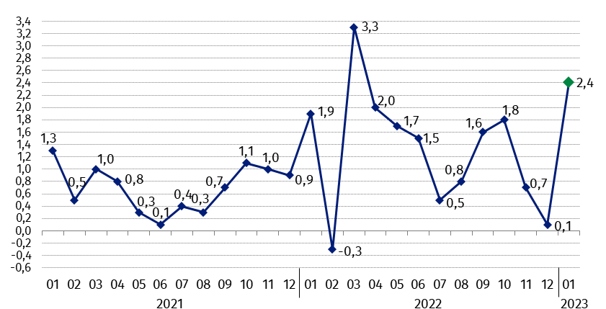
Chart 1. Changes in consumer prices as related to the previous period (in %)

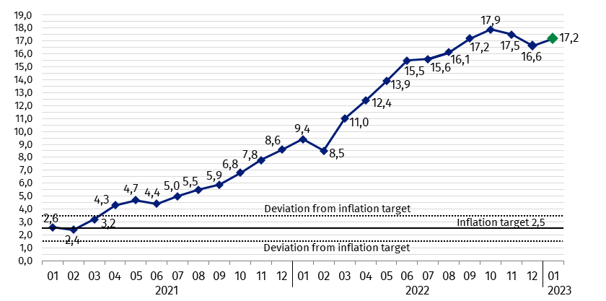
Chart 2. Changes in consumer prices^{b} as related to the corresponding period of the pre-vious year (in %)
Since April 2021 the consumer price index is above the upper band for deviations from inflation target determined by the Monetary Policy Council (2,5% +/- 1 pp)

Chart 3. Weighting system used in the compilations of consumer price indices in 2022

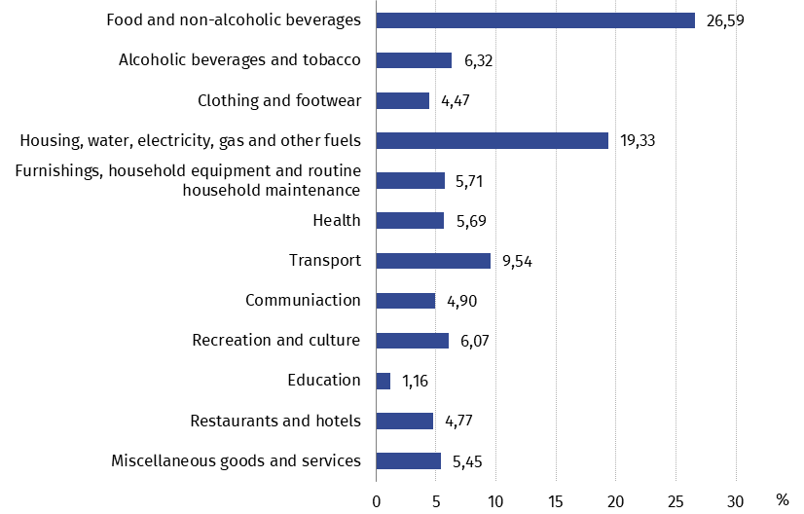

In case of quoting Statistics Poland data, please provide information: “Source of data: Statistics Poland”, and in case of publishing calculations made on data published by Statistics Poland, please include the following disclaimer: “Own study based on figures from Statistics Poland”.
Prepared by:  Trade and Services Department  Director Ewa Adach-Stankiewicz  Phone: (+48 22) 608 31 24 | Issued by:  The Spokesperson for the President  of Statistics Poland  Karolina Banaszek  Phone: (+48) 695 255 011
Press Office  Phone: (+48 22) 608 38 04  e-mail: obslugaprasowa@stat.gov.pl | www.stat.gov.pl/en/
 | @StatPoland
 | @GlownyUrzadStatystyczny
 | gus_stat
 | glownyurzadstatystycznygus
 | glownyurzadstatystyczny
Related information
Communications and Announcements
News releases
Data available in databases
Knowledge Database Prices
Macroeconomic Data Bank
Local Data Bank
Price indices (Topics: Prices, Trade)
Prices (Topics: Prices, Trade)
Terms used in official statistics
Price index of consumer goods and services
Retail price

Data is preliminary and is presented in a narrower scope. It is calculated based on the structure of households’ expenditure (excluding own consumption) from 2021
Final data with the exception of the preliminary data for January 2023
Structure of households’ expenditure (excluding own consumption) from 2021

