Producer price indices for business services in the first quarter of 2022

In the first quarter of 2022, the producer prices for business services increased compared to the previous quarter by 2.2% and compared to the first quarter of 2021 by 5.1%.
102.2
Increase in producer prices for business services compared to the fourth quarter of 2021

Table 1. Producer price indices for business services in the first quarter of 2022
Specification | quarter 1 2022
 | quarter 4 2021=100 | quarter 1 2021=100
Total | 102,2 | 105,1
Publishing activities | 102,8 | 106,9
Motion picture, video and television programme production, sound recording and music publishing activities | 100,8 | 102,3
Programming and broadcasting activities | 98,6 | 96,0
Computer programming, consultancy and related activities | 102,9 | 105,3
Information service activities | 102,0 | 103,3
Real estate activities | 102,2 | 105,4
Legal and accounting activities; management consultancy activities | 101,6 | 104,5
Architectural and engineering activities; technical testing and analysis | 102,3 | 103,0
Advertising and market research | 100,3 | 102,3
Other professional, scientific and technical activities | 101,2 | 104,7
Rental and leasing activities | 103,8 | 113,8
Employment activities | 104,5 | 107,2
Travel agency, tour operator and other reservation service and related activities | 103,3 | 111,8
Security and investigation activities | 104,0 | 105,9
Services to buildings and landscape activities | 104,4 | 106,5
Office administrative, office support and other business support activities | 102,3 | 106,5
In the 1st quarter of 2022, the highest increase of prices compared to the previous quarter was recorded in the employment activities
In the first quarter of 2022 the highest increase of prices compared to the previous quarter, was recorded in the employment activities, that is, by 4.5%. The increase occurred in activities of employment placement agencies, temporary employment agency activities and other human resources provision and it was justified by enterprises i.a. from an increase in the wages and salaries offered to workers recruited by employment agencies or workers assigned to work by temporary employment agencies. Similarly to the previous years, the 1st quarter of this year, was a period of a significant increase in prices in the services to buildings and landscape activities (increase by 4.4% compared to the previous quarter) and security and investigation activities (increase by 4.0% compared to the previous quarter). The increase resulted from a raise in the cost of their provision, mainly due to an increase in staff wages and salaries, including the increase of the minimum wage from 2021. The smallest price increase, below 1%, were recorded for services in motion picture, video and television programme production, sound recording and music publishing activities (by 0.8%) and advertising and market research (by 0.3%).
Price decrease compared with the previous quarter was recorded in the case of programming and broadcasting activities (by 1.4%), which was mostly related to a decrease in the selling price of TV advertising time and space.
Compared to the first quarter of 2021, the highest increase of prices occurred in rental and leasing activities (by 13.8%), travel agency, tour operator and other reservation service and related activities (by 11.8%) and employment activities (by 7.2%).
On the other hand the decrease in prices compared to the first quarter of the previous year was recorded in the case of programming and broadcasting activities (by 4.0%).

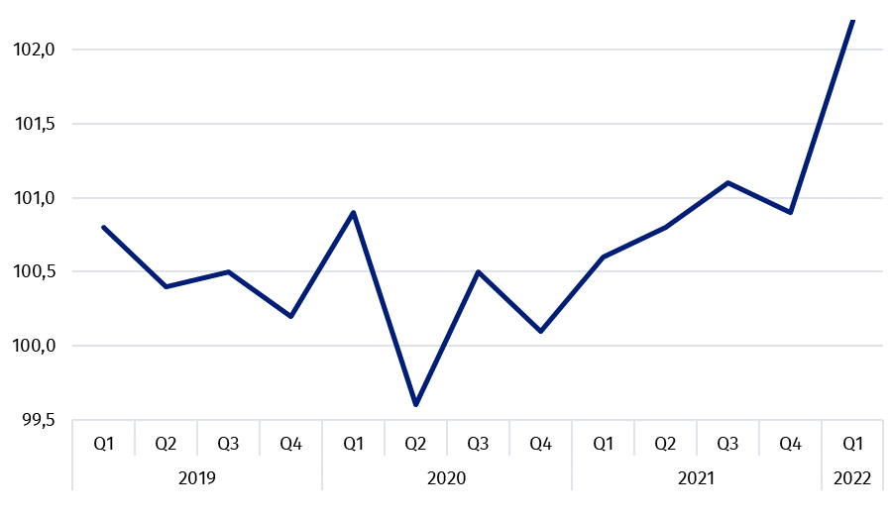
Chart 1. Producer price changes of business services in 2019-2022 (the previous quarter = 100)

Chart 2. Producer price changes of business services in 2019-2022 (corresponding period of the previous year = 100)

In case of quoting Statistics Poland data, please provide information: “Source of data: Statistics Poland”, and in case of publishing calculations made on data published by Statistics Poland, please include the following disclaimer: “Own study based on figures from Statistics Poland”.

Prepared by:  Trade and Services Department  Director Ewa Adach-Stankiewicz  Phone: (+48 22) 608 31 24 | Issued by:  The Spokesperson for the President  of Statistics Poland  Karolina Banaszek  Phone: (+48) 695 255 011
Press Office  Phone: (+48 22) 608 38 04  e-mail: obslugaprasowa@stat.gov.pl | www.stat.gov.pl/en/
 | @StatPoland
 | @GlownyUrzadStatystyczny
 | gus_stat
 | glownyurzadstatystycznygus
 | glownyurzadstatystyczny
Related information
News releases

Prices in the national economy

Data available in databases
Analytical Platform - Knowledge Databases
Prices indices (Topics: Prices, Trade)

Terms used inn official statistics
Producer price indices for business services

