Price indices of construction and assembly production in February 2023

According to preliminary data, in February 2023 the prices of construction and assembly production in comparison with the corresponding month of the previous year increased by 12.9%, and in comparison with January 2023 by 0.6%.
12.9%
the growth of producer prices in construction in comparison with February 2022

In February 2023 in comparison with January 2023 the growth of prices was recorded in civil engineering by 0.8%, construction of buildings by 0.5% as well as in specialised construction activities by 0.3%.
In comparison with February 2022 the increase of prices was noticed in construction of buildings by 13.9%, civil engineering - by 13.4% as well as in specialised construction activities - by 10.9%.

Table 1. Price indices of construction and assembly production in January and February 2023
 | 01 2023 |  | 02 2023 |  |  | 01-02 2023
SPECIFICATION | 12 2022=100 | corresponding period 2022=100 |  | 01 2023=100 | 12 2022=100 | 01-02 2022=100
TOTAL | 100.4* | 113.6* | 112.9 | 100.6 | 101.0 | 113.3
Construction of buildings | 100.5* | 114.7* | 113.9 | 100.5 | 101.0 | 114.3
Civil engineering | 100.6* | 113.9* | 113.4 | 100.8 | 101.4 | 113.7
Specialised construction activities | 100.1* | 111.7* | 110.9 | 100.3 | 100.4 | 111.3

* Data revised.

Chart 1. Prices changes of construction and assembly production in 2021-2023 in relation
In February 2023 the prices of construction and assembly production increased in relation to previous month by 0.6%
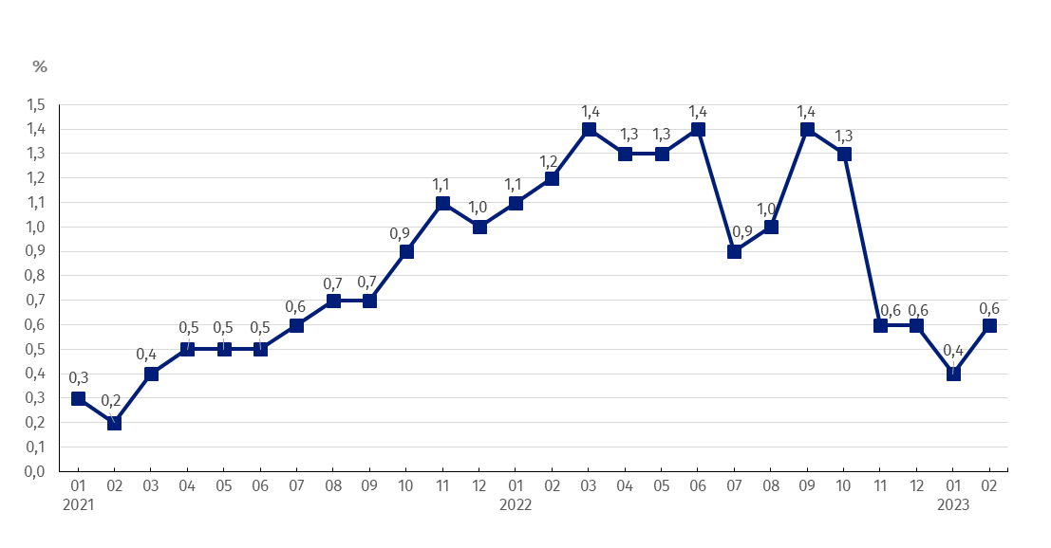
to the previous period

Chart 2. Prices changes of construction and assembly production in 2021-2023 in relation
In February 2023 the prices of construction and assembly production in annual terms increased by 12.9%
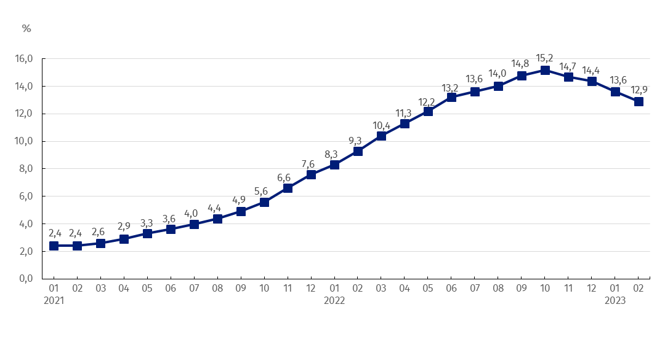
to the same period of the previous year

Chart 3. Prices changes of production and assembly construction by divisions NACE in 2021-2023 in relation to December 2020
In relation to December 2020 the prices of construction of buildings rose the most

In case of quoting Statistics Poland data, please provide information: “Source of data: Statistics Poland”, and in case of publishing calculations made on data published by Statistics Poland, please include the following disclaimer: “Own study based on figures from Statistics Poland”.

Prepared by:  The Trade and Services Department  Director Ewa Adach-Stankiewicz  Phone: (+48 22) 608 31 24 | Issued by:  The Spokesperson for the President  of Statistics Poland  Karolina Banaszek  Phone: (+48) 695 255 011
Press Office  Phone: (+48 22) 608 38 04  e-mail: obslugaprasowa@stat.gov.pl | www.stat.gov.pl/en/
 | @StatPoland
 | @GlownyUrzadStatystyczny
 | gus_stat
 | glownyurzadstatystycznygus
 | glownyurzadstatystyczny
Related information
Statistical Bulletin
News Releases

Data available in databases
Analytical Platform - Knowledge Databases
Macroeconomic Data Bank
Prices indices (Topics: Prices, Trade)
Terms used inn official statistics
Price index of construction and assembly production

