Price indices of construction and assembly production in January 2023

According to preliminary data, in January 2023 the prices of construction and assembly production in comparison with the corresponding month of the previous year increased by 13.1%, and in comparison with December 2022 remained at the similar level to that recorded a month ago.
13.1%
the growth of producer prices in construction in comparison with January 2022

In January 2023 in comparison with December 2022 the slight growth of prices was recorded in construction of buildings as well as in civil engineering - by 0.1% each . However, the prices drop was observed in specialised construction activities by 0.1%.
In comparison with January 2022 the increase of prices was noticed in construction of buildings by 14.2%, civil engineering - by 13.2% as well as in specialised construction activities - by 11.5%.

Table 1. Price indices of construction and assembly production in December 2022 and January 2023
 | 12 2022 |  | 01-12 2022 | 01 2023
SPECIFICATION | 11 2022=100 | corresponding period 2021=100 |  | 01 2022=100 | 12 2022=100
TOTAL | 100.6* | 114.4* | 112.7 | 113.1 | 100.0
Construction of buildings | 100.6* | 115.5* | 113.5 | 114.2 | 100.1
Civil engineering | 100.6* | 114.4* | 112.8 | 113.2 | 100.1
Specialised construction activities | 100.7* | 113.0* | 111.2 | 111.5 | 99.9
* Data revised.

Chart 1. Prices changes of construction and assembly production in 2021-2023 in relation
In January 2023 the prices of construction and assembly production remained at the similar level to that recorded in December 2022
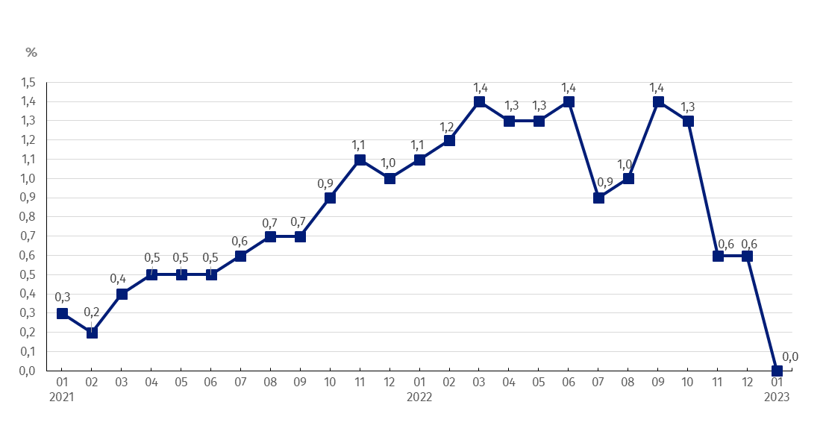
to the previous period

Chart 2. Prices changes of construction and assembly production in 2021-2023 in relation
In January 2023 the prices of construction and assembly production in annual terms increased by 13.1%
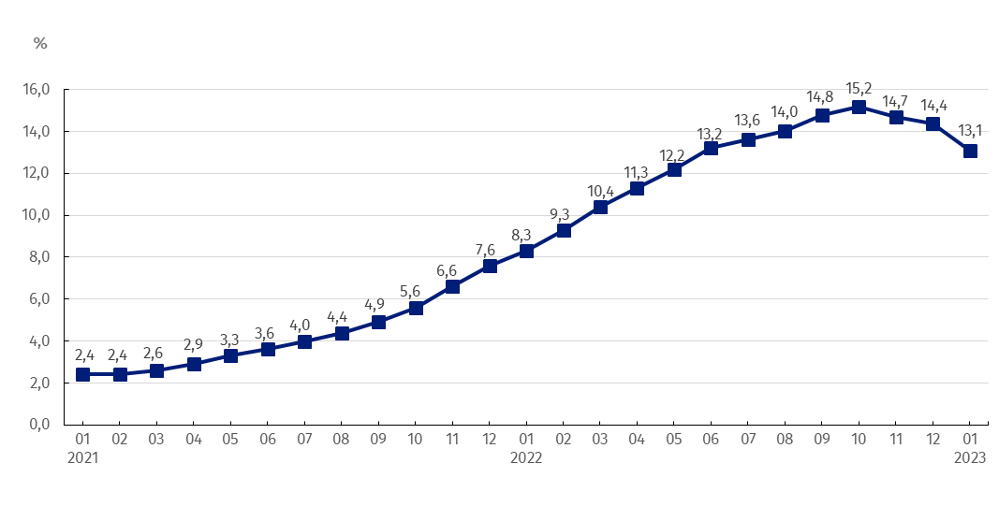
to the same period of the previous year

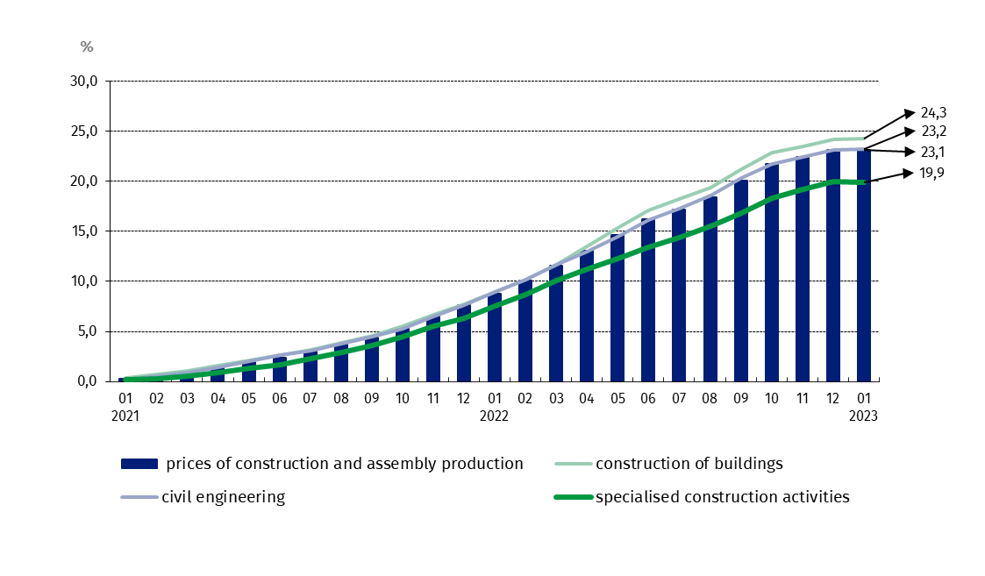
Chart 3. Prices changes of production and assembly construction by divisions NACE in 2021-2023 in relation to December 2020
In relation to December 2020 the prices of construction of buildings rose the most

In case of quoting Statistics Poland data, please provide information: “Source of data: Statistics Poland”, and in case of publishing calculations made on data published by Statistics Poland, please include the following disclaimer: “Own study based on figures from Statistics Poland”.

Prepared by:  The Trade and Services Department  Director Ewa Adach-Stankiewicz  Phone: (+48 22) 608 31 24 | Issued by:  The Spokesperson for the President  of Statistics Poland  Karolina Banaszek  Phone: (+48) 695 255 011
Press Office  Phone: (+48 22) 608 38 04  e-mail: obslugaprasowa@stat.gov.pl | www.stat.gov.pl/en/
 | @StatPoland
 | @GlownyUrzadStatystyczny
 | gus_stat
 | glownyurzadstatystycznygus
 | glownyurzadstatystyczny
Related information
Statistical Bulletin
News Releases

Data available in databases
Analytical Platform - Knowledge Databases
Macroeconomic Data Bank
Prices indices (Topics: Prices, Trade)
Terms used inn official statistics
Price index of construction and assembly production

