Price indices of construction and assembly production in December 2020

According to preliminary data, in December 2020 the prices of construction and assembly production in comparison with the corresponding month of the previous year increased by 2.7%, and in comparison with November 2020 - by 0.2%.

2.7%

the growth of producer prices in construction in comparison with December 2019

In comparison with the previous month the growth of prices was recorded in construction of buildings by 0.3% as well as in civil engineering and in specialised construction activities - by 0.2% each.

In comparison with December 2019 the increase of prices was noticed in construction of buildings by 2.8% as well as in civil engineering by 2.5% and in specialised construction activities - by 2.2%.

**Table 1. Price indices of construction and assembly production in December 2020**

|  |  |  |  |  |  |
| --- | --- | --- | --- | --- | --- |
|  | XI 2020 | | XII 2020 | | I-XII 2020 |
| SPECIFICATION | X 2020=100 | corresponding period 2019=100 | | XI 2020=100 | I-XII 2019=100 |
| **TOTAL** | **100.2** | **102.4** | **102.7** | **100.2** | **102.6** |
| Construction of buildings | 100.2* | 102.6* | 102.8 | 100.3 | 103.0 |
| Civil engineering | 100.1* | 102.5 | 102.5 | 100.2 | 102.6 |
| Specialised construction activities | 100.2* | 102.1* | 102.2 | 100.2 | 102.3 |

* Data revised.

In December 2020, as in October and November 2020, the prices of construction and assembly production increased compared to the previous month by 0.2%

Chart 1. Prices changes of construction and assembly production in 2019-2020 in relation

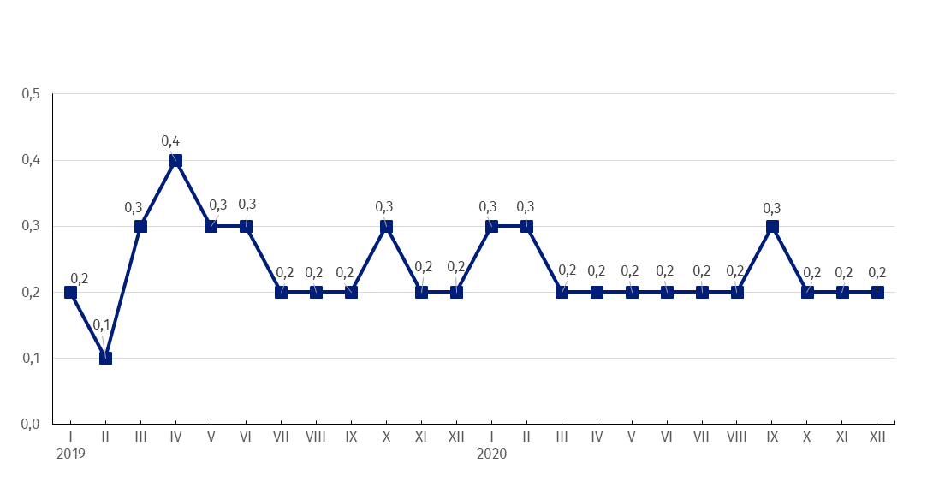 to the previous period ( in %)

Chart 2. Prices changes of construction and assembly production in 2019-2020 in relation

In December 2020 the prices growth of construction and assembly production in annual term was the highest since May 2020

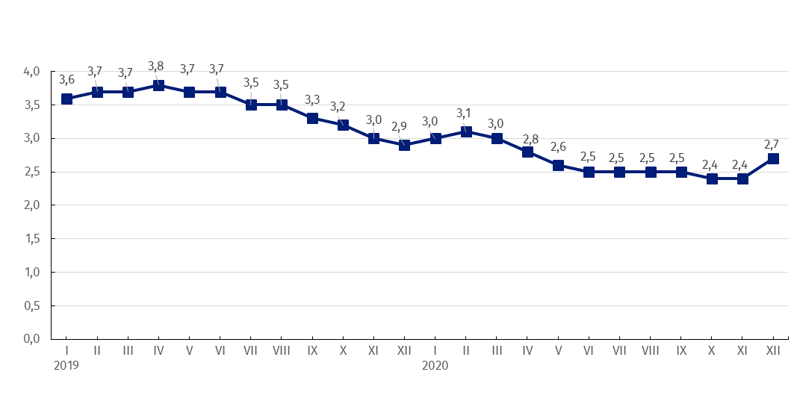to the same period of the previous year (in %)

Chart 3. Prices changes of production and assembly construction by divisions NACE in 2019-2020

Starting from January 2019 the highest prices growth is recorded in construction of buildings

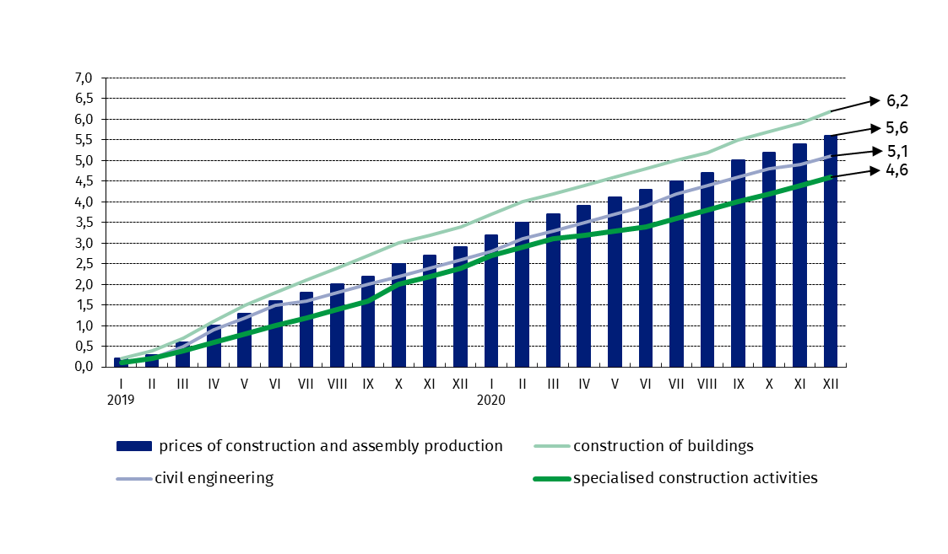 in relation to December 2018 (in %)

In case of quoting Statistics Poland data, please provide information: “Source of data: Statistics Poland”, and in case of publishing calculations made on data published by Statistics Poland, please include the following disclaimer: “Own study based on figures from Statistics Poland”.

|  |  |
| --- | --- |
| Prepared by:  **The Trade and Services Department** **Director Ewa Adach-Stankiewicz**Office: tel. (+48 22) 608 31 24 | Issued by: **The Spokesperson for the President**  **of Statistics Poland** **Karolina Banaszek**Mobile: (+48) 695 255 011 |

|  |  |  |
| --- | --- | --- |
| **Press Office**  Office: tel. (+4822) 608 34 91, 608 38 04  **e-mail:** [**obslugaprasowa@stat.gov.pl**](mailto:obslugaprasowa@stat.gov.pl) |  | www.stat.gov.pl/en/ |
|  | @StatPoland |
|  | @GlownyUrzadStatystyczny |

**Related information**

[Statistical Bulletin](https://stat.gov.pl/en/topics/other-studies/informations-on-socio-economic-situation/statistical-bulletin-no-112020,4,119.html)

[News Releases](http://stat.gov.pl/en/latest-statistical-news/news-releases/)

**Data available in databases**

[Analytical Platform - Knowledge Databases](http://swaid.stat.gov.pl/EN/SitePagesDBW/Ceny.aspx)

[Macroeconomic Data Bank](http://bdm.stat.gov.pl/)

[Prices indices (Topics: Prices, Trade)](http://stat.gov.pl/en/topics/prices-trade/price-indices/)

**Terms used in official statistics**

[Price index of construction and assembly production](http://stat.gov.pl/en/metainformations/glossary/terms-used-in-official-statistics/709,term.html)