Price indices of construction and assembly production in March 2020

According to preliminary data in March 2020 the prices of construction and assembly production were higher by 3.0% in comparison with the corresponding month of the previous year and by 0.2% in comparison with February 2020.

3.0%

the growth of producer prices in construction in comparison with March 2019

In comparison with the previous month the growth of prices was recorded in construction of buildings as well as in civil engineering (by 0.2% each). The prices in specialised construction activities increased (by 0.1%).

In comparison with March 2019 the increase of prices was noticed in construction of buildings (by 3.5%), in civil engineering (by 2.8%) as well as in specialised construction activities (by 2.5%).

**Table 1. Price indices of construction and assembly production in March 2020**

|  |  |  |  |  |  |  |
| --- | --- | --- | --- | --- | --- | --- |
|  | II 2020=100 | | III 2020=100 | | | I-III 2020 |
| SPECIFICATION | I 2020=100 | corresponding period 2019=100 | | II 2020=100 | XII 2019=100 | I-III 2019 |
| **TOTAL** | **100.3** | **103.1** | **103.0** | **100.2** | **100.8** | **103.0** |
| Construction of buildings | 100.3 | 103.7 | 103.5 | 100.2 | 100.8 | 103.6 |
| Civil engineering | 100.3 | 102.9 | 102.8 | 100.2 | 100.7 | 102.8 |
| Specialised construction activities | 100.2 | 102.6 | 102.5 | 100.1 | 100.6 | 102.6 |

* Data revised.

In March 2020, the prices of construction and assembly production increased by 0.2% in comparison with the previous month

Chart 1. Prices changes of construction and assembly production in 2018-2020 in relation

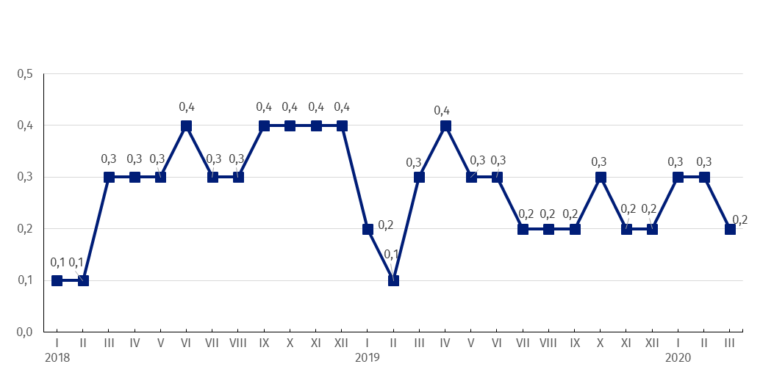 to the previous period ( in %)

In March this year, same as in January this year, the prices of construction and assembly production in annual term increased by 3.0%

Chart 2. Prices changes of construction and assembly production in 2018-2020 in relation

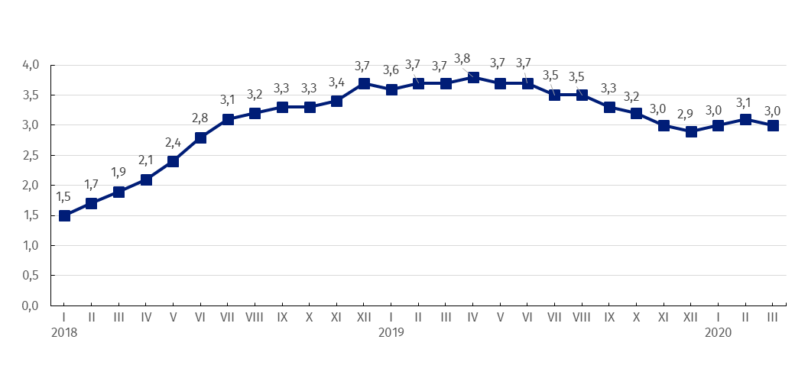to the same period of the previous year (in %)

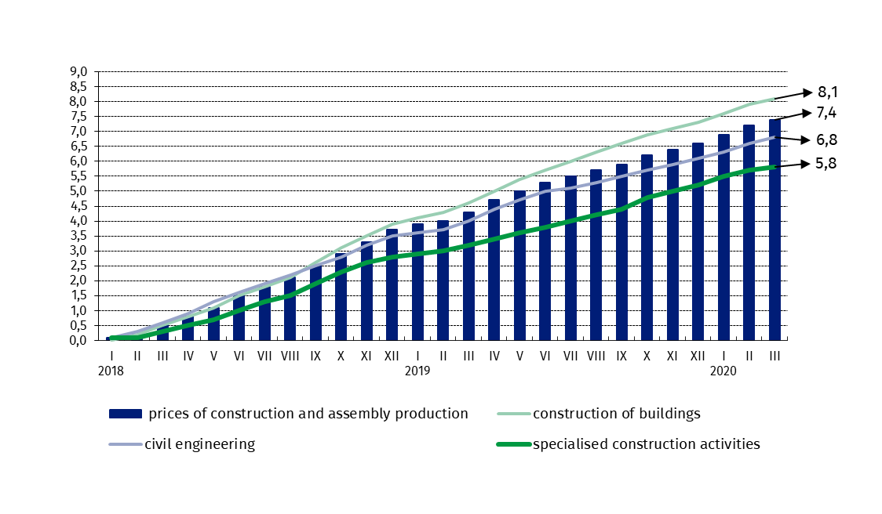Chart 3. Prices changes of production and assembly construction by divisions NACE in 2018-2020

In March this year in relation to XII 2017 the highest prices growth of construction of buildings was recorded

in relation to XII 2017 (in %)

|  |  |
| --- | --- |
| Prepared by:  **The Trade and Services Department** **Director Ewa Adach-Stankiewicz**Office: tel. (+48 22) 608 31 24 | Issued by: **The Spokeperson for the President**  **of Statistics Poland** **Karolina Banaszek**Mobile: (+48) 695 255 011 |

|  |  |  |
| --- | --- | --- |
| **Press Office**  Office: tel. (+4822) 608 34 91, 608 38 04  **e-mail:** [**obslugaprasowa@stat.gov.pl**](mailto:obslugaprasowa@stat.gov.pl) |  | www.stat.gov.pl/en/ |
|  | @StatPoland |
|  | @GlownyUrzadStatystyczny |

**Related information**

[Statistical Bulletin](https://stat.gov.pl/en/topics/other-studies/informations-on-socio-economic-situation/statistical-bulletin-no-22020,4,110.html)

[News Releases](http://stat.gov.pl/en/latest-statistical-news/news-releases/)

**Data available in databases**

[Analytical Platform - Knowledge Databases](http://swaid.stat.gov.pl/EN/SitePagesDBW/Ceny.aspx)

[Macroeconomic Data Bank](http://bdm.stat.gov.pl/)

[Prices indices (Topics: Prices, Trade)](http://stat.gov.pl/en/topics/prices-trade/price-indices/)

**Terms used in official statistics**

[Price index of construction and assembly production](http://stat.gov.pl/en/metainformations/glossary/terms-used-in-official-statistics/709,term.html)